Supplementary material

Climate Change Amplifies Surface Fire Hazard in the Tropical Andes: High-Resolution FlamMap Simulations in Southern Ecuador

María Mercedes Ojeda-Muñoz, Juan Gabriel Mollocana-Lara and Cesar Ivan Alvarez

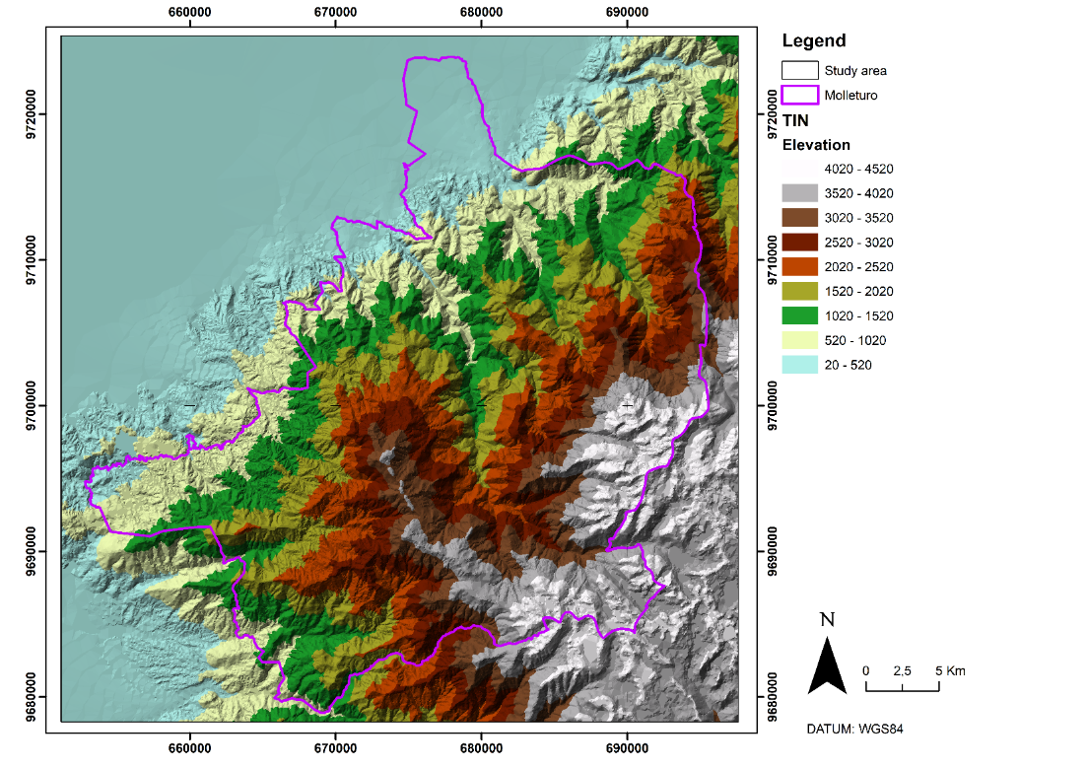
Fig. S1. TIN of the study area

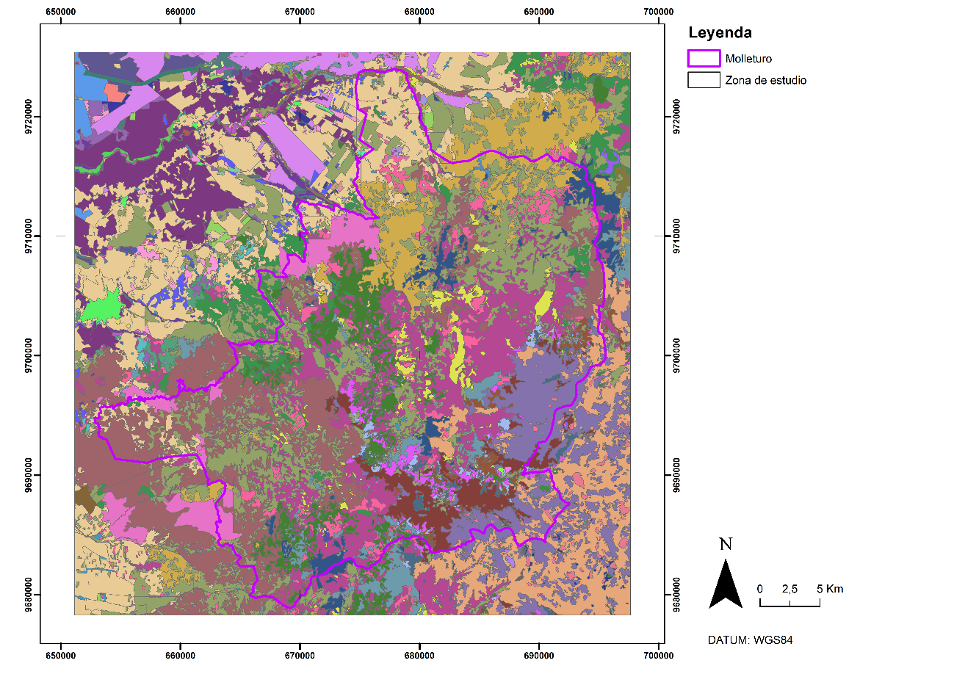
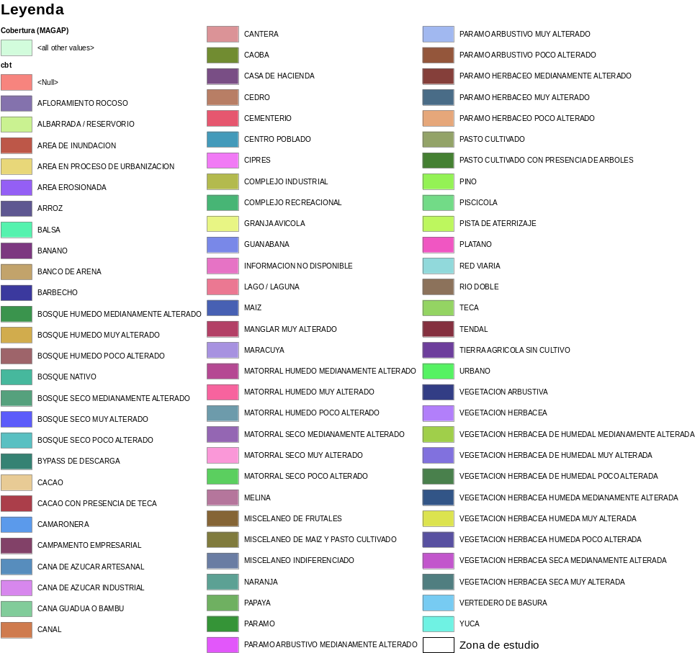
Fig. S2. Land cover and use of the study area.

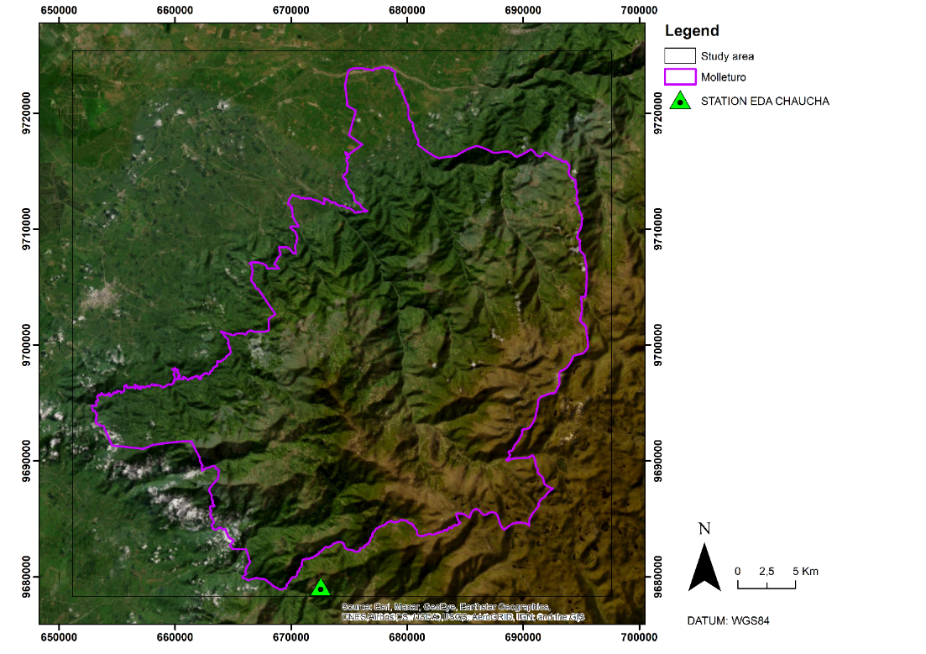
Fig. S3. Location of the EDA CHAUCHA weather station.

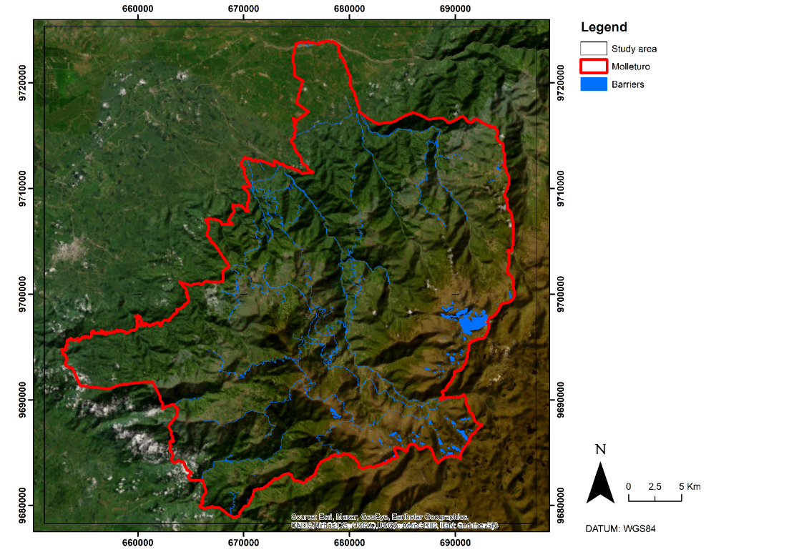
Figure S4. Fire barriers in the study area.
Table S1. Temperature and humidity data for simulation periods.
 | Period | Temperature (°C) | Relative Humidity (%)
 | 2014-2020 | 16.74 | 89.41
RCP 4.5 Scenario | 2030-2050 | 19.98 | 83.07
RCP 4.5 Scenario | 2051-2070 | 20.56 | 82.84
RCP 8.5 Scenario | 2030-2050 | 20.19 | 83.03
RCP 8.5 Scenario | 2051-2070 | 21.29 | 82.85
Table S2. Wind speed and direction data for simulation periods.
 | Period | Maximum Wind Speed (km/h) | Wind Direction (°)
 | 2014-2020 | 8.00 | 189.60
RCP 4.5 Scenario | 2030-2050 | 10.00 | 189.60
RCP 4.5 Scenario | 2051-2070 | 13.00 | 189.60
RCP 8.5 Scenario | 2030-2050 | 10.00 | 189.60
RCP 8.5 Scenario | 2051-2070 | 13.00 | 189.60
Table S3. Information about the study area.
 | Minimum | Maximum | Mean | Standard Deviation
Elevation (m) | 20 | 4520 | 1495, 23 | 1414.63
Slope (%)) | 0 | 68.83 | 17.73 | 14.52
Aspect (°) | -1 | 359.99 | 180.64 | 126.07
Vegetation Cover (%) | 1 | 100 | 26.15 | 36.62
Table S4. Average values of fire behaviour and growth indicators by scenario, fire behaviour algorithm (FB).
Scenario | Flame Length (m) | Rate of Spread (m/min) | Fireline Intensity (kW/m) | Crown Fire Activity
BASE PERIOD (2014-2020) | 0.32 ± 0.60 | 1.02 ± 2.76 | 115,40 ± 514,51 | 1.00
RCP 8.5 (2030-2050)  RCP 8.5 (2051-2070) | 0.31 ± 0.58 | 1.02 ± 2.76 | 104,63 ± 411.87 | 1.00
RCP 8.5 (2030-2050)  RCP 8.5 (2051-2070) | 0.35 ± 0.63 | 1.02 ± 2.75 | 129.69 ± 445.99 | 1.00

Table S5. Percentage of area by category for flame length by scenario.
Flame Length (m) | BASE PERIOD (2014–2020) | RCP 8.5 (2030–2050) | RCP 8.5 (2051–2070)
Flame Length (m) | Percentage of Area (%)
Low (0–1.2) | 91.34% | 91.12% | 88.20%
Moderate (1.2-2.4) | 7.09% | 7.77% | 9.52%
High (2.4-2.4) | 1.11% | 0.88% | 2.05%
Very High (>3.4) | 0.46% | 0.23% | 0.23%
Table S6. Percentage of area by category for the spread rate by scenario.
Rate of Spread (m/min) | BASE PERIOD (2014–2020) | RCP 8.5 (2030–2050) | RCP 8.5 (2051–2070)
Rate of Spread (m/min) | Percentage of Area (%)
Low (<2) | 86.90% | 86.59% | 85.74%
Moderate (2-15) | 12.48% | 12.65% | 12.85%
High (15-30) | 0.60% | 0.74% | 1.36%
Very High (>30) | 0.02% | 0.02% | 0.04%
Table S7. Percentage of area by category for fireline intensity by scenario.
Fireline Intensity (kW/m) | PERIODO BASE (2014-2020) | RCP 8.5 (2030-2050) | RCP 8.5 (2051-2070)
Fireline Intensity (kW/m) | Percentage of Area (%)
Low (0-300) | 90.83% | 90.54% | 89.31%
Moderate (350-1700) | 7.55% | 8.30% | 9.37%
High (1700-3500) | 1.11% | 0.90% | 1.05%
Very High (>3500) | 0.51% | 0.27% | 0.27%
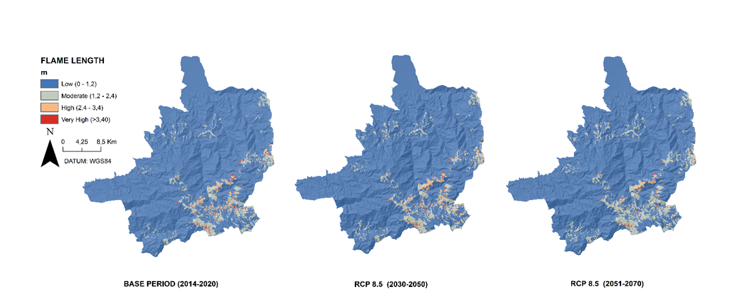
Fig. S5. Flame Length (FL) in the base and future scenarios (m).
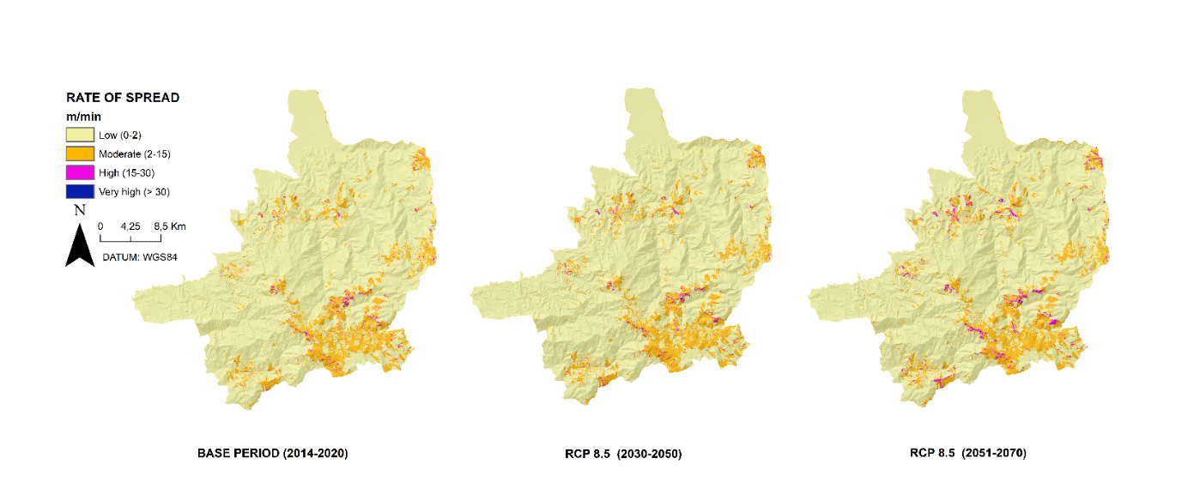
Fig. S6. Propagation rate in the base and future scenarios (m/min).
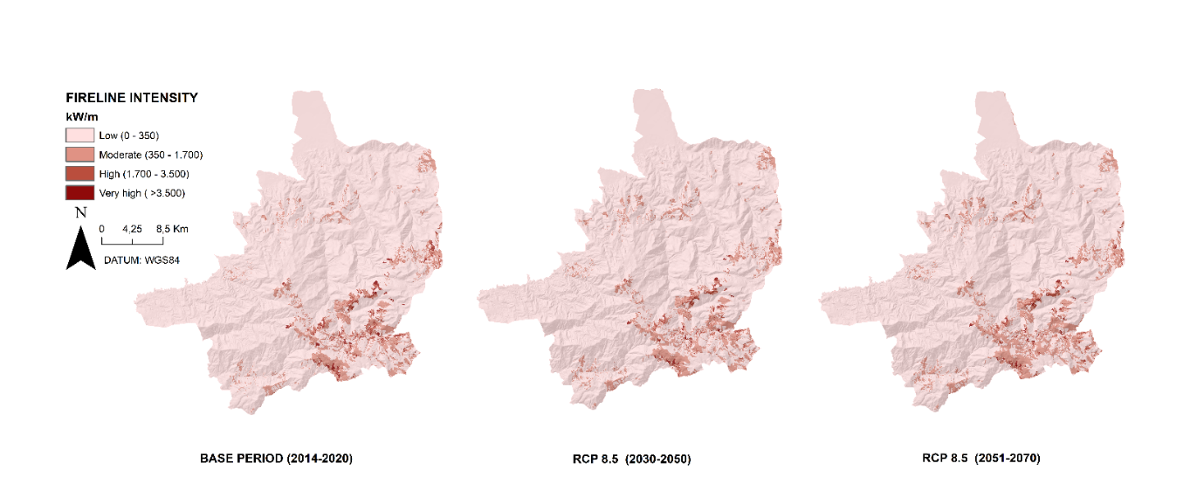
Fig. S7. Fire line intensity in the base and future scenarios (kW/m).
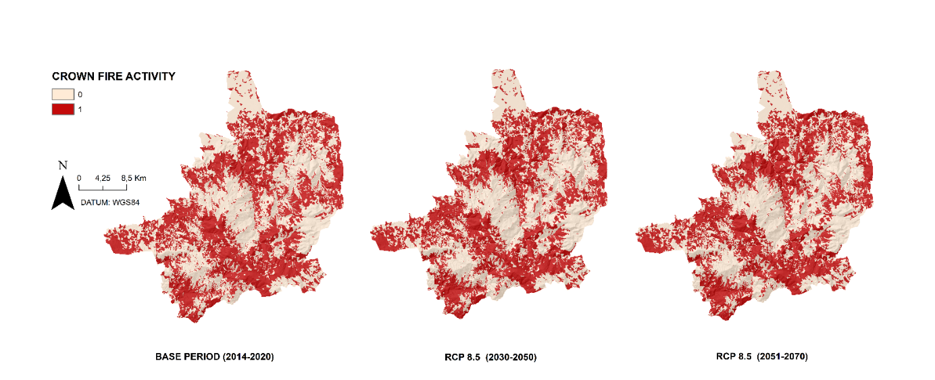
Fig. S8. Corona fire activity in the base and future scenarios (kW/m).

