Appendix. Supplementary data
Colored noise-induced logical stochastic resonance in a low-power-consumption spintronics neuron
Zhiqiang Liao^{1, 2,} *, Siyi Tang¹, Md Shamim Sarker^{2, 3}, Hiroyasu Yamahara², Munetoshi Seki^{1, 4}, Hitoshi Tabata^{1, 2, 4,} *
¹ Department of Electrical Engineering and Information Systems, Graduate School of Engineering, The University of Tokyo, 7-3-1 Hongo, Bunkyo-ku, Tokyo 113-8656, Japan
² Department of Bioengineering, Graduate School of Engineering, The University of Tokyo, 7-3-1 Hongo, Bunkyo-ku, Tokyo 113-8656, Japan
³ Department of Electrical and Electronic Engineering, Khulna University of Engineering and Technology, Khulna-9203, Bangladesh
⁴ Center for Spintronics Research Network, Graduate School of Engineering, The University of Tokyo, 7-3-1 Hongo, Bunkyo-ku, Tokyo 113-8656, Japan
* liao@bioxide.t.u-tokyo.ac.jp; tabata@bioeng.t.u-tokyo.ac.jp

Supplementary Note 1: Logic flipping probability of SMTJ under the influence of red and pink noise
Fig. A1. Example time series of (a) $V_{1}$ and (b) $V_{2}$. Resistance state switching time series of the SMTJ performing logic operations on the example $V_{1}$ and $V_{2}$ as an AND gate with (c) red and (d) pink noise. The logical driving amplitude $A$ is 700 mV with a bias of $-$350 mV. The noise intensity is set as 150 mV. Flipping probability of the SMTJ performing AND operations with (e) red and (f) pink noise.

Figure A1 illustrates the temporal dynamical evolution of SMTJ-based logic gates under the influence of red noise and pink noise. Taking the SMTJ with red noise injection as an example, the temporal evolution of its resistance state does not fully align with the ideal logical output, as shown in Fig. A1(c). Due to the suppression effect of red noise on junction frequency [A1], both $P_{AP→P}$ and $P_{P→AP}$ often simultaneously assume very low values, leading to delayed switching or no switching in the SMTJ. For pink noise, similar phenomena can occur at certain times, as observed during the first logic operation in Figs. A1(d) and A1(f).

Supplementary Note 2: Logic flipping probability of SMTJ under the influence of white, blue, and violet noise
Fig. A2. Example time series of (a) $V_{1}$ and (b) $V_{2}$. Resistance state switching time series of the SMTJ performing logic operations on the example $V_{1}$ and $V_{2}$ as an AND gate (c) without noise and (d) with white noise. The logical driving amplitude $A$ is 700 mV with a bias of $-$235 mV. The noise intensity of white noise is set as 110 mV. Flipping probability of the SMTJ performing AND operations (e) without noise and (f) with white noise.

To emphasize the role of noise, Fig. A2 presents the temporal dynamical evolution of SMTJ-based logic gates driven by $V_{1}$ and $V_{2}$ under noise-free and white noise conditions. The selected driving conditions are subthreshold, resulting in the inability of noise-free SMTJ to completely and promptly transition its state between logical codes, as shown in Figs. A2(c) and A2(e). When white noise is injected, the phase difference between the SMTJ-based logic gate and the ideal output is significantly reduced, with only a one-sample delay during the 10 ns logic code transition, as illustrated in Fig. A2(d). Figure A2(f) shows that at $V_{1}+V_{2}=0$, the system provides sufficient perturbation to drive the evolution toward the P state.

As shown in Figures A3(a) and A3(b), SMTJs under blue noise and violet noise injection also perform logical operations with minimal phase difference from the ideal output. Due to the higher energy of high-frequency signals in violet and blue noise, SMTJ-based logic gates exhibit more frequent escape attempts along the bias modulation direction at $V_{1}+V_{2}=0$, as depicted in Figs. A3(c) and A3(d). However, thermal phase shifts induced by noise can occasionally lead to premature or delayed switching of the SMTJ.
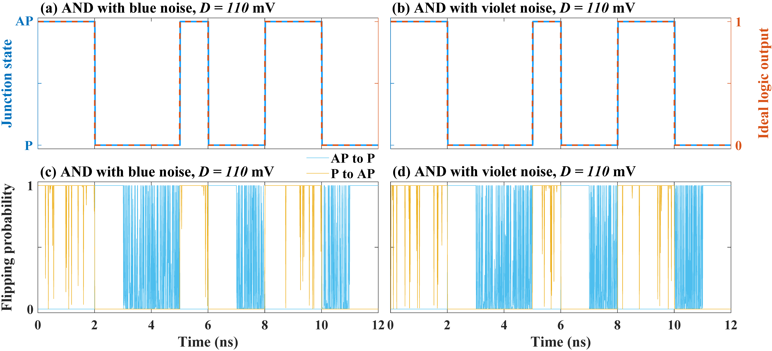
Fig. A3. Resistance state switching time series of the SMTJ performing logic operations on the example $V_{1}$ and $V_{2}$ as an AND gate with (a) blue and (b) violet noise. The logical driving amplitude $A$ is 700 mV with a bias of $-$235 mV. The noise intensity of blue and violet noise is set as 110 mV. Flipping probability of the SMTJ performing AND operations with (c) blue and (d) violet noise.

Supplementary Note 3: Influence of effective code length on STJ-based OR logical gate
Similar to the AND operation in the main text, the parameter robustness region of an SMTJ-based OR gate can also be enhanced by reducing $L$. As shown in Figs. A4(a–c), under the influence of red noise, the region where the SMTJ robustly performs the AND logic operation narrows as $L$ increases. Similarly, for violet noise with $m>0$, the robust logic operation region of the SMTJ (with a success rate of 100%) also shrinks as $L$ increases, as illustrated in Figs. A4(f–h). Within the region where the SMTJ reliably executes logic operations, there exists a maximum tolerable noise intensity. Due to the symmetry of the parameter space with respect to $bias=0$, the SMTJ-based AND and OR gates share the same maximum tolerable noise intensity.
Fig. A4. Logical success rate heatmaps of the SMTJ-based OR gate with $A=550$ mV across varying red noise intensities and biases for (c) $L=0.2$, (d) $L=0.5$, and (e) $L=0.8$, respectively. Logical success rate heatmaps of the SMTJ-based OR gate with $A=550$ mV across varying violet noise intensities and biases for (f) $L=0.2$, (g) $L=0.5$, and (h) $L=0.8$, respectively. The region enclosed by the red solid line represents the robust region with a 100% logical success rate.

Reference
[A1] Liao Z, Ma K, Tang S, Sarker MS, Yamahara H, Tabata H. Phase locking of ultra-low power consumption stochastic magnetic bits induced by colored noise. Chaos, Solitons and Fractals. 2021;151:111262.
[A2] Locatelli N, Mizrahi A, Accioly A, Matsumoto R, Fukushima A, Kubota H, et al. Noise-enhanced synchronization of stochastic magnetic oscillators. Physical Review Applied. 2014;2:034009.

