Supplementary Materials
of
Time-Series Deep Learning for Dynamical Mode Identification in Complex Flow Systems: Application to Combustor-Inspired Circular Flame Arrays

Weiming Xu^{1,2#}, Tao Yang^{1,2#}, and Peng Zhang^{1,2∗}
1. Department of Mechanical Engineering, City University of Hong Kong, Kowloon Tong, Kowloon, 999077, Hong Kong
2. Shenzhen Research Institute, City University of Hong Kong, Shenzhen, 518057, P. R. China

Content
1. Numerical simulations of flickering flames in circular arrays 2
2. Long-short Term Memory (LSTM) cell for capturing temporary dependencies 4
3. Variational Autoencoder (VAE) model for dimension reduction 6
4. Results of various flame configurations in ca 8.6 group cases 8
5. Reconstruction performance of PCA, VAE, and Chrono-attention VAE 10
6. Selection of latent space dimensionality in the Chrono-attention VAE 11
7. Sensitivity of 2D–Wasserstein distance to KDE resolution 13
8. Visualization of latent trajectories and Wasserstein distance distributions 13

Numerical simulations of flickering flames in circular arrays
In the present study, flickering buoyant diffusion flames were computationally produced using Fire Dynamics Simulator (FDS) [1], which is a widely used open-source code for solving the unsteady, three-dimensional, low-Mach, and variable-density flow. Spatial integration was carried out using a kinetic-energy-conserving central difference scheme, and an explicit second-order predictor/corrector scheme advanced the time integration. The thermally driven flows were computed by FDS. Based on FDS, our previous computational works [2-4] successfully captured the dynamical behaviors of flickering buoyant diffusion flames in a quiescent environment and reproduced a variety of dynamical modes in the dual- and triple-flame systems. More details of the simulation validations, including the scaling law of flickering frequency, the computing domain study, and the grid independent study, are given in [2, 3].
Following our previous work [4], we show the present validation of flickering frequencies of buoyant diffusion flames in Fig. S1. The simulations were set up according to Table S1 and the results agree fairly with previous experiments [5-8] and particularly predict the famous scaling relation of $f_{0}\sim \sqrt{gD}$ [9], although the flickering frequency has a very small difference in using infinite and finite fast one-step overall reaction. Using a detailed reaction mechanism is insignificant in simulating small-scale buoyant-controlled thermal flows. Considering the computational cost, we use the mixing-limited chemical reaction to simulate the circular arrays of flame oscillators.

Table S1 Key parameters of numerical simulations
Fuel | Methane gas with a uniform inlet velocity $U_{0}$=0.165 m/s
Bunsen burner | Eight identical square burners with $D$=10 mm length and 3$D$ height
Domain | Whole computation in the $16D×16D×24D$ zone
Boundary | Six sides are open boundary condition for gas flowing in and out freely
Grid | $160×160×240$ structured, uniform, staggered grids.
Models | Mixing-limited chemical reaction (infinitely fast reaction of lumped species); no modeling for the insignificant influences of adiation and soot
All simulations | Dataset obtained from the fully developed flows after running all cases at least 20 times longer than $L/U_{0}$)
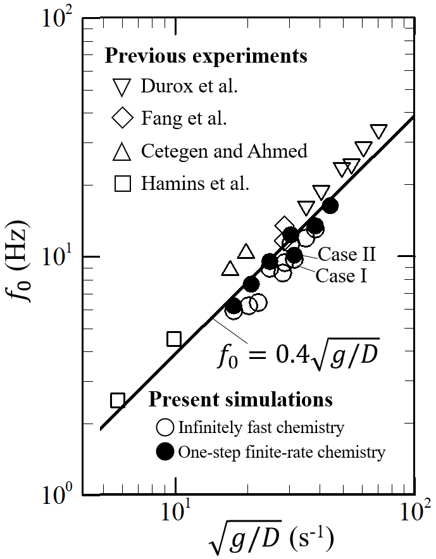
Fig. S1. Validation of single flickering flames with the scaling laws [9] and previous experiments [5-8]. The numerical results of flame in various gravity $g$ are obtained by using infinitely fast chemistry (IFC) and one-step finite rate chemistry (OFC).

Long-short Term Memory (LSTM) cell for capturing temporary dependencies
The LSTM architecture is inherently designed to address the losing temporal information problem at processing long sequences, as shown in Fig. S2. The LSTM cells are regulated by three kinds of gates: input gate, output gate, and forget gate. The input and output gates control the information entering the memory cell and the data flowing to other parts of the network, respectively. The forget gate facilitates the retention and transfer of information from one step to the next. Information is stored in the memory cell through activation functions when the input unit shows high activation levels. The mathematical relationships are expressed by
 | $f_{t}=sigmoid(W_{fg}X_{t}+W_{hfg}h_{t-1}+b_{fg})$ | (S1)
 | $i_{t}=sigmoid(W_{ig}X_{t}+W_{hig}h_{t-1}+b_{ig})$ | (S2)
 | $o_{t}=sigmoid(W_{og}X_{t}+W_{hog}h_{t-1}+b_{og})$ | (S3)
 | $C_{t}=C_{t-1}⊙{\left(f_{t}\right)}_{t}+{\left(i_{t}\right)}_{t}⊙(tanh(W_{C}X_{t}+W_{hC}h_{t-1}+b_{C}))$ | (S4)
 | $h_{t}=o_{t}⊙tanh(C_{t-1})$ | (S5)
where $W_{fg}$, $W_{hfg}$, $b_{fg}$ denote the weights and biases of the forget gate $f_{t}$, respectively. Similarly, $W_{ig}$, $W_{hig}$, and $b_{ig}$ are for the input gate $i_{t}$; $W_{og}$, $W_{hog}$ , and $b_{og}$ are for output gate $o_{t}$; $W_{C}$, $W_{hC}$ and $b_{C}$ are for $C_{t}$. $t-1$and $t$ are previous and current time steps.
LSTM possesses the capability to process historical information yet is unable to effectively learn future information. However, in the context of cyclic flame oscillation data, the information from both the preceding and succeeding moments demonstrates a strong temporal correlation with the current state. To address this limitation, this study employs a sophisticated two-layer Bi-LSTM network structure. Comprising two layers of bidirectional LSTM networks, each layer incorporates two distinct LSTM hidden layers, which yield similar outputs in opposing directions. For a given input sequence, the forward computation of the Bi-LSTM generates the output $h_{t}^{forward}$, while the backward computation generates the output $h_{t}^{backward}$. The final output of this layer is expressed as $h_{t}=[h_{t}^{forward},h_{t}^{backward}]$.

Fig. S2. Neural network architecture: (a) 2Bi-LSTM neural network, (b) Conventional VAE. The 2Bi-LSTM layer is structured with an input layer, two hidden layers, and two output layers composed of LSTM cells, where each hidden layer has two computational paths in the forward and backward directions. The LSTM cell is composed of an input gate, an output gate, and a forget gate. The VAE model, including the encoder and decoder featuring fully connected layers, and the reparameterization for latent representation.

Variational Autoencoder (VAE) model for dimension reduction
The fundamental structure of VAE comprises three parts: an encoder, a reparameterization process, and a decoder in Fig. S3. The encoder reduces the dimensionality of raw input data to a latent space, while the decoder reconstructs the original data from this representation. The two coders traditionally consisting of multiple layers of fully connected networks, can be regarded as implicit nonlinear mapping functions $f$. In the encoder, the correlation between the input $X=(x_{1}, x_{2},x_{3},⋯,x_{n},t)$ and the output $Y=(μ,σ^{2})$, consisting of a two-variable vector, is briefly depicted by
 | $$(μ, \log{σ^{2}})=f_{Θ}(X; θ_{μ},θ_{σ})$$ | (S6)
where $μ$ and $σ^{2}$ denote the parameters outputted by the encoder, using the log variance $logσ^{2}$ instead of the variance $σ^{2}$ provides numerical stability and facilitates optimization. The encoder, represented by the neural network $f_{Θ}$, is defined by the parameter set $Θ$, encompassing all network weights and biases. Specifically, $θ_{μ}$and $θ_{σ}$ are the weight and bias of the encoder that are used to compute $μ$ and$logσ^{2}$, respectively. Particularly, to handle the challenge of sampling from a Gaussian distribution during gradient-based optimization, VAE employs a reparameterization trick to represent $Z$ as a deterministic function of a standard normal distribution $ζ\sim N(0,I)$ and the learned parameters $μ$ and $σ^{2}$ [10]. Thus, the input of the decoder can be elegantly expressed as
 | $$Z=μ+σ^{2}⊙ζ$$ | (S7)
where $⊙$ denotes the Hadamard product. Then the relationship between the decoder output $X^{'}=({x_{1}}^{'}, x_{2},{x_{3}}^{'},⋯{x_{n}}^{'},t^{'})$ and the encoder input $Z=(Z_{1}, Z_{2})$ is shown by
 | $$X^{'}=f_{Φ}(Z)$$ | (S8)
where $f_{Φ}$ is a neural network of encoder. The parameter set $Φ$ includes all the weights and biases that define the decoder's structure and functionality. The details of the model parameters of the 2Bi-LSTM-VAE-WD architecture are illustrated in Fig.14.
Fig. S3. Structure of the Chrono-attention VAE -WDC architecture consisting of four modules: (a) a time series dataset of dynamical system, (b) a neural network model of 2Bi-LSTM-VAE (bidirectional long short-term memory variational autoencoder), (c) a recurrent structure of 2Bi-LSTM, and (d) a flowchart of WD (Wasserstein distance) classifier for distinguishing the latent space distributions of dynamical systems.

Results of various flame configurations in ca 8.6 group cases
We investigated collective flame behaviors of dual, triple, and octuple-flame systems from the perspective of vortex dynamics. In this study, the flame dynamics are shown in supplementary videos. Figure S4 presents the flame configurations for the CA8.6 test cases, where panels Fig. S4(b) and Fig. S4(c) respectively show the time-domain characteristics, frequency-domain characteristics with Gaussian fitting of velocity magnitude $U$ from the first measurement point. Figure S5 further demonstrates the distribution characteristics of latent variable frequencies for the six annular flame configurations in this group.
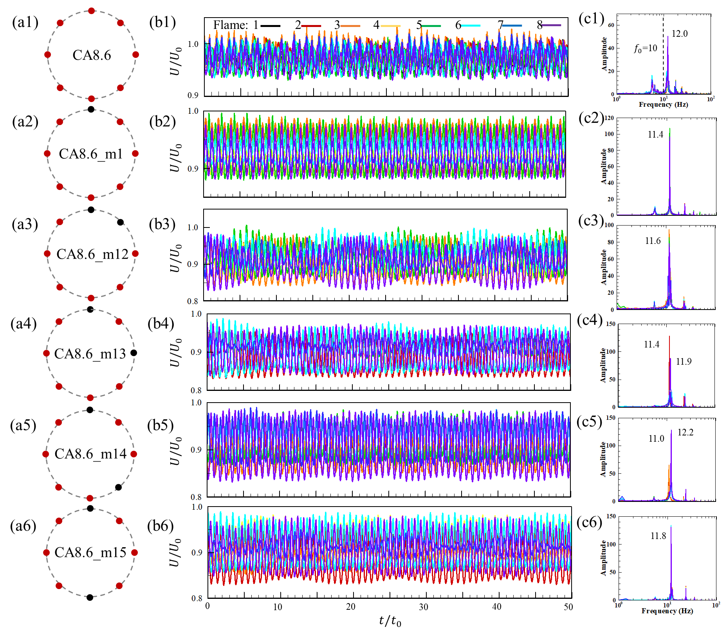
Fig. S4. (a) Six flame configurations of flickering flames in the group cases of CA8.6, where $L$=8.6$D$ and one or two flames could be missing. (b) Time domain, and (c) frequency domain of the velocity magnitude $U$from the first sensor in the corresponding configurations. CA8.6_m1 case with missing one flame at position 1, CA8.6_m12 case with missing two flames at position 1 and 2, CA8.6_m13 case with missing two flames at the position 1 and 3, CA8.6_m14 case with missing two flames at the position 1 and 4, and CA8.6_m15 case with missing two flames at the position 1 and 5.

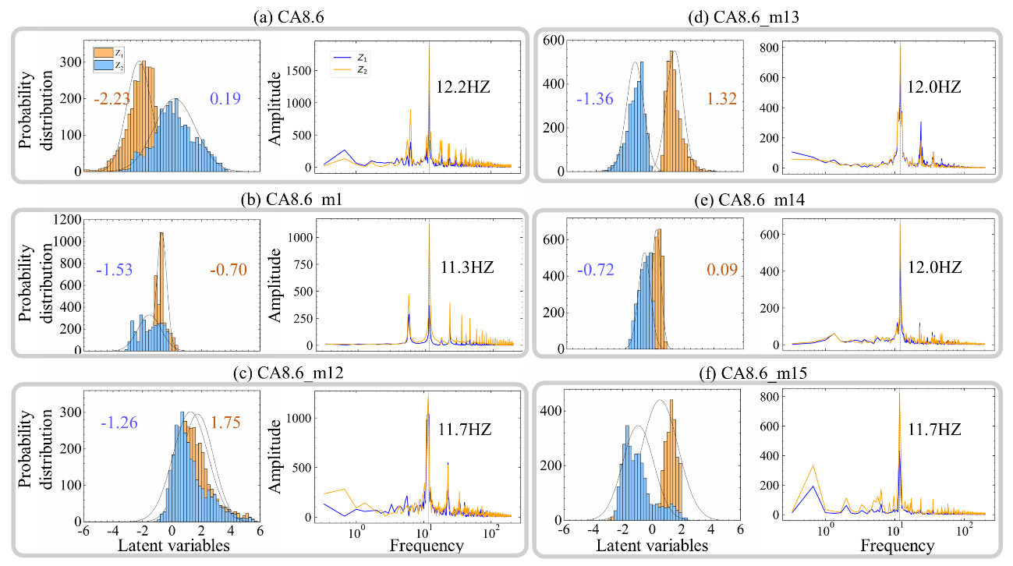
Fig. S5. Gaussian fitting and frequency of the latent variables in circular flame systems for (a-f) six modes in CA8.6 group.

Reconstruction performance of PCA, VAE, and Chrono-attention VAE
In this study, Chrono-attention VAE demonstrates distinct advantages, particularly in modeling temporal dependencies and capturing complex dynamic behaviors, such as cylinder flow, single flickering flame, and circular flame arrays.
The nonlinear Chrono-attention VAE model outperforms the traditional VAE and the linear PCA models for these cases of cylinder flow and single flame, as shown in Fig. S6. Specifically, PCA requires at least 13 and 7 principal components to achieve the same reconstruction accuracy of Chrono-attention VAE with two latent variables for the cylindrical flow and single flickering flame, respectively. This emphasizes PCA’s limitations in capturing the rich features of complex time-series data for dimensionality reduction. In addition, the performance of VAE without the chrono-attention function is relatively inferior to Chrono-attention VAE in the reconstruction performance.

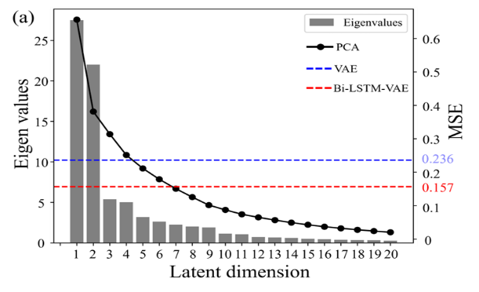
Fig. S6. MSE values of VAE, and Chrono-attention VAE models with two latent dimensions and the PCA across various latent dimensions for (a) the cylinder flow and (b) the single flickering flame.

The training and validating loss of the Chrono-attention VAE for the CA7.0 and CA8.6 group cases are plotted in Fig. S7. Additionally, we outlined the computational cost (training time and the number of parameters) and reconstruction error of three models from the circular flame data to the 2D latent space in Table S2. Chrono-attention VAE’s MSE value is significantly lower than those of VAE and PCA, while the more sophisticated model requires larger training time and parameters. These results again confirm that our model shows superior performance in reconstructing temporal-spatial data of complex flame systems.
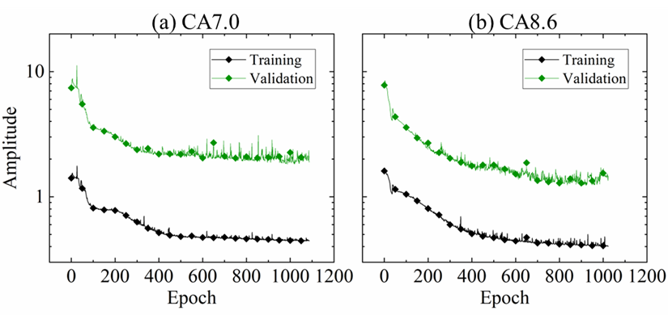
Fig. S7. Training and validating loss of two group cases: (a) CA7.0 and (b) CA8.6.

Table S2 Computational cost and reconstruction error of three models.
Cases | Models | Training time | Parameter number | MSE
CA7.0  group cases | PCA | - | 1443 | 0.817
CA7.0  group cases | VAE | 3764s | 703480 | 0.242
CA7.0  group cases | Chrono-attention VAE | 7368s | 1907366 | 0.150
CA8.6  group cases | PCA | - | 1443 | 0.789
CA8.6  group cases | VAE | 3018s | 703480 | 0.298
CA8.6  group cases | Chrono-attention VAE | 14880s | 1907366 | 0.185

Selection of latent space dimensionality in the Chrono-attention VAE
The choice of latent space dimensionality is crucial for is essential for the model’s design and performance. An ablation study was conducted for group CA8.6, testing latent dimensions from 1 to 5. Reconstruction fidelity was evaluated by the mean squared error (MSE), while cluster separability among different dynamical modes was quantified by the Silhouette coefficient [3]. The results are summarized in Fig. S8.
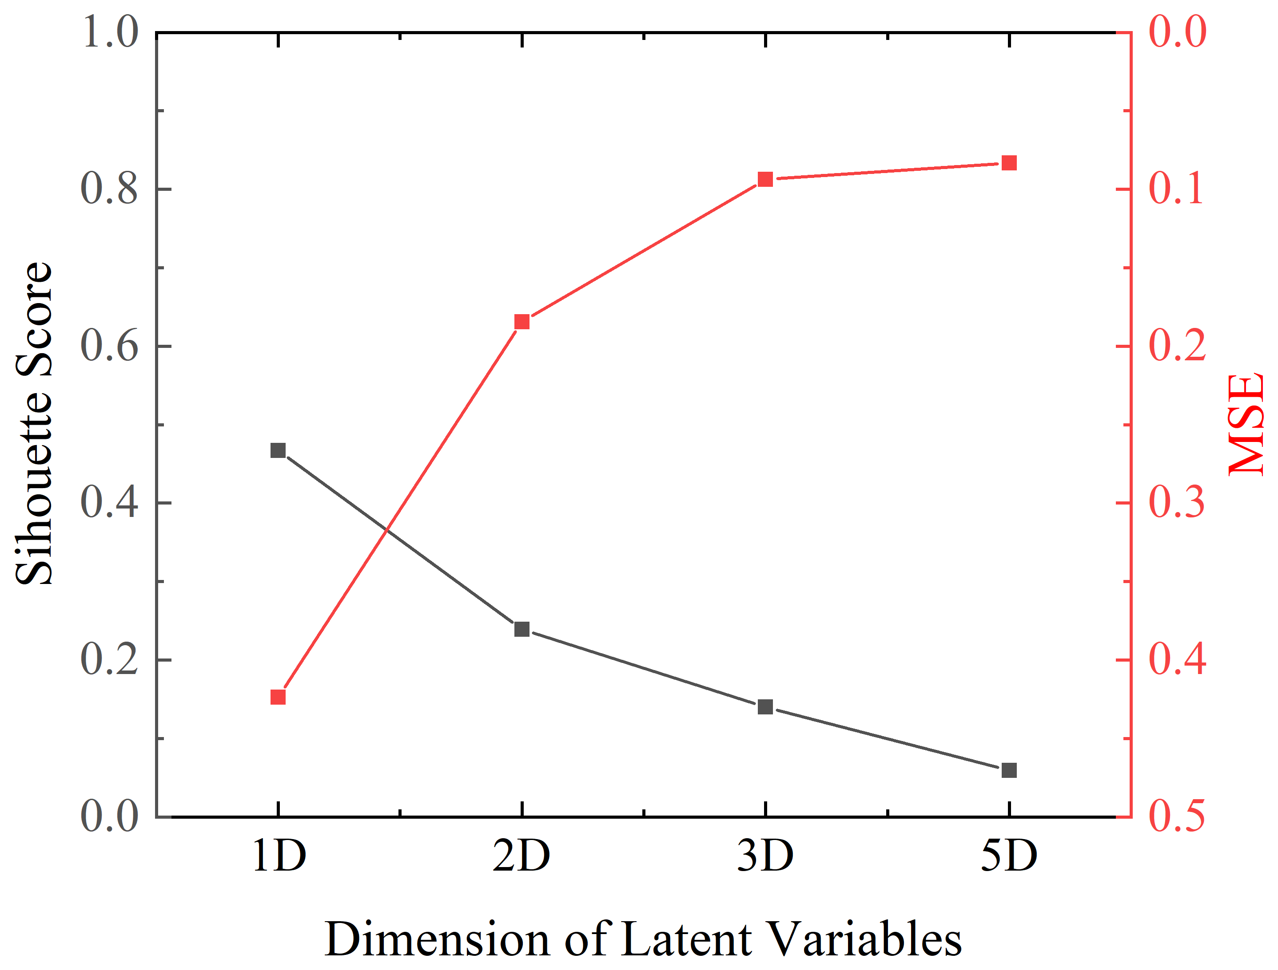
Fig. S8. Reconstruction fidelity and the Silhouette coefficient across various dimensions of latent variables.

A two-dimensional latent space provides the best compromise between reconstruction fidelity and mode separability (MSE = 0.185, Silhouette = 0.239). In contrast, the one-dimensional case exhibits strong separability (Silhouette = 0.467) but large reconstruction error (MSE = 0.424), indicating inadequate capacity to represent the complex flame–flow dynamics. Increasing dimensionality beyond two reduces interpretability, as latent clusters increasingly overlap (e.g., 5D Silhouette = 0.059).
Furthermore, the flickering of individual flames can be regarded as a self-excited oscillator, whose dynamics are well described by amplitude–phase models such as the Stuart–Landau equation [11-13]. Hence, a two-dimensional latent representation naturally corresponds to amplitude and phase variables, making it well suited for the dynamical mode identification performed in this study. For turbulent flames, however, capturing richer spatiotemporal dynamics would likely require a higher-dimensional latent space, which represents an important direction for future work.

Sensitivity of 2D–Wasserstein distance to KDE resolution
The robustness of the proposed Chrono-attention VAE–WDC framework with respect to kernel density estimation (KDE) resolution was assessed through a sensitivity analysis. Grid resolutions of 50×50, 75×75, and 125×125 were tested and compared with the 100×100 grid used in the main manuscript.
As shown in Fig. S9, the results remain consistent across all resolutions, confirming the robustness and precision of the latent-space representation. For example, in case T-1, the computed 2D–Wasserstein distances between the test and benchmark modes vary only slightly—(0.00136, 0.00125, 0.00518) for 50×50, 75×75, and 125×125 grids, respectively—while the smallest distance consistently corresponds to benchmark B-Ⅰ.
These findings indicate that the proposed framework can reliably identify distinct dynamical modes regardless of KDE resolution, demonstrating its insensitivity to parameter variations in the latent-space density estimation.
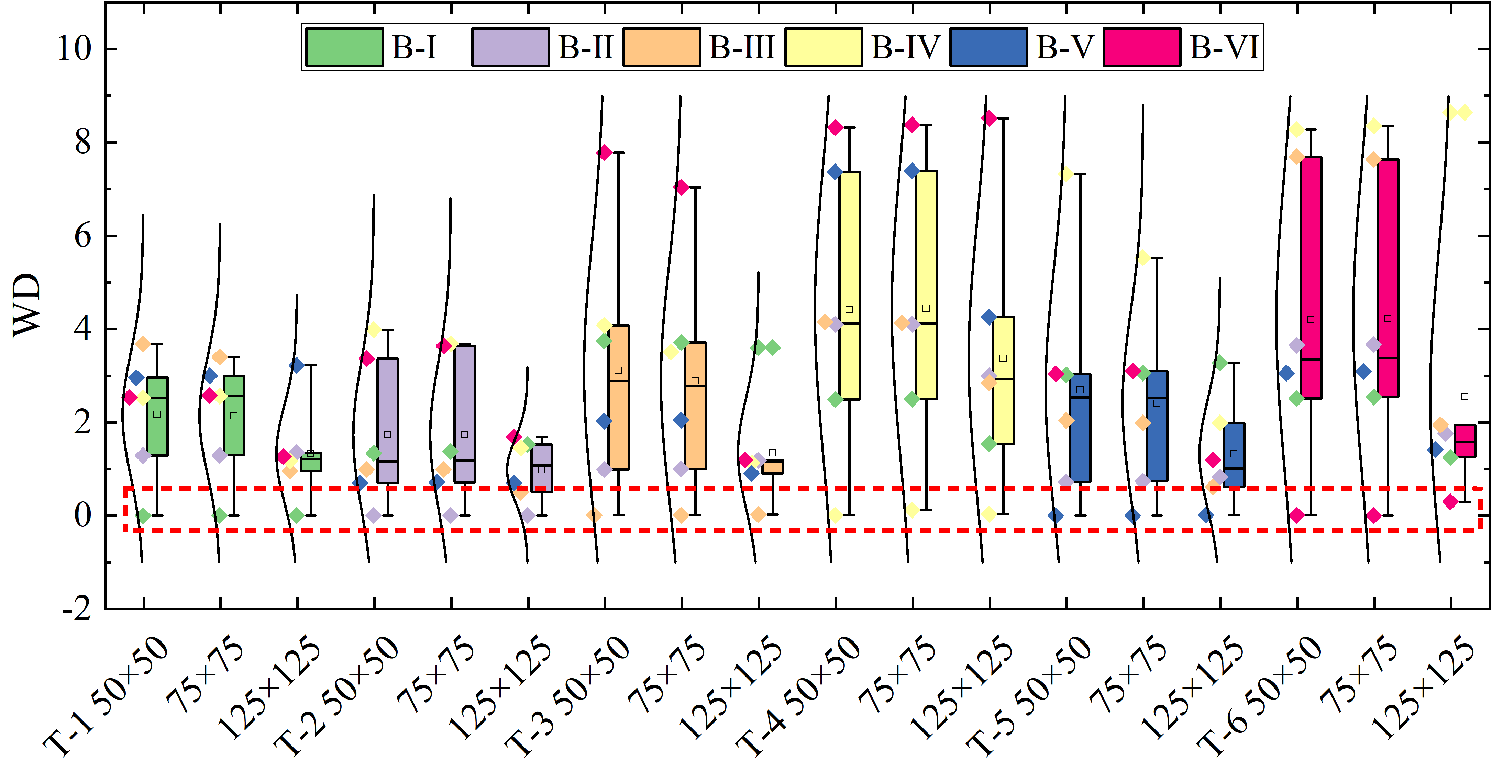
Fig. S9. Sensitivity analysis of 2D-WD distributions under varying KDE grid resolutions (50$×$50, 75$×$75, and 125$×$125).

Visualization of latent trajectories and Wasserstein distance distributions
To provide a clearer visualization of mode separation, the latent trajectories are presented with kernel density estimate (KDE) contours rather than scatter plots alone. As shown in Fig. S10, the contours reveal distinct and well-separated regions in the latent space for the different dynamical modes, with each color corresponding to one mode and the gray curves showing the underlying phase trajectories. This visualization highlights the compactness and separability of the learned latent representations across cases CA7.0 and CA8.6.
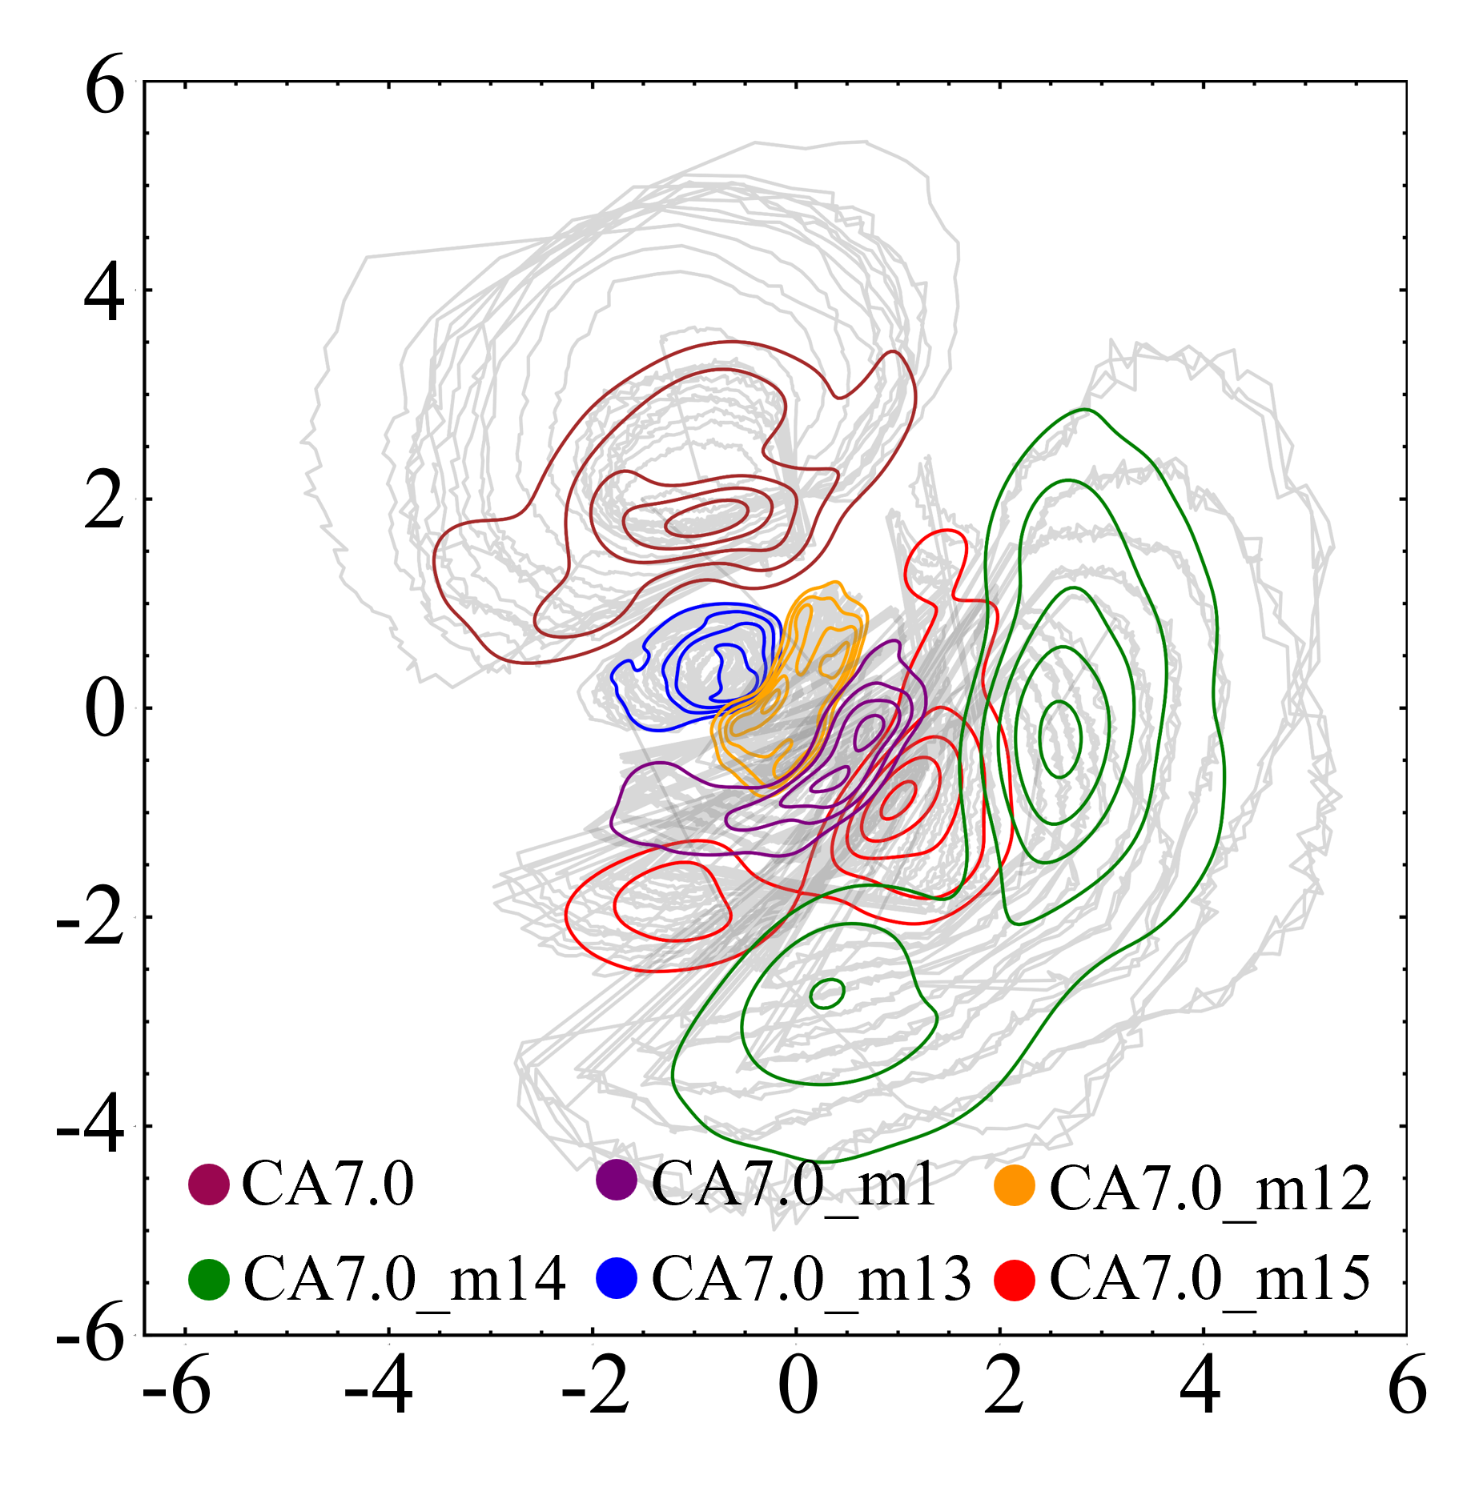 | 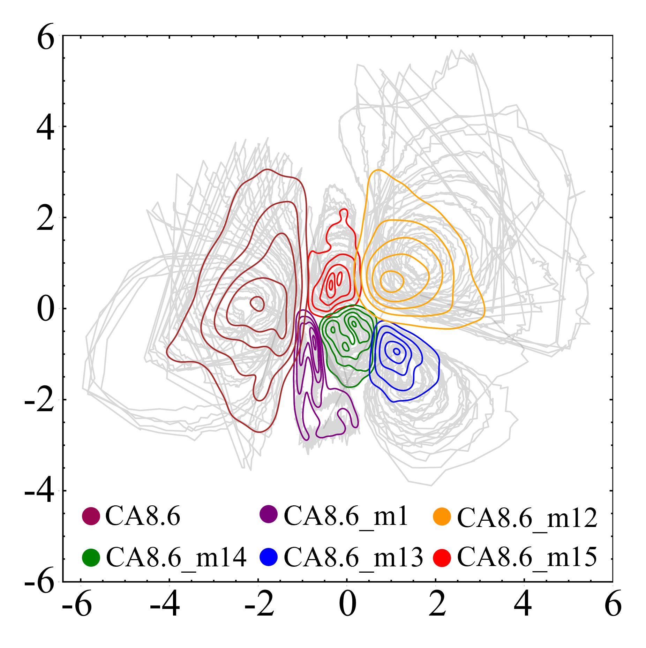
- CA7.0 | - CA8.6
Fig. S10. Latent trajectories with kernel density estimate (KDE) contours for two group cases. Different contour colors indicate distinct modes, while gray lines show the underlying latent trajectories.

To further illustrate the variability and robustness of the Wasserstein distance (WD)–based classification, Fig. S11 presents the 2D–WD distributions between benchmark and test modes using box plots. Compared with the heatmaps shown in the main manuscript, these box plots better reveal the spread and consistency of WD values across different test–benchmark combinations. The narrow interquartile ranges confirm that the WD metric is stable and discriminative across cases.
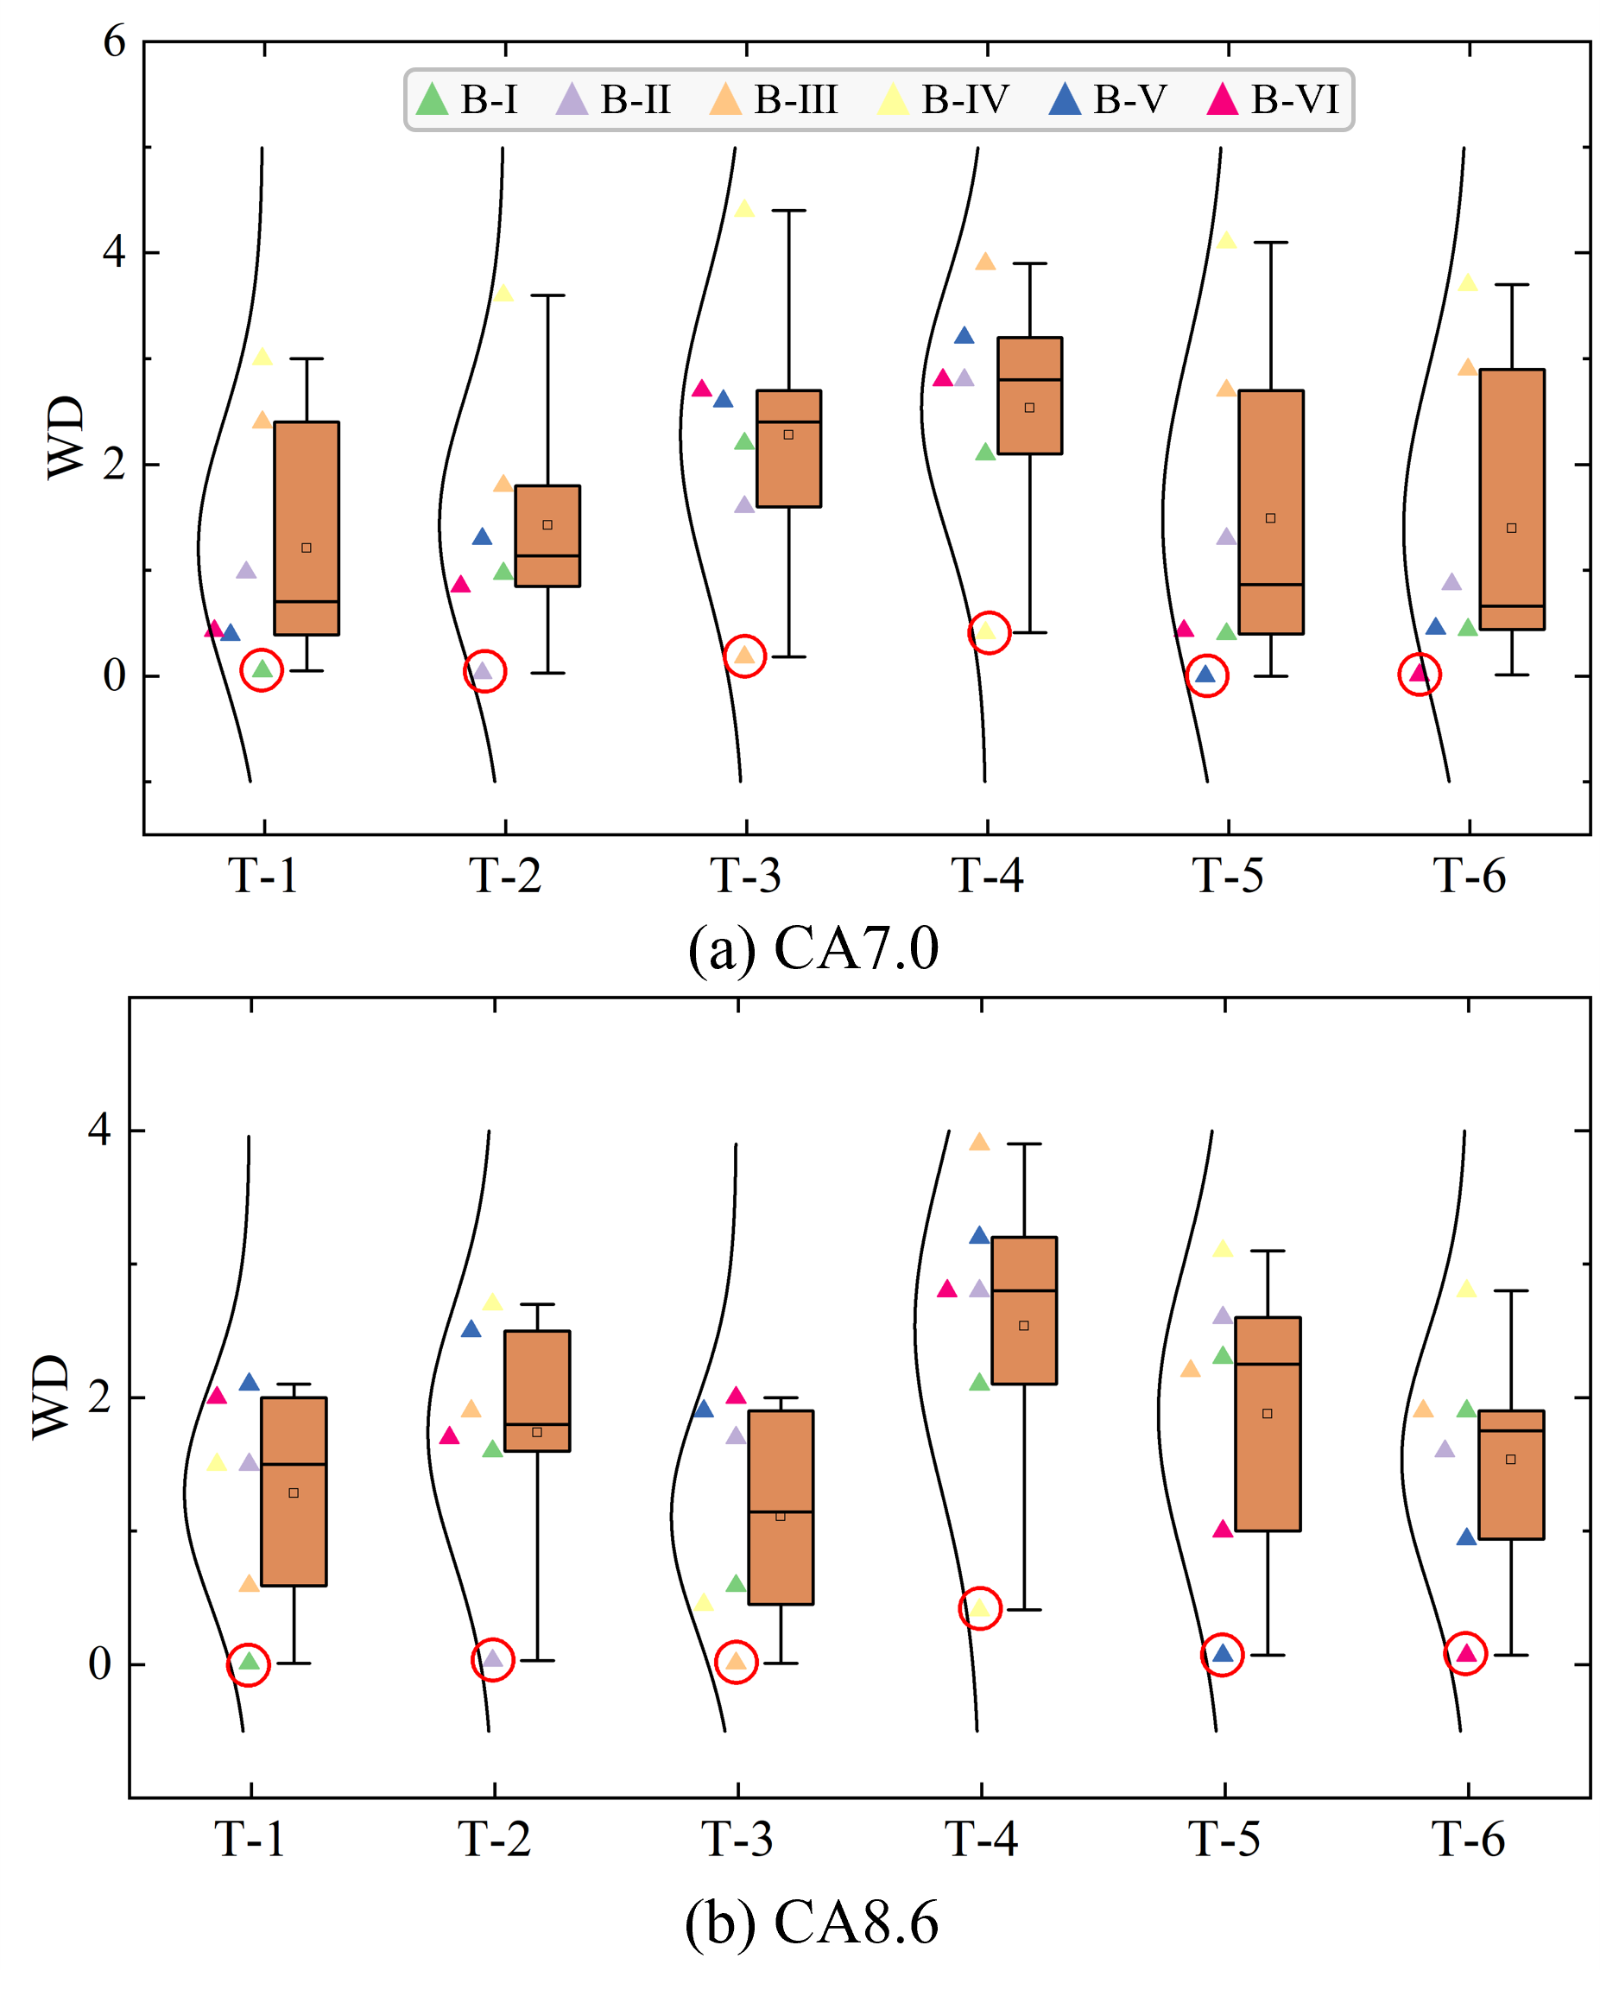
Fig. S11. 2D-WD distributions between the benchmarks (from B-I to B-VI) and the tests (from T-1 to T-2) for (a) of CA7.0 and (b) CA8.6 groups.

Reference

[1] K. McGrattan, S. Hostikka, R. McDermott, et al., Fire dynamics simulator user’s guide, NIST Special Publication 1019 (2013) 1-339.
[2] T. Yang, X. Xia, P. Zhang, Vortex-dynamical interpretation of anti-phase and in-phase flickering of dual buoyant diffusion flames, Phys. Rev. Fluids 4 (2019) 053202.
[3] T. Yang, Y. Chi, P. Zhang, Vortex interaction in triple flickering buoyant diffusion flames, Proc. Combust. Inst. 39 (2023) 1893-1903.
[4] T. Yang, P. Zhang, Faster flicker of buoyant diffusion flames by weakly rotatory flows, Theor. Comput. Fluid Dyn., (2023) 1-18.
[5] D. Durox, T. Yuan, F. Baillot, et al., Premixed and diffusion flames in a centrifuge, Combust. Flame 102 (1995) 501-511.
[6] J. Fang, J.-w. Wang, J.-f. Guan, et al., Momentum-and buoyancy-driven laminar methane diffusion flame shapes and radiation characteristics at sub-atmospheric pressures, Fuel 163 (2016) 295-303.
[7] A. Hamins, J. Yang, T. Kashiwagi, An experimental investigation of the pulsation frequency of flames, Symposium (international) on combustion 24 (1992) 1695-1702.
[8] B.M. Cetegen, T.A. Ahmed, Experiments on the periodic instability of buoyant plumes and pool fires, Combust. Flame 93 (1993) 157-184.
[9] X. Xia, P. Zhang, A vortex-dynamical scaling theory for flickering buoyant diffusion flames, J. Fluid Mech. 855 (2018) 1156-1169.
[10] D.J. Rezende, S. Mohamed, D. Wierstra, Stochastic backpropagation and approximate inference in deep generative models, International conference on machine learning, (2014) 1278-1286.
[11] Y. Chi, Z. Hu, T. Yang, et al., Synchronization modes of triple flickering buoyant diffusion flames: Experimental identification and model interpretation, Phys. Rev. E 109 (2024) 024211.
[12] T. Yang, Y. Ma, P. Zhang, Computational identification and Stuart-Landau modeling of collective dynamical behaviors of octuple laminar diffusion flame oscillators, Combust. Flame 275 (2025) 114090.
[13] K. Manoj, S.A. Pawar, S. Dange, et al., Synchronization route to weak chimera in four candle-flame oscillators, Physical Review E 100 (2019) 062204.

∗ Corresponding author E-mail address: penzhang@cityu.edu.hk, Tel: (852)34429561. # The authors equally contributed to the work.

