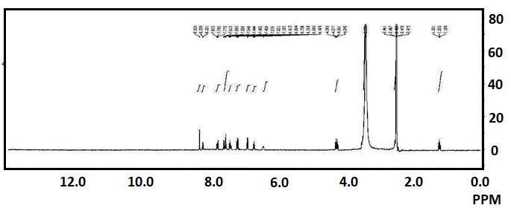

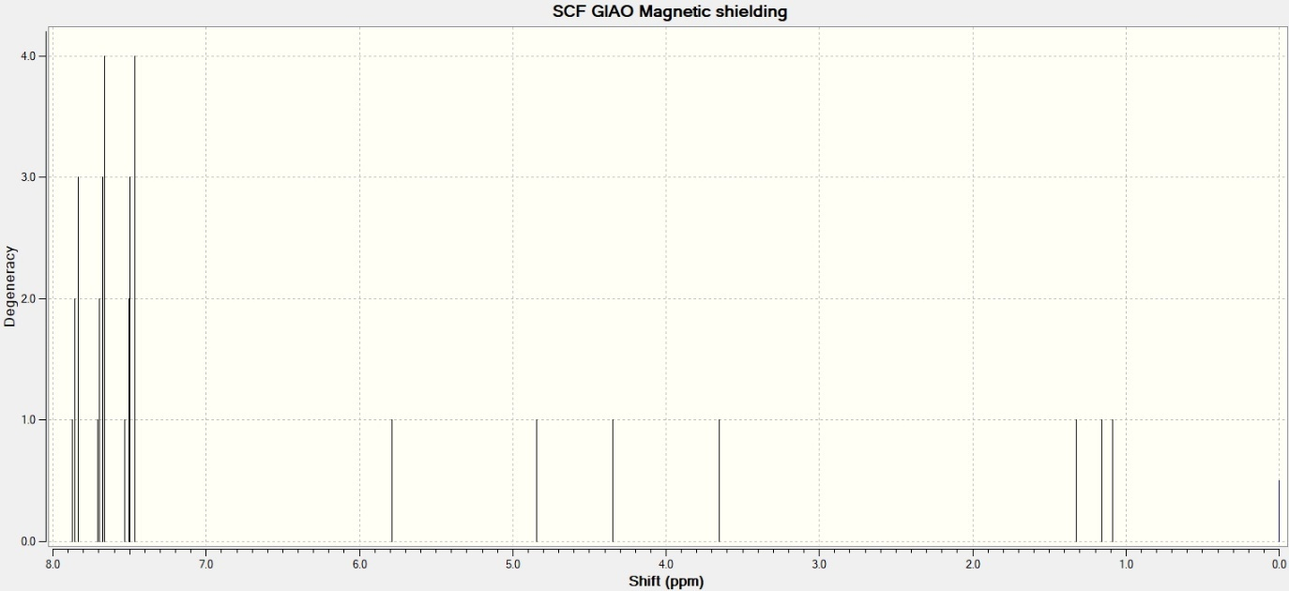

Fig. S1. (a) Experimental and (b) Calculated ¹H NMR spectrum, (c) Correlation graph between experimental and calculated ¹H-NMR chemical shifts of APPQ at B3LYP/6-311++G (d,p).
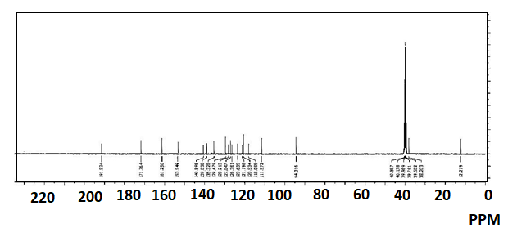

Fig. S2. (a) Experimental and (b) Calculated ¹³C NMR spectrum, (c) Correlation graph between experimental and calculated ¹³C NMR chemical shifts of APPQ at B3LYP/6-311++G (d,p)

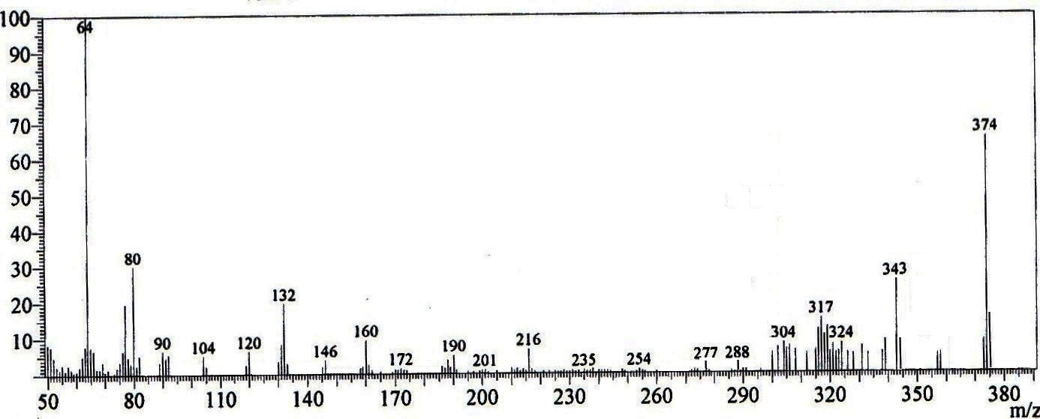

Fig. S3. The mass spectrum of APPQ.

