Donor Moiety Engineering in D-D-π-A-π-A Quinoxaline Sensitizers for Efficient Dye-Sensitized Solar Cells
Aisha R. Al-Marhabiª, Reda M. El-Shishtawy^{b,c}, Khalid O. Al-Footy^{b}, Kenan Ozel*^{d}, Abdullah Atilgan^{e}, and Abdullah Yildiz^{f}
ª Chemistry Department, Al-Qunfudah University College, Umm Al-Qura University, Makkah, Saudi Arabia
^{b} Chemistry Department, Faculty of Science, King Abdulaziz University, Jeddah 21589, Saudi Arabia
^{c} Dyeing, Printing and Textile Auxiliaries Department, Textile Research and Technology Institute, National Research Centre, 33 EL Buhouth St., Dokki, Giza, 12622, Egypt
^{d} Department of Electrical and Energy, GAMA Vocational School, Ankara University, Ankara, Turkey
^{e} Central Research Laboratory Application and Research Center, Ankara Yildirim Beyazit University, Ankara 06010, Turkey
^{f} Department of Energy Systems Engineering, Faculty of Engineering and Natural Sciences, Ankara Yildirim Beyazıt University, Ankara 06010, Turkey

Supplementary Materials

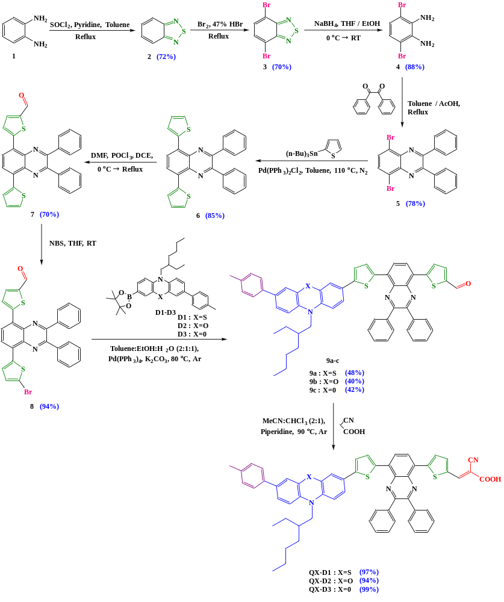

Scheme S1. The synthetic route to QX-D1, QX-D2, and QX-D3 dyes.

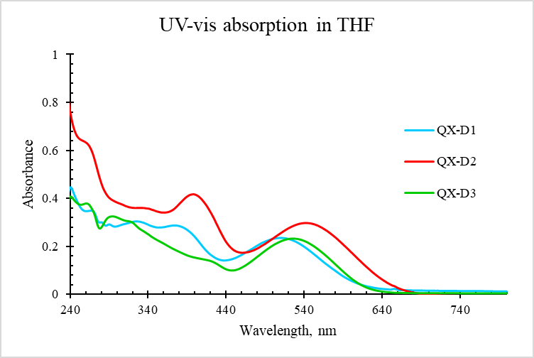
Fig. S1. UV-Vis absorption spectra of QX-D1, QX-D2, and QX-D3 in THF solutions at a concentration (C = 1×10⁻⁵ M).

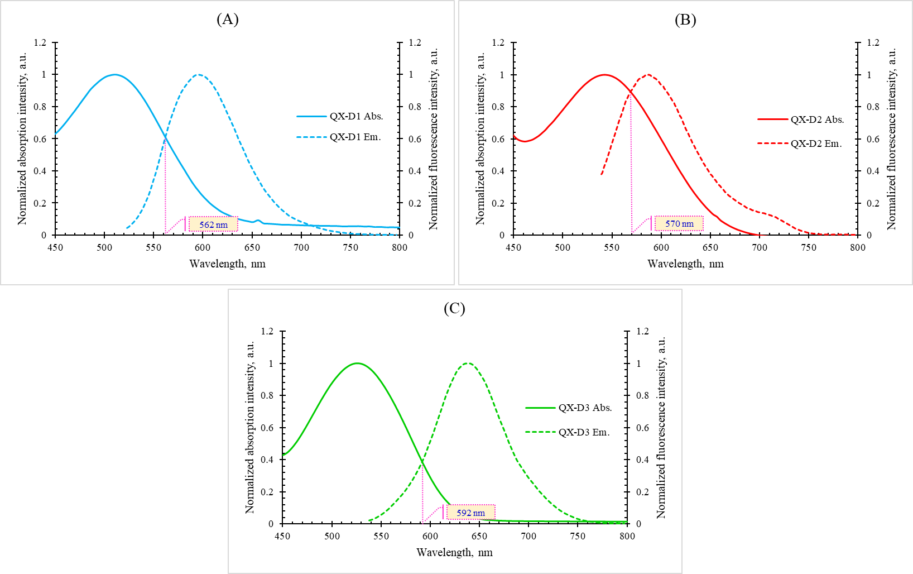
Fig. S2. Normalized absorption and emission for (A) QX-D1, (B) QX-D2, and (C) QX-D3 dyes in THF solutions.
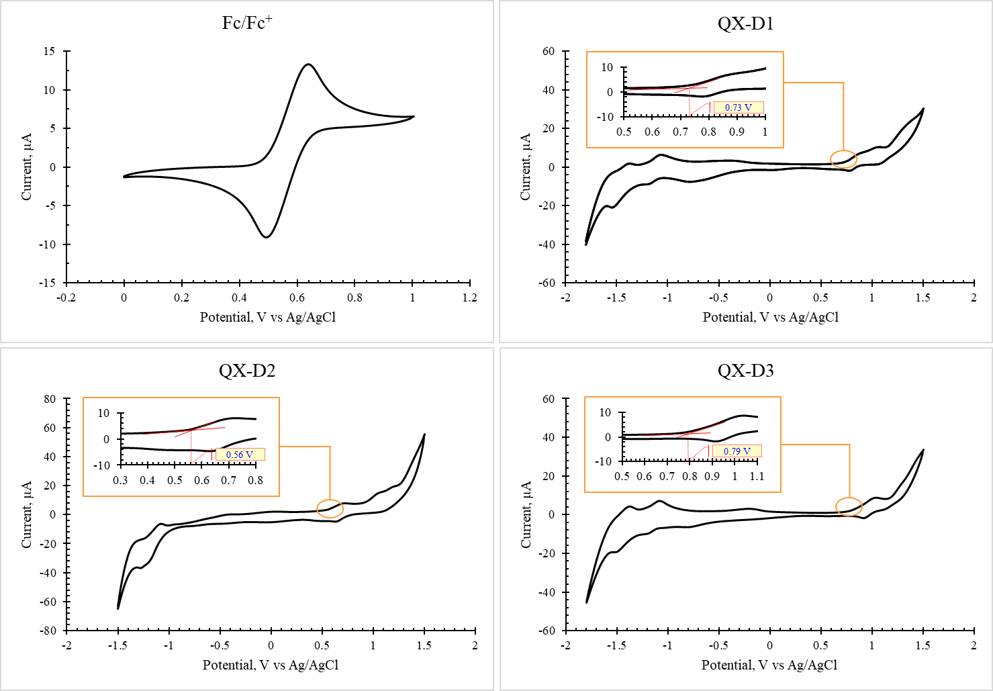
Fig. S3. Cyclic voltammograms of QX-D1, QX-D2, and QX-D3 dyes and ferrocene as internal reference in THF solutions.

Table S1
Optical and electrochemical data for QX-D1, QX-D2, and QX-D3 dyes measured in THF solutions (C = 1×10⁻⁵ M).

Compound | Absorption |  | Emission | Stokes shift (cm⁻¹) | λ_{intercept} (nm) | E_{g} (eV) | E_{ox(onset)} vs. Ag/AgCl (V) | HOMO (eV) | LUMO (eV)
Compound | λ_{max} (nm) | ε (M⁻¹ cm⁻¹) | λ_{em} (nm)
QX-D1 | 511 | 23434 | 594 | 2734 | 562 | 2.21 | 0.73 | -5.07 | -2.86
QX-D2 | 542 | 29825 | 587 | 1414 | 570 | 2.18 | 0.56 | -4.90 | -2.72
QX-D3 | 526 | 23214 | 639 | 3362 | 592 | 2.09 | 0.79 | -5.13 | -3.04
Fc/Fc⁺ |  |  |  |  |  |  | 0.46

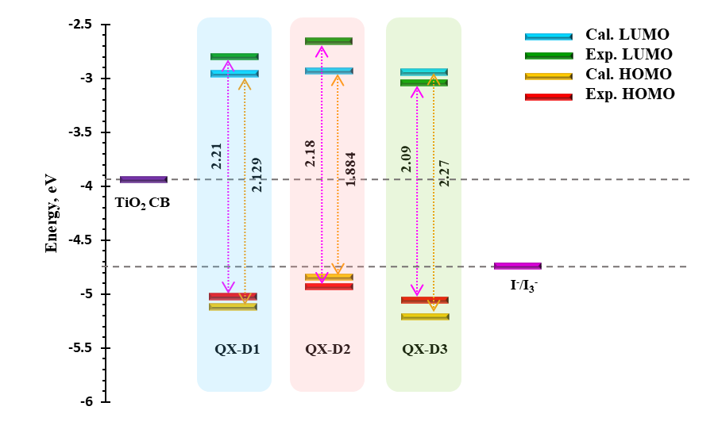
Fig. S4. Frontier molecular orbital energy levels obtained at B3LYP/6-31G(d,p) in THF solvent compared with the experimental data.

