Data supplement

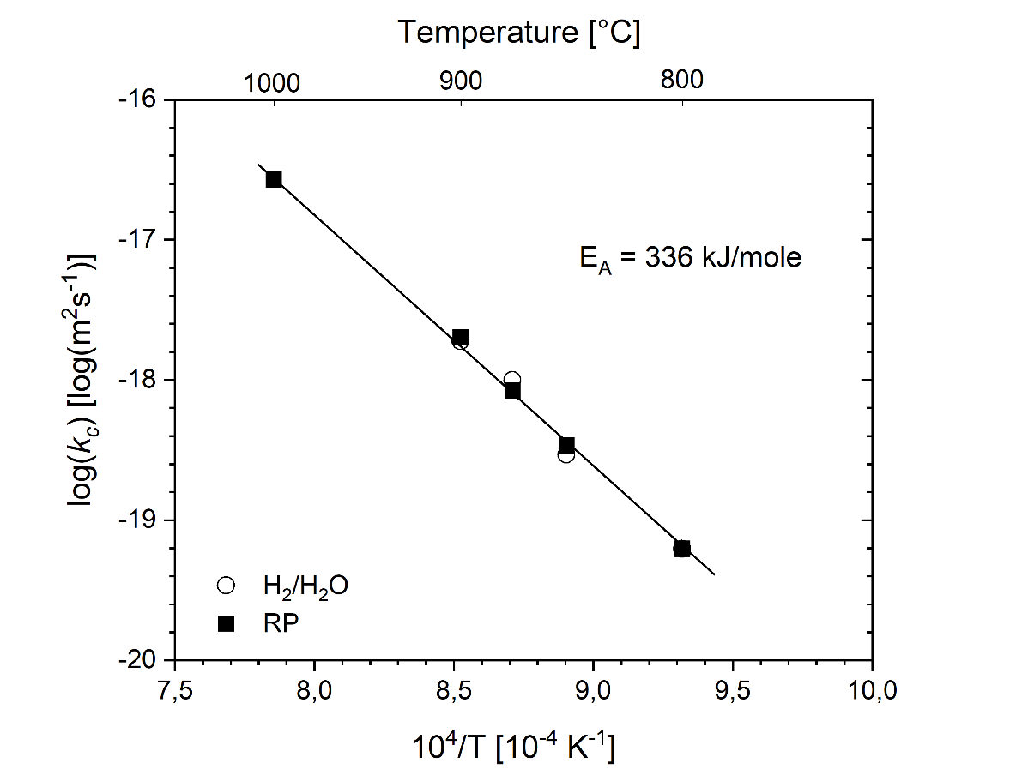
Figure A 1: Temperature dependence of parabolic rate constant in terms of metal recession, k_{c}, for binary Fe-18Cr alloy exposed in H₂/H₂O (empty symbols) and Fe/FeO Rhines pack (full symbols)

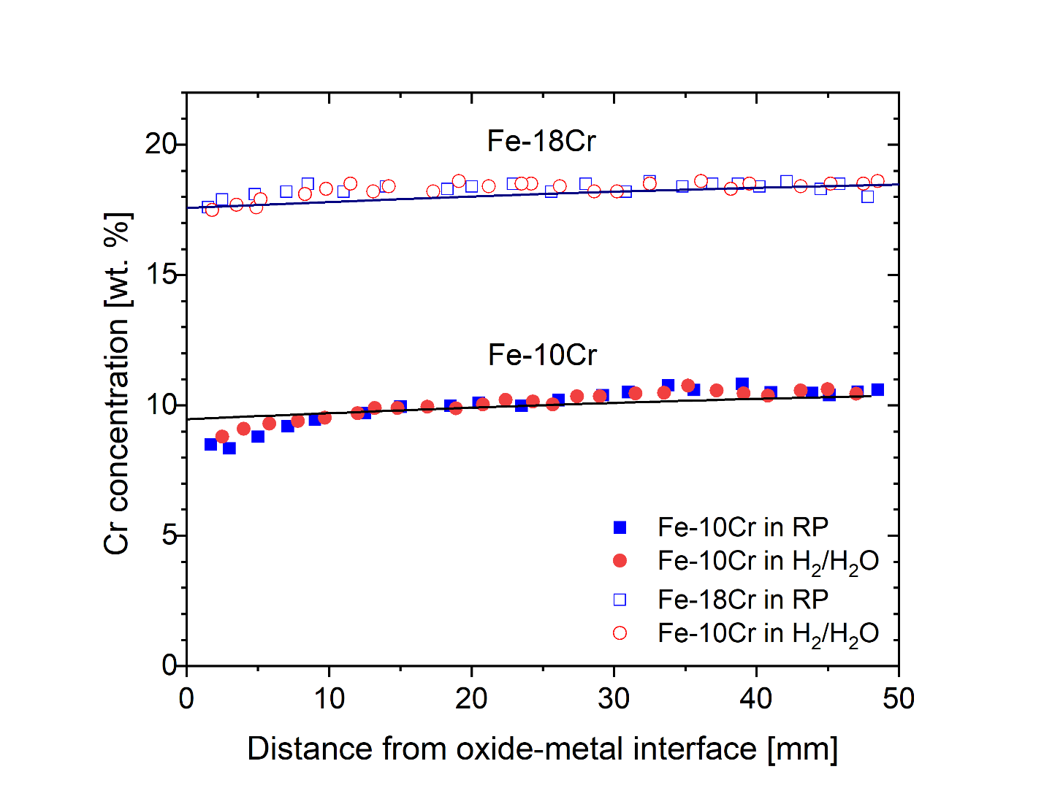

Figure A 2: Concentration profiles of Cr measured with EDX in Fe-10Cr (full symbols) and Fe-18Cr (empty symbols) after 72 h exposure in Fe/FeO RP and H₂/H₂O at 850 °C. In Fe-10Cr exposed in H₂/H₂O (Fig. 2a), Cr profiles were measured beneath a continuous external oxide scale. Lines are predicted Cr depletion profiles calculated using Wagner’s model [45] and input data from Table 4.

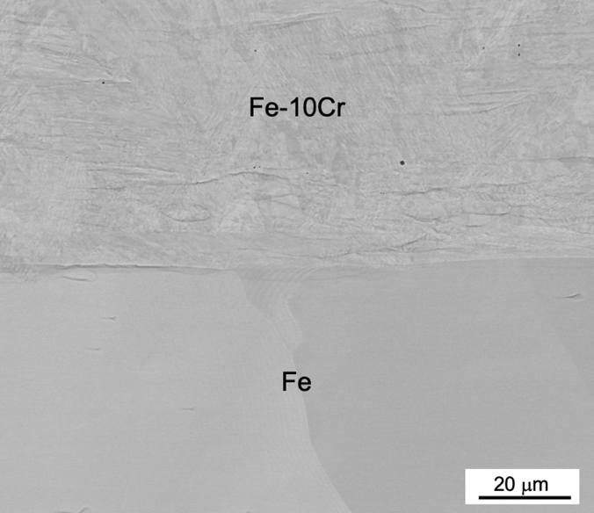
Figure A 3: BSE image of Fe-10Cr/Fe diffusion couple after 72 h annealing at 1000 °C

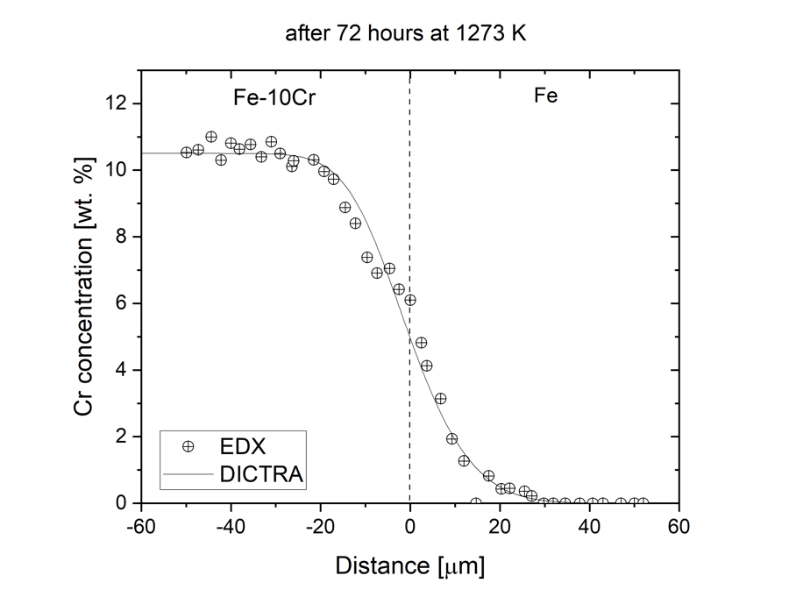

Figure A 4: Interdiffusion profile of Cr measured with EDX in Fe-10Cr/Fe diffusion couple after 72 h annealing at 1000 °C along with interdiffusion simulation in DICTRA using TCFE6 [35] and MOB2 [65] databases (${\tilde{D}}_{Cr}$ = 2.2×10⁻¹⁵ m²s-1).

