Supporting Information
Optimization of Non-thermal Plasma-assisted Catalytic Oxidation for Methane Emissions Abatement as the Exhaust Aftertreatment Technology
Rahman Gholami¹, Cristina Stere¹, Sarayute Chansai¹, Alexandre Goguet², Peter Hinde³, Paul Millington ³, Amit Singhania¹ and Christopher Hardacre¹*

¹ School of Chemical Engineering and Analytical Science, The University of Manchester, Manchester M13 9PL, UK.
² School of Chemical Engineering and Chemistry, The Queen’s University of Belfast, Belfast BT9 5AG, U.K.
³ Johnson Matthey Technology Centre, Reading, UK

* Email: c.hardacre@manchester.ac.uk

S.1 Catalyst characterization
Nitrogen (N₂) adsorption-desorption analysis was performed at −196 °C using a Micromeritics ASAP2020 to determine the specific surface area of the catalysts (based on the BET method). Before analysis, the catalysts were dried under vacuum at 300 °C for 3 h. The BET surface area of Al₂O₃ was 218 m²/g. A slight decrease in the surface area was observed with the loading of the noble metal, corresponding to 183 m²/g and 170 m²/g for the 2 wt% and 10 wt% Pd loading, respectively.
Fig. S1 shows the XRD patterns of the 2 wt% and 10 wt% Pd catalysts. The XRD patterns of materials were obtained by PANalytical X'Pert Pro X-ray diffractometer using CuKα emission lines from a generator operating at 40 keV and 40 mA. XRD scan was performed at 2θ = 10°–90° with a step size of 0.033°. Several peaks are assigned to the support and to PdO species and no Pd clusters are observed. As expected, 10 wt% Pd/Al₂O₃ has higher degree of PdO crystallinity than 2 wt% Pd/Al₂O₃, however, the PdO crystallite size of 10 wt% Pd/Al₂O₃ (4 nm) was smaller than 2 wt% Pd/Al₂O₃ (9 nm).

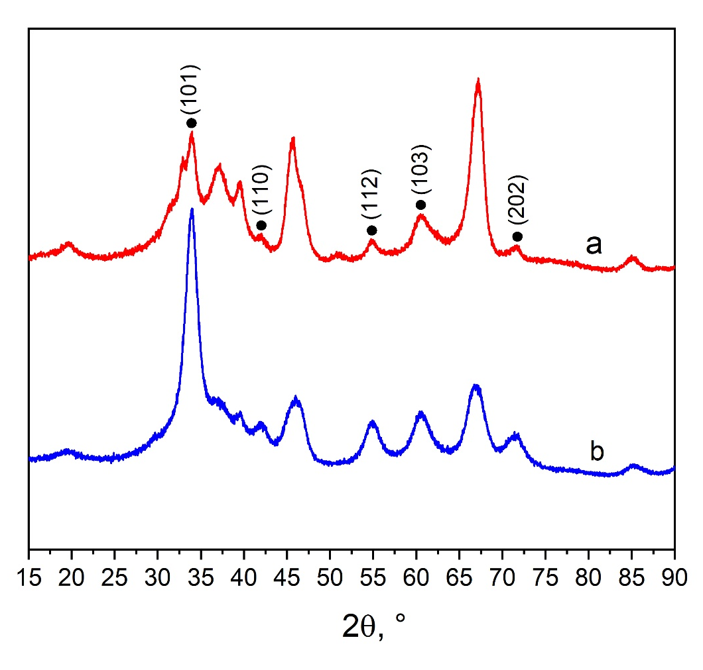
Fig. S1 XRD patterns for fresh (a) 2 wt% Pd/Al₂O₃ and (b) 10 wt% Pd/Al₂O₃ catalysts. PdO (⬤)

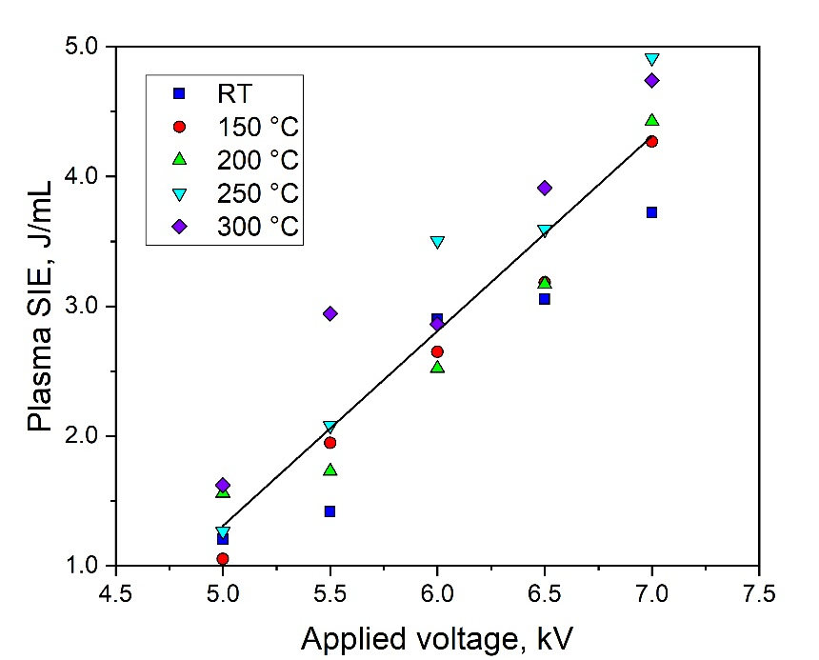
Fig. S2 Plasma SIE as a function of the applied peak voltage at various temperatures in NTP-catalytic CH₄ oxidation. Reaction conditions are 30 kHz, 10 wt% Pd/Al₂O₃, 0.5 kPa CH₄, 10 kPa O₂, 7 kPa H₂O, 5.5 kPa CO₂ and 0.1 kPa NO in N₂ with 171,429 mL g⁻¹ h⁻¹ GHSV. Room temperature (RT) is assumed to be 20 °C
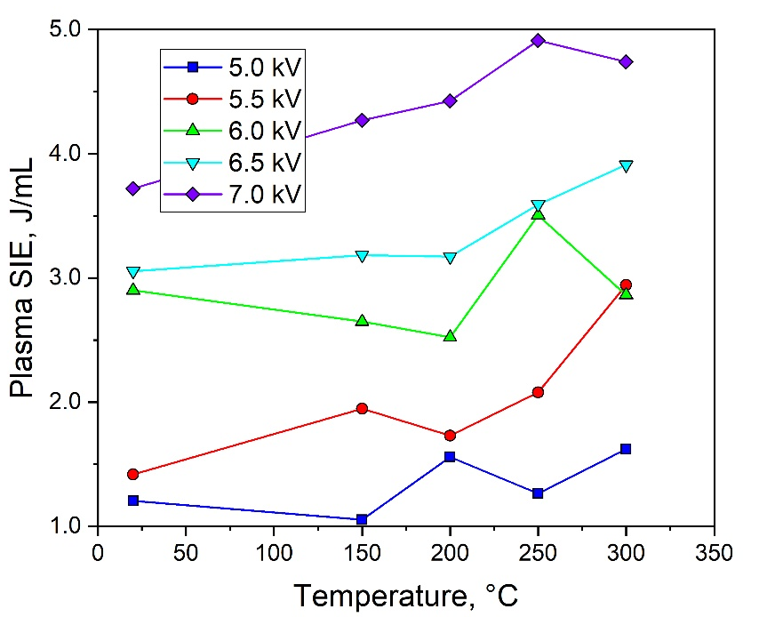
Fig. S3 Plasma SIE as a function of temperature at various applied voltages in NTP-catalytic CH₄ oxidation. Reaction conditions are 30 kHz, 10 wt% Pd/Al₂O₃, 0.5 kPa CH₄, 10 kPa O₂, 7 kPa H₂O, 5.5 kPa CO₂ and 0.1 kPa NO in N₂ with 171,429 mL g⁻¹ h⁻¹ GHSV
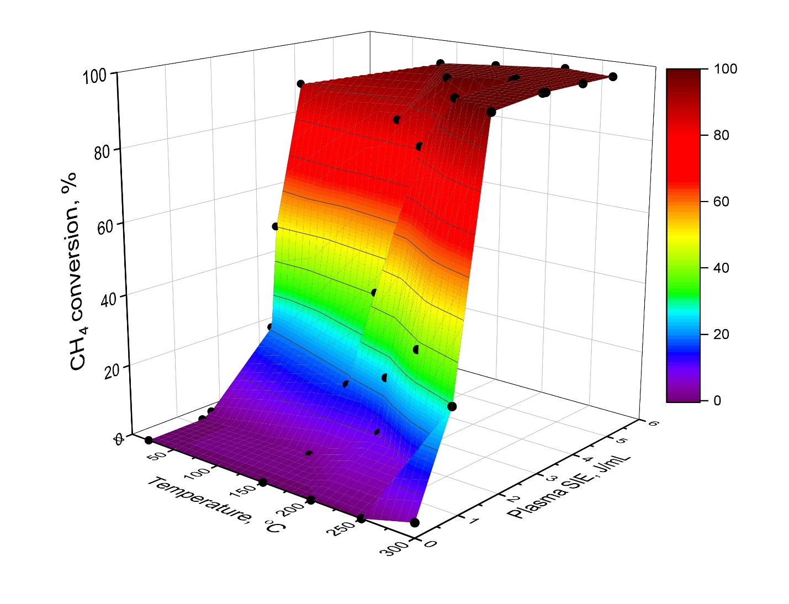
Fig. S4 Surface plot of Plasma SIE, temperature and CH₄ conversion in NTP-catalytic CH₄ oxidation. Reaction conditions are 30 kHz, 10 wt% Pd/Al₂O₃, 0.5 kPa CH₄, 10 kPa O₂, 7 kPa H₂O, 5.5 kPa CO₂ and 0.1 kPa NO in N₂ with 171,429 mL g⁻¹ h⁻¹ GHSV

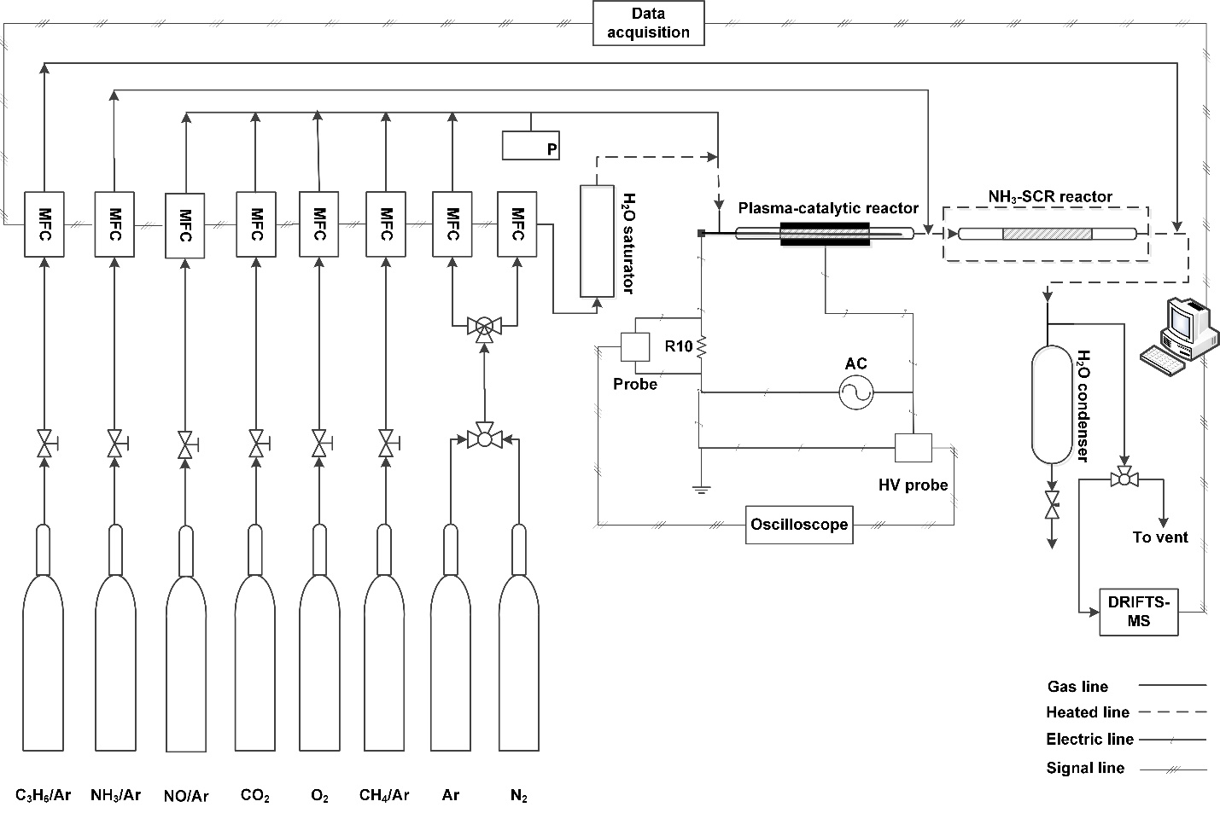
Fig. S5 Schematics of the dual-stage setup: upstream plasma reactor, followed by a thermal NH₃-SCR reactor
S2. Plasma gas phase reactions considered in the manuscript from references ESI Section S2 [22, 50–56]
O₂ + e⁻ → e⁻ + O₂* (S1)
N₂ + e⁻ → e⁻ + N₂* (S2)
N₂ + 2·O → 2NO (S3)
N₂ + 2·O → NO + ·N (S4)
N₂ + ·OH → NO + ·H (S5)
NO + ·N → N₂O (S6)
NO₂ + ·N → N₂O + ·O (S7)
NO₂ + ·NH₂→ N₂O +H₂O (S8)
·O + NO → NO₂ (S9)
O₃ + NO → NO₂ +O₂ (S10)
e⁻ + NO₂ → e⁻ +NO + ·O (S11)
·O + NO₂ → NO +O₂ (S12)
·N + NO₂ → N₂ +O₂ (S13)
·N + NO → N₂ + ·O (S14)
O₃ + NO₂ → NO₃ +O₂ (S15)
e⁻ + NH₃ → ·NH₂ + ·H (S16)
·O + NH₃ → ·NH₂ + ·OH (S17)
·H + NH₃ → ·NH₂ + H₂ (S18)
·OH + NH₃ → ·NH₂ + H₂O (S19)
·NH₂ + NO → N₂ + H₂O (S20)
·NH₂ + NO₂ → N₂ + H₂O (S21)
NO₂ + NH₃ → N₂ + H₂O (S22)
N₂O + ·O→ 2NO (S23)
e⁻ + H₂O → e⁻ +·H + ·OH (S24)
·O + H₂O → ·OH + ·OH (S25)
CH₄ + e⁻→ CH₄* + 2 e⁻ (S26)
CH₄ + e⁻→ ·CH₃ + ·H + e⁻ (S27)
e⁻ + CH₄ → ·C+H₂ + H₂ + e⁻ (S28)
e⁻ + ·CH₃ → ·CH₂ + ·H+ e⁻ (S29)
e⁻ + ·CH₃ → ·CH + H₂ + e⁻ (S30)
e⁻ + ·CH₂ → ·CH + ·H + e⁻ (S31)
·O + CH₄ → CO + 2H₂ (S32)
·O + CH₄ → CO + H₂O (S33)
·O + CO → CO₂ (S34)
CH₄ + ½ O₂ → CO + 2H₂ (S35)
22. Baylet A, Marécot P, Duprez D, et al (2012) Synergetic effect of plasma/catalysis hybrid system for CH₄ removal. Appl Catal B Environ 113–114:31–36. https://doi.org/10.1016/j.apcatb.2011.10.026
50. Wang W, Snoeckx R, Zhang X, et al (2018) Modeling plasma-based CO₂ and CH₄ conversion in mixtures with N₂, O₂, and H₂O: The bigger plasma chemistry picture. J Phys Chem C 122:8704–8723. https://doi.org/10.1021/acs.jpcc.7b10619
51. Wu J, Xia Q, Wang H, Li Z (2014) Catalytic performance of plasma catalysis system with nickel oxide catalysts on different supports for toluene removal: Effect of water vapor. Appl Catal B Environ 156–157:265–272. https://doi.org/10.1016/j.apcatb.2014.03.017
52. Falkenstein Z, Coogan JJ (1997) Microdischarge behaviour in the silent discharge of nitrogen - oxygen and water - air mixtures. J Phys D Appl Phys 30:817–825. https://doi.org/10.1088/0022-3727/30/5/015
53. Zhang J, Liu Y, Yao X, et al (2020) Enhanced moisture resistance of Cu/Ce catalysts for CO oxidation via plasma−catalyst interactions. Chemosphere 261:127739. https://doi.org/10.1016/j.chemosphere.2020.127739
54. Wang Z, Kuang H, Zhang J, et al (2019) Nitrogen oxide removal by non-thermal plasma for marine diesel engines. RSC Adv 9:5402–5416. https://doi.org/10.1039/C8RA09217F
55. Snoeckx R, Heijkers S, Van Wesenbeeck K, et al (2016) CO₂ conversion in a dielectric barrier discharge plasma: N₂ in the mix as a helping hand or problematic impurity? Energy Environ Sci 9:999–1011. https://doi.org/10.1039/C5EE03304G
56. Pavlovich MJ, Ono T, Galleher C, et al (2014) Air spark-like plasma source for antimicrobial NO_{X} generation. J Phys D Appl Phys 47:505202. https://doi.org/10.1088/0022-3727/47/50/505202

