Plasma Chemistry and Plasma Processing
Supplementary Materials to
The use of cold atmospheric pressure plasma for the synthesis of saccharide-stabilized Re nanostructures enabling effective deactivation of nitro-based antimicrobial agents
Piotr Cyganowski^{1*#}, Magda Caban², Mujahid Ameen Khan³, Mateusz M. Marzec⁴, Andrzej Zak⁵, Pawel Pohl³, Piotr Jamroz³, Andrzej Bernasik^{4,6}, and Anna Dzimitrowicz^{3*#}
¹ Department of Process Engineering and Technology of Polymer and Carbonaceous Materials, Faculty of Chemistry, Wroclaw University of Science and Technology, 27 Wybrzeze Wyspianskiego, 50-370 Wroclaw, Poland;
² Department of Environmental Analysis, Faculty of Chemistry, University of Gdansk,
63 Wita Stwosza, 80-308 Gdansk, Poland;
³ Department of Analytical Chemistry and Chemical Metallurgy, Faculty of Chemistry, Wroclaw University of Science and Technology, 27 Wybrzeze Wyspianskiego, 50-370 Wroclaw, Poland;
⁴ Academic Centre for Materials and Nanotechnology, AGH University of Science and Technology, A. Mickiewicza Av. 30, 30-059 Cracow, Poland
⁵ Faculty of Mechanical Engineering, Wroclaw University of Science and Technology, 27 Wybrzeze Wyspianskiego, 50-370 Wroclaw, Poland;
⁶ Faculty of Physics and Applied Computer Science, AGH University of Science and Technology, A. Mickiewicza Av. 30, 30-059 Cracow, Poland

Correspondence to: piotr.cyganowski@pwr.edu.pl (P.C.) and anna.dzimitrowicz@pwr.edu.pl (A.D.)

#Dr. Piotr Cyganowski and Dr. Anna Dzimitrowicz have equally contributed to this work

These supplementary materials contain two Figures associated with the UV/Vis absorption spectra. In Figure S1, the full-range UV/Vis spectra of the ReOxNPs: raw, fructose-stabilized, and Arabic gum-stabilized are displayed. In Figure S2, the full-range UV/Vis spectra of fructose and Arabic gum are shown. Figure S3 and S4 display additional XPS spectra. Figure S5 shows the full-range UV/Vis spectra of FRz during its catalytic reduction using (A) the raw-ReOxNPs, (B) the fructose-stabilized ReOxNPs, and (C) the Arabic gum-stabilized ReOxNPs are shown.

Figure S1. The full-range UV/Vis spectra of the ReOxNPs: raw, fructose-stabilized, and Arabic gum-stabilized.

Figure S2. The full-range UV/Vis spectra of fructose and Arabic gum.

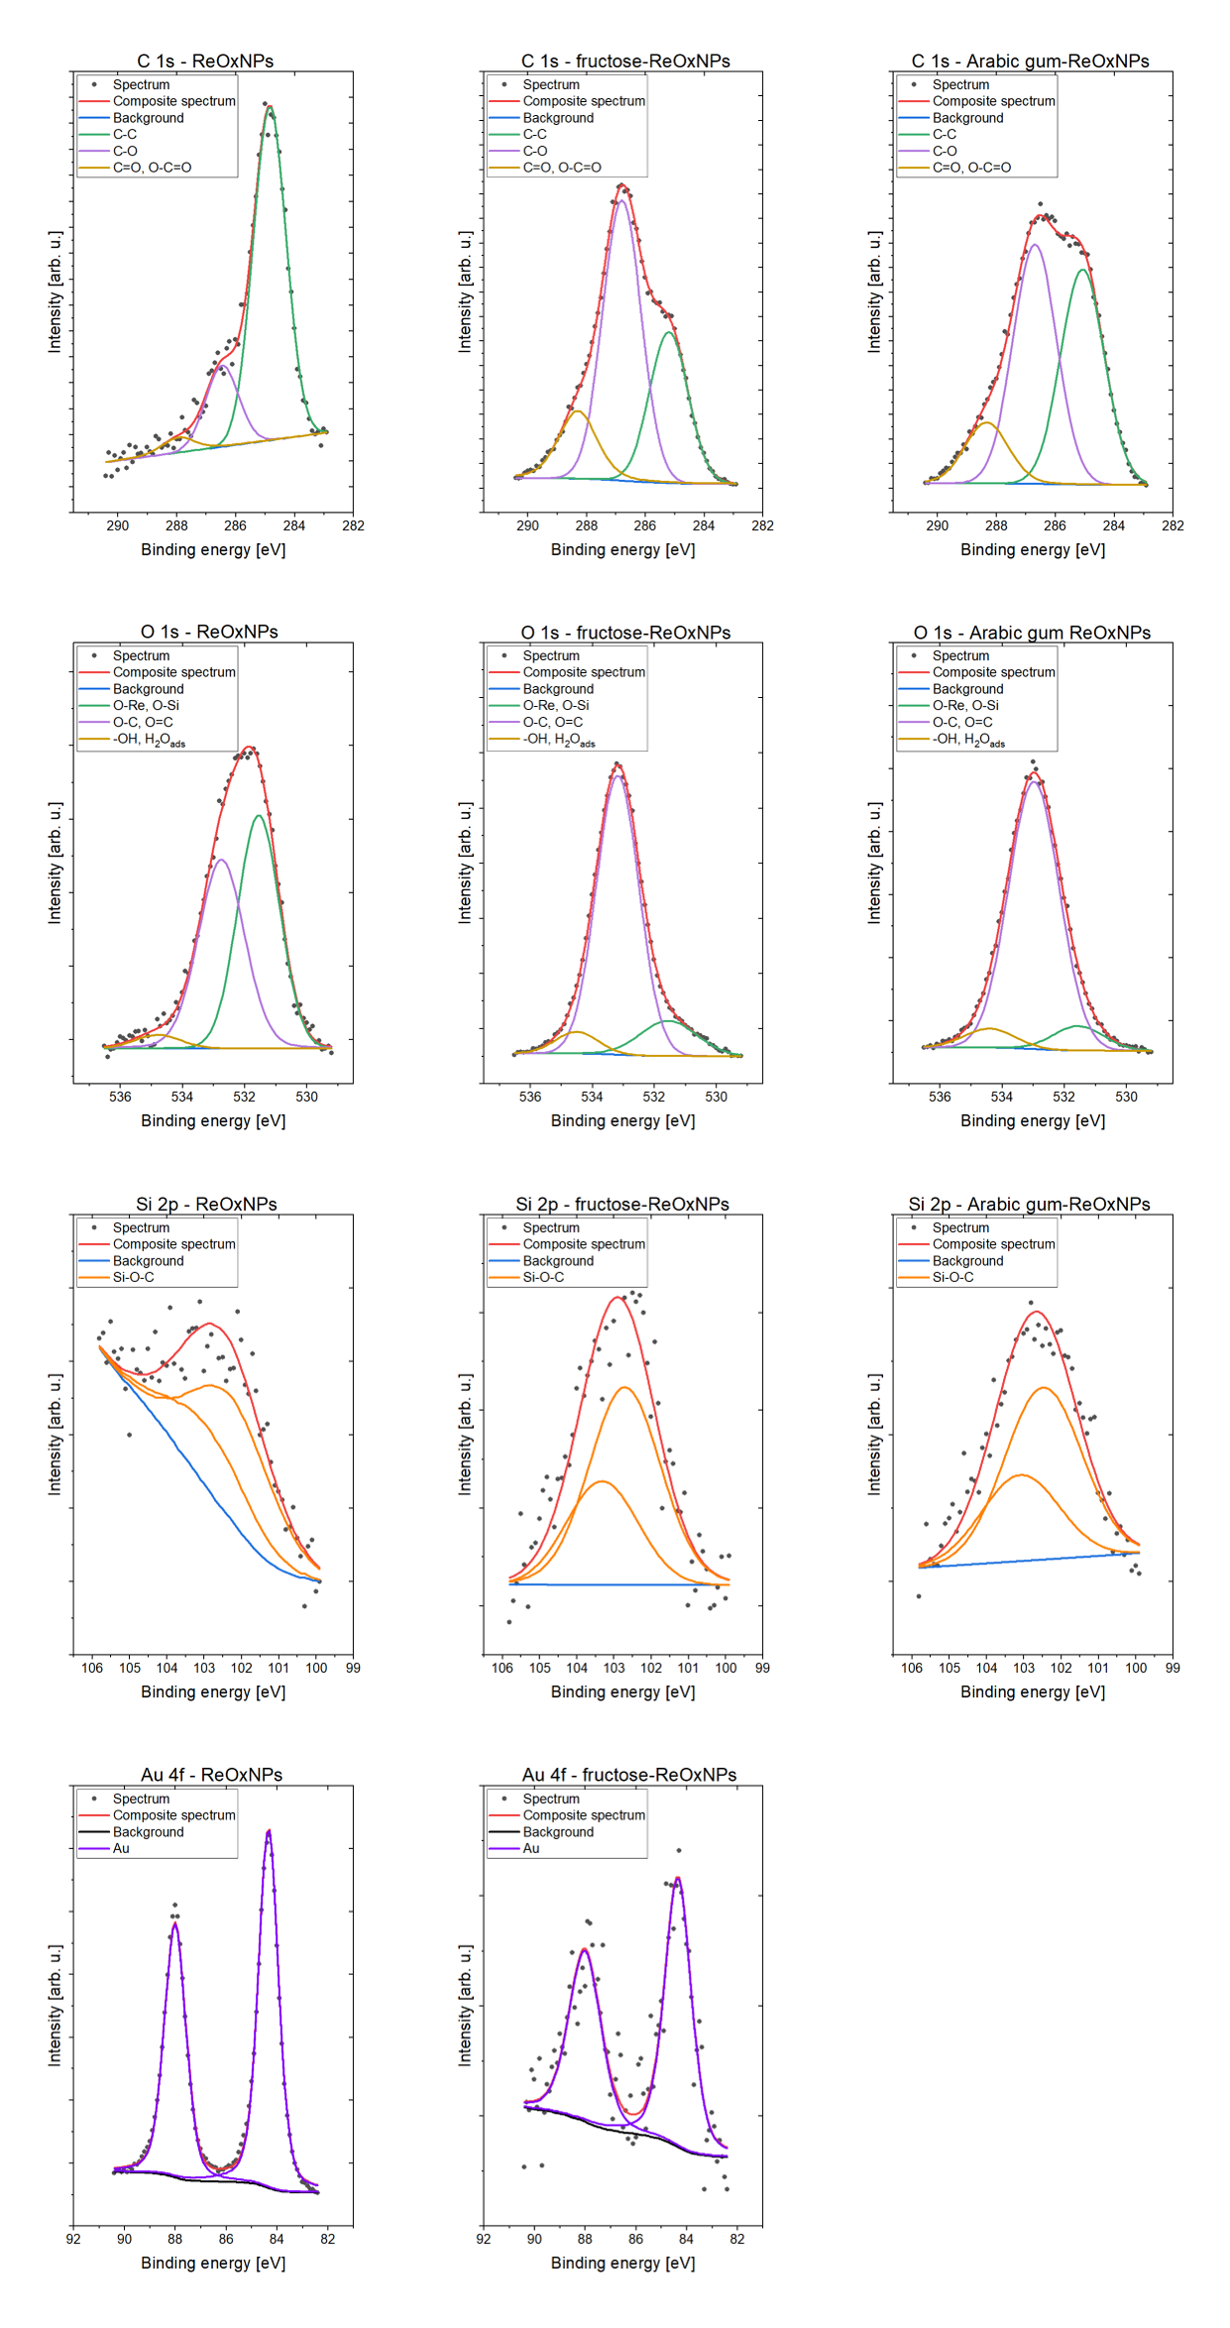
Figure S3. C 1s, O 1s, Si 2p, Au 4f spectra of Re-based nanomaterials

The Au 4f spectra were fitted with doublet structure (doublet separation f_{7/2} – f_{5/2} equals 3.67 eV) with main 4f_{7/2} line centered at 84.1 eV which can be ascribed to metallic gold (Figure S3) [1]. The gold presence come from the substrate and non-uniform lateral distribution of obtained thin film from drop-casting method. In turn, the Si 2p spectra show one doublet structure (doublet separation p_{3/2} – p_{1/2} equals 0.61 eV) with main 2p_{3/2} line centered at 102.3 eV which indicate Si-O type compounds like in e.g. siloxane/silicones (Si-O-C) [1, 2].

1. NIST Standard Reference Database 20 tabase 20. http:/srdata.nist.gov/xps/, 2003. http:/srdata.nist.gov/xps/.
2. Wagner CD, Passoja DE, Hillery HF, Kinisky TG, Six HA, Jansen WT, et al. (1982) Auger and photoelectron line energy relationships in aluminum–oxygen and silicon–oxygen compounds. Journal of Vacuum Science and Technology 21(4):933-44.

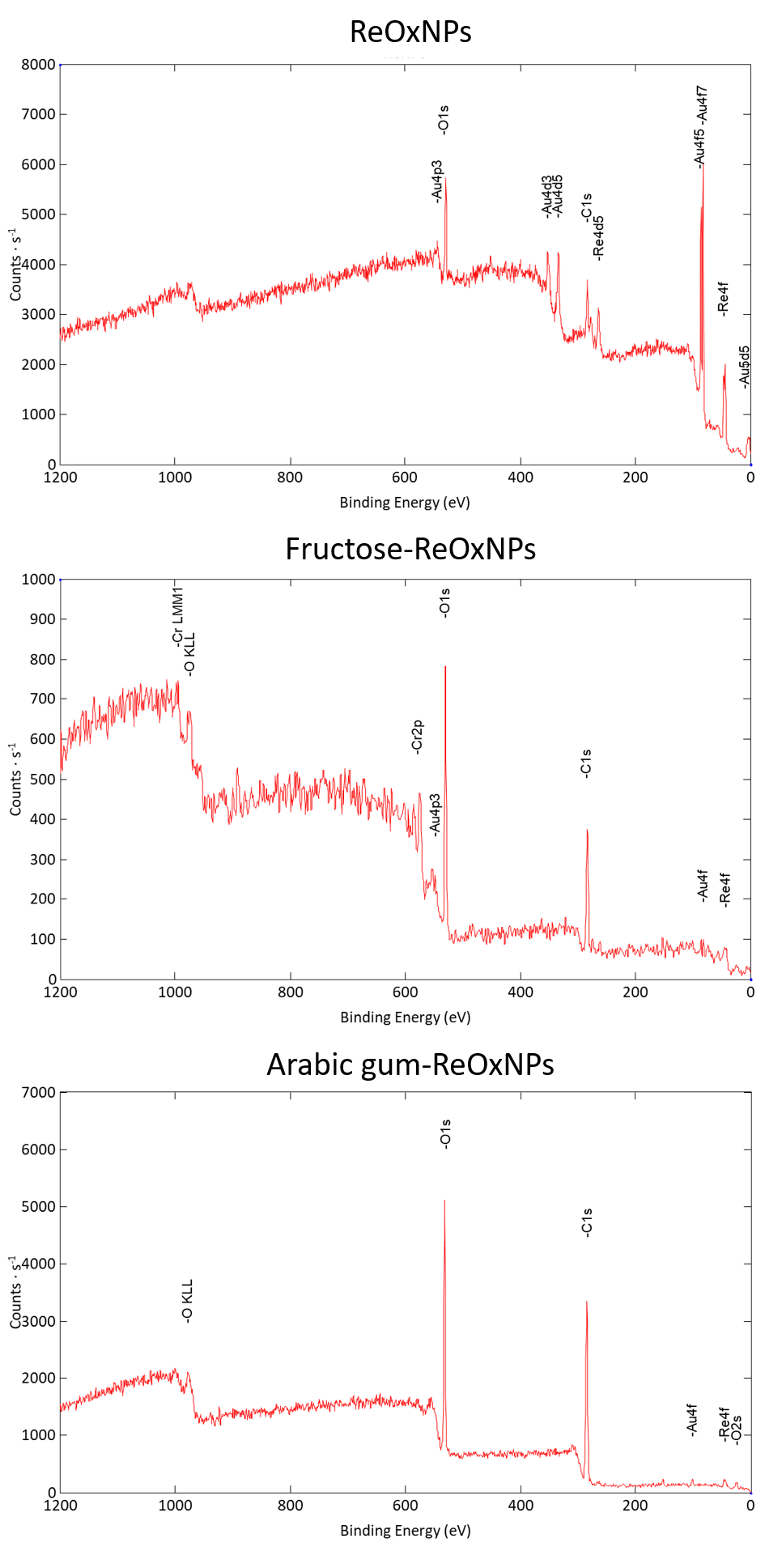
Figure S4. XPS survey spectra of the synthesized Re-based nanomaterials

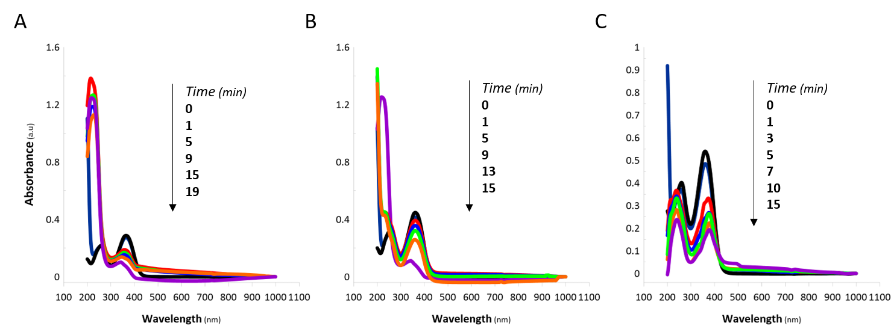
Figure S5. The full-range UV/Vis spectra of FRz during its catalytic reduction using (A) the raw-ReOxNPs, (B) the fructose-stabilized ReOxNPs, and (C) the Arabic gum-stabilized ReOxNPs.

