Supplementary Material

Title
Assessing the Preservation Effectiveness: A Comparative Study of Plasma Activated Water with Various Preservatives on Capsicum annuum L. (Jalapeño and Pusa Jwala)

Authors
Vikas Rathore¹, Piyush Sharma², Arun Prasath Venugopal², and Sudhir Kumar Nema^{1,3}

Affiliations
¹Atmospheric Plasma Division, Institute for Plasma Research (IPR), Gandhinagar, Gujarat382428, India
²Department of Food Process Engineering, National Institute of Technology Rourkela, Odisha 769008, India
³Homi Bhabha National Institute, Training School Complex, Anushaktinagar, Mumbai,400094, India

Author to whom correspondence should be addressed:
Vikas Rathore
Email: vikas.rathore@ipr.res.in, vikasrathore9076@gmail.com

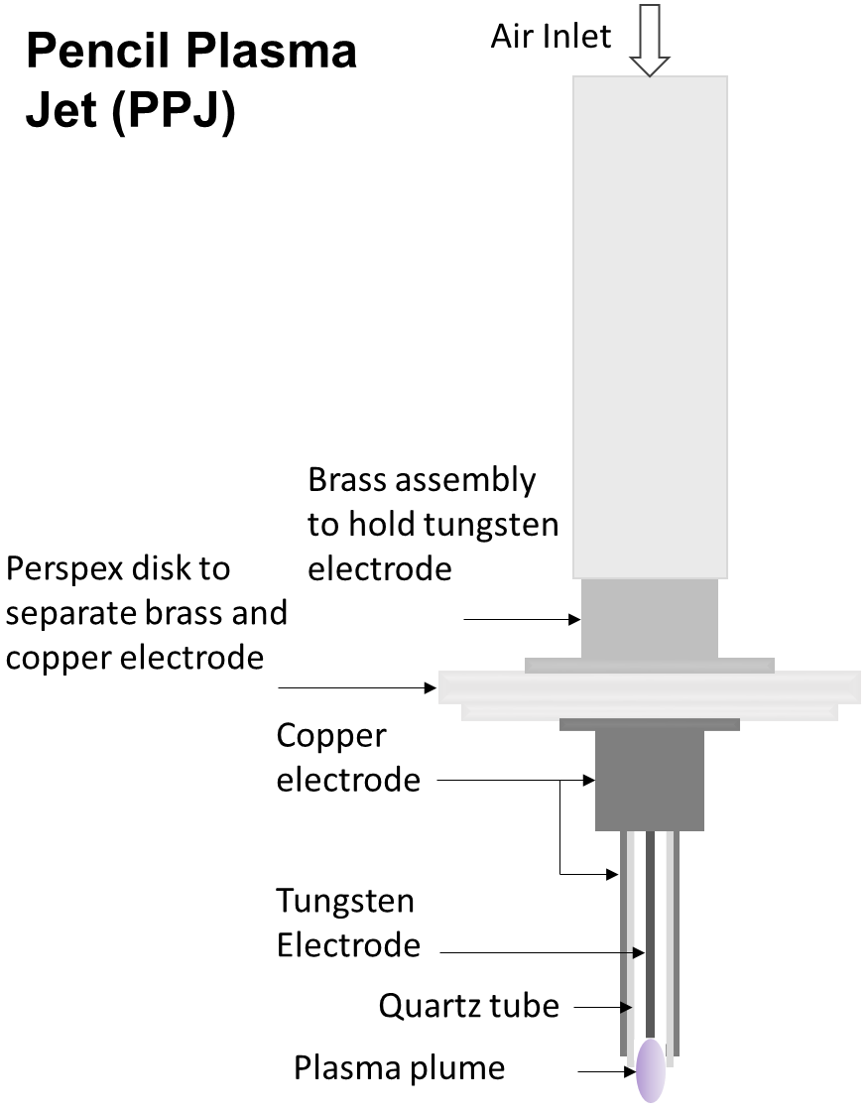
Figure S1. Schematic of Dielectric Barrier Discharge Pencil Plasma Jet

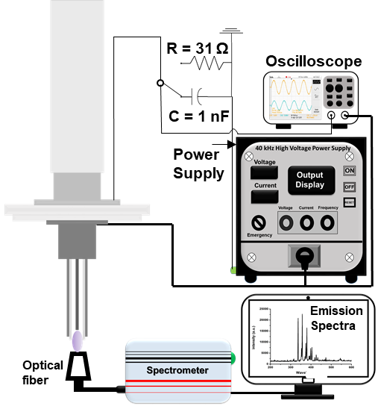
Figure S2. Schematic of Electrical Characterization and identification of reactive/species and radicals using optical emission characterization.
Figure S3. Emission spectra of air plasma
Figure S4. Voltage-current waveform of air plasma

Table S1. Specification of devices used for plasma diagnosis (electrical characterization and optical emission spectroscopy)
SN | Devices | Specification
1. | Digital Oscilloscope | 4 Channel, Bandwidth – 100 MHz, Sampling rate – 2 GS s-1, Memory depth – 2.5 Kpts, manufacturer – Tektronix, model – TDS2014C
2. | High voltage probe | 1000x probe, 3.0 pF 100 MΩ, manufacturer – Tektronix, model – P6015A
3. | Voltage Probe for current and charge measurement | 10x probe, 200 MHz, 10 MΩ/ < 12 pF, manufacturer – Tektronix, model – TPP0201
4. | Spectrometer | (Model EPP2000-UV from StellarNet Inc.) with an integration time of 1000 ms (range 1–65 000 ms). The calibration of the spectrometer having a ruled grating with a grating groove density of 1200 lines mm−1, 0.5 nm spectral resolution, and 60 mm effective focal length was performed before recording discharge spectra using a mercury lamp with a calibration wavelength of 253.6 nm

Table S2. Specification of Devices used for measurement of physicochemical properties of plasma activated water
SN | Devices | Specification
1. | pH meter | Eutech pH 700, Range -2 to 16, Resolution – 0.01, single junction pH electrode
2. | ORP (oxidation-reduction potential) meter | Eutech pH 700, Range -2000 to 2000 mV, Resolution – 0.1 mV, single junction ORP electrode
3. | TDS (total dissolved solid) meter | HM digital, Model number AP-1, Resolution – 1 ppm, Range – 0 to 5000 ppm
4. | EC (electric conductivity) meter | Contech Instruments, Model – CC-01, Range – 0 to 200 mS cm-1, Resolution – 1 µS cm-1
Table S3. Methods used for the measurement of reactive oxygen-nitrogen species concentration
SN | Species | Method
1. | NO₃ˉ ions | The UV spectrophotometric screening method was used to determine NO₃ˉ ion concentration in PAW. Absorption measured at 220 nm. (A. P. H. Association, A. W. W. Association, W. P. C. Federation, and W. E. Federation, Standard Methods for the Examination of Water and Wastewater (American Public Health Association., 1915), Vol. 2.)
2. | NO₂ˉ ions | NO₂ˉ ions have a property such that they react with reagent A in a pH range of 2–2.5 to form a reddish purple azo dye that shows maximum absorbance at 543 nm. Sulfanilamide addition with N-(1-naphthyl) ethylenediamine dihydrochloride was used to make reagent A. (A. P. H. Association, A. W. W. Association, W. P. C. Federation, and W. E. Federation, Standard Methods for the Examination of Water and Wastewater (American Public Health Association., 1915), Vol. 2.)
3. | H₂O₂ | This method shows the reaction between titanium ions and hydrogen peroxide in the acidic region to give peroxotitanium (pertitanic acid), which is yellowish and possesses maximum absorbance at 407 nm. (P. Lukes, E. Dolezalova, I. Sisrova, and M. Clupek, Plasma Sources Sci. Technol. 23, 015019 (2014). https://doi.org/10.1088/0963-0252/23/1/015019)
4. | Dissolved O₃ | The indigo colorimetric method was used to determine dissolved O3 present in PAW.46 This method signifies rapid decolorization of the indigo reagent by dissolved ozone in an acidic solution.45 The indigo stock solution and the indigo reagents were prepared using DM water, phosphoric acid, potassium indigo trisulfonate, and sodium dihydrogen phosphate, respectively. We used following Equation to calculate the dissolved O3 concentration in PAW.  Spectrophotometric, volumetric method:  $$\frac{mg}{l}ofO_{3}=\frac{100×∆A}{f×b×V}$$  ΔA - difference in absorbance in PAW and control (blank) at 600 nm  b - optical path length of the cell (cm),  f - sensitivity factor (0.42)  V - volume of the sample (ml)  (A. P. H. Association, A. W. W. Association, W. P. C. Federation, and W. E. Federation, Standard Methods for the Examination of Water and Wastewater (American Public Health Association., 1915), Vol. 2.)

Table S4 Reactions of formation of various reactive oxygen-nitrogen species in water through plasma-water interaction.
Reaction | Rate constant (k) | Eq.
$$N_{2} \left(g\right)+e^{-}→2N (g)+e^{-}$$ | 6.3 × 10⁻⁶ T_{e}^{-1.6} e^{-9.8/Te} cm³ s⁻¹ | 1
$$H_{2}O \left(g\right)+e^{-}→OH \left(g\right)+H (g)+e^{-}$$ | 2.6 × 10⁻¹² cm³ s⁻¹ | 2
$$H_{2}O \left(g\right)+N_{2}\left(A\right) \left(g\right)→OH \left(g\right)+H \left(g\right)+N_{2} (g)$$ | 4.2 × 10⁻¹¹ cm³ s⁻¹ | 3
$$N \left(g\right)+O_{2} \left(g\right)→NO \left(g\right)+O (g)$$ | 8.5 × 10⁻¹⁷ cm³ s⁻¹ | 4
$$O(g)+NO(g)+M(g)→{NO}_{2}(g)+M(g)$$ | 9.0 × 10⁻³² cm⁶ s⁻¹ | 5
$$O \left(g\right)+O_{2} \left(g\right)→O_{3} (g)$$ | 1.7 × 10⁻¹² cm³ s⁻¹ | 6
$$OH \left(g\right)+OH \left(g\right)→H_{2}O_{2} (g)$$ | 2.6 × 10⁻¹¹ cm³ s⁻¹ | 7
$$OH \left(g\right)+O_{3} \left(g\right)→{HO}_{2} \left(g\right)+O_{2} (g)$$ | 1.9 × 10⁻¹² cm³ s⁻¹ | 8
$$OH \left(aq.\right)+NO \left(aq.\right)→{NO}_{2}^{-} (aq.)+H^{+}(aq.)$$ | 1.0 × 10¹⁰ M⁻¹ s⁻¹ | 9
$$O_{3} \left(aq.\right)+{NO}_{2}^{-} \left(aq.\right)→O_{2} \left(aq.\right)+{NO}_{3}^{-} (aq.)$$ | 2.5 × 10⁵ M⁻¹ s⁻¹ | 11
$$OH \left(aq.\right)+OH \left(aq.\right)→H_{2}O_{2} (aq.)$$ | 5.0 × 10⁹ M⁻¹ s⁻¹ | 12
$$OH \left(aq.\right)+O_{3} \left(aq.\right)→O_{2} \left(aq.\right)+{HO}_{2} (aq.)$$ | 1.0 × 10⁸ M⁻¹ s⁻¹ | 13
$${HO}_{2} \left(aq.\right)+{HO}_{2} \left(aq.\right)→O_{2} \left(aq.\right)+H_{2}O_{2} (aq.)$$ | 1.0 × 10⁶ M⁻¹ s⁻¹ | 14
$${NO}_{2} \left(aq.\right)+NO \left(aq.\right)+H_{2}O \left(aq.\right)→{2NO}_{2}^{-} \left(aq.\right)+{2H}^{+} (aq.)$$ | 2.0 × 10⁸ M⁻¹ s⁻¹ | 15
$${2NO}_{2} \left(aq.\right)+H_{2}O \left(aq.\right)→{NO}_{3}^{-} \left(aq.\right)+{NO}_{2}^{-} \left(aq.\right)+{2H}^{+} (aq.)$$ | 0.5 × 10⁸ M⁻¹ s⁻¹ | 16
$$H_{2}O_{2} \left(aq.\right)+OH \left(aq.\right)→H_{2}O \left(aq.\right)+O_{2}^{-} \left(aq.\right)+H^{+} (aq.)$$ | 2.7 × 10⁷ M⁻¹ s⁻¹ | 17
$$H_{2}O \left(aq.\right)+{HO}_{2} \left(aq.\right)+O_{2}^{-} \left(aq.\right)→O_{2} \left(aq.\right)+H_{2}O_{2} \left(aq.\right)+{HO}^{-} (aq.)$$ | 9.7 × 10⁷ M⁻¹ s⁻¹ | 18
$${NO}_{2}^{-} \left(aq.\right)+H_{2}O_{2} \left(aq.\right)+ H^{+} \left(aq.\right)→ONOOH \left(aq.\right)+ H_{2}O (aq.)$$ | 1.1 × 10³ M⁻¹ s⁻¹ | 19
$${NO}_{2}^{-} \left(aq.\right)+OH \left(aq.\right)+H^{+} \left(aq.\right)→{NO}_{3}^{-} \left(aq.\right)+{2H}^{+} (aq.)$$ | 5.3 × 10⁹ M⁻¹ s⁻¹ | 20
$$ONOOH \left(aq.\right)→{NO}_{3}^{-} \left(aq.\right)+H^{+} (aq.)$$ | 0.9 s⁻¹ | 21

