Supplementary Material about NO contribution to NO₂¯ ions formation
Comparison of the Transport of Reactive Nitrogen Plasma Species into Water Bulk vs. Aerosolized Microdroplets
Mostafa Elsayed Hassan^{a,b,c}, Mário Jandaª and Zdenko Machalaª

ªDivision of Environmental Physics, Faculty of Mathematics, Physics and Informatics, Comenius University, Mlynská Dolina, 842 48 Bratislava, Slovakia
^{b}Department of Physics, Faculty of Science, Ain Shams University, 11566 Cairo, Egypt
^{c}AG Experimentelle Plasmaphysik, Universität Augsburg, 86135 Augsburg, Germany

To clarify the relative contributions of NO and NO₂ to the NO₂¯ ion formation in water, we conducted an experiment of NO (600 ppm) alone, or with a mixture of NO (600 ppm) + NO₂ (100 ppm), or NO₂ (100 ppm in air) alone.
Figure S1 shows the amount of NO₂¯ ions formed in 500 µl of bulk water during 1-4 minutes of treatment time with external sources of species. The working gases were: 600 ppm NO in N₂, or a mixture of 600 ppm NO in N₂ + 100 ppm NO₂ in synthetic air, or only 100 ppm NO₂ in synthetic air. The amount of NO₂¯ from the solvation of the gas mixture (NO + NO₂) is increased with the treatment time.
Despite the addition of NO (600 ppm) to NO₂ (100 ppm), the amount of NO₂¯ ions is almost the same as that formed by the solvation from NO₂ gas only (100 ppm) during 1 min. On the other hand, if we consider that not all NO would be oxidized in air to NO₂ and the remaining NO gas (which survived from oxidization; this is an unknown amount) reacts with NO₂ to from NO₂¯ ions (reaction 4), in that case, NO contribution is only ~ 5 % compared to the direct NO₂ contribution to from NO₂¯ ions in bulk water.
Furthermore, the NO₂¯ formation efficiency for both gas mixture (NO + NO₂) and pure NO₂ are quite similar, which is more than one order of magnitude larger with respect to the formation efficiency of pure NO.
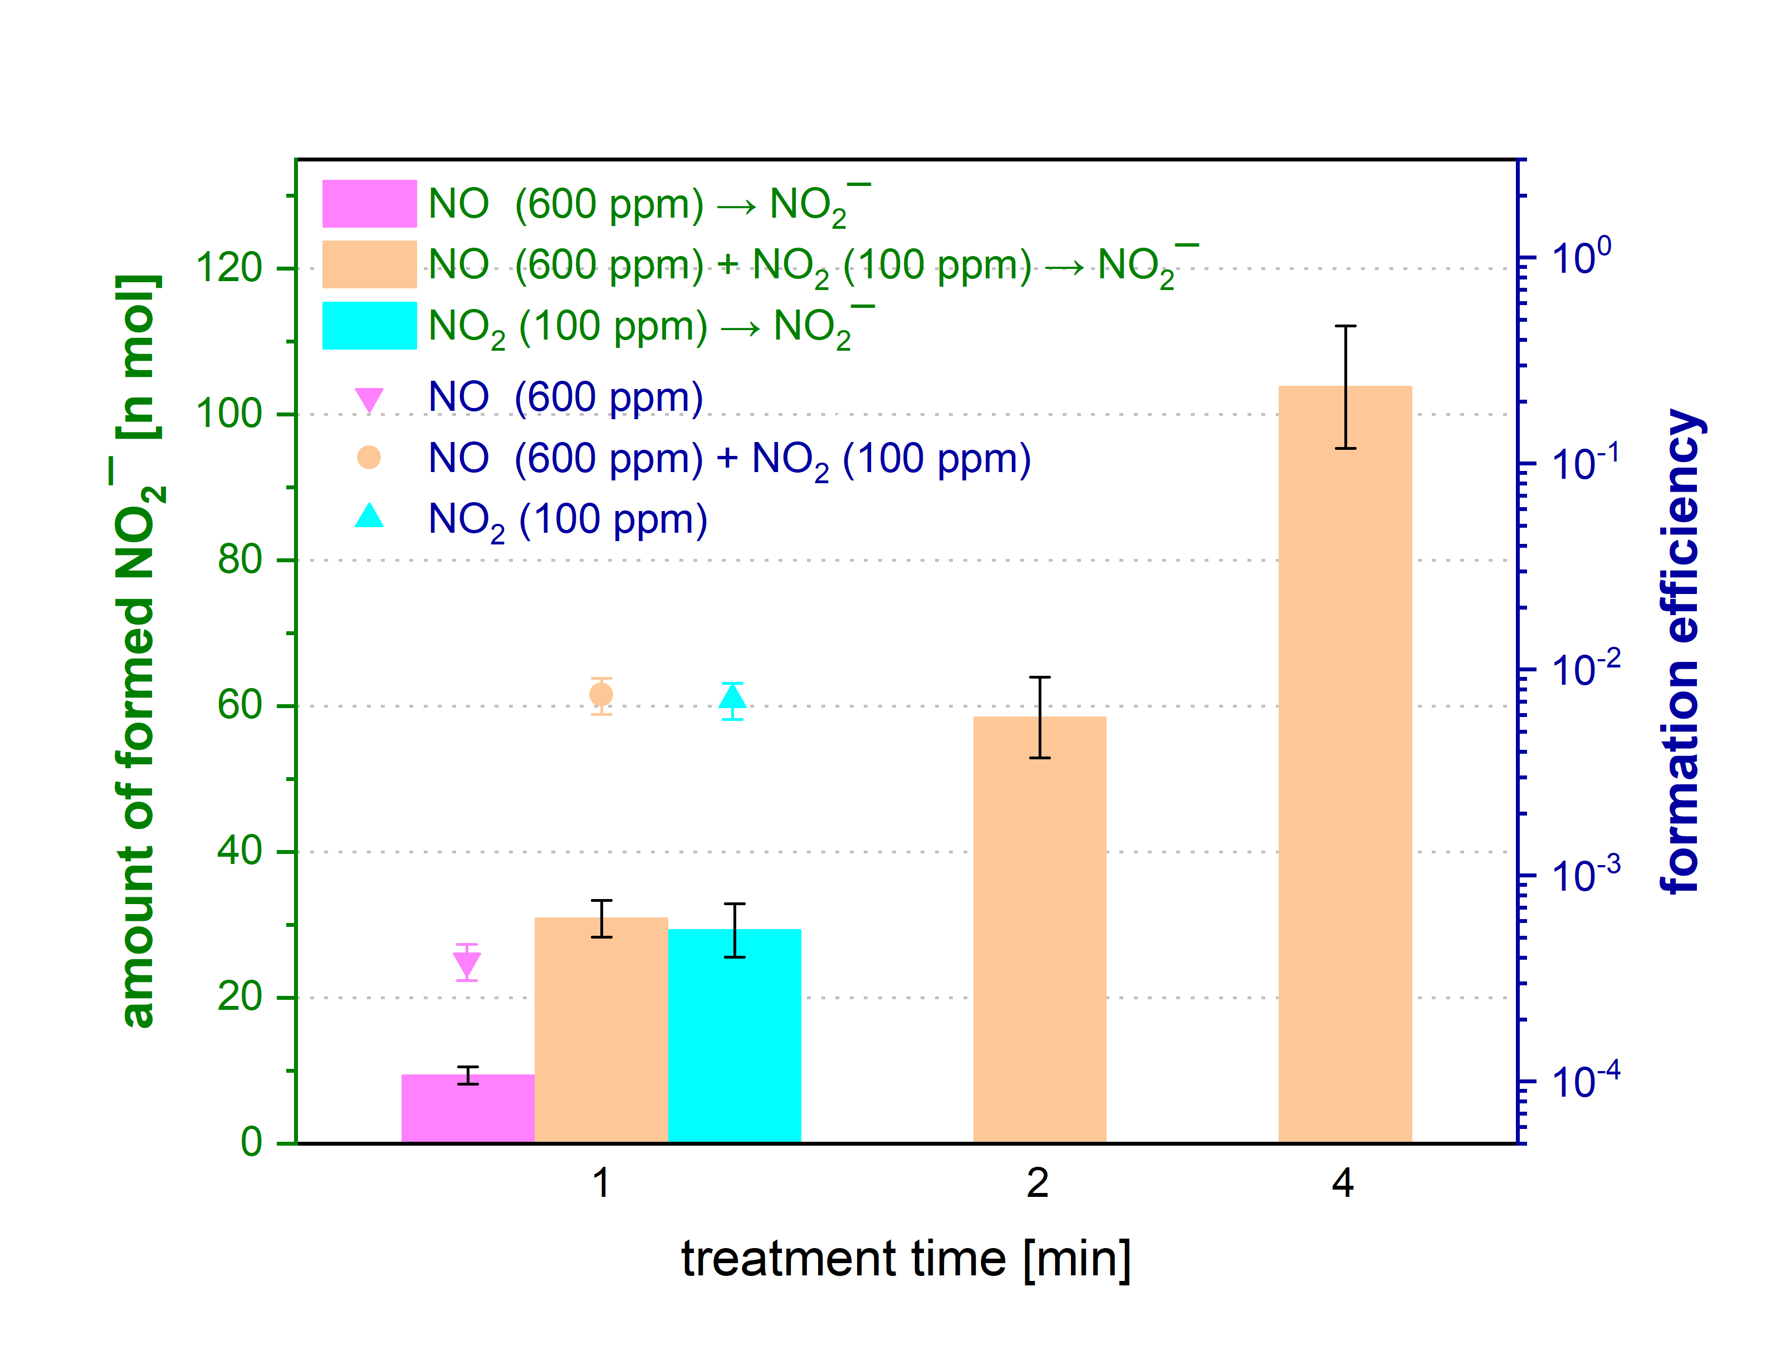
Figure S1 – Left axis: Molar amounts of NO₂¯ ions formed in bulk water as a function of treatment time at constant water volume of 500 µl, under constant water surface area, with the inlet gas only 600 ppm NO in N₂, or mixture 600 ppm NO in N₂ + 100 ppm NO₂ in synthetic air, or only 100 ppm NO₂ in synthetic air, during 1-4 min of treatment time; Right axis: NO₂¯ formation efficiency of only 600 ppm NO in N₂, or gas mixture 600 ppm NO in N₂ + 100 ppm NO₂ in synthetic air, or only 100 ppm NO₂ in synthetic air, during 1 min of treatment time at constant water volume of 500 µl.

Figure S2 shows the amount of NO₂¯ ions produced by dissolving NO (from a mixture of 600 ppm NO in N₂) in a bulk water experiment with a water volume of 500 µl, and duration of 1, 2, and 4 minutes, and into microdroplets from the nebulizer or microdroplets obtained by the electrospray (ES). The water flow rate in the nebulizer experiments was set to 500 µl/min. In the experiment with ES, the water flow rate varied from 200 to 1000 µl/min and the applied voltage varied from 5 to 13 kV. The treatment time of the experiments with ES microdroplets was 2 minutes; while it was 4 minutes in the experiments with nebulizer microdroplets, the amount of NO₂¯ shown here in the graph was divided by 2 (to validate the comparison of ES and bulk results).
NO itself contributed to low molar amounts of NO₂¯ formed in water (~10 nmol for bulk, below 40 nmol for nebulized or ES microdroplets (under 11 kV) at the given conditions. The increase of the applied voltage (especially 13 kV) leads to the ignition of the glow corona discharge around the HV electrode tip that leads to the conversion of NO to other molecules, especially HNO₂ with a much higher efficiency of NO₂¯ ions formation.
This can be explained by the fact that due to the presence of the glow corona discharge at the higher ES applied voltages, there is a possibility of OH radicals production by the dissociative attachment of electrons to water vapor molecules in reaction (1S), or from the reaction of the created atomic oxygen with water vapor in reactions (2S-3S).
 | e + H₂O → OH + H + e | (1S)
 | e + O₂ → O (¹D) + O + e | (2S)
 | O (¹D) + H₂O → 2 OH | (3S)

These OH radicals are then attached to the NO molecules to produce the highly soluble HNO₂ in reaction (1). Assuming a linear relationship between RONS concentration in water and the gas phase, we can extrapolate the produced gas HNO₂ concentration (based on results from the external gas sources). Even low concentration of the HNO₂ (~ 2-5 ppm), can form NO₂¯ of 30 to 80 nmol at the applied voltages of 11 and 13 kV, and water flow rates of 200 and 500 µl/min, respectively.
This NO₂¯ production becomes much higher up to 2,480 nmol at the applied voltage 13 kV and higher water flow rate 1000 µl/min, which leads to the creation of more HNO₂ (~ 109 ppm).
We also observed that the formed amount of NO₂¯ by NO solvation in water was enhanced more by the nebulized water microdroplets. This refers to that NO solvation is strongly enhanced by orders of magnitude higher water surface area produced by nebulized microdroplets. For low-solubility NO, this surface area effect is more pronounced than for HNO₂ and NO₂, in which their solvation was enhanced more by the positively ES charged microdroplets with respect to the nebulized microdroplets.
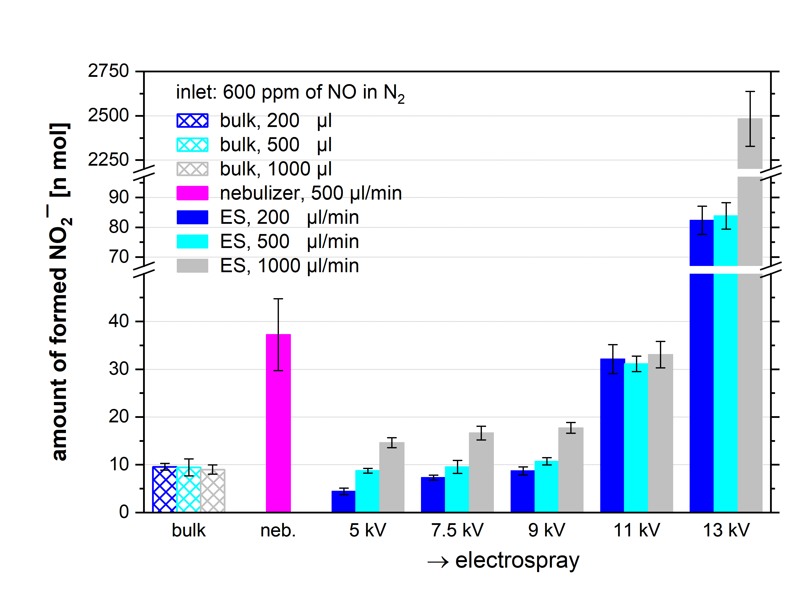
Figure S2 – Molar amount of NO₂¯ ions formed in water in the experiment with 600 ppm of NO in N₂ in the inlet gas; comparison of the amount of NO₂¯ ions formed in the bulk water (1 minute, water volume 200-1000 µl), in nebulized microdroplets (water flow rate 500 µl/min, half of the amount of NO₂¯ formed in 4 minutes is shown) and in ES microdroplets (applied voltage 5-13 kV, water flow rate 200-1000 µl/min, 2 minutes).

The results of this experiment revealed that the efficiency of the NO₂¯ formation from NO₂ alone was statistically indistinguishable from that in the NO/NO₂ mixture. This finding concludes that gaseous NO has a negligible role in forming NO₂¯ in water compared to NO₂ and HNO_{2,} and thus NO solvation was not considered further in the main article.

