Supplementary Information

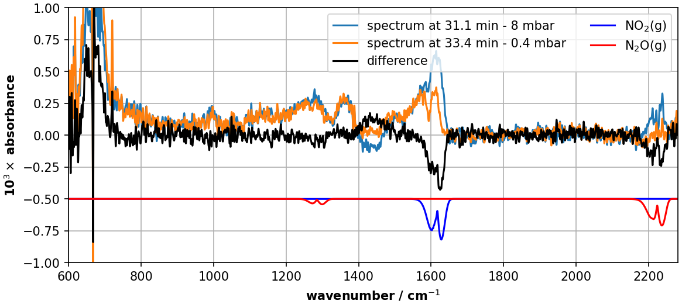
Figure 1: The reflectance spectra before and after evacuating the plasma of figure 7, where the absorbance is plotted as function of the wavenumber.

