Supplementary Information for manuscript titled Using Viral Aerosol Fluorescence for Detection of Virus Infectivity Change Induced by Non-thermal Plasma

This supplementary information contains two parts: 1) Additional scatter plots for the particle fluorescence data discussed in the manuscript Using Viral Aerosol Fluorescence for Detection of Virus Damage Induced by Non-thermal Plasma, which are standalone plots that do not interact with other information presented in the manuscript and therefore included here as supplementary information; 2) Experimental steps and preliminary results of protein gel electrophoresis analyses on collected viral aerosol samples treated by non-thermal plasma.

Part I. Scatter plots of aerosol fluorescence intensity of nebulized virus stock and virus-free buffer liquid
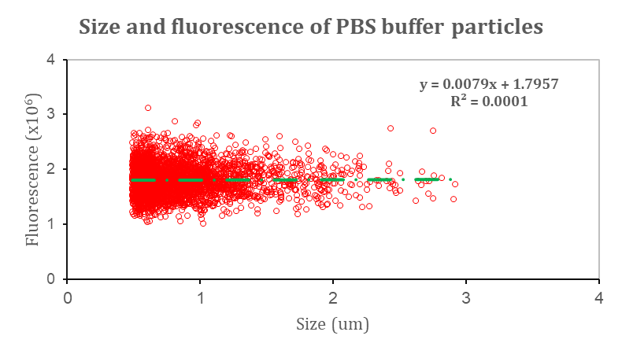
Figure SI-1. Scatter plot of WIBS-measured size and fluorescence of 20% 1xPBS particles.
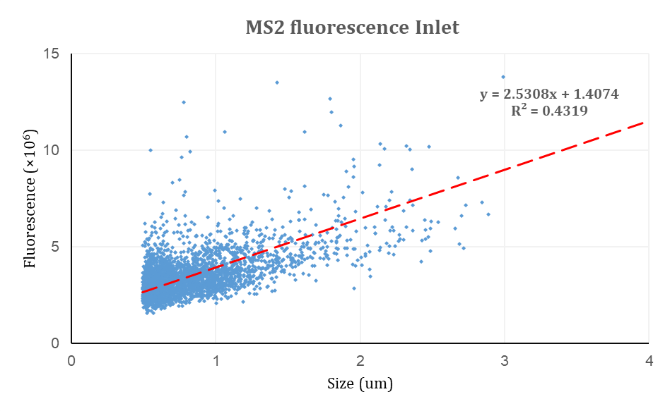
Figure SI-2. Scatter plot of WIBS-measured particle size and fluorescence of MS2 viral aerosol at the NTP reactor inlet and the linear fit curve.

Part II. Protein gel electrophoresis of collected MS2 viral aerosol treated by non-thermal plasma

Methods for viral protein analysis
MS2 virus protein-related experiments include protein assays to evaluate the protein concentration in the collected samples and protein gel electrophoresis analyses to further evaluate the concentration change of proteins of a specific size, after exposure to non-thermal plasma.

To perform the analyses, the MS2 virus stock is first concentrated by passing through a centrifugal filter with a molecular weight cutoff (MWCO) of 100 kilodaltons (kDa). A total volume of 80 mL of MS2 stock is concentrated via the centrifugal filter by centrifuging at 2500X extra g-force (xg) several times until the final volume reaches 4 mL. This 4 mL concentrated MS2 stock is then aerosolized, exposed to NTP, and collected into impingers following the same procedure described above. 10 mL of liquid samples in the impingers at the reactor inlet and reactor outlet are extracted for the following analyses.

Protein assays are performed to determine the total protein concentration in the samples. The protein concentration is determined by the light absorbance of the mixture of the virus protein sample and protein dye reagent. In this study, 100 μL of the virus sample is mixed with 150 μL of QuickStart™ Bradford 1x Dye Reagent in a 96-well plate, and triplicate samples are created for each sample. After 15 minutes of incubation, the mixture is measured for its optical absorbance at 595 nm. The blank sample and standard curves are created by mixing the dye reagent with nuclease-free water and bovine serum albumin (BSA) protein standard (Bio-rad #5000207).

The gel electrophoresis steps are adapted from published standard procedures ¹. For the protein preparation of gel electrophoresis, the 10 mL collected impinger virus samples are further concentrated by centrifuging through a series of centrifugal filters with a 10kDa MWCO at 3000 xg for 30 minutes and 10000 xg for 5 minutes. The final concentrated virus protein sample has a volume of approximately 100 μL, 50 μL of which is mixed with 50 μL of running buffer (2x Laemmli Sample Buffer, Bio-rad #1610737), then heated at 95 °C for 5 minutes. For the SDS-PAGE run, triplicate samples of 30 μL of the heated virus protein sample are loaded on a precast Tris-HCl protein gel (15% Criterion™ Tris-HCl Protein Gel, Bio-rad #3450019), along with protein standard (Precision Plus Protein™ Standards, Bio-rad #1610377) in separate wells. Then, the gel is run for 50 minutes at 200 kV in 500 mL of running SDS buffer (1x dilution of 10x Tris/Glycine/SDS, Bio-rad #1610732). After finishing the electrophoresis, the gel is rinsed with 300 mL of deionized water three times for 5 minutes each. The rinsed gel is first dyed with Coomassie blue stain (Bio-Safe™ Coomassie Stain, Bio-rad #1610786) for 1 hour on a shaker, then the excess dye is removed by rinsing with 300 mL of deionized water three times for 5 minutes each. Photos of the processed protein gel are taken in a dark room with a backlit background, using a black/white lens and a shutter speed of 2 seconds. No additional digital adjustments are made to the photos after they are taken, except for the annotation.

Results of viral protein analysis
Protein gel electrophoresis was performed as a protein analytical method in order to inform the plaque assay and viral aerosol fluorescence intensity results. Initial protein assays determined that the protein concentration in aerosols sampled before plasma exposure (0.48 mg/mL) versus after plasma exposure (0.51 mg/mL) is not statistically different. One-dimensional sodium dodecyl sulfate-polyacrylamide gel electrophoresis (SDS-PAGE) involved loading into each well of the gel viral aerosols collected before and after non-thermal plasma exposure that had been verified to contain a protein concentration of approximately 0.62 mg/mL, which suggests a protein load of 13 μg per lane, excluding the lane for the protein ladder to show the standardized protein size. As can be easily seen from the Coomassie blue-dyed protein gel (Fig SI-1), there is a clearly distinct difference between the bands corresponding to proteins of collected aerosols before plasma exposure versus those after plasma exposure. More specifically, the MS2 coat protein and the MS2 A-protein, which have molecular weights of 13.7 kDa and 44 kDa respectively ², can be identified on the gel separated by a distance corresponding to the protein migration rate. These two most abundant MS2 proteins, responsible for the primary structural component of the virus capsid (coat protein) and attachment to the bacterial pilus and in vivo infectivity (A-protein) ², both appear to be present at significantly reduced concentrations after plasma exposure as compared to before plasma exposure.

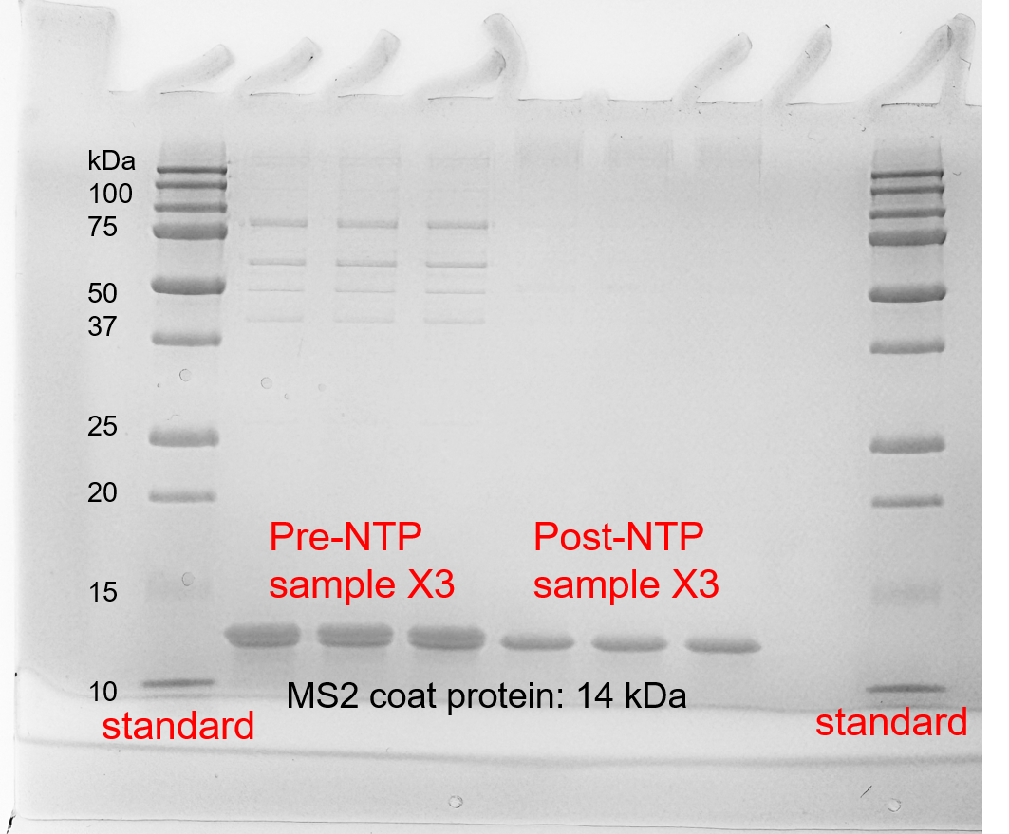
Figure SI-3. Stained SDS-PAGE gel of MS2 virus protein before and after NTP exposure.
Plasma operating conditions: 20 kV plasma peak-to-peak voltage, 300 Hz driving frequency, 1.4 Watts plasma discharge power, 0.3 seconds exposure time.

In addition to the two primary protein bands, other bands that could be hardly visible due to their sheer abundance become indistinguishable after receiving plasma exposure. Furthermore, the absence of additional protein bands arising in the plasma-exposed samples suggests that the plasma-driven reactions or processes are non-specific, not resulting in the production or formation of smaller proteins from the original with a lower specific molecular weight following a well-defined mechanism. This SDS-PAGE gel result could suggest that plasma-induced inactivation is typical for non-enzyme-driven protein degradation ^{3, 4}, which is expected for NTP, as inactivation mechanism studies highlight the importance of oxidative species ⁵ instead of any protease that targets a specific chemical bond in the protein structure. The reason for the same protein concentration detected from protein assays, despite starkly different protein concentrations of specific molecular weights, could be the light absorption-based protein assay mechanism itself, as the chemical dye could also combine with fragments of protein or amino acid chains and have light absorbance effects. Despite some trivial differences within the triplicate group, the destruction of MS2 capsid protein is uniformly observed compared to the non-treated triplicates, which suggests the importance of capsid protein damage in the inactivation mechanism of non-thermal plasma.

Water- and surface-based NTP studies have found bacteria lipid and virus protein damage caused by the oxidants; however, the absence to date of similar results obtained for bioaerosols having undergone direct, but much shorter (< 1 sec), NTP exposure highlights the need for similar protein damage assessments involving NTP treatment of aerosols. Previous research has suggested that MS2 bacteriophage fluorescence may be related to its protein structure and protein-protein interactions in virus assembly ⁶, which supports the present study's hypothesis that non-thermal plasma exposure can induce virus protein damage detectable by UV fluorescence measurements. Such viral protein damage is not only detected via UV fluorescence, but also verified through protein gel electrophoresis in the present study. Previous studies have provided protein gel electrophoresis results for waterborne viruses treated by plasma jet in batch liquids ⁷ or plasma-activated water ⁸, or deposited on a wet surface ^{9, 10}. In contrast, the protein gel electrophoresis results of the present study reflect the effects of viral aerosols exposed to non-thermal plasma in air. The direct evidence from the gel electrophoresis results could be used to imply that the measured reduction in fluorescence intensity is the result of induced protein damage, and that differential UV-LIF measurements can be used to infer virus capsid protein damage.

Combining the findings of an infectivity and fluorescence intensity correlation with the observed changes in viral aerosol capsid protein structure, a reasonable assumption would be that plasma-induced viral aerosol protein damage is more likely to have a direct influence on viral infectivity. Previous studies also stressed the importance of viral protein damage resulting from non-thermal plasma treatment as a means of inactivating pathogenic aerosols ^{8, 11}. Future studies should strive for quantitative analysis of protein damage and the development of proposed reaction mechanisms that relate such damage to changes in fluorescence intensity. In summary, the present study reports a correlation between viral aerosol infectivity and UV fluorescence intensity, not causation. These results do not exclude the possibility of plasma-induced protein damage that is sufficient to cause loss of infectivity but insufficient to produce detectable UV fluorescence intensity changes, or vice versa. Future studies would require a more thorough understanding of the relationship between infectivity and fluorescence, and distinguishing between protein-related and genome-related infectivity loss.

Reference
(1) Gallagher, S. R. One‐dimensional SDS gel electrophoresis of proteins. Current protocols in immunology 2006, 75 (1), 8.4. 1-8.4. 37.
(2) Kuzmanovic, D. A.; Elashvili, I.; Wick, C.; O'Connell, C.; Krueger, S. Bacteriophage MS2. Structure 2003, 11 (11), 1339-1348. DOI: 10.1016/j.str.2003.09.021.
(3) Sadeghi, A. A.; Nikkhah, A.; Shawrang, P.; Shahrebabak, M. M. Protein degradation kinetics of untreated and treated soybean meal using SDS-PAGE. Animal Feed Science and Technology 2006, 126 (1-2), 121-133. DOI: 10.1016/j.anifeedsci.2005.05.026.
(4) Davies, K. J. Protein damage and degradation by oxygen radicals. I. general aspects. Journal of Biological Chemistry 1987, 262 (20), 9895-9901. DOI: 10.1016/s0021-9258(18)48018-0.
(5) Vaze, N. D.; Park, S.; Brooks, A. D.; Fridman, A.; Joshi, S. G. Involvement of multiple stressors induced by non-thermal plasma-charged aerosols during inactivation of airborne bacteria. PLOS ONE 2017, 12 (2), e0171434. DOI: 10.1371/journal.pone.0171434.
(6) Lima, S. M. B.; Vaz, A. C. Q.; Souza, T. L. F.; Peabody, D. S.; Silva, J. L.; Oliveira, A. C. Dissecting the role of protein–protein and protein–nucleic acid interactions in MS2 bacteriophage stability. The FEBS Journal 2006, 273 (7), 1463-1475. DOI: 10.1111/j.1742-4658.2006.05167.x.
(7) Aboubakr, H. A.; Gangal, U.; Youssef, M. M.; Goyal, S. M.; Bruggeman, P. J. Inactivation of virus in solution by cold atmospheric pressure plasma: identification of chemical inactivation pathways. Journal of Physics D: Applied Physics 2016, 49 (20), 204001. DOI: 10.1088/0022-3727/49/20/204001.
(8) Guo, L.; Xu, R.; Gou, L.; Liu, Z.; Zhao, Y.; Liu, D.; Zhang, L.; Chen, H.; Kong, M. G. Mechanism of Virus Inactivation by Cold Atmospheric-Pressure Plasma and Plasma-Activated Water. Applied and Environmental Microbiology 2018, 84 (17), AEM.00726-00718. DOI: 10.1128/aem.00726-18.
(9) Yasuda, H.; Hashimoto, M.; Rahman, M. M.; Takashima, K.; Mizuno, A. States of biological components in bacteria and bacteriophages during inactivation by atmospheric dielectric barrier discharges. Plasma Processes and Polymers 2008, 5 (6), 615-621.
(10) Yasuda, H.; Miura, T.; Kurita, H.; Takashima, K.; Mizuno, A. Biological evaluation of DNA damage in bacteriophages inactivated by atmospheric pressure cold plasma. Plasma Processes and Polymers 2010, 7 (3‐4), 301-308.
(11) Aboubakr, H. A.; Mor, S. K.; Higgins, L.; Armien, A.; Youssef, M. M.; Bruggeman, P. J.; Goyal, S. M. Cold argon-oxygen plasma species oxidize and disintegrate capsid protein of feline calicivirus. PloS one 2018, 13 (3), e0194618.

