Quantification of eroded Fe contamination in plasma activated water using acoustic levitation assisted Laser-Induced Breakdown Spectroscopy by a novel method - multi-line calibration curve.
Jairo C. Peralta¹, Pankaj Pareek², Ivan A. Urbina¹, Sanath J. Shetty¹, Matej Veis¹, Mario Janda² and Pavel Veis^{1*}
- Dept. of Exp. Physics, Faculty of Math., Phys. and Informatics, Comenius Univ., Mlynska dol. F2, 842 48 Bratislava, Slovakia.
- Dept. of Astronomy, Physics of the Earth, and Meteorology, Faculty of Math., Phys. and Informatics, Comenius Univ., Mlynska dol. F2, 842 48 Bratislava, Slovakia.
* Corresponding author: pavel.veis@fmph.uniba.sk

Appendix A. Supplementary Information
Under the assumption for a plasma in local thermodynamics equilibrium (LTE) conditions and optically thin plasma behaviour, the integral intensity can be expressed as follow:

$$I(λ)=FC_{a} {g_{k}A}_{ki}\frac{e^{-\frac{E_{k}}{k_{B}T_{e}}}}{U_{a}(T)λ} (A.1)$$

where I$(λ)$ is the integrated intensity of the line after corrected by the sensitivity curve of the instrument for the species a which depends on $λ$, T_{e} is the electron temperature, g_{k} is degeneracy of upper level of the transition, with energy E_{k}, k_{B} is the Boltzmann constant and U_{a}(T_{e}) is the partition function of the species a at the temperature T_{e}. C_{a} is the concentration atoms of the species a and F is a experimental factor.
By applying natural logarithm function to equation (A.1) the linear dependence of Boltzmann Plot (BP) is given by:
$\ln\left(\frac{I(λ)λ}{g_{k}A_{kj}}\right)=\frac{-E_{k}}{k_{b}T_{e}}+\ln\left(\frac{FC_{a}}{U_{a}(T_{e})}\right)$ $(A.2)$
After the following substitution:
$$y=\ln\left(\frac{I(λ)λ}{g_{k}A_{kj}}\right);x=E_{k}; m=-\frac{1}{k_{b}T_{e}};q=\ln\left(\frac{FC_{a}}{U_{a}(T_{e})}\right)$$
Equation (A.2) can be defined as a linear function $y=m.x+q$, where y is the dependent variable, x the independent variable, m the slope and b the interception of the BP with y axis.

The construction of the BP allows the determination of the electronic temperature (T_{e}) and the concentration $C_{a}$. A dynamic range on x-coordinates should include a good distribution of points to construct an accurate Boltzmann Polt. Nevertheless, often times it is not possible to obtain such quantity of points with varied upper energy levels E_{k}, an example of such a Boltzmann plot is shown in Figure F.1.
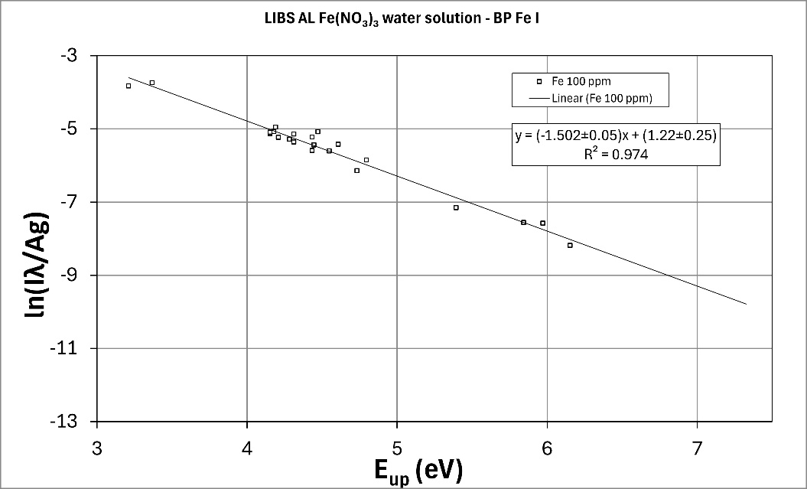
Figure. F.1 Boltzmann Plot for a standard solution 100ppm Fe for Fe I lines.

The points enclosed with in the red circle in Figure. F.1 has a relatively high density of points on the graph; and a lack of homogeneous distribution of points along the fitted line can be observed. Having the homogeneous distribution and precise evaluation of BP points, the electron temperature could be precisely evaluated from the BP line slope m.

For the same experimental conditions, if the electronic temperature is similar between the standard solutions, the linear fit of the BP shifts up with increasing in the concentration.
For the aforementioned reason, in this article it is proposed a new method with the aim to improve the accuracy of the quantification, here multiple spectral line intensities are used to construct a new multi-line (MLCC) based on BP. This method relates the synthetic intensity (calculated from the center of mass BP) and concentration of the analytes under study.

The center of mass is a pair of x and y coordinates that represent a single point with the most dense cluster in the BP (Hihglighted in the Figure F1). Since the number of suitable lines for constructing the BP often decreases with decreasing concentration, the different distributions of points could lead to a shift in the center of mass. Therefore, the x-coordinate of the center of mass for each concentration was averaged to define a new value, x₀ (in energy units). The synthetic intensity was determined based on the corresponding x₀ value in each BP. The number of suitable lines to construct the BP often decreases with decreasing concentrations, resulting in the “center of mass” for each BP occurring at a different x-coordinate value.

The new approach in general is proposed to correlate the LTE, the stochiometric condition of the LPP with a linear regression for a Calibration Curve to improve the accuracy of the analytical determination using standard solution with lack distribution of lines in the Boltzmann Plot. In other words:
$$I({λ, T}_{e, }) α C(T_{e})$$
In this study a new method is proposed to find the mathematical correlation between I and C for a T_{e.}

With x₀ obtained, a new y-coordinate is re-calculated from the linear regression model of the BP, this new intensity will be referred as the synthetic intensity.

$\ln\left[{\left(\frac{I(λ)λ}{g_{k}A_{kj}}\right)}_{SYNTH}\right]=mx_{0}+q$ $(A.4)$

Reformulated A.4 using the previous definition of q:

$\ln\left[{\left(\frac{I(λ)λ}{g_{k}A_{kj}}\right)}_{SYNTH}\left(\frac{U_{a}(T_{e})}{FC_{a}}\right)\right]=mx_{0}$ (A.5)

Applying $e^{x}$ function on A.5, is obtained:

${\left(\frac{I(λ)λ}{g_{k}A_{kj}}\right)}_{SYNTH}\left(\frac{U_{a}(T_{e})}{FC_{a}}\right)=e^{mx_{0}}$ (A.6)

Reformulating A.6 to express a correlation between the synthetic intensity and the concentration for the species a:

${\left(\frac{I(λ)λ}{g_{k}A_{kj}}\right)}_{SYNTH}=C_{a}\left[{\left(\frac{F}{U_{a}(T_{e})}\right)e}^{mx_{0}}\right]+δ$ (A.7)

Equation A.7 shows a directly proportional between the synthetic intensity and the concentration of the species a. This relationship can be modelled by a linear regression fitting for a polynomial order 1 when the terms in square brackets are constant for all the standard solution considered.

With the x₀ and slope obtained from the BP, the T_{e} is determined for all the standard solutions for the species a (neutral or ions) with the LTE condition fulfilled, therefore the change in experimental factor for all the solutions consider should be $δF→0$, then
$m, x_{0}, U_{a}\left(T_{e}\right), F=Ctte$ (A.8)
Therefore, whether A.8 is fulfilled, equation A.7 can be adjust fitted by a linear regression where $δ$ is the error of the regression in the interception.
Moreover, if those conditions are achieved the plasma is stoichiometric with the sample, under this conditions C_{a} α C_{M}, where M is the analyte concentration. This proportionality should be constant across the standard solutions, but different depending on the species (i.e one MLCC for neutral and another for the different ions).

This method is called Multiline Calibration Curve (MLCC) and can be applied to ions a neutral.

The emission lines of Fe I and Fe II used in this work are in the table below

Species | Wavelength  [nm] | A_{ki}  [s⁻¹] | E_{low}  [eV] | E_{up}  [eV] | g_{i} | g_{k}
Fe I | 385.991 | 9.69E+06 | 0 | 3.211 | 9 | 9
Fe I | 392.291 | 1.08E+06 | 0.052 | 3.211 | 7 | 9
Fe I | 367.991 | 1.38E+06 | 0.000 | 3.368 | 9 | 9
Fe I | 346.586 | 1.19E+07 | 0.110 | 3.686 | 3 | 3
Fe I | 298.357 | 2.79E+07 | 0 | 4.154 | 9 | 7
Fe I | 304.761 | 2.84E+07 | 0.087 | 4.154 | 5 | 7
Fe I | 296.690 | 2.72E+07 | 0 | 4.178 | 9 | 11
Fe I | 383.422 | 4.52E+07 | 0.958 | 4.191 | 7 | 5
Fe I | 381.296 | 7.91E+06 | 0.958 | 4.209 | 7 | 5
Fe I | 293.690 | 1.30E+07 | 0 | 4.220 | 9 | 9
Fe I | 372.762 | 2.24E+07 | 0.958 | 4.283 | 7 | 5
Fe I | 364.784 | 2.91E+07 | 0.915 | 4.312 | 9 | 11
Fe I | 438.355 | 5.00E+07 | 1.485 | 4.312 | 9 | 11
Fe I | 440.475 | 2.75E+07 | 1.557 | 4.371 | 7 | 9
Fe I | 427.176 | 2.28E+07 | 1.485 | 4.386 | 9 | 11
Fe I | 441.512 | 1.19E+07 | 1.608 | 4.415 | 5 | 7
Fe I | 352.126 | 6.14E+06 | 0.915 | 4.435 | 9 | 9
Fe I | 420.203 | 8.22E+06 | 1.485 | 4.435 | 9 | 9
Fe I | 430.790 | 3.40E+07 | 1.557 | 4.435 | 7 | 9
Fe I | 360.886 | 8.13E+07 | 1.011 | 4.446 | 3 | 5
Fe I | 432.576 | 4.97E+07 | 1.608 | 4.473 | 5 | 7
Fe I | 404.581 | 8.62E+07 | 1.485 | 4.549 | 9 | 9
Fe I | 406.359 | 6.78E+07 | 1.557 | 4.608 | 7 | 7
Fe I | 407.174 | 7.65E+07 | 1.608 | 4.652 | 5 | 5
Fe I | 381.584 | 1.31E+08 | 1.485 | 4.733 | 9 | 7
Fe I | 382.782 | 1.05E+08 | 1.557 | 4.795 | 7 | 5
Fe I | 273.358 | 8.63E+07 | 0.859 | 5.393 | 11 | 9
Fe I | 339.933 | 3.82E+07 | 2.198 | 5.844 | 5 | 5
Fe I | 326.562 | 3.78E+07 | 2.176 | 5.972 | 7 | 5
Fe I | 365.205 | 6.23E+07 | 2.759 | 6.153 | 7 | 9
Fe II | 262.567 | 3.35E+07 | 0.048 | 4.768 | 8 | 10
Fe II | 262.829 | 8.56E+07 | 0.121 | 4.837 | 2 | 4
Fe II | 262.167 | 4.85E+07 | 0.121 | 4.849 | 2 | 2
Fe II | 240.489 | 1.69E+08 | 0.083 | 5.237 | 6 | 8
Fe II | 239.924 | 1.37E+08 | 0.083 | 5.249 | 6 | 6
Fe II | 240.666 | 1.62E+08 | 0.107 | 5.257 | 4 | 4
Fe II | 275.574 | 2.11E+08 | 0.986 | 5.484 | 8 | 10
Fe II | 273.955 | 1.93E+08 | 0.986 | 5.511 | 8 | 8
Fe II | 271.441 | 5.48E+07 | 0.986 | 5.553 | 8 | 6
Fe II | 273.073 | 2.51E+07 | 1.076 | 5.615 | 4 | 4
Fe II | 256.254 | 1.51E+08 | 0.986 | 5.823 | 8 | 6
Fe II | 258.258 | 7.72E+07 | 1.076 | 5.876 | 4 | 4
Fe II | 257.437 | 1.55E+08 | 2.583 | 7.397 | 6 | 4
Fe II | 266.466 | 1.52E+08 | 3.387 | 8.038 | 8 | 10
Fe II | 245.878 | 2.65E+08 | 3.199 | 8.240 | 10 | 12

