Online Appendix A. Alternative estimates of country-level relationship between school closures and the increase in the truancy rate using a different measure of school closures.
- OECD countries only (b) All countries
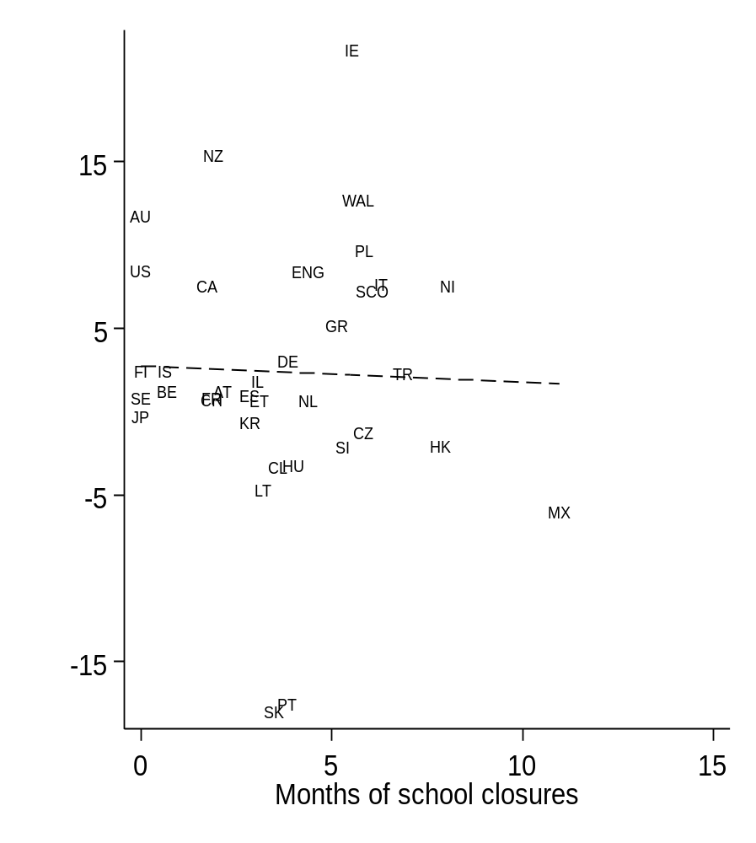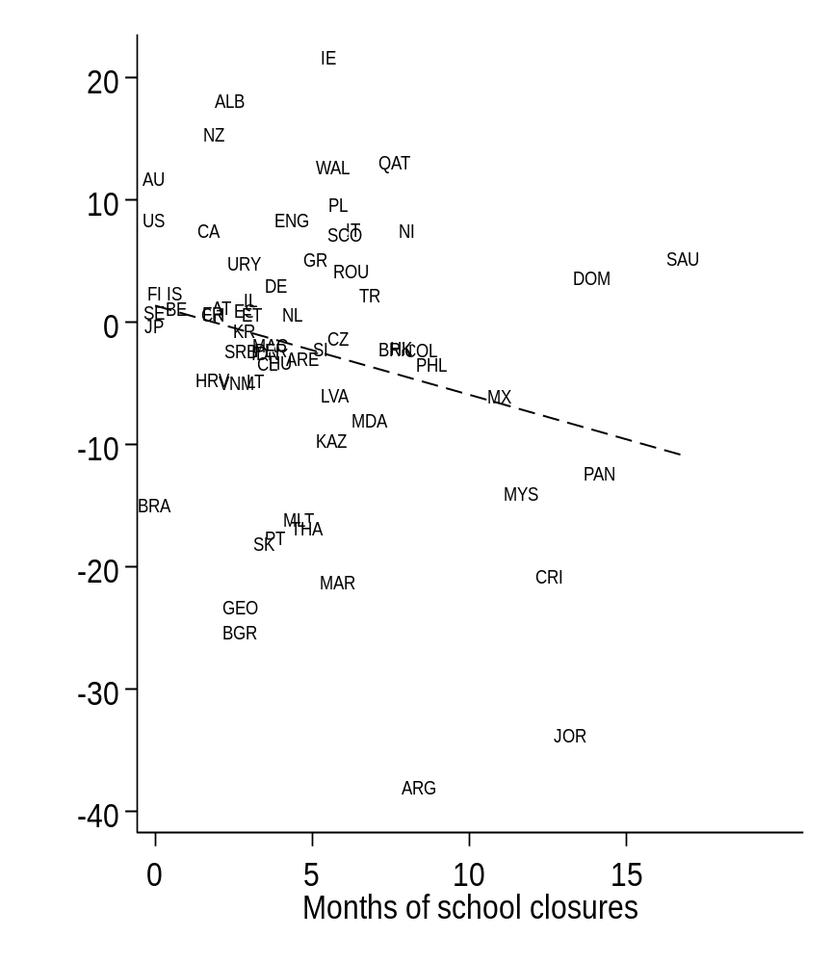
Online Appendix B. Alternative estimates of the pre/post pandemic change in student truancy excluding the data from PISA 2012
Online Table B1. The percentage of 15-year-olds skipping school before (2015-2018) and after (2022) the COVID-19 pandemic
Country | Two-letter code | Pre-pandemic truancy % | Standard error | Post-pandemic truancy % | Standard error | Change since pandemic
Ireland | IE | 26.9 | 0.5 | 41.1 | 0.8 | 14.2**
Australia | AU | 30.8 | 0.4 | 43.0 | 0.5 | 12.2**
New Zealand | NZ | 26.8 | 0.5 | 38.8 | 0.9 | 12.0**
USA | US | 19.9 | 0.8 | 29.0 | 0.9 | 9.1**
Wales | WAL | 28.8 | 1.3 | 37.4 | 1.4 | 8.6**
Scotland | SCO | 20.6 | 0.6 | 28.9 | 1.0 | 8.3**
Canada | CA | 20.4 | 0.3 | 28.6 | 0.6 | 8.2**
England | ENG | 17.7 | 0.6 | 25.7 | 0.9 | 8.0**
Northern Ireland | NI | 25.3 | 1.1 | 33.1 | 1.2 | 7.8**
Poland | PL | 22.0 | 0.7 | 29.4 | 1.0 | 7.5**
Italy | IT | 56.0 | 0.6 | 60.8 | 0.8 | 4.8**
Greece | GR | 23.9 | 0.5 | 28.4 | 0.8 | 4.5**
Turkey | TR | 49.2 | 0.6 | 53.2 | 0.8 | 4.0**
Denmark | DK | 18.2 | 0.5 | 20.4 | 0.6 | 2.1**
Spain | ES | 26.8 | 0.5 | 28.3 | 0.5 | 1.5**
Iceland | IS | 5.7 | 0.3 | 6.8 | 0.5 | 1.1**
Finland | FI | 13.2 | 0.6 | 14.2 | 0.5 | 1.0
Germany | DE | 10.4 | 0.4 | 11.4 | 0.6 | 0.9
Belgium | BE | 7.9 | 0.2 | 8.3 | 0.4 | 0.4
Norway | NO | 13.5 | 0.4 | 13.9 | 0.5 | 0.4
Israel | IL | 35.3 | 0.7 | 35.6 | 0.9 | 0.3
Sweden | SE | 9.5 | 0.4 | 9.5 | 0.4 | 0.1
Japan | JP | 1.9 | 0.2 | 1.6 | 0.2 | -0.3
France | FR | 13.3 | 0.4 | 12.8 | 0.5 | -0.4
Netherlands | NL | 6.2 | 0.3 | 5.6 | 0.4 | -0.6
South Korea | KR | 2.0 | 0.2 | 1.4 | 0.3 | -0.7*
Austria | AT | 13.8 | 0.4 | 12.9 | 0.5 | -0.9
Estonia | ET | 20.2 | 0.5 | 19.2 | 0.7 | -1.0
Switzerland | CH | 11.7 | 0.5 | 9.9 | 0.5 | -1.8**
Slovenia | SI | 14.9 | 0.4 | 12.6 | 0.4 | -2.3**
Czech Republic | CZ | 9.3 | 0.3 | 6.9 | 0.3 | -2.3**
Hong Kong | HK | 5.1 | 0.2 | 2.6 | 0.3 | -2.5**
Chile | CL | 9.8 | 0.4 | 5.7 | 0.4 | -4.1**
Hungary | HU | 10.1 | 0.4 | 5.7 | 0.4 | -4.4**
Lithuania | LT | 24.6 | 0.5 | 17.7 | 0.6 | -6.9**
Mexico | MX | 26.8 | 0.6 | 18.6 | 0.8 | -8.2**
Portugal | PT | 24.2 | 0.5 | 5.0 | 0.3 | -19.2**
Slovak Republic | SK | 36.3 | 0.7 | 7.8 | 0.5 | -28.4**
OECD average |  | 19.4 |  | 20.3 |  | 0.9
Notes: Figures refer to the percent of 15-year-olds who reported having skipped school at any point over the previous two weeks. The change column indicates the percentage-point difference before (PISA 2015-2018) and after (PISA 2022) the COVID-19 pandemic. * and ** indicate where the change following the pandemic is statistically significant at the 5% level. English-speaking countries are highlighted in green.
Online Table B2. The percentage of 15-year-olds reporting skipping school by PISA cycle. Comparison across English-speaking countries.
Country | 2015 | 2018 | 2022
Australia | 29 | 33 | 43
Ireland | 24 | 30 | 41
New Zealand | 25 | 29 | 39
Wales | - | 29 | 37
Northern Ireland | - | 25 | 33
USA | - | 20 | 29
Scotland | 19 | 22 | 29
Canada | 18 | 23 | 29
England | - | 18 | 26
Anglophone average | 23 | 25 | 34
OECD average | 18 | 21 | 19

Notes: Figures refer to the percent of 15-year-olds who reported skipping school at least one time in the past two weeks. Green/red shading indicates where the percentage skipping school is lower/higher.

Online Table B3. Gender differences in the percentage of 15-year-olds skipping school before (2015-2018) and after (2022) the COVID-19 pandemic
Country | Two-letter code | Pre-pandemic gender gap | Standard error | Post-pandemic gender gap | Standard error | Change since pandemic
South Korea | KR | 0.8 | 0.3 | 1.6 | 0.5 | 0.8
Japan | JP | 0.6 | 0.2 | 0.5 | 0.3 | 0.0
Slovak Republic | SK | 1.9 | 1.2 | 1.6 | 0.8 | -0.3
Netherlands | NL | 1.1 | 0.5 | 0.4 | 0.7 | -0.7
Belgium | BE | 3.1 | 0.5 | 2.4 | 0.7 | -0.7
Czech Republic | CZ | 1.8 | 0.6 | 0.9 | 0.6 | -0.9
Chile | CL | 3.4 | 0.7 | 2.5 | 0.7 | -0.9
Italy | IT | -0.5 | 1.0 | -1.4 | 1.3 | -0.9
Australia | AU | -2.5 | 0.7 | -3.4 | 1.0 | -0.9
Hungary | HU | 3.2 | 0.6 | 1.9 | 0.6 | -1.3
Germany | DE | 1.0 | 0.7 | -0.5 | 0.9 | -1.5
Turkey | TR | 9.6 | 1.1 | 7.8 | 1.4 | -1.7
Ireland | IE | -4.1 | 1.1 | -6.0 | 1.6 | -1.9
Hong Kong | HK | 1.8 | 0.5 | -0.1 | 0.5 | -1.9**
Scotland | SCO | -1.9 | 1.1 | -3.8 | 1.6 | -2.0
Canada | CA | -1.5 | 0.6 | -3.6 | 1.3 | -2.0
Iceland | IS | 2.2 | 0.5 | -0.1 | 0.8 | -2.3**
Norway | NO | 3.0 | 0.7 | 0.1 | 1.0 | -2.9**
Sweden | SE | 0.7 | 0.6 | -2.4 | 0.8 | -3.1**
Spain | ES | -1.0 | 0.7 | -4.3 | 0.9 | -3.3**
Portugal | PT | 4.4 | 0.9 | 0.6 | 0.7 | -3.7**
Mexico | MX | 5.6 | 0.8 | 1.7 | 1.1 | -3.9**
USA | US | -2.3 | 1.1 | -6.3 | 1.4 | -3.9**
Northern Ireland | NI | -0.5 | 2.3 | -4.9 | 2.4 | -4.4
Lithuania | LT | 7.2 | 0.8 | 2.8 | 1.0 | -4.4**
Estonia | ET | -0.6 | 1.0 | -5.2 | 1.0 | -4.6**
Slovenia | SI | 7.8 | 0.7 | 2.8 | 0.9 | -5.0**
Israel | IL | 3.2 | 1.3 | -2.0 | 1.6 | -5.2**
England | ENG | 0.0 | 1.1 | -5.8 | 1.6 | -5.8**
Denmark | DK | 1.5 | 0.8 | -4.4 | 1.2 | -5.8**
France | FR | 5.3 | 0.8 | -0.6 | 0.8 | -5.9**
Austria | AT | 1.5 | 0.7 | -4.6 | 0.8 | -6.0**
Switzerland | CH | 4.2 | 0.8 | -2.2 | 0.8 | -6.4**
New Zealand | NZ | 0.4 | 1.0 | -6.1 | 1.5 | -6.5**
Finland | FI | 3.1 | 1.1 | -4.8 | 0.8 | -8.0**
Greece | GR | 10.0 | 0.9 | 2.0 | 1.1 | -8.0**
Poland | PL | 7.6 | 0.8 | -1.5 | 1.6 | -9.1**
Wales | WAL | 2.3 | 1.7 | -7.2 | 1.8 | -9.5**
OECD average |  | 2.2 |  | -1.4 |  | -3.5

Notes: Gender gap refers to the truancy rate for boys minus the truancy rate for girls. Negative values therefore indicate where girls are more likely to skip school than boys. Negative values in the change column indicate where girls are increasingly more likely to skip schools than boys following the pandemic. * and ** indicate where the change since the pandemic is statistically significant at the 10% and 5% levels. English-speaking countries are highlighted in green.

Online Table B4. Socio-economic differences in the percentage of 15-year-olds skipping school before (2015-2018) and after (2022) the COVID-19 pandemic.
Country | Two-letter code | Pre-pandemic SES gap | Standard error | Post-pandemic SES gap | Standard error | Change since pandemic
Estonia | ET | 8.6 | -1.2 | 12.7 | -1.4 | 4.2**
Mexico | MX | 1.2 | -1.4 | 5.1 | -1.6 | 3.9*
Wales | WAL | 8.2 | -2.2 | 11.7 | -2.7 | 3.5
Germany | DE | 4.4 | -0.9 | 7.4 | -1.1 | 3.0**
Slovak Republic | SK | 5.5 | -1.3 | 8.2 | -1.1 | 2.7
Norway | NO | 3.9 | -0.9 | 6.3 | -1.0 | 2.4*
Scotland | SCO | 10.9 | -1.4 | 12.8 | -2.4 | 2.0
Austria | AT | 3.6 | -0.9 | 5.5 | -1.3 | 1.9
Poland | PL | 5.4 | -1.2 | 7.3 | -1.9 | 1.9
New Zealand | NZ | 9.5 | -1.2 | 11.4 | -2.0 | 1.8
Belgium | BE | 4.5 | -0.6 | 6.2 | -0.8 | 1.7*
Slovenia | SI | 5.8 | -0.9 | 7.3 | -1.2 | 1.5
Finland | FI | 6.3 | -1.0 | 7.7 | -1.1 | 1.4
Lithuania | LT | 10.3 | -1.0 | 11.7 | -1.3 | 1.4
Sweden | SE | 6.0 | -0.8 | 7.1 | -0.9 | 1.1
Spain | ES | 9.2 | -1.0 | 10.3 | -1.0 | 1.1
Ireland | IE | 6.5 | -1.3 | 7.5 | -1.8 | 1.0
Netherlands | NL | 1.4 | -0.7 | 2.4 | -0.9 | 0.9
Italy | IT | 10.4 | -1.4 | 11.1 | -1.8 | 0.8
France | FR | 9.7 | -0.9 | 10.1 | -1.1 | 0.4
Iceland | IS | 3.6 | -0.9 | 3.7 | -1.1 | 0.0
South Korea | KR | 1.6 | -0.3 | 1.6 | -0.8 | 0.0
Japan | JP | 0.8 | -0.3 | 0.6 | -0.5 | -0.2
Switzerland | CH | 4.4 | -0.8 | 4.1 | -1.0 | -0.4
Turkey | TR | -8.3 | -1.4 | -8.7 | -1.4 | -0.4
Hong Kong | HK | -1.0 | -0.7 | -1.6 | -0.8 | -0.6
Czech Republic | CZ | 4.4 | -0.8 | 3.7 | -0.8 | -0.6
Canada | CA | 7.6 | -0.6 | 6.8 | -1.5 | -0.9
Chile | CL | 2.4 | -0.8 | 1.4 | -0.8 | -1.0
Northern Ireland | NI | 8.6 | -2.5 | 7.3 | -3.1 | -1.2
Australia | AU | 9.1 | -0.9 | 7.5 | -1.4 | -1.5
Greece | GR | 4.2 | -1.1 | 1.0 | -1.6 | -3.2*
England | ENG | 9.7 | -1.5 | 6.4 | -1.8 | -3.3
Hungary | HU | 6.8 | -0.9 | 3.4 | -0.8 | -3.4**
Portugal | PT | 7.8 | -1.1 | 4.1 | -0.7 | -3.8**
Denmark | DK | 10.0 | -1.0 | 5.8 | -1.5 | -4.2**
USA | US | 8.3 | -1.8 | 3.8 | -1.6 | -4.5*
Israel | IL | 4.4 | -1.3 | -1.1 | -1.6 | -5.5**
OECD average |  | 5.7 |  | 5.8 |  | 0.1

Notes: Socio-economic gap refers to the truancy rate for the most disadvantaged third of students minus the truancy rate for most advantaged third of students. Positive values therefore indicate where disadvantaged students are more likely to skip school than their more advantaged peers. Negative values in the change column indicate where the socio-economic gap in skipping school has decreased following the pandemic. * and ** indicate where the change since the pandemic is statistically significant at the 10% and 5% levels. English-speaking countries are highlighted in green.
Online Figure B1. The percentage of 15-year-olds skipping school before (2015-2018) and after (2022) the COVID-19 pandemic
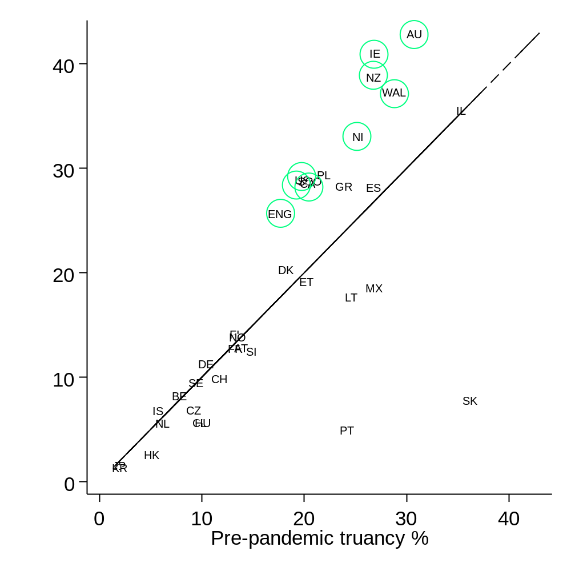
Notes: Figures refer to the percent of 15-year-olds who reported having skipped school at any point over the past two weeks. Pre-pandemic figures along the horizontal axis is the average across the 2015-2018 PISA waves. Post-pandemic figures along the vertical axis uses data from PISA 2022. English-speaking countries highlighted in green circles. See Table 1 for the two-letter country codes. Data for Italy and Turkey not presented in the scatterplot to aid presentation of results (see Table B1 for the estimates for these countries).
Online Figure B2. Gender and socio-economic gaps in skipping school at any point in last two weeks pre and post pandemic
- Gender gap (b) Socio-economic gap
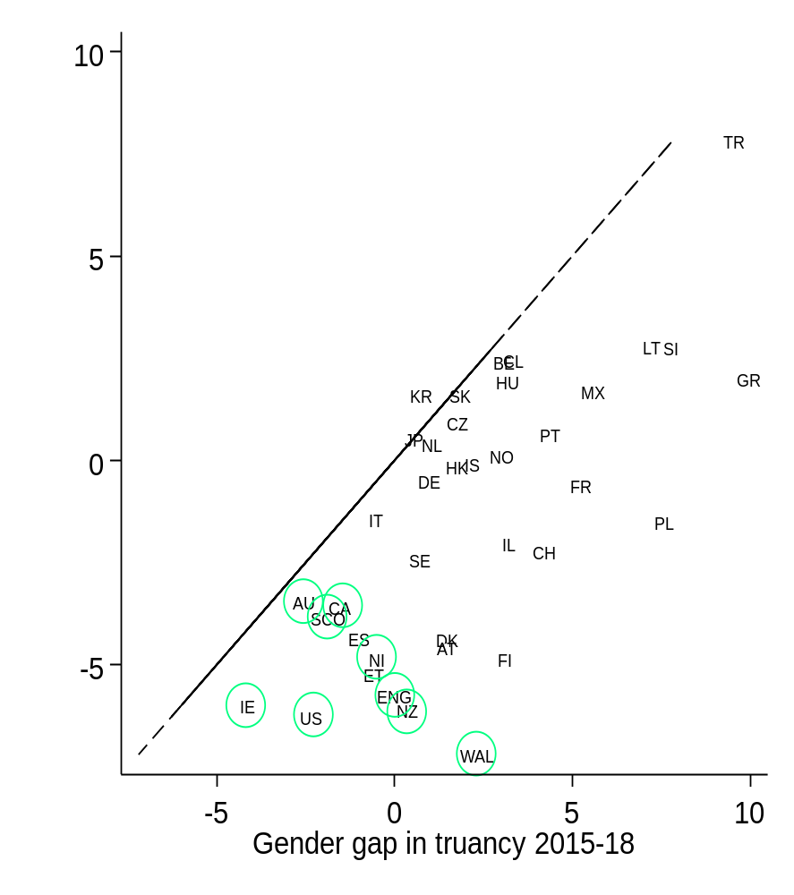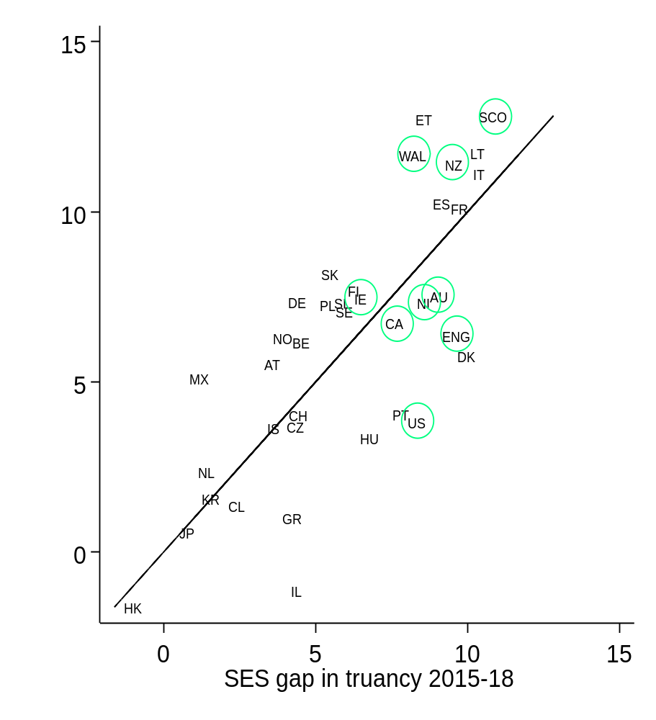Notes: Negative figures in the left-hand panel indicate the truancy rate is higher for girls than boys. Figures in the right-hand panel illustrate differences between teenagers in the bottom versus top third of the socio-economic status distribution. English-speaking countries in green circles. Diagonal lines illustrate where the gender/socio-economic gap has remained unchanged before/after the pandemic. See Table B1 for two-letter country codes.
Online Figure B3. The country-level relationship between school closures and the increase in the truancy rate
- OECD countries only (b) All countries
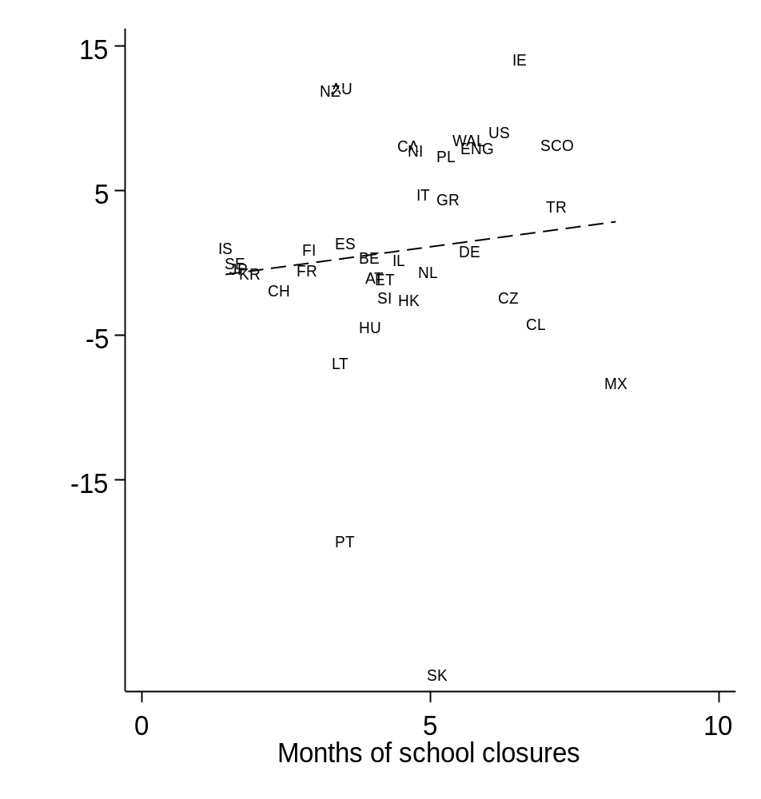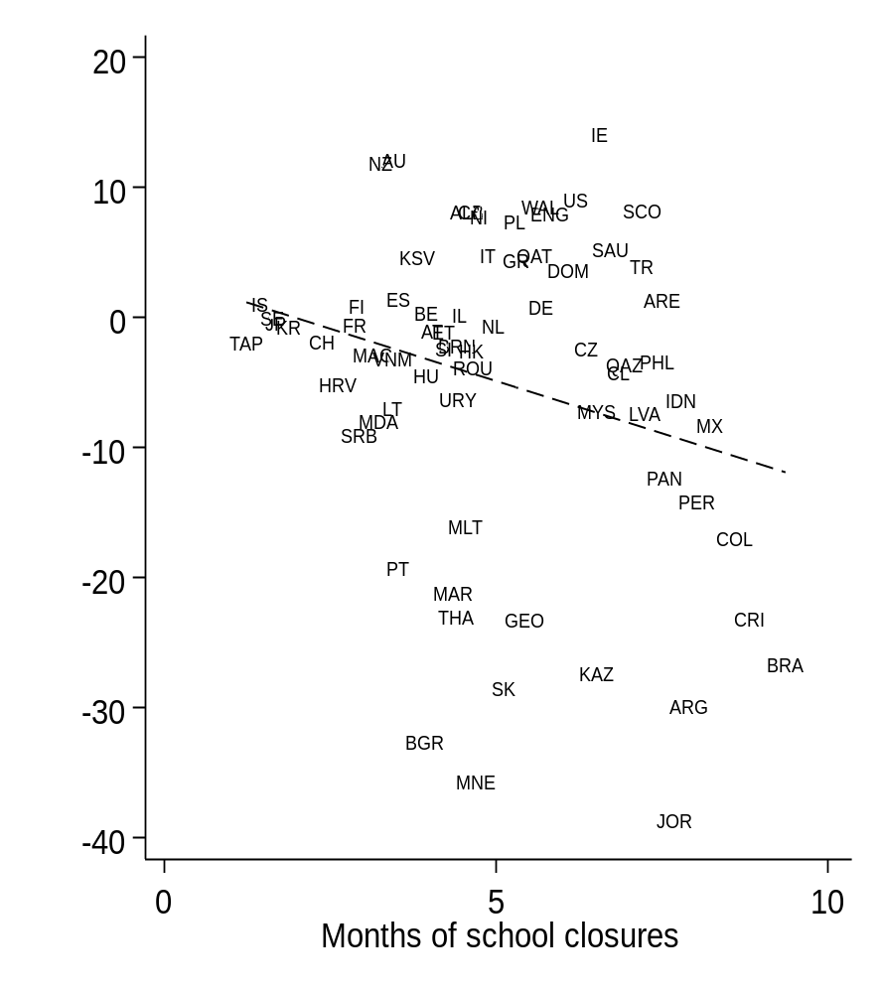
Notes: Values along the horizontal axis refer to the number of months schools were closed due to COVID-19. This information is based upon the country-level average of student reports. Values on the vertical axis refer to the increase in the percent of students skipping school before (PISA 2015-18) and after (PISA 2022) the pandemic (these are the values in the right-hand column of Table B1). The country-level OLS estimate of the association is represented by the dashed line. Correlation is +0.16 in the panel on the left and -0.18 in the panel on the right.

Online Appendix C. Modelling the change truancy pre/post pandemic accounting for time trends.
- Linear time trend
Country | Two-letter code | Pandemic increase | Standard error
Australia | AU | 10.7** | 1.0
USA | US | 9.9** | 1.8
Scotland | SCO | 9.0** | 1.6
Northern Ireland | NI | 8.1** | 2.4
England | ENG | 7.5** | 1.4
Canada | CA | 6.6** | 1.0
Turkey | TR | 5.4** | 1.5
Wales | WAL | 3.7* | 2.1
New Zealand | NZ | 1.0 | 1.6
Poland | PL | -0.1 | 1.8
Spain | ES | -0.5 | 1.3
Finland | FI | -0.9 | 1.1
Japan | JP | -0.9 | 0.6
South Korea | KR | -1.1* | 0.6
Estonia | ET | -2.2 | 1.3
Sweden | SE | -2.4** | 1.0
Belgium | BE | -2.5** | 0.7
Greece | GR | -2.6* | 1.5
Italy | IT | -2.9** | 1.5
Iceland | IS | -3.9** | 0.9
Netherlands | NL | -4.8** | 0.9
Norway | NO | -5.2** | 1.0
Hong Kong | HK | -5.5** | 0.8
Slovenia | SI | -6.1** | 1.0
Czech Republic | CZ | -6.6** | 1.0
Chile | CL | -6.8** | 1.1
France | FR | -6.9** | 1.4
Denmark | DK | -7.0** | 1.3
Germany | DE | -7.1** | 1.3
Israel | IL | -7.4** | 1.7
Ireland | IE | -9.0** | 1.4
Hungary | HU | -9.4** | 1.1
Austria | AT | -9.8** | 1.1
Switzerland | CH | -12.1** | 1.6
Lithuania | LT | -15.4** | 1.6
Mexico | MX | -15.9** | 1.5
Portugal | PT | -27.7** | 1.2
Slovak Republic | SK | -33.7** | 1.3
OECD average |  | -4.1 | 1.3

- Time fixed effects
 | 2015 |  | 2018 |  | 2022
 | Percentage point difference from 2012 | SE | Percentage point difference from 2012 | SE | Percentage point difference from 2012 | SE
Ireland | 20.3%** | 0.8% | 25.9%** | 0.9% | 37.0%** | 0.8%
New Zealand | 7.9%** | 1.0% | 11.9%** | 1.0% | 21.7%** | 1.2%
Wales | - | - | 7.3%** | 1.5% | 15.9%** | 1.6%
Poland | 4.4%** | 1.2% | 8.1%** | 1.3% | 13.6%** | 1.5%
Italy | 7.1%** | 0.9% | 8.7%** | 1.1% | 12.6%** | 1.0%
Australia | -2.8%** | 0.9% | 1.2% | 0.7% | 11.2%** | 0.8%
Denmark | 7.4%** | 0.8% | 10.0%** | 0.9% | 10.7%** | 0.9%
England | - | - | 0.8% | 1.0% | 8.8%** | 1.1%
USA | - | - | -1.2% | 1.2% | 7.9%** | 1.3%
Northern Ireland | - | - | -0.4% | 1.6% | 7.4%** | 1.7%
Norway | 6.4%** | 0.6% | 6.5%** | 0.7% | 6.8%** | 0.7%
Greece | -2.0%* | 1.2% | 6.9%** | 1.1% | 6.7%** | 1.2%
Canada | -4.3%** | 0.8% | 1.1% | 0.7% | 6.5%** | 0.8%
Germany | 3.7%** | 0.6% | 8.1%** | 0.9% | 6.2%** | 0.7%
Scotland | -3.8%** | 1.1% | -1.1% | 1.4% | 5.7%** | 1.5%
Israel | 2.2%* | 1.3% | 7.9%** | 1.2% | 5.1%** | 1.1%
Switzerland | 4.7%** | 0.8% | 10.5%** | 1.1% | 5.0%** | 0.6%
Austria | 2.9%** | 0.7% | 9.3%** | 0.9% | 4.9%** | 0.7%
Iceland | 2.4%** | 0.4% | 5.3%** | 0.5% | 4.8%** | 0.5%
Estonia | 7.7%** | 1.0% | 2.2%** | 0.9% | 3.9%** | 0.8%
Finland | - | - | 2.8%** | 0.7% | 3.8%** | 0.7%
France | 1.4%* | 0.8% | 6.7%** | 0.9% | 3.4%** | 0.8%
Netherlands | 2.7%** | 0.4% | 4.6%** | 0.6% | 3.0%** | 0.4%
Belgium | 1.5%** | 0.5% | 3.1%** | 0.5% | 2.7%** | 0.5%
Sweden | 1.8%** | 0.6% | 2.8%** | 0.7% | 2.4%** | 0.6%
Czech Republic | 2.2%** | 0.6% | 4.6%** | 0.7% | 1.1%** | 0.5%
Spain | -3.4%** | 1.1% | 1.6% | 1.0% | 0.2% | 1.0%
Japan | 0.2% | 0.3% | 0.6% | 0.4% | 0.0% | 0.3%
South Korea | 0.1% | 0.3% | 0.4% | 0.4% | -0.4% | 0.4%
Turkey | -7.3%** | 1.3% | -2.6%** | 1.2% | -1.0% | 1.3%
Hungary | 1.7%** | 0.6% | 5.3%** | 0.9% | -1.0%* | 0.6%
Lithuania | 3.3%** | 1.2% | 8.8%** | 1.2% | -1.3% | 1.0%
Hong Kong | -0.4% | 0.4% | 3.0%** | 0.6% | -1.3%** | 0.5%
Slovenia | -1.7%** | 0.7% | 3.6%** | 0.8% | -1.6%** | 0.7%
Slovak Republic | 41.7%** | 1.1% | 8.0%** | 0.8% | -1.6%** | 0.7%
Chile | 1.6%** | 0.8% | 2.8%** | 0.8% | -2.0%** | 0.6%
Mexico | 4.9%** | 0.9% | 7.8%** | 1.1% | -2.3%** | 0.9%
Portugal | 1.5% | 1.0% | 8.8%** | 1.0% | -14.3%** | 0.8%

Online Appendix D. Regression model estimates linking country-level measures of school closures to pupil truancy
In their work investigating the impact of school closures on learning loss, Jakubowski et al. (2024) and Kennedy & Strietholt (2023) estimate a student-level regression model, with the covariate of interest being a country-level measure of school closures. These models pooled student-level data across countries and multiple waves of data. A country-level measure of school closures was then interacted with a dummy variable capturing whether the data was collected prior to or during/after the COVID-19 pandemic.
The models these authors use are essentially a simple extension of equation (1) presented in the main text. In this online appendix we thus estimate a similar model using the PISA data, exploring the link between country-level measures of school closures and truancy rates. Formally this model is specified as:
${Truancy}_{ijct}= α+δ.{Close}_{c}*2022 + β.{Year}_{t} +u_{c}+ε_{ijt}$ (D1)
Where:
${Truancy}_{ijct}$ = A binary variable coded 0 if student $i$ in school $j$ in year $t$ reports not truanting at all over the last two weeks, and 1 if they reported playing truant at all over the past two weeks
${Year}_{t}$ = A linear time trend.
${Close}_{c}$ = A country-level measure of school closures (number of months schools closed). This is based on student-reported information aggregated to the country level.
${2022}_{t}$ = A binary variable, coded 1 for the 2022 sweep and 0 for the 2012, 2015 and 2018 sweeps
$u_{c}$ = Country fixed effects.
$ε_{ijt}$ = a random error term.
The parameter of interest from this model is $δ$. This captures the estimated effect of an additional month of school closures on trends in student truancy.
We estimate this model twice. We first focus on the same OECD sample used throughout out main analyses. Then, to check the robustness of our finding to that sample selection, we estimate the model including all countries with data available. Consistent with the scatterplots presented in Figure 3, when the analysis is restricted to just members of the OECD, essentially no association is observed (parameter estimate is +0.001 with a standard error of 0.001). On the other hand, a weak negative association is found in the analysis including all countries. The parameter estimate is -.0135 (standard error = .0008) indicating that each additional month of school closure is associated with around a 1.3 percentage point decline in the student truancy rate.

Online Appendix E. Non-response over time in PISA
In this online appendix we discuss the issue of missing data across PISA cycles and across countries in detail. Specifically, we consider non-response across three aspects of the PISA study:
- School non-response. Where a school is sampled but chooses not to participate in PISA. (Apply weights).
- Student non-response. Where a student within a participating school is sampled to participate but does not complete the PISA survey/test (usually due to school absence). (Apply weights – but these don’t do much good).
- Item non-response. Where the student participates in PISA but does not respond to the survey item asking about truancy.
Note that in the case of school and student non-response it is not possible to impute data or conduct any additional non-response bias analysis outside of that provided in the PISA technical reports or within a small number of academic studies utilising PISA linked to administrative data (e.g. *blind for review*). This is because the publicly available PISA data does not provide any information on non-responding pupils and schools. Thus the only adjustment that can be made for school and student non-response is to apply the PISA weights which includes some limited adjustment for non-response (which we do throughout our analysis). Previous studies have suggested that while bias from school non-response is likely to be limited (and often reasonably account for via the application of the PISA weights) the adjustment made for student non-response within the PISA weights is limited (*blind for review*).
Online Appendix Table E1 below begins by illustrating how school non-response changed in PISA between 2012 and 2022. Overall, in most countries, school response rates are very high – over 90%. Moreover, on average across countries, the school non-response rate in 2022 was similar to the pre-pandemic average. This however masks quite substantial variation across countries. With respect to the Anglophone nations, school non-response is clearly more of an issue in some than others, and has also varied more over time. For instance, school response rates in Australia and Ireland have consistently been over 90% across each PISA wave, and only saw small declines in 2022 compared to before the pandemic. In contrast, school response rates are consistently amongst the lowest amongst New Zealand, the United Kingdon and the United States and have fallen by more since the COVID-19 pandemic. We have also investigated the country-level correlation between the change in school response rates before (2012-2018) and after (2022) the pandemic with the change in student-reported truancy rate in PISA. We find there to be a weak, negative association (-0.12).
Online Appendix Table E2 provides analogous figures for student non-response. On average across countries, the student response rate is over 90%. However, across most PISA waves, the student response rate tends to be lower across the Anglophone countries. Student response rates have also fallen in PISA since the COVID-19 pandemic, dropping by an average of around 3.5 percentage points. It is notable that the drop in the student response rate is particularly high in most of the Anglophone countries. This includes Australia (9 percentage point decline), Ireland (10 percentage point decline), New Zealand (11 percentage point decline), the United Kingdom (11 percentage point decline) and the United States (8 percentage point decline). Given that student non-response to PISA is closely related to absence from school (*blind for review*) this find is consistent with school absences (including but not limited to truancy) having particularly risen in the Anglophone countries following the COVID-19 pandemic. We also find a moderate negative correlation (r = -0.33) between the change in student response rates and the change in student reported truancy. In other words, in countries where the student response rate has fallen by more, the student-reported truancy rate has tended to increase. This is likely due to both measures (student response rates and self-reported truancy rates) at least partly reflecting student absence from school.
Online Appendix Table E3 then turns to item non-response (i.e. students failing to answer the question on truancy). In the 2012, 2015 and 2022 PISA cycles, item non-response on this question is low. On average across countries, it sat at less than 5%, and not (in general) standing out as higher in the Anglophone countries than elsewhere. The 2018 PISA wave is clear outlier, where item non-response on this question was notably higher than in all other waves (we are unsure – and unaware of any literature – discussing why this is the case). However, in most countries, item non-response to this question was similar in 2022 to 2015 and marginally higher than in 2012 (though with the United Kingdom standing out as a country where item non-response following the pandemic being much higher). We find there to be no correlation between the change in item non-response pre/post the pandemic with the change in the student-reported truancy rate (Pearson correlation = 0.09, falling to 0 when excluding the item non-response from 2018).
Online Appendix Table E1. Non-participation in PISA amongst initially sampled schools (school non-response)
Weighted School Participation Rate Before Replacement
(%) (SCHRRW1)
 | 2012 | 2015 | 2018 | 2022 | Change (2012-2018 vs 2022)
Albania | 100 | 99.75 | 96.92 | 94.7 | -4.2
Argentina | 95.49 | 88.74 | 95.23 | 98.3 | 5.1
Australia | 97.89 | 94.42 | 94.81 | 92.5 | -3.2
Austria | 100 | 99.95 | 99.91 | 95.7 | -4.2
Baku (Azerbaijan) |  |  | 93.47 | 100.0 | 6.5
Belgium | 84.43 | 83.07 | 86.54 | 80.3 | -4.4
Brazil | 92.74 | 93.19 | 86.76 | 80.9 | -10.0
Brunei |  |  | 100.00 | 100.0 | 0.0
Bulgaria | 99.18 | 99.61 | 95.88 | 84.5 | -13.7
Canada | 91.28 | 74.48 | 85.73 | 81.3 | -2.5
Chile | 91.89 | 92.43 | 90.22 | 84.3 | -7.3
Chinese Taipei | 100 | 100 | 97.38 | 82.6 | -16.5
Colombia | 86.61 | 98.64 | 94.71 | 96.6 | 3.3
Costa Rica | 98.94 | 99.12 | 100.00 | 99.0 | -0.3
Croatia | 98.69 | 99.78 | 97.24 | 99.8 | 1.2
Cyprus | 96.58 | 96.76 | 97.83 | 97.5 | 0.5
Czech Republic | 98.15 | 98.13 | 98.82 | 100.0 | 1.6
Denmark | 86.95 | 90.46 | 88.11 | 90.1 | 1.6
Dominican Republic |  | 98.9 | 96.29 | 98.5 | 0.9
Estonia | 100 | 99.89 | 100.00 | 99.4 | -0.6
Finland | 99.03 | 99.78 | 99.50 | 99.5 | 0.0
France | 96.58 | 90.75 | 98.01 | 99.6 | 4.5
Georgia |  | 97.49 | 99.11 | 93.6 | -4.7
Germany | 97.71 | 96.25 | 95.68 | 92.9 | -3.6
Greece | 93.16 | 92.23 | 85.03 | 90.1 | 0.0
Hong Kong (China) | 78.7 | 75.11 | 69.44 | 59.6 | -14.8
Hungary | 97.61 | 93.42 | 98.41 | 88.8 | -7.7
Iceland | 99.34 | 98.82 | 97.57 | 96.4 | -2.2
Indonesia | 94.89 | 98.44 | 99.35 | 99.3 | 1.8
Ireland | 98.7 | 99.29 | 100.00 | 99.4 | 0.1
Israel | 91.05 | 90.9 | 95.47 | 90.7 | -1.8
Italy | 89.09 | 74.39 | 93.41 | 96.0 | 10.4
Japan | 86.34 | 94.45 | 89.34 | 91.9 | 1.9
Jordan | 100 | 100 | 100.00 | 100.0 | 0.0
Kazakhstan | 100 | 100 | 100.00 | 98.5 | -1.5
Korea | 99.86 | 99.65 | 100.00 | 88.9 | -10.9
Kosovo |  | 100 | 94.37 | 96.1 | -1.1
Latvia | 87.89 | 86.46 | 82.23 | 83.9 | -1.6
Lithuania | 98.2 | 99.36 | 99.62 | 99.6 | 0.5
Macao (China) | 100 | 100 | 100.00 | 100.0 | 0.0
Malaysia | 100 | 51.39 | 98.96 | 99.7 | 16.3
Malta |  | 99.95 | 99.95 | 100.0 | 0.1
Mexico | 91.79 | 95.46 | 89.46 | 95.9 | 3.7
Montenegro | 100 | 99.85 | 99.21 | 98.8 | -0.9
Morocco |  |  | 99.46 | 99.8 | 0.3
Netherlands | 75.33 | 63.31 | 61.04 | 65.5 | -1.0
New Zealand | 80.85 | 71.43 | 82.59 | 61.4 | -16.9
North Macedonia |  |  | 99.93 | 100.0 | 0.1
Norway | 85.15 | 95.17 | 97.72 | 98.7 | 6.0
Panama |  |  | 94.13 | 84.1 | -10.0
Peru | 97.93 | 99.52 | 99.06 | 94.0 | -4.8
Philippines |  |  | 99.44 | 100.0 | 0.6
Poland | 85.38 | 88.49 | 91.62 | 88.6 | 0.1
Portugal | 95.4 | 85.87 | 85.18 | 94.7 | 5.9
Qatar | 99.94 | 98.98 | 100.00 | 100.0 | 0.4
Republic of Moldova |  | 100 | 100.00 | 99.7 | -0.3
Romania | 100 | 99.36 | 98.22 | 100.0 | 0.8
Saudi Arabia |  |  | 99.38 | 91.9 | -7.4
Serbia | 90 |  | 97.12 | 98.7 | 5.1
Singapore | 97.54 | 97.17 | 96.52 | 98.5 | 1.4
Slovak Republic | 87.5 | 92.69 | 92.13 | 90.5 | -0.2
Slovenia | 98.12 | 97.69 | 98.89 | 97.2 | -1.0
Spain | 99.65 | 98.87 | 98.67 | 97.7 | -1.3
Sweden | 98.92 | 99.7 | 98.75 | 97.8 | -1.3
Switzerland | 94.46 | 93.16 | 86.08 | 95.1 | 3.9
Thailand | 98.04 | 98.5 | 100.00 | 98.8 | 0.0
Turkey | 97.49 | 96.88 | 97.14 | 99.4 | 2.2
Ukraine | - - |  | 97.83 | 79.8 | -18.0
United Arab Emirates | 99.4 | 98.5 | 99.41 | 99.8 | 0.7
United Kingdom | 80.06 | 83.65 | 72.89 | 67.3 | -11.5
United States of America | 67.09 | 66.67 | 64.96 | 51.4 | -14.8
Uruguay | 99.41 | 98.28 | 96.73 | 99.4 | 1.3
Vietnam | 100 | 100 | 100.00 | 100.0 | 0.0
Average | 94.1 | 93.2 | 94.3 | 92.7 | -1.2
Median | 97.7 | 97.9 | 97.6 | 97.2 | -0.5

Online Appendix Table E2. Non-participation in PISA amongst sampled students (student non-response)
 | Weighted Student Participation Rate After All Replacements
 | 2012 | 2015 | 2018 | 2022 | Change (2012-2018 vs 2022)
Albania | 92.49 | 93.53 | 98.27 | 86.5 | -8.3
Argentina | 87.99 | 90.36 | 86.28 | 85.8 | -2.4
Australia | 86.78 | 83.99 | 85.14 | 76.1 | -9.2
Austria | 91.67 | 86.59 | 92.54 | 88.8 | -1.4
Baku (Azerbaijan) |  |  | 88.86 | 87.8 | -1.1
Belgium | 90.87 | 90.63 | 91.10 | 86.6 | -4.3
Brazil | 90.06 | 87.32 | 88.85 | 84.2 | -4.6
Brunei |  |  | 98.97 | 93.2 | -5.7
Bulgaria | 95.7 | 94.87 | 93.08 | 88.8 | -5.8
Canada | 80.76 | 80.8 | 84.03 | 77.0 | -4.9
Chile | 94.65 | 93.31 | 93.09 | 84.0 | -9.7
Chinese Taipei | 96.33 | 98 | 94.63 | 82.3 | -14.0
Colombia | 93.08 | 94.52 | 92.82 | 91.8 | -1.7
Costa Rica | 88.97 | 92.46 | 97.05 | 92.0 | -0.8
Croatia | 92.17 | 91.35 | 92.02 | 85.2 | -6.6
Cyprus | 93.3 | 94.03 | 93.35 | 83.8 | -9.7
Czech Republic | 90.07 | 88.77 | 91.90 | 91.2 | 1.0
Denmark | 89.06 | 89.08 | 86.44 | 84.2 | -4.0
Dominican Republic |  | 93.82 | 89.85 | 92.7 | 0.9
Estonia | 92.89 | 93.22 | 92.10 | 88.2 | -4.6
Finland | 90.73 | 93.44 | 92.83 | 88.7 | -3.6
France | 89.46 | 88.21 | 92.57 | 90.7 | 0.6
Georgia |  | 93.91 | 95.13 | 98.1 | 3.6
Germany | 93.24 | 93.27 | 90.40 | 88.0 | -4.3
Greece | 96.72 | 94.32 | 95.68 | 92.4 | -3.2
Hong Kong (China) | 93.09 | 93.08 | 85.32 | 75.3 | -15.1
Hungary | 92.7 | 92.3 | 93.96 | 92.3 | -0.7
Iceland | 84.72 | 86.11 | 86.65 | 80.1 | -5.7
Indonesia | 95.15 | 97.51 | 95.64 | 95.2 | -0.9
Ireland | 84.1 | 88.6 | 86.48 | 76.8 | -9.6
Israel | 90.02 | 90.48 | 90.51 | 84.1 | -6.3
Italy | 92.76 | 87.67 | 86.28 | 91.9 | 3.0
Japan | 96.1 | 97.24 | 96.35 | 91.9 | -4.7
Jordan | 94.96 | 97.42 | 97.66 | 97.5 | 0.8
Kazakhstan | 98.87 | 97.29 | 99.06 | 98.3 | -0.1
Korea | 98.75 | 98.56 | 97.40 | 94.4 | -3.9
Kosovo |  | 98.58 | 96.21 | 91.1 | -6.3
Latvia | 90.9 | 90.42 | 89.29 | 88.5 | -1.7
Lithuania | 92.09 | 90.57 | 92.66 | 92.7 | 0.9
Macao (China) | 99.42 | 99.31 | 99.37 | 99.1 | -0.2
Malaysia | 93.96 | 96.66 | 97.47 | 93.5 | -2.5
Malta |  | 84.63 | 85.73 | 79.1 | -6.1
Mexico | 93.88 | 95.43 | 96.10 | 94.9 | -0.2
Montenegro | 93.77 | 93.79 | 96.25 | 94.6 | 0.0
Morocco |  |  | 97.22 | 98.1 | 0.9
Netherlands | 84.97 | 85.12 | 83.34 | 80.9 | -3.6
New Zealand | 84.68 | 80.31 | 82.55 | 71.7 | -10.8
North Macedonia |  |  | 92.47 | 89.6 | -2.8
Norway | 90.88 | 90.75 | 91.16 | 86.7 | -4.3
Panama |  |  | 89.76 | 76.8 | -13.0
Peru | 96.01 | 98.9 | 98.66 | 97.5 | -0.4
Philippines |  |  | 97.06 | 95.2 | -1.8
Poland | 87.6 | 87.54 | 86.01 | 81.0 | -6.0
Portugal | 87.36 | 82.02 | 76.11 | 86.1 | 4.2
Qatar | 99.73 | 94.09 | 90.81 | 89.0 | -5.9
Republic of Moldova |  |  | 98.05 | 94.1 | -3.9
Romania | 97.83 | 99.21 | 97.70 | 97.4 | -0.8
Saudi Arabia |  |  | 97.19 | 97.1 | -0.1
Serbia | 93.36 |  | 93.65 | 91.2 | -2.3
Singapore | 94.31 | 93.33 | 94.62 | 91.4 | -2.7
Slovak Republic | 93.75 | 92.37 | 93.20 | 90.9 | -2.2
Slovenia | 90.45 | 91.77 | 90.68 | 82.5 | -8.5
Spain | 89.88 | 89.14 | 89.76 | 86.3 | -3.3
Sweden | 92.17 | 90.67 | 86.46 | 85.1 | -4.7
Switzerland | 91.96 | 92.45 | 94.35 | 90.9 | -2.0
Thailand | 98.9 | 96.88 | 98.74 | 96.4 | -1.7
Turkey | 98.22 | 95.19 | 98.76 | 98.0 | 0.6
Ukraine | - | - | 95.73 | 86.9 | -8.9
United Arab Emirates | 94.66 | 94.62 | 95.57 | 92.9 | -2.0
United Kingdom | 86.07 | 89.02 | 83.10 | 75.2 | -10.9
United States of America | 88.86 | 89.76 | 84.80 | 79.9 | -7.9
Uruguay | 90.02 | 86.16 | 87.01 | 86.7 | -1.0
Vietnam | 99.86 | 99.6 | 98.77 | 99.4 | 0.0
Average | 92.2 | 92.0 | 92.2 | 88.7 | -3.4
Median | 92.6 | 92.5 | 92.8 | 89.0 | -3.6

Online Appendix Table E3. Non-response to the truancy question amongst participating students (item non-response)
 | Item non-response
 | 2012 | 2015 | 2018 | 2022
Albania | 7.0 | - | 3.7 | 18.7
Argentina | 1.0 | - | 34.7 | 12.8
Australia | 1.6 | 4.7 | 22.7 | 3.8
Austria | 0.6 | 1.9 | 19.0 | 2.8
Baku (Azerbaijan) |  | - | 38.2 | 20.1
Belgium | 1.1 | 6.4 | 14.2 | 4.5
Brazil | 1.5 | 18.7 | 34.5 | 10.0
Brunei |  | - | 27.7 | 1.4
Bulgaria | 1.1 | 7.2 | 23.4 | 9.9
Canada | 2.6 | 4.4 | 14.2 | 9.4
Chile | 1.5 | 3.4 | 33.6 | 7.9
Chinese Taipei | 0.3 | - | 2.3 | 1.3
Colombia | 0.8 | 3.1 | 28.8 | 8.5
Costa Rica | 1.4 | 14.6 | 11.7 | 6.9
Croatia | 0.4 | 2.1 | 14.2 | 2.4
Cyprus |  | -
Czech Republic | 0.4 | 4.3 | 9.8 | 2.4
Denmark | 1.3 | 6.4 | 17.7 | 4.6
Dominican Republic |  | 8.6 | 69.3 | 10.3
Estonia | 0.9 | 2.2 | 8.3 | 2.5
Finland | 1.7 | - | 9.5 | 3.9
France | 2.2 | 4.5 | 19.6 | 4.4
Georgia |  | - | 14.2 | 13.7
Germany | 13.8 | 18.7 | 54.7 | 12.4
Greece | 0.5 | 2.6 | 11.1 | 4.5
Hong Kong (China) | 1.9 | 2.1 | 7.1 | 5.0
Hungary | 0.9 | 3.1 | 15.5 | 3.3
Iceland | 2.6 | 3.6 | 24.1 | 3.6
Indonesia | 0.7 | - | 4.6 | 3.0
Ireland | 0.6 | 1.6 | 16.9 | 1.9
Israel | 2.6 | 3.3 | 13.6 | 7.4
Italy | 0.8 | 3.0 | 19.9 | 1.3
Japan | 1.4 | 0.5 | 2.3 | 0.9
Jordan | 2.6 | - | 8.6 | 8.3
Kazakhstan | 0.1 | - | 18.9 | 2.0
Korea | 0.1 | 1.0 | 1.2 | 1.5
Kosovo |  | - | 6.9 | 8.0
Latvia | 0.7 | 2.0 | 12.2 | 4.4
Lithuania | 0.5 | 3.7 | 16.5 | 2.6
Macao (China) | 0.4 | 0.1 | 0.4 | 0.3
Malaysia | 0.6 | - | 4.6 | 1.9
Malta |  | - | 13.1 | 6.7
Mexico | 0.9 | 2.7 | 48.2 | 1.9
Montenegro | 1.4 | 6.6 | 11.2 | 7.2
Morocco |  | - | 57.6 | 7.6
Netherlands | 1.2 | 4.2 | 20.0 | 4.9
New Zealand | 1.8 | 4.3 | 17.4 | 4.5
North Macedonia |  | - | - | 8.3
Norway |  | 4.3 | 7.7 | 6.8
Panama |  | - | 66.4 | 14.6
Peru | 0.7 | 5.6 | 63.2 | 2.7
Philippines |  | - | 11.4 | 3.3
Poland | 0.6 | 0.5 | 8.3 | 2.4
Portugal | 1.5 | 2.2 | 16.2 | 2.5
Qatar | 1.3 | 8.6 | 13.6 | 10.6
Republic of Moldova |  | - | 7.1 | 4.8
Romania | 0.5 | - | 10.1 | 4.4
Saudi Arabia |  | - | 11.2 | 5.2
Serbia | 1.4 | - | 20.5 | 3.8
Singapore | 0.4 | 0.5 | 3.6 | 0.8
Slovak Republic | 1.1 | 5.3 | 16.2 | 3.7
Slovenia | 1.2 | 2.5 | 18.9 | 2.9
Spain | 1.0 | 1.8 | 28.4 | 5.2
Sweden | 2.1 | 4.3 | 11.3 | 4.8
Switzerland | 1.3 | 2.1 | 36.9 | 2.7
Thailand | 0.3 | 2.8 | 2.6 | 1.7
Turkey | 0.8 | 2.3 | 2.9 | 2.1
Ukraine |  | - | 14.5
United Arab Emirates | 0.7 | 5.0 | 9.1 | 9.1
United Kingdom | 1.7 | - | 9.3 | 22.3
United States of America | 1.1 | - | 4.9 | 6.0
Uruguay | 1.4 | 6.6 | 37.4 | 7.8
Vietnam | 0.1 | - | 1.3 | 1.8
Average | 1.4 | 4.5 | 18.5 | 5.7
Median | 1.1 | 3.4 | 14.2 | 4.5

Online Appendix F. Results by country groups.
In this online appendix we present additional results, dividing countries into language/geographic groupings. The analysis includes OECD countries only.
Table F1. Mapping between countries and country groupings
Country | Group
Australia | English
Austria | Germanic
Belgium | Germanic
Canada | English
Switzerland | Germanic
Chile | Spanish
Colombia | Spanish
Czech Republic | East Europe
Germany | Germanic
Denmark | Scandinavian
England | English
Spain | Spanish
Estonia | East Europe
Finland | Scandinavian
France | French
Greece | Other
Hungary | East Europe
Ireland | English
Iceland | Scandinavian
Israel | Other
Italy | Italian
Japan | East Asia
Korea | East Asia
Lithuania | East Europe
Luxemburg | Germanic
Latvia | East Europe
Mexico | Spanish
Northern Ireland | English
Netherlands | Germanic
Norway | Scandinavian
New Zealand | English
Poland | East Europe
Portugal | Spanish
Romania | East Europe
Scotland | English
Slovak Republic | East Europe
Slovenia | East Europe
Sweden | Scandinavian
Turkey | Other
USA | English
Wales | English
Table F2. The percentage of 15-year-olds reporting skipping school by PISA cycle. Comparison across country groups
 | 2012 |  | 2015 |  | 2018 |  | 2022
 | % truant | SE | % truant | SE | % truant | SE | % truant | SE
East Asia | 1.7% | 0.2% | 1.9% | 0.2% | 2.3% | 0.3% | 1.6% | 0.1%
East Europe | 16.6% | 0.4% | 19.1% | 0.5% | 25.4% | 0.5% | 24.3% | 0.5%
English | 21.0% | 0.6% | 22.8% | 0.3% | 20.7% | 0.6% | 29.7% | 0.7%
French | 9.5% | 0.6% | 10.8% | 0.6% | 16.1% | 0.7% | 12.8% | 0.5%
Germanic | 5.0% | 0.2% | 8.3% | 0.3% | 11.8% | 0.4% | 10.2% | 0.4%
Italian | 48.2% | 0.5% | 55.2% | 0.8% | 56.8% | 1.0% | 60.8% | 0.8%
Other | 48.9% | 0.8% | 43.2% | 0.8% | 48.5% | 0.8% | 49.2% | 0.6%
Scandinavian | 8.3% | 0.2% | 12.4% | 0.3% | 13.4% | 0.3% | 13.5% | 0.2%
Spanish/Portuguese | 17.1% | 0.3% | 28.0% | 0.5% | 30.7% | 0.5% | 20.4% | 0.4%
Notes: Figures refer to the percent of 15-year-olds who reported skipping school at least one time in the past two weeks.

Table F3. The change truancy pre/post pandemic above the pre-pandemic trend. Comparison across country groups
 | % above pre-pandemic trend
 | Percent | SE
English | 9.1% | 1.3%
Other | 3.0% | 1.2%
East Asia | -1.1% | 0.4%
Italian | -2.9% | 1.5%
Scandinavian | -3.8% | 0.6%
East Europe | -6.2% | 0.9%
Germanic | -6.2% | 0.7%
French | -6.9% | 1.4%
Spanish/Portuguese | -21.6% | 0.8%

Notes: Figures refer to the extent that truancy has increased within the group of countries (above pre-pandemic trends) following the COVID-19 pandemic.

Table F4. Gender differences in the percentage of 15-year-olds skipping school before (2012-2018) and after (2022) the COVID-19 pandemic. Comparison across country groups
Country group | Pre-pandemic gender gap | Standard error | Post-pandemic gender gap | Standard error | Change since pandemic
East Asia | 0.6 | 0.1 | 0.8 | 0.3 | 0.2
Spanish/Portuguese | 2.1 | 0.3 | 1.3 | 0.7 | -0.8
Germanic | 1.0 | 0.3 | -0.4 | 0.5 | -1.4
Other | 7.7 | 0.8 | 6.2 | 1.2 | -1.4
Italian | 0.1 | 0.7 | -1.4 | 1.3 | -1.5
English | -2.4 | 0.6 | -5.9 | 1.1 | -3.4
Scandinavian | 0.8 | 0.3 | -2.7 | 0.5 | -3.5
East Europe | 4.1 | 0.4 | 0.1 | 0.7 | -4.0
French | 4.0 | 0.6 | -0.6 | 0.8 | -4.6
Notes: Gender gap refers to the truancy rate for boys minus the truancy rate for girls. Negative values therefore indicate where girls are more likely to skip school than boys. Negative values in the change column indicate where girls are increasingly more likely to skip schools than boys following the pandemic
Table F5. Socio-economic differences in the percentage of 15-year-olds skipping school before (2012-2018) and after (2022) the COVID-19 pandemic. Comparison across country groups
Country group | Pre-pandemic gender gap | Standard error | Post-pandemic gender gap | Standard error | Change since pandemic
East Asia | 0.6 | 0.1 | 0.8 | 0.3 | 0.2
Spanish/Portuguese | 2.1 | 0.3 | 1.3 | 0.7 | -0.8
Germanic | 1.0 | 0.3 | -0.4 | 0.5 | -1.4
Other | 7.7 | 0.8 | 6.2 | 1.2 | -1.4
Italian | 0.1 | 0.7 | -1.4 | 1.3 | -1.5
English | -2.4 | 0.6 | -5.9 | 1.1 | -3.4
Scandinavian | 0.8 | 0.3 | -2.7 | 0.5 | -3.5
East Europe | 4.1 | 0.4 | 0.1 | 0.7 | -4.0
French | 4.0 | 0.6 | -0.6 | 0.8 | -4.6
Notes: Socio-economic gap refers to the truancy rate for the most disadvantaged third of students minus the truancy rate for most advantaged third of students. Positive values therefore indicate where disadvantaged students are more likely to skip school than their more advantaged peers. Negative values in the change column indicate where the socio-economic gap in skipping school has decreased following the pandemic.

Online Appendix G. Alternative estimates of the pre/post pandemic change in student truancy excluding the data from PISA 2012
Online Table G1. The percentage of 15-year-olds skipping school before (2015-2018) and after (2022) the COVID-19 pandemic
Country | Two-letter code | Pre-pandemic truancy % | Standard error | Post-pandemic truancy % | Standard error | Change since pandemic
Ireland | IE | 14.6 | 0.5 | 41.1 | 0.8 | 26.5**
New Zealand | NZ | 21.0 | 0.4 | 38.8 | 0.9 | 17.8**
Wales | WAL | 21.5 | 0.8 | 37.4 | 1.4 | 15.9**
Australia | AU | 30.4 | 0.4 | 43.0 | 0.5 | 12.6**
Poland | PL | 18.0 | 0.6 | 29.4 | 1.0 | 11.5**
Italy | IT | 51.6 | 0.5 | 60.8 | 0.8 | 9.2**
England | ENG | 16.9 | 0.7 | 25.7 | 0.9 | 8.8**
Canada | CA | 20.0 | 0.4 | 28.6 | 0.6 | 8.6**
USA | US | 21.1 | 0.8 | 29.0 | 0.9 | 7.9**
Greece | GR | 20.7 | 0.6 | 28.4 | 0.8 | 7.7**
Scotland | SCO | 21.3 | 0.7 | 28.9 | 1.0 | 7.5**
Northern Ireland | NI | 25.7 | 1.0 | 33.1 | 1.2 | 7.4**
Denmark | DK | 13.1 | 0.4 | 20.4 | 0.6 | 7.3**
Germany | DE | 6.9 | 0.3 | 11.4 | 0.6 | 4.4**
Israel | IL | 31.7 | 0.5 | 35.6 | 0.9 | 4.0**
Finland | FI | 10.4 | 0.5 | 14.2 | 0.5 | 3.8**
Norway | NO | 10.2 | 0.4 | 13.9 | 0.5 | 3.7**
Iceland | IS | 3.2 | 0.2 | 6.8 | 0.5 | 3.6**
Austria | AT | 9.4 | 0.4 | 12.9 | 0.5 | 3.5**
Turkey | TR | 50.5 | 0.7 | 53.2 | 0.8 | 2.7**
France | FR | 10.2 | 0.4 | 12.8 | 0.5 | 2.7**
Switzerland | CH | 7.3 | 0.4 | 9.9 | 0.5 | 2.6**
Belgium | BE | 6.3 | 0.2 | 8.3 | 0.4 | 2.0**
Spain | ES | 26.3 | 0.5 | 28.3 | 0.5 | 2.0**
Netherlands | NL | 4.0 | 0.2 | 5.6 | 0.4 | 1.7**
Sweden | SE | 8.1 | 0.3 | 9.5 | 0.4 | 1.5**
Estonia | ET | 19.0 | 0.5 | 19.2 | 0.7 | 0.3
Czech Republic | CZ | 7.0 | 0.3 | 6.9 | 0.3 | 0.0
Japan | JP | 1.7 | 0.2 | 1.6 | 0.2 | -0.1
South Korea | KR | 1.8 | 0.2 | 1.4 | 0.3 | -0.5
Slovenia | SI | 13.3 | 0.4 | 12.6 | 0.4 | -0.8
Hong Kong | HK | 3.8 | 0.2 | 2.6 | 0.3 | -1.1**
Hungary | HU | 7.5 | 0.3 | 5.7 | 0.4 | -1.8**
Chile | CL | 8.5 | 0.4 | 5.7 | 0.4 | -2.8**
Lithuania | LT | 20.5 | 0.6 | 17.7 | 0.6 | -2.8**
Mexico | MX | 23.4 | 0.5 | 18.6 | 0.8 | -4.7**
Portugal | PT | 20.1 | 0.5 | 5.0 | 0.3 | -15.1**
Slovak Republic | SK | 28.8 | 0.6 | 7.8 | 0.5 | -21.0**
OECD average |  | 16.7 |  | 20.3 |  | 3.6
Notes: Figures refer to the percent of 15-year-olds who reported having skipped school at any point over the previous two weeks. The change column indicates the percentage-point difference before (PISA 2012-2015) and after (PISA 2022) the COVID-19 pandemic. English-speaking countries are highlighted in green.

Table G2. The percentage of 15-year-olds reporting skipping school by PISA cycle. Comparison across English-speaking countries.
Country | 2012 | 2015 | 2022
Australia | 32 | 29 | 43
Ireland | 4 | 24 | 41
New Zealand | 17 | 25 | 39
Wales | 22 | - | 37
Northern Ireland | 26 | - | 33
USA | 21 | - | 29
Scotland | 23 | 19 | 29
Canada | 22 | 18 | 29
England | 17 | - | 26
Anglophone average | 20 | 23 | 34
OECD average | 15 | 18 | 19

Notes: Figures refer to the percent of 15-year-olds who reported skipping school at least one time in the past two weeks. Green/red shading indicates where the percentage skipping school is lower/higher.

Table G3. Gender differences in the percentage of 15-year-olds skipping school before (2012-2015) and after (2022) the COVID-19 pandemic
Country | Two-letter code | Pre-pandemic gender gap | Standard error | Post-pandemic gender gap | Standard error | Change since pandemic
Slovak Republic | SK | -0.5 | 1.4 | 1.6 | 0.8 | 2.1
Netherlands | NL | -0.6 | 0.4 | 0.4 | 0.7 | 1.0
Australia | AU | -4.4 | 0.5 | -3.4 | 1.0 | 1.0
Belgium | BE | 1.4 | 0.4 | 2.4 | 0.7 | 1.0
Chile | CL | 1.5 | 0.7 | 2.5 | 0.7 | 1.0
South Korea | KR | 0.8 | 0.3 | 1.6 | 0.5 | 0.8
Hungary | HU | 1.6 | 0.7 | 1.9 | 0.6 | 0.3
Czech Republic | CZ | 0.9 | 0.7 | 0.9 | 0.6 | 0.0
Germany | DE | -0.4 | 0.4 | -0.5 | 0.9 | -0.1
Portugal | PT | 0.8 | 0.9 | 0.6 | 0.7 | -0.2
Japan | JP | 0.7 | 0.2 | 0.5 | 0.3 | -0.2
Norway | NO | 0.5 | 0.8 | 0.1 | 1.0 | -0.3
Hong Kong | HK | 0.5 | 0.5 | -0.1 | 0.5 | -0.6
Canada | CA | -2.9 | 0.6 | -3.6 | 1.3 | -0.7
Turkey | TR | 8.6 | 1.2 | 7.8 | 1.4 | -0.7
Iceland | IS | 0.8 | 0.4 | -0.1 | 0.8 | -0.9
Slovenia | SI | 3.8 | 0.6 | 2.8 | 0.9 | -1.0
Italy | IT | -0.2 | 0.8 | -1.4 | 1.3 | -1.2
Mexico | MX | 3.4 | 0.6 | 1.7 | 1.1 | -1.7
Spain | ES | -2.6 | 0.7 | -4.3 | 0.9 | -1.8
England | ENG | -3.8 | 1.4 | -5.8 | 1.6 | -1.9
Scotland | SCO | -1.7 | 1.0 | -3.8 | 1.6 | -2.2
Sweden | SE | -0.2 | 0.5 | -2.4 | 0.8 | -2.2**
Israel | IL | 0.6 | 1.0 | -2.0 | 1.6 | -2.7
USA | US | -2.8 | 1.2 | -6.3 | 1.4 | -3.5*
Lithuania | LT | 6.5 | 0.9 | 2.8 | 1.0 | -3.7**
France | FR | 3.1 | 0.7 | -0.6 | 0.8 | -3.7**
Finland | FI | -1.0 | 0.8 | -4.8 | 0.8 | -3.9**
Denmark | DK | -0.1 | 0.6 | -4.4 | 1.2 | -4.3**
Austria | AT | -0.3 | 0.7 | -4.6 | 0.8 | -4.3**
Northern Ireland | NI | -0.5 | 2.2 | -4.9 | 2.4 | -4.3
Wales | WAL | -2.4 | 1.5 | -7.2 | 1.8 | -4.8**
Switzerland | CH | 2.7 | 0.6 | -2.2 | 0.8 | -5.0**
Ireland | IE | -0.7 | 0.8 | -6.0 | 1.6 | -5.3**
Estonia | ET | 0.3 | 0.9 | -5.2 | 1.0 | -5.6**
New Zealand | NZ | -0.3 | 0.9 | -6.1 | 1.5 | -5.8**
Greece | GR | 8.6 | 0.9 | 2.0 | 1.1 | -6.6**
Poland | PL | 5.6 | 0.9 | -1.5 | 1.6 | -7.0**
OECD average |  | 0.7 |  | -1.4 |  | -2.1

Notes: Gender gap refers to the truancy rate for boys minus the truancy rate for girls. Negative values therefore indicate where girls are more likely to skip school than boys. Negative values in the change column indicate where girls are increasingly more likely to skip schools than boys following the pandemic. * and ** indicate where the change since the pandemic is statistically significant at the 10% and 5% levels. English-speaking countries are highlighted in green.

Table G4. Socio-economic differences in the percentage of 15-year-olds skipping school before (2012-2015) and after (2022) the COVID-19 pandemic.
Country | Two-letter code | Pre-pandemic SES gap | Standard error | Post-pandemic SES gap | Standard error | Change since pandemic
Mexico | MX | -0.8 | -0.9 | 5.1 | -1.6 | 5.9**
Estonia | ET | 7.8 | -1.1 | 12.7 | -1.4 | 4.9**
Norway | NO | 1.4 | -0.8 | 6.3 | -1.0 | 4.9**
Germany | DE | 2.8 | -0.7 | 7.4 | -1.1 | 4.6**
Slovak Republic | SK | 4.5 | -1.3 | 8.2 | -1.1 | 3.7**
Austria | AT | 2.0 | -0.9 | 5.5 | -1.3 | 3.5**
Ireland | IE | 4.3 | -1.0 | 7.5 | -1.8 | 3.2
Poland | PL | 4.2 | -1.1 | 7.3 | -1.9 | 3.1
Switzerland | CH | 1.7 | -0.6 | 4.1 | -1.0 | 2.3**
Italy | IT | 9.0 | -1.0 | 11.1 | -1.8 | 2.1
France | FR | 8.1 | -0.8 | 10.1 | -1.1 | 2.0
Finland | FI | 5.7 | -1.2 | 7.7 | -1.1 | 2.0
Lithuania | LT | 9.9 | -1.1 | 11.7 | -1.3 | 1.9
Slovenia | SI | 5.6 | -1.0 | 7.3 | -1.2 | 1.8
Belgium | BE | 4.5 | -0.6 | 6.2 | -0.8 | 1.7*
Iceland | IS | 2.0 | -0.5 | 3.7 | -1.1 | 1.6
Sweden | SE | 5.8 | -0.8 | 7.1 | -0.9 | 1.3
Netherlands | NL | 1.2 | -0.5 | 2.4 | -0.9 | 1.2
Czech Republic | CZ | 2.6 | -0.8 | 3.7 | -0.8 | 1.1
Canada | CA | 6.1 | -0.8 | 6.8 | -1.5 | 0.6
England | ENG | 5.9 | -1.4 | 6.4 | -1.8 | 0.4
South Korea | KR | 1.3 | -0.4 | 1.6 | -0.8 | 0.3
Turkey | TR | -8.6 | -1.5 | -8.7 | -1.4 | -0.1
Japan | JP | 0.9 | -0.3 | 0.6 | -0.5 | -0.3
Denmark | DK | 7.1 | -0.9 | 5.8 | -1.5 | -1.4
New Zealand | NZ | 12.8 | -1.0 | 11.4 | -2.0 | -1.5
Scotland | SCO | 14.3 | -1.5 | 12.8 | -2.4 | -1.5
Spain | ES | 12.0 | -1.0 | 10.3 | -1.0 | -1.7
Hong Kong | HK | 0.1 | -0.6 | -1.6 | -0.8 | -1.7*
Chile | CL | 3.2 | -0.7 | 1.4 | -0.8 | -1.8*
Australia | AU | 10.0 | -0.9 | 7.5 | -1.4 | -2.5
Greece | GR | 3.5 | -0.9 | 1.0 | -1.6 | -2.5
Wales | WAL | 14.3 | -1.8 | 11.7 | -2.7 | -2.6
Hungary | HU | 6.0 | -1.0 | 3.4 | -0.8 | -2.6**
Portugal | PT | 6.8 | -1.2 | 4.1 | -0.7 | -2.7*
Israel | IL | 4.5 | -1.0 | -1.1 | -1.6 | -5.6**
USA | US | 11.7 | -1.5 | 3.8 | -1.6 | -7.9**
Northern Ireland | NI | 16.7 | -2.1 | 7.3 | -3.1 | -9.3**
OECD average |  | 5.5 |  | 5.8 |  | 0.2

Notes: Socio-economic gap refers to the truancy rate for the most disadvantaged third of students minus the truancy rate for most advantaged third of students. Positive values therefore indicate where disadvantaged students are more likely to skip school than their more advantaged peers. Negative values in the change column indicate where the socio-economic gap in skipping school has decreased following the pandemic. * and ** indicate where the change since the pandemic is statistically significant at the 10% and 5% levels. English-speaking countries are highlighted in green.
Figure G1. The percentage of 15-year-olds skipping school before (2015-2018) and after (2022) the COVID-19 pandemic
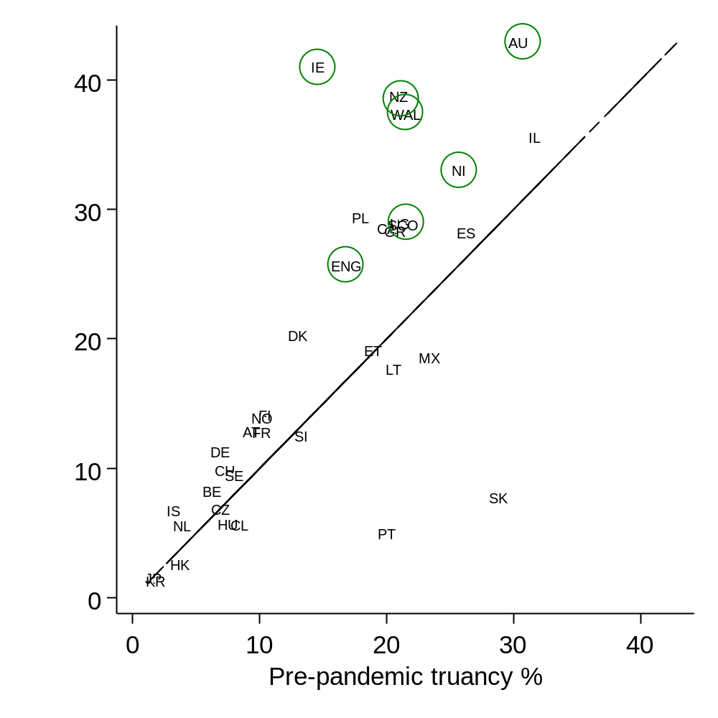
Notes: Figures refer to the percent of 15-year-olds who reported having skipped school at any point over the past two weeks. Pre-pandemic figures along the horizontal axis is the average across the 2012-2015 PISA waves. Post-pandemic figures along the vertical axis uses data from PISA 2022. English-speaking countries highlighted in green circles. See Table 1 for the two-letter country codes.
Figure G2. Gender and socio-economic gaps in skipping school at any point in last two weeks pre and post pandemic
- Gender gap (b) Socio-economic gap
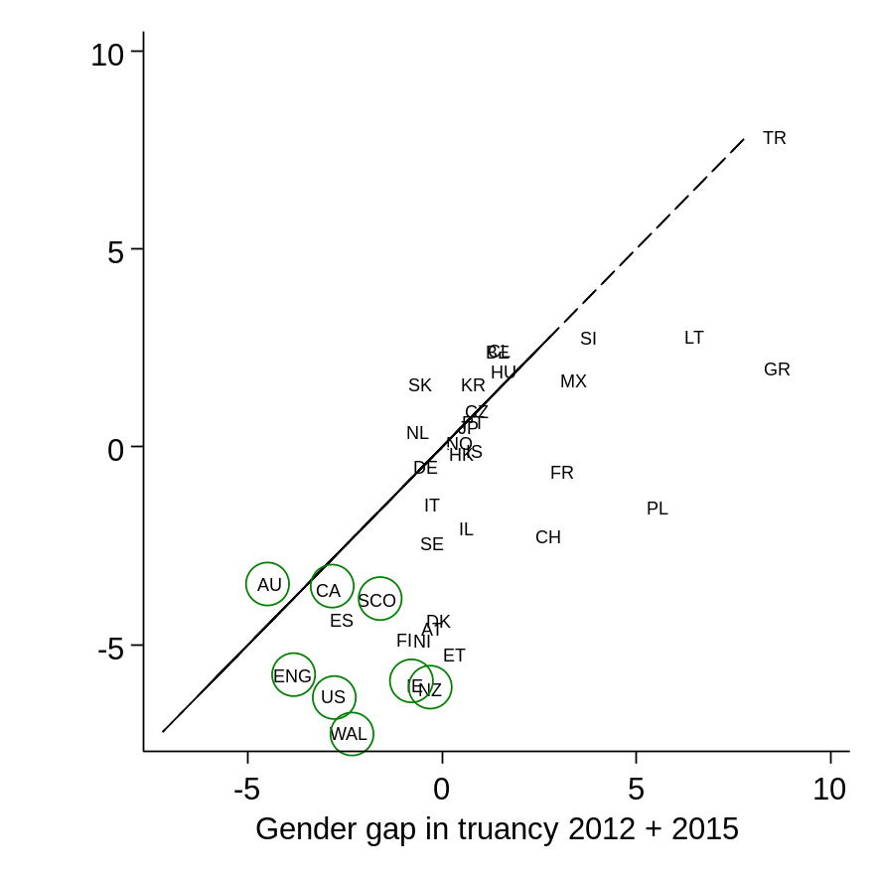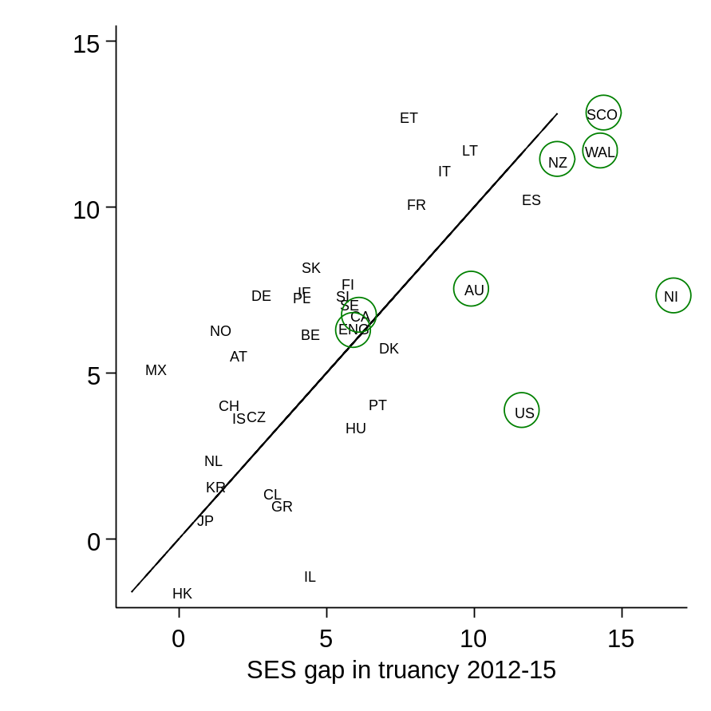

Notes: Negative figures in the left-hand panel indicate the truancy rate is higher for girls than boys. Figures in the right-hand panel illustrate differences between teenagers in the bottom versus top third of the socio-economic status distribution. English-speaking countries in green circles. Diagonal lines illustrate where the gender/socio-economic gap has remained unchanged before/after the pandemic.

Figure G3. The country-level relationship between school closures and the increase in the truancy rate
- OECD countries only (b) All countries
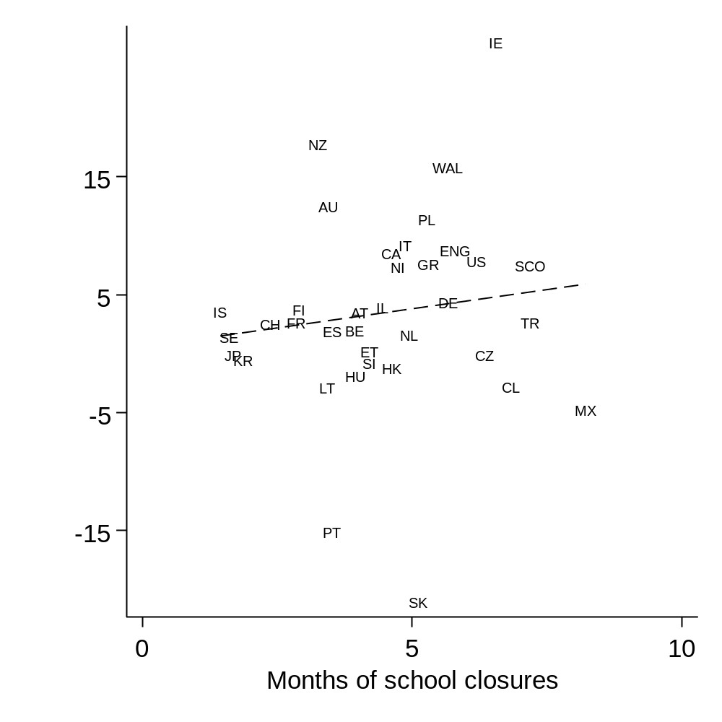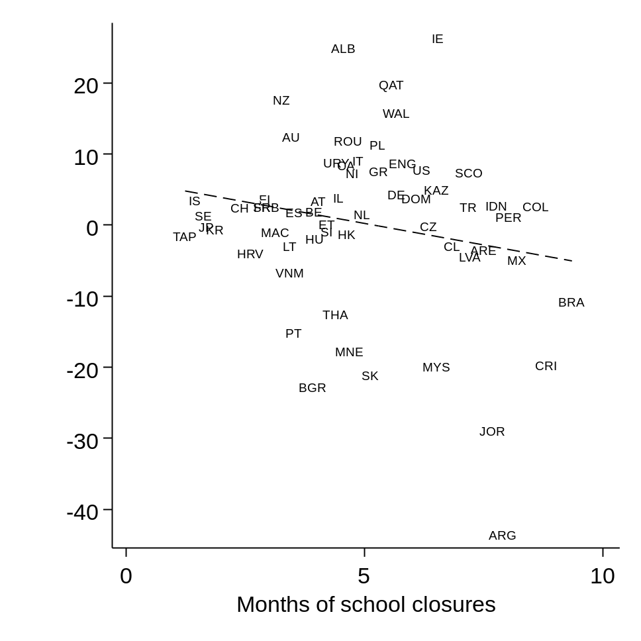
Notes: Values along the horizontal axis refer to the number of months schools were closed due to COVID-19. This information is based upon the country-level average of student reports. Values on the vertical axis refer to the increase in the percent of students skipping school before (PISA 2012-15) and after (PISA 2022) the pandemic (The country-level OLS estimate of the association is represented by the dashed line. Correlation is 0.18 in the panel on the left and -0.05 in the panel on the right.

