Appendix A
Sample representativeness
Table A1 shows the proportion of students with two separate teachers for mathematics and science per education system. In a few cases, for example Ontario in 2003, and South Korea in 2019, less than half the students in the TIMSS sample have two teachers. However, this number rises to above 50% when the student weights are used, and therefore these cycles are kept within the analysis. Table 1 also shows the number of students included (unweighted) for each education system with TIMSS cycles pooled.
 | 2003 | 2007 | 2011 | 2015 | 2019 | # students | # observations
Australia | 72% | 75% | 76% | 80% | 81% | 32,120 | 66,505
Chile | 74% |  | 97% | 85% | 69% | 18,923 | 40,766
Chinese Taipei | 99% | 97% | 99% | 92% | 96% | 24,553 | 49,702
England |  | 53% | 93% | 65% | 85% | 10,130 | 24,357
Hong Kong | 97% | 97% | 93% | 90% | 91% | 18,384 | 37,350
Ireland |  |  |  | 96% | 91% | 8,158 | 16,223
Israel | 56% | 54% | 83% | 61% | 73% | 20,391 | 48,030
Japan | 100% | 66% | 85% | 49% | 53% | 22,245 | 50,644
Rep. Korea | 84% | 72% |  | 58% | 47% | 18,329 | 41,696
New Zealand | 96% |  | 100% | 98% | 91% | 21,080 | 42,363
Can (Ontario) | 47% | 56% | 52% | 55% | 100% | 18218 | 36,544
Can (Quebec) | 98% | 91% | 78% |  | 97% | 15633 | 31,821
Singapore | 96% | 67% | 100% | 100% | 99% | 26,682 | 54,908
Spain (Basque) | 84% | 98% |  |  |  | 4,369 | 8769
Turkey | 100% | 100% | 100% | 100% | 100% | 21281 | 42,562
USA | 92% | 96% | 96% | 55% | 97% | 32,802 | 69.899
All countries | 84% | 78% | 88% | 77% | 85% | 313,298 | 662,139
Table A1. Proportion of students with separate teachers for mathematics and science and sample size

Appendix B
PD variables
Table B1. Descriptive statistics by education system (PD variables)
System | PD3 (math) | SD | % miss. | PDdays (math) | SD | % miss. | PD3 (sci) | SD | % miss. | PDdays (sci) | SD | % miss.
AUS | 1.91 | 1.16 | 12.9 | 1.96 | 1.5 | 10.6 | 1.76 | 1.17 | 17.4 | 1.96 | 1.53 | 15
CHL | 1.55 | 1.19 | 6.2 | 1.92 | 1.75 | 10.3 | 1.31 | 1.19 | 17.9 | 1.85 | 1.8 | 12.7
CTPE | 2.26 | 1.02 | 0.2 | 1.99 | 1.44 | 3.4 | 1.9 | 1.14 | 1.8 | 1.78 | 1.47 | 1.6
ENG | 1.99 | 0.94 | 0.1 | 1.82 | 1.43 | 4.2 | 2.0 | 1.12 | 4.5 | 2.05 | 1.66 | 6.3
HK | 1.89 | 1.16 | 2.1 | 1.68 | 1.48 | 3.3 | 2.1 | 1.04 | 1.4 | 1.71 | 1.4 | 5
IRL | 1.29 | 0.77 | 8.7 | 1.75 | 1.36 | 10.6 | 1.46 | 0.97 | 7.5 | 1.52 | 1.25 | 7.3
ISR | 1.95 | 1.15 | 8.7 | 3.1 | 1.61 | 7.2 | 1.95 | 1.15 | 7.9 | 3.1 | 1.65 | 5.4
JPN | 2.09 | 1.0 | 1.5 | 2.15 | 1.14 | 1.2 | 2.01 | 1.03 | 1.0 | 2.13 | 1.15 | 1.4
KOR | 1.43 | 1.2 | 8.3 | 1.92 | 1.72 | 5.2 | 1.72 | 1.18 | 7.2 | 2.68 | 1.66 | 7.1
NZ | 2.04 | 0.97 | 6.6 | 1.97 | 1.51 | 5.7 | 1.86 | 0.95 | 8.5 | 2.0 | 1.64 | 6.3
ONT | 2.09 | 1.11 | 7.2 | 2.13 | 1.48 | 9 | 1.15 | 1.27 | 14.1 | 0.76 | 1.12 | 20.4
QUE | 1.86 | 0.97 | 6.2 | 1.91 | 1.25 | 7.6 | 1.58 | 1.21 | 28.6 | 1.52 | 1.25 | 25.2
SGP | 2.15 | 1.03 | 1.6 | 2.34 | 1.48 | 0.8 | 2.24 | 0.98 | 1.6 | 2.77 | 1.48 | 0.5
ESP | 0.86 | 1.17 | 0.4 | 1.08 | 0.92 | 1.8 | 1.23 | 1.08 | 2.2 | 1.42 | 1.06 | 1.7
TUR | 1.04 | 1.17 | 0.6 | 0.81 | 1.28 | 1.2 | 1.18 | 1.21 | 0.8 | 1.02 | 1.46 | 1.1
USA | 2.34 | 0.99 | 11.3 | 2.54 | 1.5 | 8.9 | 2.2 | 1.08 | 18.2 | 2.52 | 1.56 | 16.7

Figure B1. Mean participation in PD3 by cycle and subject
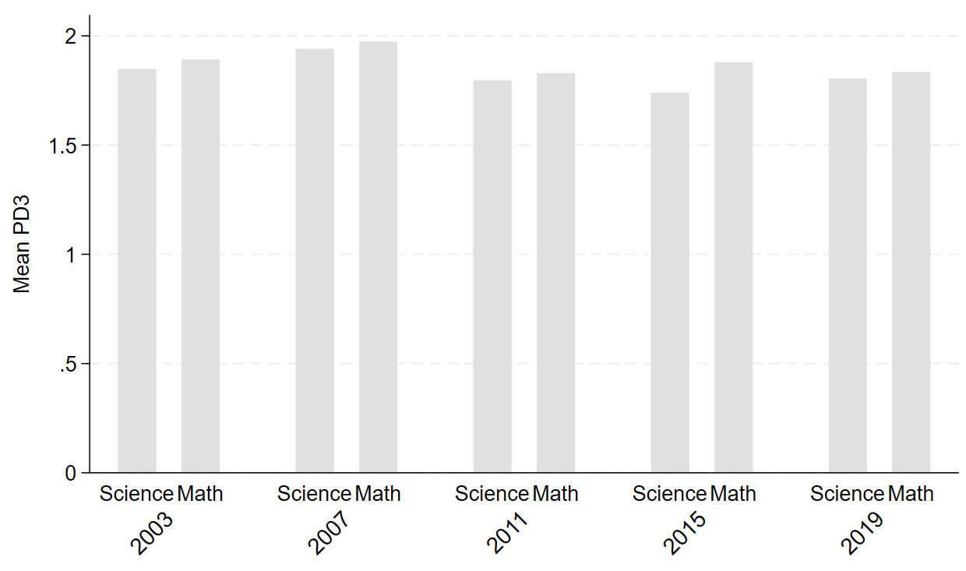
Figure B2. Mean participation in PD content by cycle and subject.
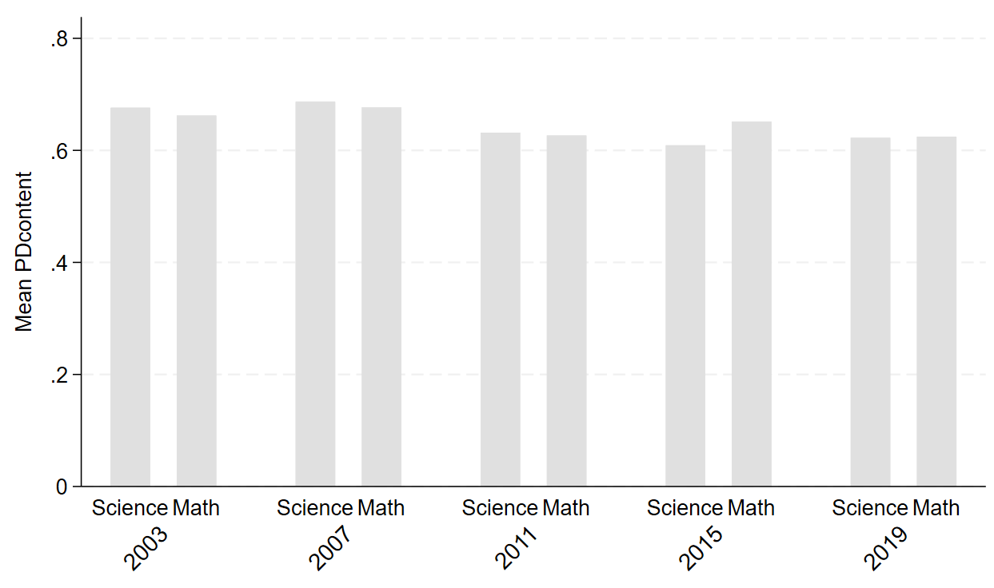
Figure B3. Mean participation in PD curriculum by cycle and subject.
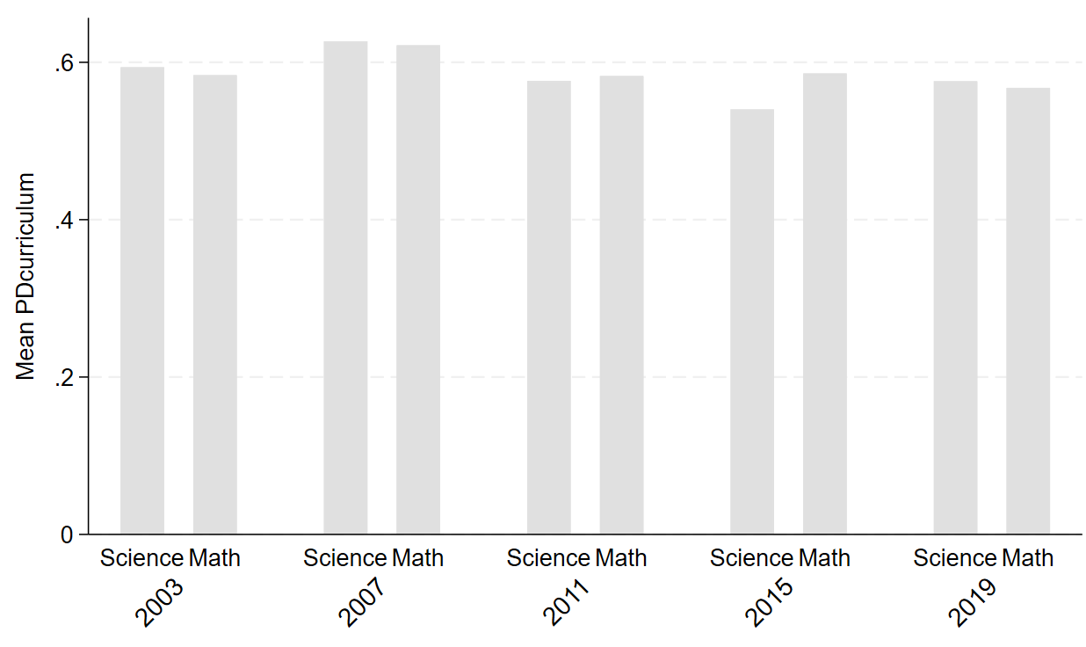
Figure B4. Mean participation in PD pedagogy by cycle and subject.
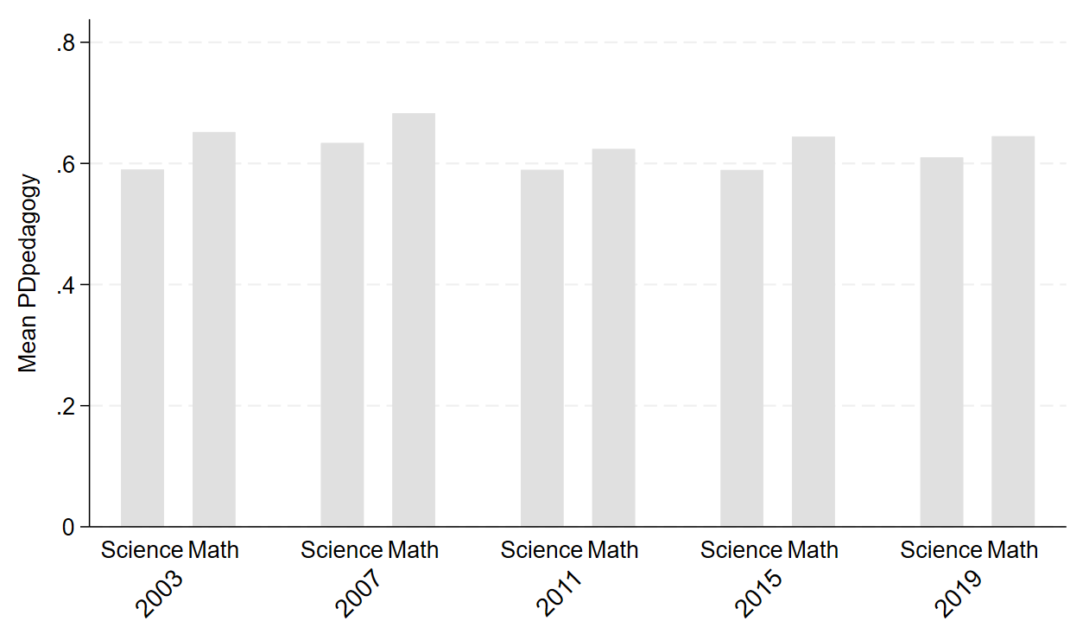

Figure B5. Mean participation in PD days by cycle and subject.
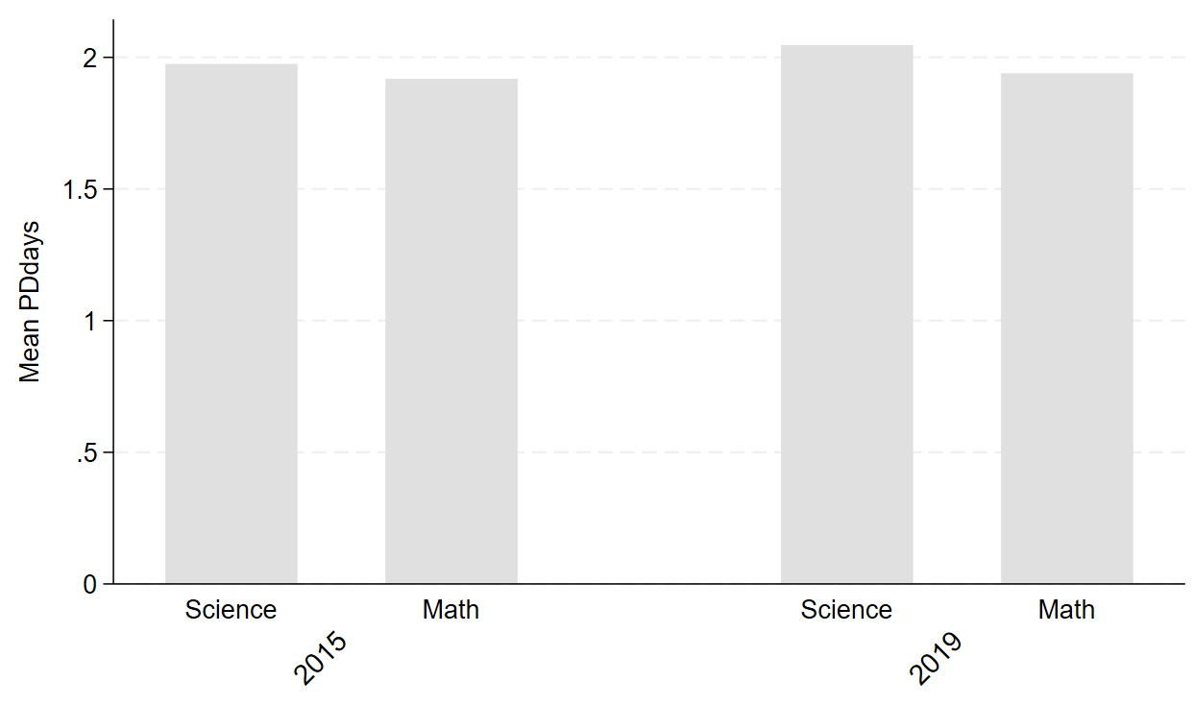

Appendix C
Within-unit variation in teacher PD participation and analytic sample representativeness
Although the WSBS models have many benefits, they sacrifice variation in the variables because variation is much smaller within units than between units. To quantify this loss of variation, we employ a descriptive investigation of the reduction in variation imposed by the fixed effects as proposed by Mummolo and Peterson (2018). Thereby, we investigate the standard deviation of the additional independent variable? (PD days) before and after the introduction of the student and subject fixed effects for each education system, as presented in Table C1. We also examine the proportion of cases with no variation at all in the independent variables. These estimates show that the introduction of the student and subject fixed effects reduces the variation by at least one fourth in all education systems, which leads to a reduction of the statistical power, making large sample sizes even more important.
Table C1 Variance reduction imposed by the student fixed effects (PD days)
PDdays | Total SD | Residualized SD | Variance reduction | % cases with no variation
AUS | 1.52 | 1.06 | -30% | 22%
CHL | 1.77 | 1.31 | -25% | 23%
CTPE | 1.47 | 1.05 | -28% | 22%
ENG | 1.49 | 1.03 | -30% | 24%
HK | 1.44 | 0.98 | -32% | 27%
IRL | 1.4 | 0.96 | -32% | 25%
ISR | 1.65 | 1.22 | -26% | 26%
JPN | 1.33 | 0.95 | -30% | 19%
KOR | 1.72 | 1.21 | -29% | 19%
NZ | 1.46 | 1.05 | -28% | 21%
ONT | 1.5 | 0.96 | -36% | 13%
SGP | 1.5 | 1.05 | -30% | 24%
TUR | 1.38 | 0.78 | -43% | 43%
USA | 1.56 | 1.1 | -29% | 18%

In Table C2, we investigate the analytic sample representativeness as well as the standardized mean difference (Imbens & Rubin, 2015). While some variables show statistically significant differences, they fall below the threshold of concern outlined by the authors.

Table C2. Means and SDs by treated vs untreated (PD days)
 | No variation in PD days | Variation in PD days
 | Mean (SD) | Mean (SD) | Mean change | t | Standardized mean difference
SES | 0.030 | 0.040 | 0.009 | 0.99
PV1 | 0.322 | 0.336 | 0.014 | 0.80
Teacher experience | 13.4 | 14.0 | 0.532 | 1.83
Teacher education | 0.639 | 0.624 | -0.015 | 1.13
Teacher subject education | 0.920 | 0.910 | -0.009 | 0.19
Instruction time | 3.23 | 3.18 | -0.051 | 1.99 | -0.068
Lecture | 0.445 | 0.447 | 0.001 | 0.52
# of students | 34264 | 110029
Note. SE clustered by class.
Table C3. Means and SDs by treated vs untreated (PD content)
 | No variation in PD content | Variation in PD content
 | Mean (SD) | Mean (SD) | Mean change | t | Standardized mean difference
SES | -0.0068 | 0.0090 | 0.0158
PV1 | 0.286 | 0.285 | -0.001
Teacher experience | 13.6 | 13.8 | 0.200
Teacher education | 0.613 | 0.611 | -0.002
Teacher subject education | 0.937 | 0.928 | -0.009 | -2.53 | -0.035
Instruction time | 3.2 | 3.08 | -0.12 | -7.93 | -0.11
Lecture | 0.465 | 0.454 | -0.011
# of students | 189625 | 132673
Note. SE clustered by class.
Table C4. Means and SDs by treated vs untreated (PD curriculum)
 | No variation in PD curriculum | Variation in PD curriculum
 | Mean (SD) | Mean (SD) | Mean change | t | Standardized mean difference
SES | -0.003 | 0.005 | 0.009
PV1 | 0.280 | 0.294 | 0.013
Teacher experience | 13.7 | 13.8 | 0.10
Teacher education | 0.61 | 0.60 | -0.012
Teacher subject education | 0.93 | 0.93 | 0.004
Instruction time | 3.21 | 3.06 | -0.149 | 9.95 | -0.14
Lecture | 0.45 | 0.46 | 0.006
# of students | 188880 | 124418
Note. SE clustered by class.
Table C4. Means and SDs by treated vs untreated (PD pedagogy)
 | No variation in PD curriculum | Variation in PD curriculum
 | Mean (SD) | Mean (SD) | Mean change | t | Standardized mean difference
SES | -0.0073 | 0.0093 | 0.016
PV1 | 0.298 | 0.270 | -0.0279 | 2.18 | -0.030
Teacher experience | 13.5 | 14 | 0.5 | 3.52 | 0.049
Teacher education | 0.614 | 0.61 | -0.004
Teacher subject education | 0.939 | 0.926 | -0.012 | 3.66 | -0.05
Instruction time | 3.19 | 3.1 | -0.089 | 5.97 | -0.084
Lecture | 0.463 | 0.457 | -0.006
# of students | 176692 | 136606
Note. SE clustered by class.

Appendix D
WSBS Estimates by SES indicator and SES quartile
We run the WSBS models for top and bottom SES quartiles to determine whether a clear pattern can be seen at either end of the socioeconomic distribution. Similar to the interaction effect models, Figures D1 shows consistently null effects. Importantly, Figure D1 is based on 1:1 PV-imputation pairs, but in Appendix F (Table F3) we report the point estimates for 1:5 imputation-PV pairs and the results are substantively the same.
Figure D1. WSBS estimates of PD3 by top and bottom SES quartile
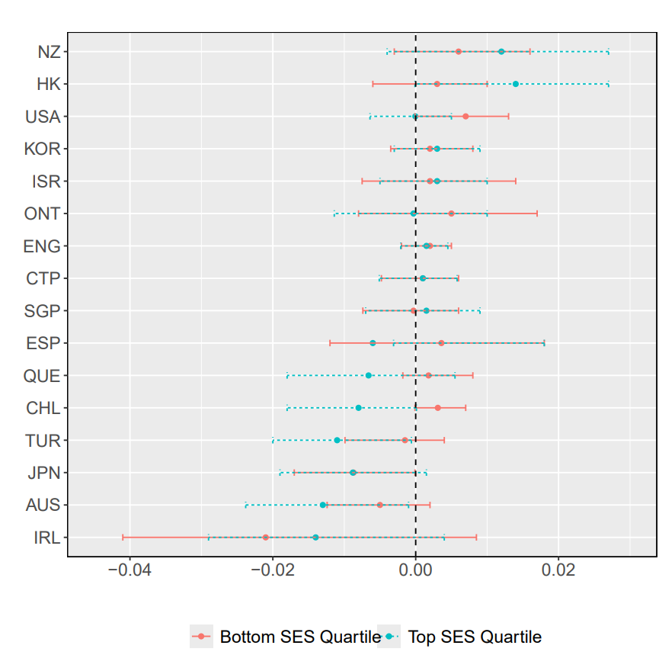

Next, we investigate whether the null differences across SES groups are dependent on how the SES variable is constructed. First, we run the analysis when student SES is defined by parental education and books at home separately (rather than as an index variable) to determine whether the null effect can be explained by differential effects as a function of the dimensions of our composite SES construct. We categorize the top and bottom SES categories based on within country proportions of students instead of the percentile method. Following Chmielewski (2019), we aim for approximately 20% of the TIMSS sample in the top and bottom groups, respectively. These results show little difference from the main models.
Figure D3. Estimates of PD3 by parental education 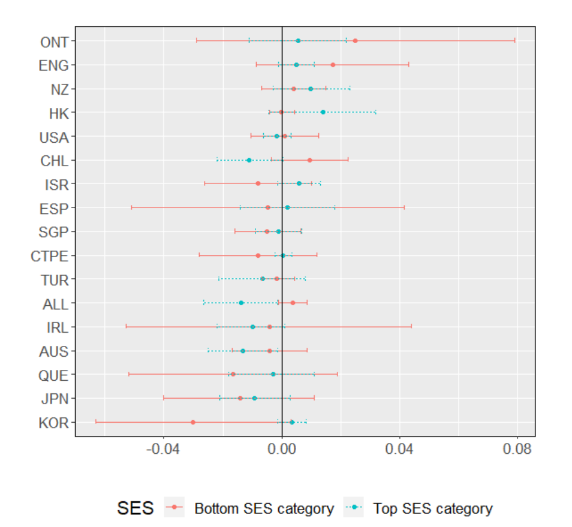
Figure D2. Estimates of PD3 by number of books at home (bottom 2 categories and top category)
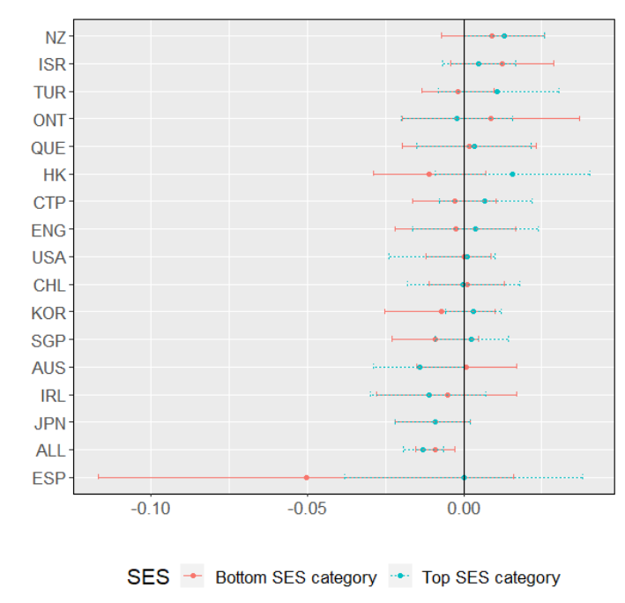

Appendix E
Sensitivity analyses: Descriptives and WSBS models of # of PD days
To test whether the findings differ when other subject-specific variables are used, we first describe the means for the number of PD days per top and bottom SES quartile in Figure E1. The findings show a similar results with the exception of Hong Kong which shows an anti-compensatory pattern, where high-SES students have teachers who participate more often in professional development on an annual basis.
Figure E1. # of PD days means across top and bottom SES quartiles by education system (2015-2019).
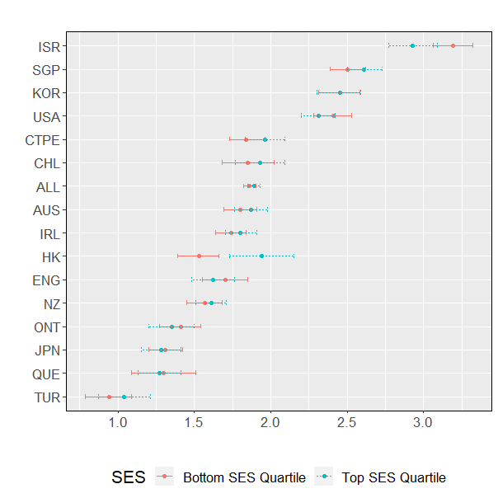

We also plot the point estimates for PD days for all students (the whole sample). This is for education systems in 2015 and 2019. The null effects remain as well as the pooled negative effect.
Figure E2. Average within-unit effects of PD days on student achievement (2015-2019).
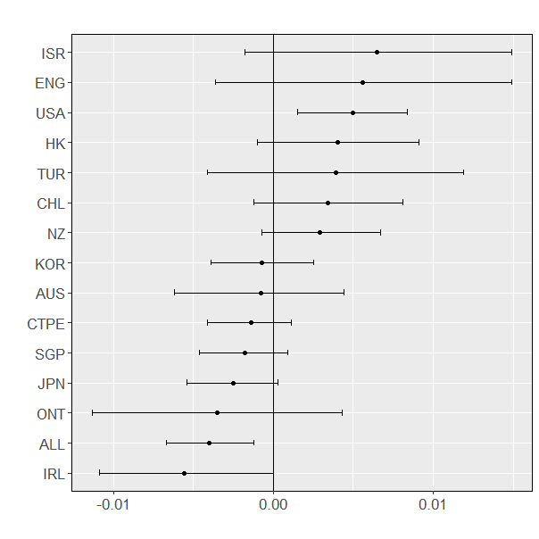

Next, we test the effect of PDdays on the cross-national SES quartiles (see Table E1). We find a similar pattern to PD3, with a small statistically significant negative point estimate for the top SES quartile.
Table E1. Cross-national WSBS estimates of participation in # of PD days by SES quartile.

 | Bottom SES quartile |  | Top SES quartile
 | Coefficient | Robust SE | Coefficient | Robust SE
# of PD days | -0.004 | 0.0024 | -0.008** | 0.003
Student fixed effects | Yes |  | Yes
Subject fixed effects | Yes |  | Yes
Teacher controls | Yes |  | Yes
N obs (unique) | 67,126 |  | 89,298
N class | 5,264 |  | 5,330
Note. *p < .05. **p < 0.01. ***p < 0.001. Senate weights applied. 1-5 Imputation-PV pair.

We run the WSBS models on the SES quartiles (as in Figure D1 for PD3) see Figure E3. It is important to note that these models use the 1:1 PV-imputation pair, in other words, 5 imputations per point estimate. However, we run a check to determine 1:5 PV-imputation pairs in Table F3 (Appendix F) and the results are substantively the same.
Figure E3. WSBS estimates of # of PD days by top and bottom SES quartile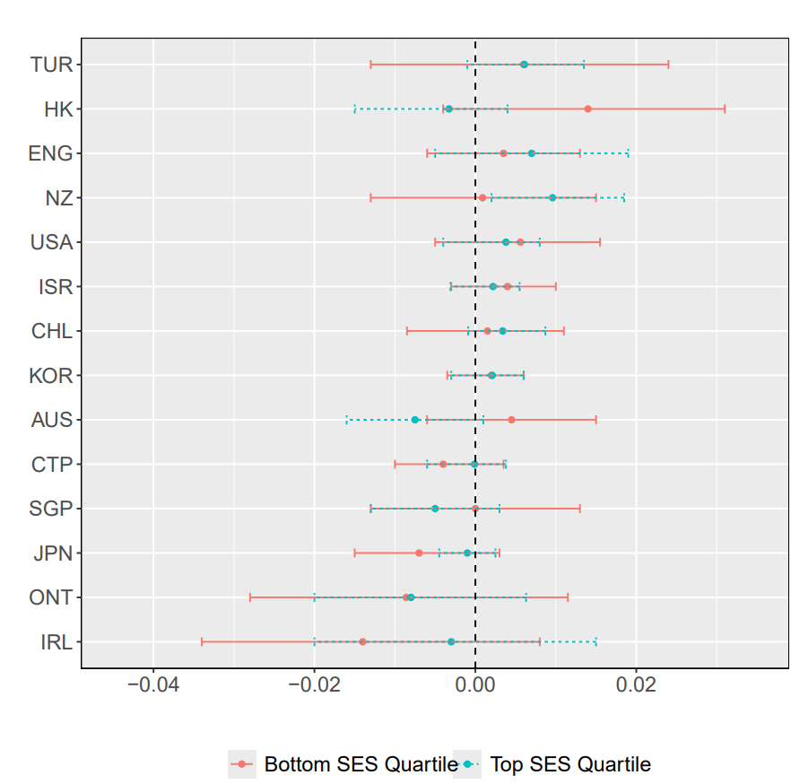

Figure E4 shows the cross-national WSBS estimates of the # of PD days on achievement subset by teacher qualification and SES.
Figure E4. Cross-national WSBS estimates of # of PD days by student SES and teacher qualifications (2015-2019).

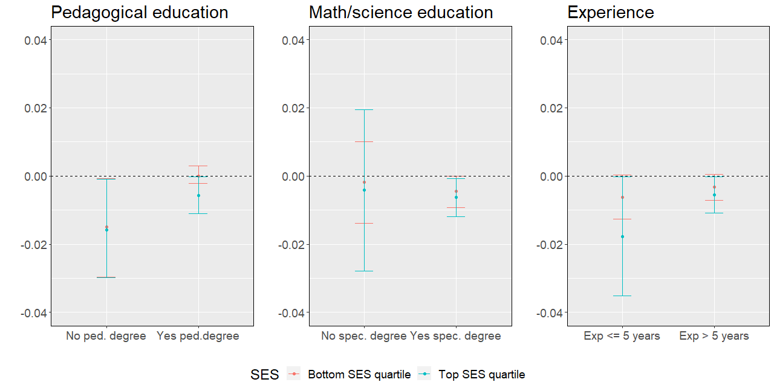

Appendix F
Table F1. WSBS estimates of PD indicators subset by SES and education system.
 | PD content |  |  |  |  |  |  |  | Pd curriculum |  |  |  |  |  |  |  | PD pedagogy
 | Low SES |  |  |  | High SES |  |  |  |  | Low SES |  |  |  |  | High SES |  |  | Low SES |  |  | High SES
 | Coeff | SE |  | Coeff |  | SE |  |  | Coeff |  | SE |  |  | Coeff |  | SE | Coeff |  | SE | Coeff |  | SE
AUS | -0.01 | 0.021 |  | 0.0006 |  | 0.018 |  |  | -0.02 |  | 0.020 |  |  | -0.020 |  | 0.021 | 0.020 |  | 0.019 | -0.01 |  | 0.01
CHL | 0.004 | 0.025 |  | -0.008 |  | 0.022 |  |  | -0.01 |  | 0.028 |  |  | -0.028 |  | 0.02 | 0.006 |  | 0.023 | 0.009 |  | 0.023
CTPE | 0.021 | 0.022 |  | 0.040 |  | 0.021 |  |  | -0.00 |  | 0.023 |  |  | 0.025 |  | 0.020 | -0.015 |  | 0.018 | -0.009 |  | 0.018
ENG | -0.02 | 0.022 |  | -0.017 |  | 0.018 |  |  | -0.00 |  | 0.021 |  |  | 0.008 |  | 0.019 | 0.035 |  | 0.027 | 0.012 |  | 0.021
HK | 0.019 | 0.027 |  | -0.008 |  | 0.024 |  |  | -0.01 |  | 0.026 |  |  | 0.013 |  | 0.023 | 0.001 |  | 0.026 | 0.042 |  | 0.027
IRL | -0.01 | 0.028 |  | -0.013 |  | 0.021 |  |  | -0.05 |  | 0.033 |  |  | -0.003 |  | 0.021 | -0.002 |  | 0.025 | -0.022 |  | 0.019
ISR | -0.02 | 0.016 |  | -0.004 |  | 0.018 |  |  | 0.009 |  | 0.016 |  |  | 0.020 |  | 0.017 | 0.017 |  | 0.019 | -0.007 |  | 0.017
JPN | -0.01 | 0.014 |  | 0.001 |  | 0.017 |  |  | -0.00 |  | 0.010 |  |  | 0.014 |  | 0.012 | -0.020 |  | 0.014 | -0.042 |  | 0.016
KOR | 0.022 | 0.016 |  | -0.002 |  | 0.012 |  |  | -0.01 |  | 0.014 |  |  | 0.015 |  | 0.010 | 0.0004 |  | 0.017 | -0.004 |  | 0.011
NZ | -0.00 | 0.018 |  | 0.029 |  | 0.022 |  |  | 0.038 |  | 0.019 |  |  | 0.022 |  | 0.018 | -0.011 |  | 0.016 | -0.019 |  | 0.017
ONT | 0.002 | 0.036 |  | 0.04 |  | 0.026 |  |  | -0.00 |  | 0.031 |  |  | 0.001 |  | 0.029 | 0.016 |  | 0.030 | -0.043 |  | 0.026
QUE | -0.02 | 0.027 |  | 0.031 |  | 0.029 |  |  | 0.011 |  | 0.026 |  |  | -0.020 |  | 0.023 | 0.011 |  | 0.021 | -0.027 |  | 0.020
SGP | 0.025 | 0.015 |  | -0.008 |  | 0.011 |  |  | -0.01 |  | 0.0139 |  |  | 0.007 |  | 0.011 | -0.012 |  | 0.017 | 0.010 |  | 0.0135
ESP | 0.075 | 0.064 |  | 0.0179 |  | 0.052 |  |  | 0.022 |  | 0.073 |  |  | -0.041 |  | 0.048 | -0.062 |  | 0.066 | 0.012 |  | 0.055
TUR | 0.010 | 0.017 |  | 0.023 |  | 0.016 |  |  | 0.004 |  | 0.016 |  |  | -0.036 |  | 0.019 | -0.024 |  | 0.017 | -0.019 |  | 0.019
USA | 0.025 | 0.02 |  | 0.003 |  | 0.016 |  |  | 0.004 |  | 0.019 |  |  | 0.021 |  | 0.015 | -0.009 |  | 0.015 | -0.017 |  | 0.012
Note. *p < .05. **p < 0.01. ***p < 0.001. Student weights applied. 1:5 Imputation-PV pair. Student fixed effects, subject fixed effects, and teacher controls included. Estimates marked in bold correspond to estimates which reach statistical significance in the interaction effects.

Appendix H
Cross-imputation variation in cross-national WSBS PD coefficients (1:5 Imputation-PV pair)
Table H1. PD subject (PD3) subset by SES.
 | PD3 (Low SES) |  | PD3 (High SES)
Imputation:PV | Coefficient | SE | Coefficient | SE
1:1 | -0.0062 | 0.0024 | -0.0108 | 0.0033
1:2 | -0.0040 | 0.0025 | -0.0132 | 0.0034
1:3 | -0.0041 | 0.0025 | -0.0110 | 0.0033
1:4 | -0.0047 | 0.0025 | -0.0133 | 0.0034
1:5 | -0.0077 | 0.0025 | -0.0127 | 0.0032
2:1 | -0.0061 | 0.0025 | -0.0111 | 0.0033
2:2 | -0.0062 | 0.0026 | -0.0108 | 0.0032
2:3 | -0.0055 | 0.0026 | -0.0110 | 0.0033
2:4 | -0.0050 | 0.0026 | -0.0131 | 0.0032
2:5 | -0.0065 | 0.0026 | -0.0108 | 0.0033
3:1 | -0.0045 | 0.0026 | -0.0116 | 0.0034
3:2 | -0.0044 | 0.0026 | -0.0121 | 0.0034
3:3 | -0.0053 | 0.0026 | -0.0124 | 0.0034
3:4 | -0.0059 | 0.0026 | -0.0113 | 0.0033
3:5 | -0.0030 | 0.0024 | -0.0099 | 0.0033
4:1 | -0.0066 | 0.0026 | -0.0092 | 0.0033
4:2 | -0.0063 | 0.0025 | -0.0108 | 0.0033
4:3 | -0.0054 | 0.0025 | -0.0120 | 0.0034
4:4 | -0.0058 | 0.0025 | -0.0117 | 0.0034
4:5 | -0.0064 | 0.0025 | -0.0109 | 0.0034
5:1 | -0.0075 | 0.0026 | -0.0118 | 0.0033
5:2 | -0.0072 | 0.0024 | -0.0132 | 0.0033
5:3 | -0.0041 | 0.0026 | -0.0116 | 0.0034
5:4 | -0.0038 | 0.0025 | -0.0122 | 0.0034
5:5 | -0.0067 | 0.0025 | -0.0104 | 0.0034
Mean | -0.0054 |  | -0.0113
SD | 0.00052 |  | 0.0010

Table H2. # of PD days subset by SES.
 |  | PD days (Low SES) |  | PD days (High SES)
 | Imputation:PV | Coefficient | SE | Coefficient | SE
 | 1:1 | -0.0022 | 0.0023 | -0.0069 | 0.0032
 | 1:2 | -0.0044 | 0.0022 | -0.0075 | 0.0030
 | 1:3 | -0.0033 | 0.0024 | -0.0072 | 0.0032
 | 1:4 | -0.0038 | 0.0025 | -0.0081 | 0.0028
 | 1:5 | -0.0058 | 0.0024 | -0.0075 | 0.0032
 | 2:1 | -0.0046 | 0.0025 | -0.0075 | 0.0032
 | 2:2 | -0.0022 | 0.0024 | -0.0069 | 0.0032
 | 2:3 | -0.0041 | 0.0025 | -0.0082 | 0.0028
 | 2:4 | -0.0040 | 0.0025 | -0.0074 | 0.0030
 | 2:5 | -0.0060 | 0.0024 | -0.0082 | 0.0032
 | 3:1 | -0.0047 | 0.0025 | -0.0075 | 0.0032
 | 3:2 | -0.0040 | 0.0025 | -0.0082 | 0.0028
 | 3:3 | -0.0022 | 0.0023 | -0.0077 | 0.0034
 | 3:4 | -0.0042 | 0.0025 | -0.0074 | 0.0032
 | 3:5 | -0.0061 | 0.0024 | -0.0081 | 0.0028
 | 4:1 | -0.0043 | 0.0025 | -0.0075 | 0.0030
 | 4:2 | -0.0040 | 0.0025 | -0.0079 | 0.0030
 | 4:3 | -0.0039 | 0.0025 | -0.0078 | 0.0032
 | 4:4 | -0.0039 | 0.0023 | -0.0071 | 0.0032
 | 4:5 | -0.0040 | 0.0022 | -0.0084 | 0.0028
 | 5:1 | -0.0044 | 0.0024 | -0.0078 | 0.0030
 | 5:2 | -0.0038 | 0.0025 | -0.0078 | 0.0029
 | 5:3 | -0.0039 | 0.0025 | -0.0080 | 0.0030
 | 5:4 | -0.0058 | 0.0024 | -0.0074 | 0.0032
 | 5:5 | -0.0034 | 0.0024 | -0.0083 | 0.0030
 | Mean | -0.0040 |  | -0.0076
 | SD | 0.00095 |  | 0.00039

Table H3 Cross-imputation means (and SDs) by education system (1:5 imputation-PV pair).
 | PD3 |  |  | PD days
 | Low SES | High SES |  | Low SES | High SES
Australia | –0.0054 (0.0022) | -0.0111 (0.0019) |  | 0.0045 (0.0025) | -0.007 (0.0014)
Chile | 0.0036 (0.0011) | -0.0077 (0.0022) |  | 0.0018 (0.0034) | 0.0049 (0.0024)
Chinese Taipei | 0.0002 (0.0027) | 0.00016 (0.0029) |  | -0.0048 (0.0022) | -0.0014 (0.0011)
England | 0.0001 (0.002) | 0.0004 (0.0018) |  | 0.0032 (0.0023) | 0.0068 (0.0024)
Hong Kong | 0.001 (0.0029) | 0.0144 (0.0024) |  | 0.0016 (0.0021) | -0.0013 (0.0037)
Ireland | -0.0200 (0.0088) | -0.0321 (0.0048) |  | -0.0105 (0.0038) | 0.0006 (0.0056)
Israel | 0.0025 (0.0034) | 0.00217 (0.0034) |  | 0.0028 (0.0024) | 0.0017 (0.0024)
Japan | -0.0083 (0.0015) | -0.0095 (0.0033) |  | -0.0047 (0.0022) | -0.0023 (0.0022)
Rep. Korea | 0.0023 (0.0020) | 0.0017 (0.0023) |  | 0.0022 (0.0022) | 0.0010 (0.0012)
New Zealand | 0.0066 (0.0025) | 0.0012 (0.0042) |  | 0.0004 0.0043) | 0.0092 (0.0017)
Ontario | 0.0047 (0.0036) | 0.00001 (0.0044) |  | -0.0083 (0.0052) | -0.0053 (0.006)
Quebec | 0.0022 (0.0031) | -0.0070 (0.0037)
Singapore | -0.00022 (0.0024) | 0.0020 (0.0028) |  | 0.0014 (0.0031) | -0.0045 (0.0012)
Spain | 0.0027 (0.0083) | -0.01210 (0.0120)
Turkey | -0.0024 (0.0032) | -0.0102 (0.0018) |  | 0.0042 (0.0072) | 0.0034 (0.0034)
USA | 0.0058 (0.0017) | 0.00001 (0.002) |  | 0.0043 (0.0022) | 0.0035 (0.0015)
Note. Mean and cross-imputation SDs from WSBS models. Senate weights applied.

