Supplementary information
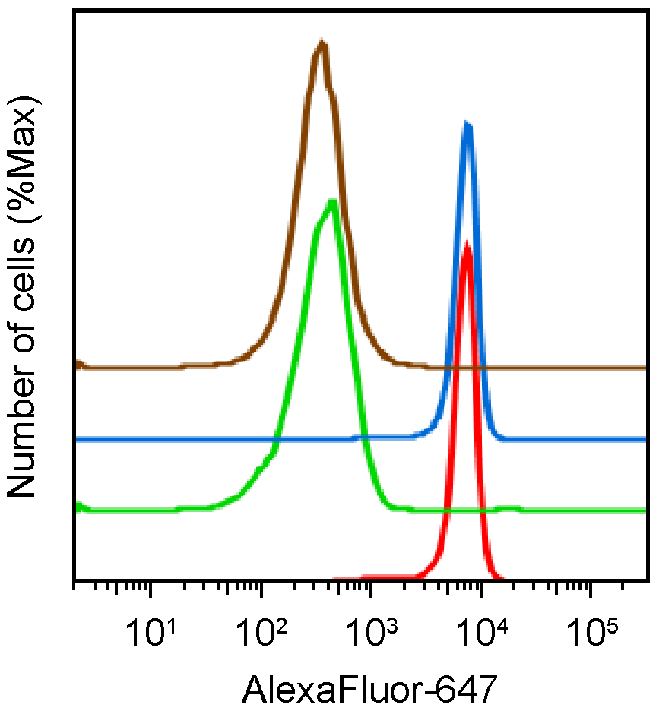
Supplementary Fig. 1 Specificity of Mavrilimumab-AlexaFluor-647 binding to CD14⁺ human monocytes. Human heparinized blood was stained with Mavrilimumab-AlexaFluor-647 and CD14-FITC and analyzed using flow cytometry. Displayed are AlexaFluor-647 histograms in the CD14⁺ monocyte gates of the samples stained with Mavrilimumab-AlexaFluor-647 (red) or IgG-AlexaFluor-647 (green). To demonstrate specific binding, cells were pre-treated with unlabeled Mavrilimumab (brown) or IgG (blue) prior to addition of Mavrilimumab-AlexaFluor-647.

