Supplementary materials
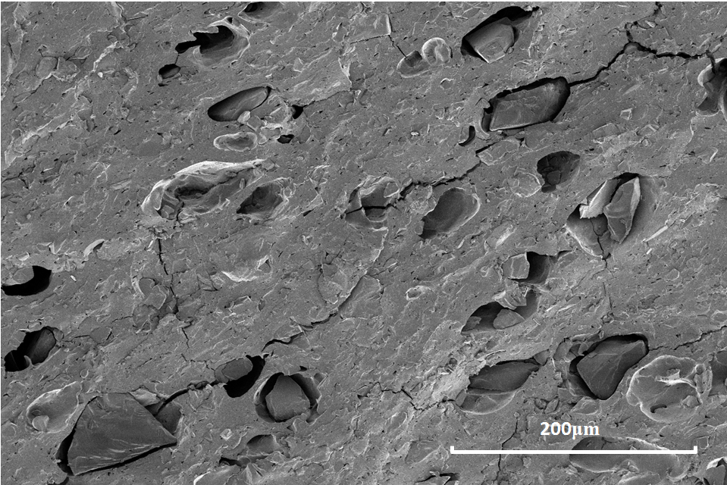
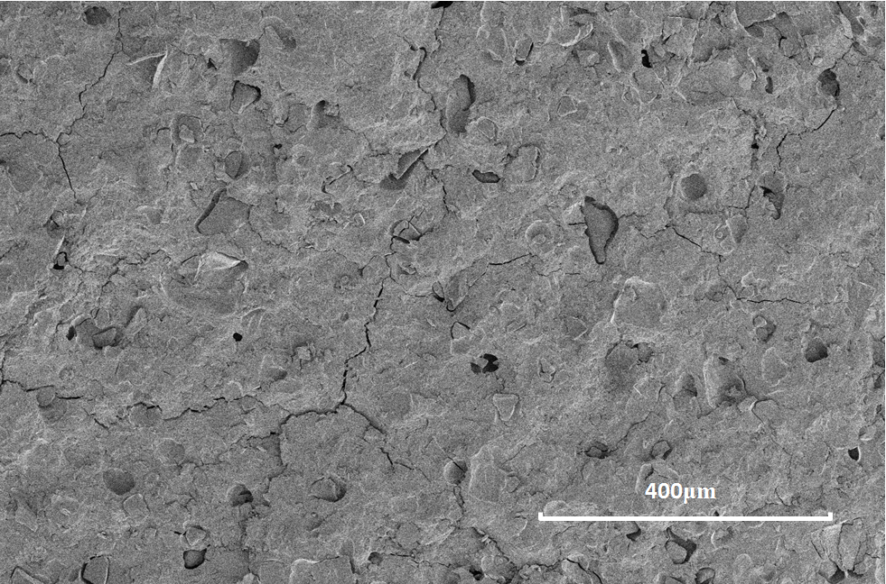
Figure 1: SEM images of cut cross sections of 22.2% loaded indomethacin caplets

