Population pharmacokinetics, efficacy exposure-response analysis, and model-based meta-analysis of fenebrutinib in subjects with rheumatoid arthritis
Phyllis Chan, PhD¹, Jiajie Yu, PhD¹, Leslie Chinn, PhD¹, Marita Prohn, MSc², Jan Huisman, BEng², Brett Matzuka, PhD³, William Hanley, PhD⁴, Katie Tuckwell, PhD⁵, Angelica Quartino, PhD¹
¹Department of Clinical Pharmacology, Genentech, South San Francisco, CA, USA
²qPharmetra, Nijmegen, The Netherlands
³qPharmetra, Cary, NC, USA
⁴Former Genentech employee, currently of Seattle Genetics, South San Francisco, CA, USA
⁵Early Clinical Development, Genentech, South San Francisco, CA, USA
Supplementary Figures and Tables:
Table S1. Summary of Studies Included in the Population PK Analysis
Table S2. Summary of Demographics of Subjects Included in the Population PK Analysis
Table S3. Summary of Demographics of Subjects Included in the E-R Analysis
Table S4. ACR20, ACR50, ACR70 E-R Model Parameter Estimates
Table S5. DAS28-3 CRP E-R Model Parameter Estimates
Table S6. Summary of treatments and clinical trials in the model-based meta-analysis dataset
Figure S1. Diagnostic Plots of Population PK Model
Figure S2. Prediction-Corrected Visual Predictive Check Plots of Population PK Model
Figure S3. Distribution of Fenebrutinib Exposure by Dose
Figure S4. ACR Simulation for Fenebrutinib (GDC-0853), Adalimumab, and Tofacitinib Treatments
Model S1. NONMEM Control Stream for Population PK Model
Model S2. NONMEM Control Stream for ACR E-R Model
Model S3. NONMEM Control Stream for DAS28 E-R Model
Data S1. R Code for MBMA Model

Table S1 Summary of Studies Included in the Population PK Analysis
Study Number | Study Description | Trial Design | Fenebrutinib Pharmacokinetic Sampling Schedule
GA29347 | Phase 1 multiple ascending dose in healthy volunteers | Subjects received the powder-in-capsule formulation of fenebrutinib at 20 mg BID, 60 mg BID, 150 mg BID, 250 mg BID, or 500 mg QD for 14 days. | Pre-dose on days 1, 2, 3, 5, 7, and 14, and post-dose (morning dose) on days 1 and 14 at 0.5, 1, 2, 3, 4, 6, 8, 11.75 13, 14, and 16 hours, as well as after the last dose on day 14 at 24, 36, and 48 hours. For BID dosing, additional sampling on days 1 and 14 at 13, 14, and 16 hours after the morning dose.
GP29832 | Phase 1 relative bioavailability/food effect/drug-drug interaction in healthy volunteers | In Part 1, subjects received 200 mg fenebrutinib in a crossover design as either the powder-in-capsule or tablet formulation in the fasted state (Treatment A or B) with the final fixed treatment consisting of the tablet formulation administered in the fasted state after prior administration of rabeprazole for 3 days (Treatment C).  In Part 2, subjects received 200 mg fenebrutinib of the tablet formulation in the fasted or fed state (Treatment D or E) in a crossover design with the final fixed treatment consisting of the tablet formulation administered in the fed state after prior administration of rabeprazole for 3 days (Treatment F).  In Part 3, subjects received a single low-dose (7.5 mg) of methotrexate in the fasted state (Treatment G) followed by a washout period of 13 days. Subsequently, subjects received six days of twice-daily administration of the GDC-0853 tablet formulation (Treatment H), with the final treatment consisting of a single low-dose (7.5 mg) of methotrexate administered together with a single dose of GDC-0853 (Treatment I). The fenebrutinib dose administered in Part 3 was 200 mg BID for Treatment H and a single 200 mg dose for Treatment I. | In Parts 1 and 2: pre-dose, and 0.5, 1, 2, 3, 4, 6, 8, 10, 12, 24, 36, 48, and 72 hours post-dose.  In Part 3: pre-dose on days 17, 18, 19, 20, and 21; post-dose on days 20 and 21 at 0.5, 1, 2, 3, 4, 6, 8, 10, 12 hours, and on day 21 at 16 and 24 hours.
GA29350 | Phase 2 in patients with rheumatoid arthritis | In cohort 1, patients were assigned to 1 of 5 parallel treatment arms (3 fenebrutinib arms, 1 placebo arm, and 1 adalimumab arm). In the fenebrutinib and placebo arms, subjects received 50 mg QD, 150 mg QD, or 200 mg BID fenebrutinib tablets or placebo tablets, together with subcutaneous (SC) placebo injections every other week for 12 weeks (n=40 in the 50 mg arm and n=109 to 111 in each of the other 4 arms). In the active comparator arm, patients received adalimumab 40 mg SC every other week and placebo tablets for 12 weeks. In cohort 2 (n=98 enrolled), patients received 200 mg fenebrutinib BID or placebo tablets for 12 weeks. Food co-administration was self-reported by the patients. | Pre-dose (morning dose) on days 1, 7, 28, 56, and 84 (all patients) and at 2 hours, 4-6 hours, and 8-10 hours (US sites only, N=8) after dosing (morning dose) on day 28

Table S2 Summary of Demographics of Subjects Included in the Population PK Analysis
 | GP29832 | GA29347 | GA29350 | All
 | (N=48) | (N=30) | (N=307) | (N=385)
Gender
Female | 1 (2.1%) | 5 (16.7%) | 249 (81.1%) | 255 (66.2%)
Male | 47 (97.9%) | 25 (83.3%) | 58 (18.9%) | 130 (33.8%)
Age (yr)
Mean (SD) | 31.6 (11) | 37.1 (7.5) | 50.6 (12) | 47.2 (13)
Median (range) | 28 (18 - 55) | 35 (25 - 51) | 52 (19 - 75) | 48 (18 - 75)
Weight (kg)
Mean (SD) | 81.5 (9.6) | 80.9 (14) | 72.9 (16) | 74.6 (16)
Median (range) | 81 (60.8 - 103) | 80.2 (55.4 - 102) | 71 (38 - 153) | 73 (38 - 153)
BMI (kg/m2)
Mean (SD) | 26 (2.9) | 26.5 (2.9) | 27 (5.7) | 26.8 (5.3)
Median (range) | 26.2 (20.2 - 30.5) | 27.1 (20.5 - 30.7) | 26.1 (16.3 - 61.3) | 26.2 (16.3 - 61.3)
C-reactive Protein (mg/L)
Mean (SD) | 1.08 (1.7) | not available | 21.5 (25) | 17.3 (24)
Median (range) | 0.7 (0 - 8.8) | not available | 12 (0.3 - 176) | 9.2 (0 - 176)
ALT (U/L)
Mean (SD) | 21.2 (8.8) | not available | 18.8 (10) | 19.1 (9.8)
Median (range) | 19 (11 - 69) | not available | 16 (6 - 71) | 18 (6 - 71)
AST (U/L)
Mean (SD) | 20.7 (3.4) | not available | 18.6 (8.3) | 19 (7.5)
Median (range) | 20 (16 - 38) | not available | 17 (6 - 100) | 18 (6 - 100)
Creatinine Clearance (mL/min)
Mean (SD) | 114 (11) | not available | 118 (37) | 117 (34)
Median (range) | 111 (101 - 156) | not available | 112 (47.3 - 251) | 111 (47.3 - 251)
Total Protein (g/L)
Mean (SD) | 71 (2.8) | not available | 72.6 (5.4) | 59 (46)
Median (range) | 71 (65 - 78) | not available | 73 (58 - 94) | 71 (-99 - 94)
Race
White | 0 (0.0%) | 14 (46.7%) | 269 (87.6%) | 283 (73.5%)
Black | 0 (0.0%) | 15 (50.0%) | 4 (1.3%) | 19 (4.9%)
Asian | 0 (0.0%) | 0 (0.0%) | 1 (0.3%) | 1 (0.3%)
Am. Indian or Alaska Native | 0 (0.0%) | 0 (0.0%) | 26 (8.5%) | 26 (6.8%)
Multiple | 0 (0.0%) | 0 (0.0%) | 5 (1.6%) | 5 (1.3%)
Missing | 48 (100.0%) | 1 (3.3%) | 2 (0.7%) | 51 (13.2%)
Subject Status
Healthy volunteer | 48 (100.0%) | 30 (100.0%) | 0 (0.0%) | 78 (20.3%)
Patient | 0 (0.0%) | 0 (0.0%) | 307 (100.0%) | 307 (79.7%)
Food
Fasted | 40 (83.3%) | 30 (100.0%) | 2 (0.7%) | 72 (18.7%)
Fed | 8 (16.7%) | 0 (0.0%) | 305 (99.3%) | 313 (81.3%)
PPI Comedicated
No | 48 (100.0%) | 30 (100.0%) | 185 (60.3%) | 263 (68.3%)
Yes | 0 (0.0%) | 0 (0.0%) | 122 (39.7%) | 122 (31.7%)
MTX-IR
Not applicable | 48 (100.0%) | 30 (100.0%) | 0 (0.0%) | 78 (20.3%)
Yes | 0 (0.0%) | 0 (0.0%) | 307 (100.0%) | 307 (79.7%)
TNF-IR
No | 0 (0.0%) | 0 (0.0%) | 259 (84.4%) | 259 (67.3%)
Not applicable | 48 (100.0%) | 30 (100.0%) | 0 (0.0%) | 78 (20.3%)
Yes | 0 (0.0%) | 0 (0.0%) | 48 (15.6%) | 48 (12.5%)
PK, pharmacokinetic; E-R, exposure-response; N, number of subjects; SD, standard deviation; BMI, body mass index; Am., American; ALT, alanine aminotransferase; AST, aspartate aminotransferase; PPI, proton pump inhibitor; MTX, methotrexate; TNF, tumor necrosis factor; IR, inadequate response.

Table S3 Summary of Demographics of Subjects Included in the E-R Analysis
 | Mean | SD | Median | Range (Min, Max) | Missing
Rheumatoid Factor (IU/mL) | 323.8 | 489.2 | 124.0 | (14.0 - 3,060.0) | 2
Disease Duration at Baseline (d) | 2,837 | 2,538 | 2,122 | (51 - 13,945) | 6
Creatinine Clearance (mL/min) | 117.3 | 37.7 | 111.0 | (47.3 - 323.8) | 1
Age (y) | 50.9 | 11.9 | 52.0 | (19.0 - 75.0) | 0
Weight (kg) | 73.1 | 16.3 | 71.0 | (38.0 - 153.0) | 1
C-Reactive Protein (mg/L) | 22.4 | 26.4 | 12.2 | (0.3 - 181.0) | 11
Categorical Covariates (N=467)
Region
US | 22 (5%)
Eastern Europe | 290 (62%)
Latin America | 155 (33%)
Smoking Status
Current | 109 (23%)
Never | 358 (77%)
Prior MTX-IR
No | 0 (0%)
Yes | 467 (100%)
Prior anti-TNF-IR
No | 369 (79%)
Yes | 98 (21%)
Prior Biologics Treatment
No | 369 (79%)
Yes | 98 (21%)
Gender
Female | 376 (81%)
Male | 91 (19%)
E-R, exposure-response; N, number of subjects; SD, standard deviation; MTX, methotrexate; TNF,
tumor necrosis factor; IR, inadequate response.

Table S4. ACR20, ACR50, ACR70 E-R Model Parameter Estimates

Parameter | Alias | Estimate | Relative SE (%) | 95% CI | Shrinkage (%)
θ1 | ACR20 baseline | -4.62 | 10 | (-5.52 - -3.72)
θ2 | ACR50 baseline | -6.47 | 6.4 | (-7.29 - -5.66)
θ3 | ACR70 baseline | -8.3 | 5.7 | (-9.22 - -7.38)
θ4 | Markov component | 0.934 | 17 | (0.623 - 1.25)
θ7 | Maximum placebo effect over time | 3.41 | 14.5 | (2.44 - 4.38)
θ8 | Time of 50% placebo effect - ACR20 (d) | 21.5 |  | (16.6 - 27.7)
θ9 | Max drug effect over time - Eastern Europe | 1.39 | 29.8 | (0.578 - 2.21)
θ10 | Exposure at which 50% drug effect (AUC ng∙hr /mL) | 2650 |  | (675 - 10400)
θ11 | Time of 50% placebo effect - ACR50 and ACR70 (d) | 32.8 |  | (26.1 - 41.1)
θ12 | Hill coefficient on time course | 2.52 |  | (1.5 - 4.23)
θ13 | Max drug effect over time - US | 2.13 | 39.7 | (0.472 - 3.78)
θ14 | Max drug effect over time - Latin America | 2.06 | 25.8 | (1.02 - 3.1)
ω16.1 | ω2IOV on baseline | 4.85 | 13.3 | (3.59 - 6.11) | 20.45

Table S5. DAS28-3 CRP E-R Model Parameter Estimates

Parameter | Alias | Estimate | Relative SE (%) | 95% CI | Shrinkage (%)
θ1 | Baseline DAS28 score | 5.46 | 0.9 | (5.37 - 5.55)
θ2 | Maximum placebo effect over time (DAS28) | -1.36 | 7.9 | (-1.57 - -1.15)
θ3 | Time of 50% placebo effect (d) | 36.7 |  | (25.7 - 52.4)
θ4 | Time of 50% drug effect (d) | 47 |  | (39.2 - 56.3)
θ5 | Exposure at which 50% drug effect (AUC ng∙hr/mL) | 293 |  | (14.5 - 5920)
θ6 | Maximum drug effect over time (DAS28) | -0.964 | 19.4 | (-1.33 - -0.598)
ω1.1 | ω2Baseline | 0.0206 | 8.6 | (0.0171 - 0.0241) | 8.63
ω2.2 | ω2Max drug effect | 0.283 | 13.6 | (0.208 - 0.358) | 25.06
σ | Additive residual error in patients (%) | 0.3 | 2.2 | (0.287 - 0.313)

Table S6: Summary of treatments and clinical trials in the model-based meta-analysis dataset
Treatment | Dose | Total number of arms | Total number of timepoints | Total number of subjects | References: Last name of the first author (publication year)
Abatacept | 2 mg/kg, 10 mg/kg, 125 mg | 6 | 13 | 2125 | Genovese (2005), Genovese (2011), Schiff (2008), Weinblatt (2007), Westhovens (2009)
Adalimumab | 1 mg/kg, 20 mg, 40 mg, 80 mg | 23 | 13 | 2605 | Breedveld (2006), Furst (2003), Roche/Genentech (2017), Genovese (2007), Kanik (2009), Keystone (2004), Mease (2005), Miyasaka (2008), Rau (2004), Soubrier (2009), van de Putte (2003), van de Putte (2004), van Vollenhoven (2011), Weinblatt (2003)
Atacicept | 25 mg, 75 mg, 150 mg | 4 | 1 | 270 | Genovese (2011), van Vollenhoven (2011)
Etanercept | 0.25 mg/m², 2 mg/m², 25 mg/m², 10 mg, 25 mg, 50 mg | 25 | 13 | 3396 | Bathon (2000), Emery (2008), Genovese (2004), Johnsen (2006), Kameda (2010), Kameda (2011), Keystone (2004), Kim (2012), Klareskog (2004), Lan (2004), Mease (2000), Mease (2004), Moreland (1997), Moreland (1999), Sterry (2010), van der Heijde (2006), van der Heijde (2007), van Riel (2006), Weinblatt (1999), Weinblatt (2008)
Fenebrutinib | 50 mg, 150 mg, 200 mg | 3 | 4 | 259 | Roche/Genentech (2017)
Ixekizumab | 0.2 mg/kg, 0.6 mg/kg, 2.0 mg/kg | 3 | 5 | 60 | Genovese (2010)
Ocrelizumab | 200 mg, 500 mg | 6 | 3 | 1644 | Rigby (2012), Stohl (2012), Tak (2012)
Placebo | Not applicable | 49 | 15 | 6039 | Blanco (2017), Breedveld (2006), Burmester (2011), Burmester (2013), den Broeder (2002), Emery (2008), Fleischmann (2009), Fleischmann (2012), Furst (2003), Roche/Genentech (2017), Genovese (2005), Genovese (2007), Genovese (2008), Genovese (2010), Genovese (2011), Kanik (2009), Keystone (2004), Klareskog (2004), Kremer (2012), Kremer (2009), Kremer (2011), Kremer (2009), Lan (2004), Mease (2000), Mease (2004), Mease (2005), Miyasaka (2008), Moreland (1997), Moreland (1999), Rau (2004), Rigby (2012), Schiff (2008), Smolen (2008), Soubrier (2009), Stohl (2012), Tak (2012), Taylor (2015), van de Putte (2003), van de Putte (2004), van der Heijde (2006), van der Heijde (2007), van Vollenhoven (2011), Weinblatt (1999), Weinblatt (2003), Weinblatt (2007), Weisman (2003), Westhovens (2009), Yazici (2012)
Tocilizumab | 4 mg/kg, 8 mg/kg | 8 | 7 | 2525 | Dougados (2011), Emery (2008), Genovese (2008), Jones (2010), Smolen (2008), Yazici (2012)
Tofacitinib | 1 mg, 3 mg, 5 mg, 10 mg, 15 mg, 20 mg | 39 | 7 | 3232 | Burmester (2011), Burmester (2013), Fleischmann (2009), Fleischmann (2012), Kanik (2009), Kremer (2009), Kremer (2012), Kremer (2011), van Vollenhoven (2011)

Figures:
Figure S1 Diagnostic Plots of Population PK Model
Green line: Loess smooth. Black line: Line of Identity. Open circles: observed data.

Figure S2 Prediction-Corrected Visual Predictive Check Plot of Population PK Model
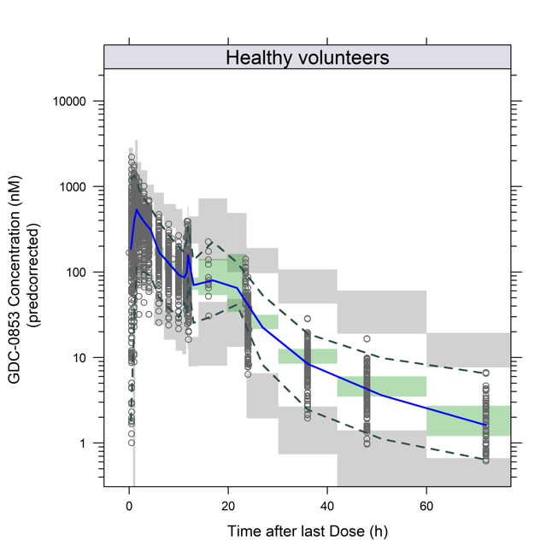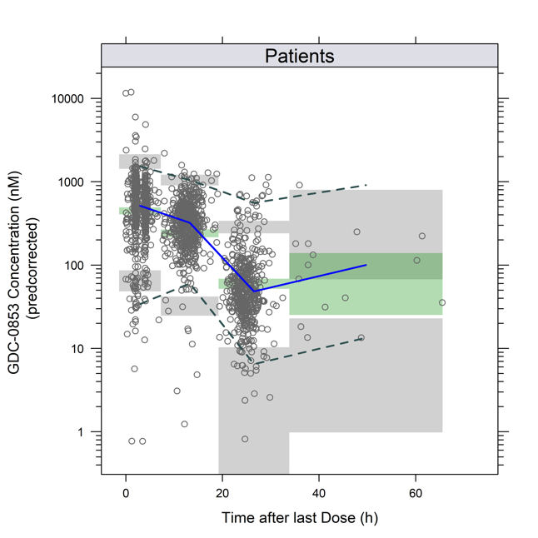
Circles: Observations, Solid Blue Line: Median of the observed fenebrutinib concentrations, Dashed Lines: 2.5th and 97.5th percentiles of the observed fenebrutinib concentrations, Shaded Area: The shaded areas indicate the 95% CI around the prediction-corrected median (green area), and 2.5th and 97.5th percentiles of the simulated concentrations (grey areas).

Figure S3 Distribution of Fenebrutinib Exposure by Dose
Y-axis, fenebrutinib dose group (mg).
Black Dot: Median; Boxes: Interquartile range;
Whiskers: 1.5 times the interquartile range or the full extent of the data, whichever is less.
AUC, area under plasma-drug concentration curve in 24 hours at steady state (ng/mL∙h).
Figure S4 ACR20, ACR50, and ACR70 Simulation for Fenebrutinib (GDC-0853), Adalimumab, and Tofacitinib Treatments in TNF-Inhibitor-Inadequate Response Population
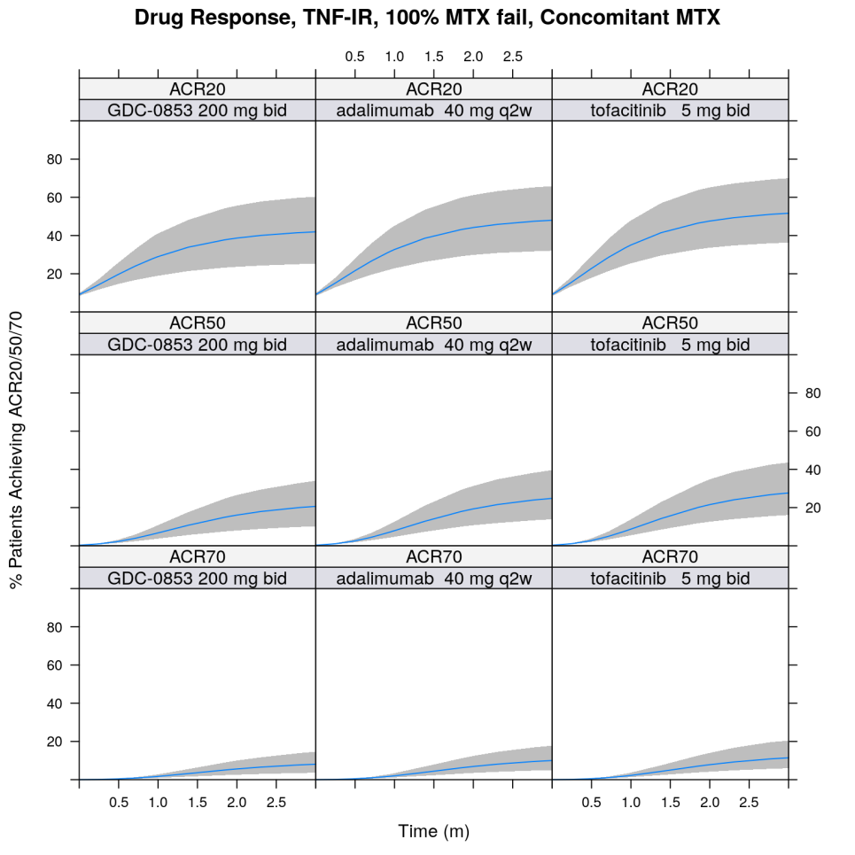
Bands: 90% prediction interval; blue line: median prediction
TNF, tumor necrosis factor; IR, inadequate response; MTX, methotrexate;
bid, twice daily; q2w, once every two weeks.

Model S1: NONMEM Control Stream for Population PK Model
$SUBROUTINE ADVAN13 TRANS1 TOL=10
$MODEL COMP=(CENTRAL,DEFOBS,DEFDOSE) ;
COMP=(PERIPH) COMP=(PERIPH)
$PK

; =========================== DEFINE OCCASIONS ===================== ;

OC1=0
OC2=0
OC3=0
OC4=0
OC5=0
IF(OCC.EQ.1)OC1=1
IF(OCC.EQ.2)OC2=1
IF(OCC.EQ.3)OC3=1
IF(OCC.EQ.11)OC4=1
IF(OCC.EQ.13)OC5=1

; PTAFD STUDY 350: 144 648 650 653 657 1320 1992
IF(STUDY.EQ.29350.AND.PTAFD.EQ.144) OC1 = 1
IF(STUDY.EQ.29350.AND.PTAFD.EQ.648) OC2 = 1
IF(STUDY.EQ.29350.AND.PTAFD.EQ.650) OC3 = 1
IF(STUDY.EQ.29350.AND.PTAFD.EQ.653) OC3 = 1
IF(STUDY.EQ.29350.AND.PTAFD.EQ.657) OC3 = 1
IF(STUDY.EQ.29350.AND.PTAFD.EQ.1320) OC4 = 1
IF(STUDY.EQ.29350.AND.PTAFD.EQ.1992) OC5 = 1

IOVF1=OC1*ETA(10)+OC2*ETA(11)+OC3*ETA(12)+OC4*ETA(13)+OC5*ETA(14)

; ======= DEFINE COVARIATE RELATIONSHIPS ===========================;

;;; CL-AGE DEFINITION
CLAGE = ((AGE/48)**THETA(22))

;;; CL-PAT DEFINITION
HVPAT = 0 ; patients most common
IF(PAT.LT.1) HVPAT=1 ; for healthy
CLPAT = HVPAT*THETA(23)

;;; CL RELATIONS
CLCOV=EXP(CLAGE)*EXP(CLPAT)

; ============= INITIALIZE TIME AND DOSE FOR TCAM MODELING ========= ;

IDX=1000
IF(STUDY.EQ.29347) IDX=2000
IF(STUDY.EQ.29350) IDX=3000
STRT = IDX+FORM*100+FED*10+PPI

IF(NEWIND.NE.2) COM(3) = 0
IF(NEWIND.NE.2) COM(4) = 0
IF(EVID.EQ.1.AND.AMT.NE.0) COM(3) = AMT
DOS=COM(3)

; CALCULATE DOSE INPUT PARAMETERS
IF(NEWIND.NE.2) COM(1) = TIME
IF(EVID.EQ.1) COM(1) = TIME

; ======= DEFINE INDICATOR VARIABLES FOR PPI USE AND FED STATUS ===== ;

PP=0
IF(PPI.EQ.1) PP=1

FOOD=0
IF(FED.EQ.1.AND.PAT.EQ.0) FOOD=1

TAB=0
IF(FORM.EQ.2) TAB=1

; ======================== MODEL PARAMETERIZATION ================== ;

TVLCL = THETA(1)
TVLV2 = THETA(2)
TVLV3 = THETA(3)
TVLQ3 = THETA(4)
TVLV4 = THETA(5)
TVLQ4 = THETA(6)
TVLNTR1 = THETA(7)
TVLMTT1 = THETA(8)
TVF1 = 1

MU_1 = TVLCL
MU_2 = TVLV2
MU_3 = TVLV3
MU_4 = TVLQ3
MU_5 = TVLV4
MU_6 = TVLQ4
MU_7 = TVLNTR1
MU_8 = TVLMTT1

NTRCOV = EXP(FED*THETA(16))*EXP(TAB*THETA(17))

MTTCOV = EXP(FED*THETA(11))*EXP(PPI*THETA(12))*EXP(PPI*FED*THETA(13))

CL = EXP(MU_1+ETA(1)) * EXP(PPI*THETA(20)) * CLCOV
V2 = EXP(MU_2+ETA(2))
V3 = EXP(MU_3+ETA(3))
Q3 = EXP(MU_4+ETA(4))
V4 = EXP(MU_5+ETA(5))
Q4 = EXP(MU_6+ETA(6))
NTR1 = EXP(MU_7+ETA(7))*NTRCOV
MTT1 = EXP(MU_8+ETA(8))*MTTCOV

F1COV = EXP(PPI*THETA(14))*EXP(PPI*FED*THETA(15))
DOSF1 = 1*EXP(ETA(9)+IOVF1)*F1COV
FRAC = 0
F1 = 0

; ================= RATE CONSTANTS =============== ;

K = CL/V2
K23 = Q3/V2
K32 = Q3/V3
K24 = Q4/V2
K42 = Q4/V4
KTR1 = (NTR1+1)/MTT1
KA = KTR1

; ===== TRANSIT COMPARTMENT ABSORPTION MODELING ===== ;

; Stirling approximation to gamma
X = 0.00001
LOGF1 = 0.5*LOG(NTR1*2*3.1415926+X) + NTR1*LOG(NTR1+X) - NTR1 + LOG(1+1/12/NTR1+1/288/NTR1/NTR1+X)
DOS=COM(3)

; ============== DIFFERENTIAL EQUATIONS ============= ;

$DES

TSTAR = T - COM(1)
IF(TSTAR.LT.0.001) TSTAR = 0.001

IF(DOSE.EQ.0) THEN
INP1 = 0
ELSE
X = 0.00001
INP1 = EXP(LOG(DOS*DOSF1*(1-FRAC)+X) + NTR1*LOG(KTR1*TSTAR+X) + LOG(KTR1+X)- KTR1*TSTAR - LOGF1)
ENDIF

IF(INP1<0) INP1=0.000001

DADT(1)=INP1-K23*A(1)+K32*A(2)-K24*A(1)+K42*A(3)-K*A(1)
DADT(2)=K23*A(1)-K32*A(2)
DADT(3)=K24*A(1)-K42*A(3)

; =================== ERROR MODEL ===================== ;

$ERROR
IF (PAT.EQ.0) THEN
ERRMAX = EXP(THETA(19))
ERRMAX=ERRMAX/(1+ERRMAX)
PROPERR = EXP(THETA(9))*(1-ERRMAX * (1- EXP(-EXP(THETA(18))*TAD)))
ELSE
PROPERR = EXP(THETA(21))
ENDIF

IPRED=A(1)/V2
IRES=DV-IPRED
W=SQRT(PROPERR**2*IPRED**2+THETA(10)**2)
IWRES=IRES/W
Y=IPRED+EPS(1)*W

IF(ICALL.EQ.4.AND.Y.LT.0.001) Y=0.001

Model S2: NONMEM Control Stream for ACR E-R Model
$PRED
IF(GEOGUSEUKORLATAM.EQ.1) REGION = 1 ; US
IF(GEOGUSEUKORLATAM.EQ.2) REGION = 2 ; Eastern Europe
IF(GEOGUSEUKORLATAM.EQ.3.OR.GEOGUSEUKORLATAM.EQ.4) REGION = 3 ; Latin america

RF=RFIN
IF(RFIN.EQ.0) RF=124 ; Median RF

IF(REGION.EQ.1) REGCOV = THETA(13) ; Fraction of EMAX
IF(REGION.EQ.2) REGCOV = 1 ; Eastern Europe most common
IF(REGION.EQ.3) REGCOV = THETA(14) ; Fraction of EMAX, Latin America

RFCOV = (RF/124)**THETA(15) ; RF centered on median
;--------------------------------------
IDX=0
IF(DOSE.GT.0) IDX=1

ACR20=0
ACR50=0
ACR70=0

IF(TYPE.EQ.10) ACR20=1
IF(TYPE.EQ.14) ACR50=1
IF(TYPE.EQ.18) ACR70=1

; add markovian element
MARKOV = THETA(4)*PDV

TVBASE=THETA(1)*ACR20+THETA(2)*ACR50+THETA(3)*ACR70
HILL=EXP(THETA(12))
TVLET50=THETA(8)*ACR20+THETA(11)*ACR50+THETA(11)*ACR70
TMAX = THETA(7)*(DAY**HILL)/((DAY**HILL)+EXP(TVLET50)**HILL)
TVLOGIT=TVBASE

DEFF = THETA(9)*REGCOV *RFCOV *AUC/(AUC+EXP(THETA(10)))

;IF(COHORT.EQ.2) DEFF = THETA(11)*AUC/(AUC+EXP(THETA(12)))
LOGIT = TVLOGIT+TMAX+DEFF+MARKOV+ETA(1)
A=EXP(LOGIT)
P=A/(1+A)

IF(P.LT.0.00001) P=0.00001
IF(P.GT.0.99999) P=0.99999

IF (DV.GT.0.5) THEN
Y=P
ELSE
Y=1-P
ENDIF

Model S3: NONMEM Control Stream for DAS28 E-R Model
$PRED

EAUC50 = EXP(THETA(5))

TVC = THETA(1)
TVTMAX = THETA(2)+THETA(6)*AUC/(EAUC50+AUC)
LNET50 = THETA(3)
LNED50 = THETA(4)

C = TVC * EXP(ETA(1))
TMAX = TVTMAX * EXP(ETA(2))
ET50 = EXP(LNET50)
ED50 = EXP(LNED50)

THILL = 1
IF(DOSE.GT.0) TMTEFF = (TMAX*(DAY**THILL)) / (DAY**THILL + ED50**THILL)
IF(DOSE.EQ.0) TMTEFF = (TMAX*(DAY**THILL)) / (DAY**THILL + ET50**THILL)
DEFF = 0

IPRED = C + TMTEFF + DEFF

Y = IPRED + EPS(1)
IRES = DV - IPRED

Data S1: R Code for MBMA Model
nlme.acrxx.4.124 = nlme.run(logit.acrxx ~ base.20*(endpoint=="ACR20") + base.50*(endpoint=="ACR50") +
base.70*(endpoint=="ACR70") +
(acr.f(eff.20,eff.50,eff.70,endpoint) + eta1 + eta2 +
(drug1.name.clean == "abatacept")*(aba.slope*drug1.gendose) +
(drug1.name.clean == "etanercept")*((etan.emax*drug1.gendose)/
(drug1.gendose+exp(etan.ln.ed50))) +
(drug1.name.clean == "ixekizumab")*(ixe.slope*drug1.gendose) +
(drug1.name.clean == "tocilizumab")*(toc.slope*drug1.gendose) +
(drug1.name.clean == "adalimumab")*(ada.emax*drug1.gendose)/
(drug1.gendose + exp(ada.ln.ed50)) +
(drug1.name.clean == "ocrelizumab") * (ocre.const) +
(drug1.name.clean == "tofacitinib") * (tofa.emax*drug1.gendose)/(drug1.gendose + exp(tofa.ln.ed50)) +
(drug1.name.clean == "atacicept") * (ata.const) +
(drug1.name.clean == "GDC-0853") * (gdc.emax*drug1.gendose)/(drug1.gendose + 525) +
(x.tnf.ir.cat == ">80")*tnf.ir.high +
mtx.fail*mtx.fail.slp + con.mtx*con.mtx.eff
) * (1 - exp(-(rate + eta3)*time.clean)),
data = model.ds.2new,
fixed = list(base.20 + base.50 + base.70 + eff.20 + eff.50 + eff.70 + rate + ada.emax +
ada.ln.ed50 + tofa.emax + tofa.ln.ed50 + aba.slope + etan.emax + etan.ln.ed50 +
ixe.slope + toc.slope + ata.const + ocre.const + tnf.ir.high + gdc.emax +
mtx.fail.slp + con.mtx.eff ~ 1),
start = c(base.20=-2.2,base.50 = -4.8, base.70 = -7.7, eff.20=0.5, eff.50=-1, eff.70=-0.4,
rate=1.175, tofa.emax = 2, tofa.ln.ed50 = 4, ada.emax = 1,
ada.ln.ed50 = 1.5, aba.slope = 0.01, etan.emax = 2, etan.ln.ed50 = 2.5,
ixe.slope = 0.01,
toc.slope = 0.01, ata.const = 0.01, ocre.const = 1,
tnf.ir.high = -0.9, gdc.emax = 1, mtx.fail.slp=0.01, con.mtx.eff=0.01),
random = list(reference.id.clean = eta1 ~ 1,
arm.id = eta2 ~ 1,
drug1.name.clean = eta3 ~ 1),
)

