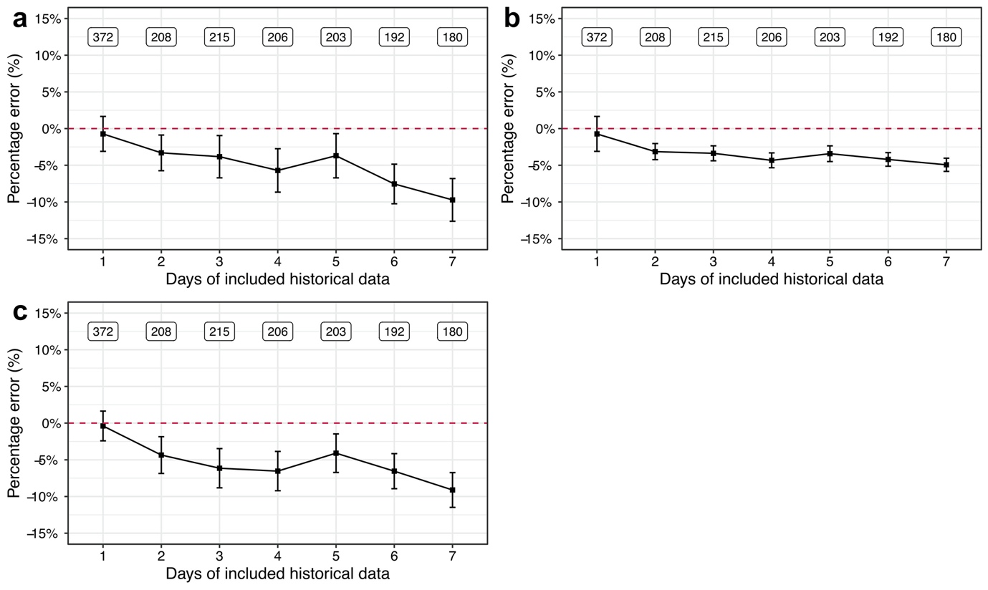
Figure S1. The percentage error of Bayesian forecasting using the standard MAP method (a), the adaptative MAP method (b), and the weighted MAP method using optimal weighting factors $ΔT_{Ref}$=4 and $α$=2 (c). The squares are the mean values, and the bars represent lower and upper boundaries of 95% confidence interval. The labeled text is the number of patients that were included for the calculation.

NONMEM control stream

Adaptive MAP estimation (First iteration)

$PROBLEM PK
$INPUT C DROP ID TIME DROP AMT RATE ADDL II CMT DV EVID AGE SEX WGT MDRD DROP OCCDAYSN DROP SCE SINGLE ETACL ETAV

$DATA ./LN_prior_1.csv IGNORE=C IGNORE=(OCCDAYSN.GT.1)

$SUBROUTINES ADVAN1 TRANS2

$PK
TVCL = THETA(1) * MDRD/100
TVV = THETA(2) * WGT

IF(NEWIND.NE.2) THEN
OETACL = ETACL
OETAV = ETAV
ENDIF

CL = TVCL * EXP(OETACL + ETA(1))
V = TVV * EXP(OETAV + ETA(2))

OETACL = ETACL
OETAV = ETAV

S1 = V

$ERROR
IPRED = F
W = 1
IRES = DV - IPRED
IWRES = IRES/W
Y = IPRED + IPRED*EPS(1) + EPS(2)

$THETA
4.58 ; TVVL (L/h)
1.53 ; TVV (L/kg)

$OMEGA
0.151321 ; omega^2 CL
0.139876 ; omega^2 V

$SIGMA
0.039601 ; Prop
5.76 ; Add

$EST METHOD=1 INTER MAXEVAL=0 NOABORT SIG=3 PRINT=1
$TABLE ID EVID ETA(1) ETA(2) ONEHEADER NOPRINT FILE=eta_LN_prior_1.tab

Weighted MAP estimation

$PROBLEM PK

$INPUT C OID ID TIME DROP AMT RATE ADDL II CMT DV EVID AGE SEX WGT MDRD OCCDAY DROP DROP SCE SINGLE MAXOCCDAY

$DATA ./LN_weight.csv IGNORE=C IGNORE=(C==2) IGNORE=(SINGLE==1)

$SUBROUTINES ADVAN1 TRANS2

$PK
TVCL = THETA(1) * MDRD/100
TVV = THETA(2) * WGT

CL = TVCL * EXP(ETA(1))
V = TVV * EXP(ETA(2))

S1 = V

$ERROR
YHAT = F
VARA = 5.76
VARP = 0.039601
VAR = VARA + VARP*YHAT**2

REF = 1
A = 1
W = REF/(MAXOCCDAY-OCCDAY)

Y = (1/SQRT(2*3.1415926*VAR)*EXP(-(DV-YHAT)**2/(2*VAR)))**(W**A)

$THETA
4.58 FIX ; TVVL (L/h)
1.53 FIX ; TVV (L/kg)

$OMEGA
0.151321 FIX ; omega^2 CL
0.139876 FIX ; omega^2 V

$EST METHOD=COND LAPLACE LIKE MAXEVAL=0 NOABORT PRINT=1

$TABLE ID EVID SINGLE SCE W ETA(1) ETA(2) ONEHEADER NOPRINT FILE=eta_r1a1.tab

