Supplementary information
Fcγ receptor-dependent internalization and off-target cytotoxicity of antibody-drug conjugate aggregates
Michihiko Aoyama^{1,*}, Minoru Tada¹, Hidetomo Yokoo², Yosuke Demizu², Akiko Ishii-Watabe¹

¹Division of Biological Chemistry and Biologicals, National Institute of Health Sciences, 3-25-26 Tonomachi, Kawasaki-ku, Kawasaki, Kanagawa, 210-9501, Japan
²Division of Organic Chemistry, National Institute of Health Sciences, 3-25-26 Tonomachi, Kawasaki-ku, Kawasaki, Kanagawa, 210-9501, Japan

*Corresponding author
Michihiko Aoyama, PhD
Division of Biological Chemistry and Biologicals, National Institute of Health Sciences, 3-25-26 Tonomachi Kawasaki-ku, Kawasaki, 210-9501, Kanagawa, Japan
Tel: +81-44-270-6515
Fax: +81-44-270-6517
E-mail: aoyama-m@nihs.go.jp
SI Table
Table S1. IC₅₀ (nM) of trastuzumab, T-DM1, and T-DXd in HER2-positive or -negative cells
 |  | HER2⁺ cell | HER2⁻ cell
 |  | SK-BR-3 | Jurkat | MEG01-S | THP-1 | TMNK-1
trastuzumab | native | 0.57
trastuzumab | stir | 5.19
trastuzumab | 90ºC | 13.90
T-DM1 | native | 0.09 | 57.7 | 98.8 |  | 11.2
T-DM1 | stir | 0.29 | 37.0 | 15.7 | 5.6
T-DM1 | 90ºC | 2.96 | 73.6 | 225.1 | 12.4
T-DXd | native | 0.18 |  | 194.8 | 498.6 | 126.8
T-DXd | stir | 0.48 | 602.0 | 0.6 | 0.6
T-DXd | 90ºC | 3.83 | 543.2 | 311.2 | 2.7
IC₅₀ (nM) of trastuzumab, T-DM1, T-DXd was calculated with non-linear fitting (4-parameter logistic fitting). Diagonal lines mean IC₅₀ could not be calculated with non-linear fitting.

SI Figure
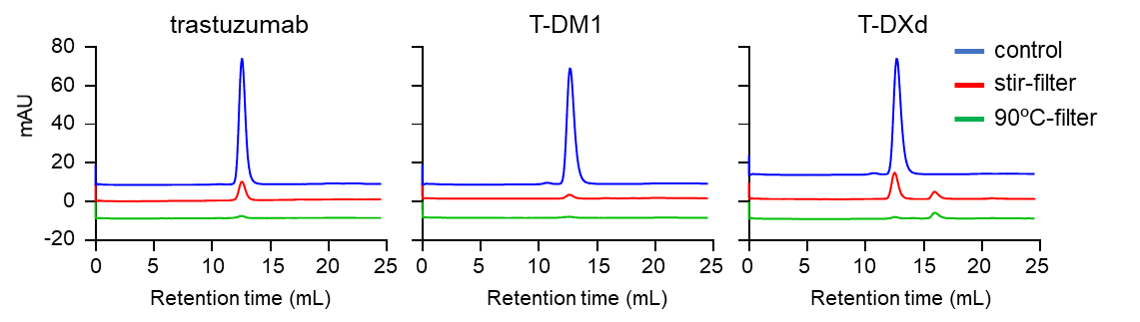

Relative amount (%) of each peak (vs total peak area of control)
 | control |  |  | stir-filter |  |  | 90ºC-filter
 | HMWS | mono  -mer | fragment | HMWS | mono  -mer | fragment | HMWS | mono  -mer | fragment
trastuzumab | — | 99.6 | — | — | 15.5 | — | — | 2.2 | —
T-DM1 | 1.2 | 98.8 | — | — | 3.2 | — | — | 1.3 | —
T-DXd | 1.0 | 99.0 | — | — | 20.6 | 5.9 | — | 1.4 | 5.6

Figure S1. Size exclusion chromatography (SEC) analysis of filtered samples of ADC aggregates
The control (non-stressed) and filtered samples of stirring- and -thermal-stress induced aggregates of trastuzumab, T-DM1, and T-DXd were analyzed by SEC using a Superdex 200 Increase 10/300 GL column. The relative amounts of HMWS, monomer, and fragments in each sample were calculated from peak area. — indicated that relative amount was lower than 1.0% of total peak area of control samples.

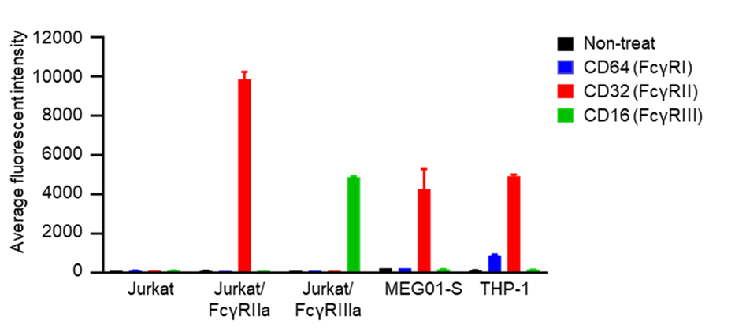
Figure S2. FcγRs-expression in the cell lines derived from immune cells
The expression of FcγRs (FcγRI, FcγRII, and FcγRIII) in Jurkat, Jurkat/ FcγRs/NFAT-Luc reporter cells, MEG01-S, and THP-1 cells was evaluated by flowcytometry analysis. The cells were stained with FITC-labelled anti-CD64 antibody, anti-CD32 antibody, or anti-CD16 antibody, and fluorescent intensities were measured by a flow cytometer. The data represent the means ± standard deviation (n=3).

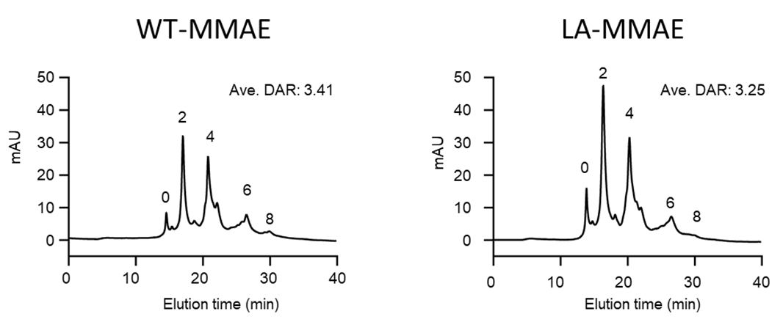
Figure S3. Hydrophobic interaction chromatography analysis of anti-HER2 mAb-based ADCs
The drug antibody ratios (DARs) of anti-HER2 mAb-based ADCs were analyzed by hydrophobic interaction chromatography (HIC) using a BSK-gel Butyl NPR column. The 5 peaks (DAR: 0, 2, 4, 6, and 8) were identified in HIC chromatograms of anti-HER2 mAb-based ADCs (WT-MMAE and LA-MMAE) obtained by a UV detector (280 nm). The average DAR was calculated from the area percentage in a chromatogram.

