On-line resource: Supplementary Figures S1 -S7

Fig. S1 XRD pattern images for Lactose Monohydrate, Naloxone HCl and Naloxone HCl microparticles

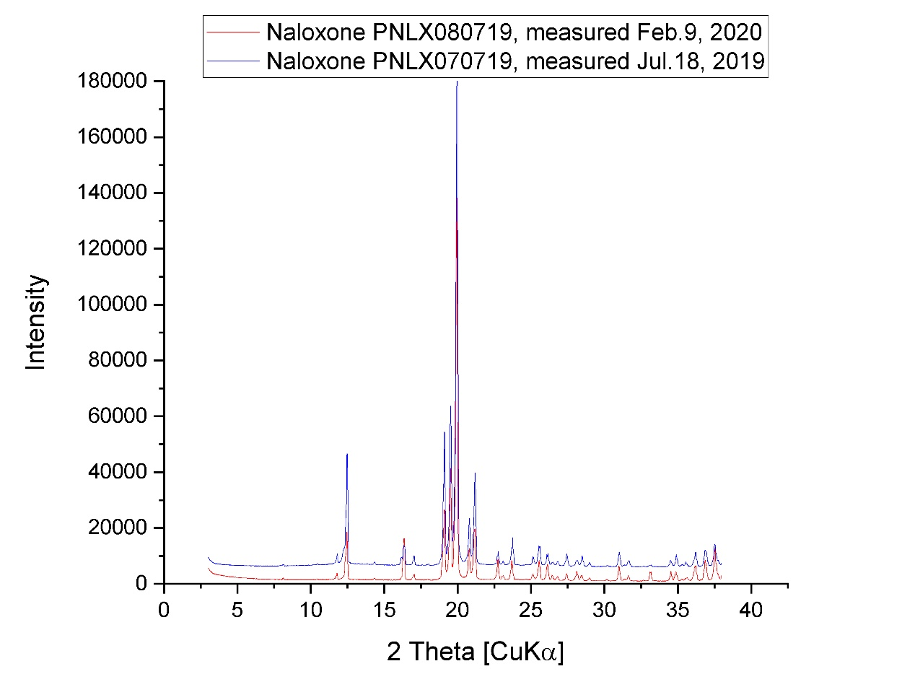
Fig. S2 XRD pattern images for Initial Naloxone microsphere powder (lower) and stored for 6 months (upper)

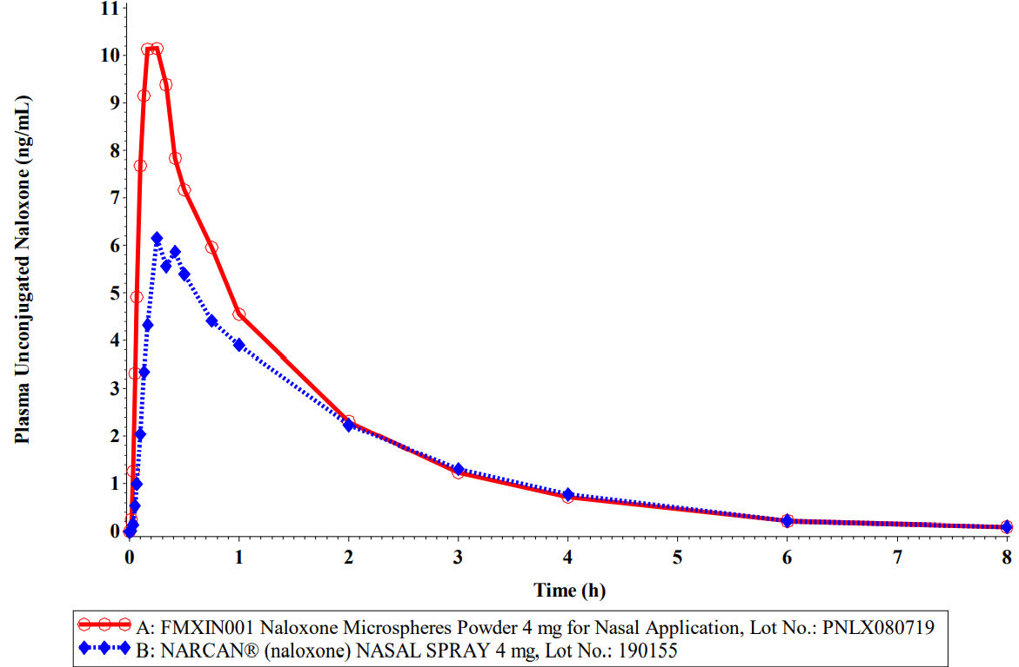
Fig. S3 Pilot Study Mean Plasma Unconjugated Naloxone Concentration-Time Profile: Linear Scale (A: n = 14 / B: n = 14)

Fig. S4 Mean (±SD) Plasma Unconjugated Naloxone Concentration-Time Profile Linear Scale (A: n = 42 / B: n = 42)

Fig. S5 Mean (±SD) Plasma Unconjugated Naloxone Concentration-Time Profile Semi-Log Scale (A: n = 42 / B: n = 42)

Fig. S6: Mean (±SD) Plasma Unconjugated Naloxone Concentration-Time Profile Linear Scale (A: n = 42 / B: n = 42)

Fig. S7: Mean (±SD) Plasma Unconjugated Naloxone Concentration-Time Profile Semi-Log Scale (A: n = 42 / B: n = 42)

