Supplemental Figures
Legend:
Figure S1: Ulotaront disappearance following incubation with human liver microsomes at 1, 10, and 100 μM.
Figure S2: Inhibition of transporter-mediated uptake of metformin (10 µM). The inhibition on OCT1-mediated uptake was determined in the presence of ulotaront at 1 to 750 µM, and the inhibition on OCT2-mediated uptake was determined in the presence of ulotaront at 0.4 to 300 µM. Data are presented as mean ± S.D.
Figure S3: Ulotaront and SEP-383103 mouse plasma and brain PK profiles following a single oral dose of 10 mg/kg ulotaront. Concentrations are presented as mean ± S.D.

Figure S1
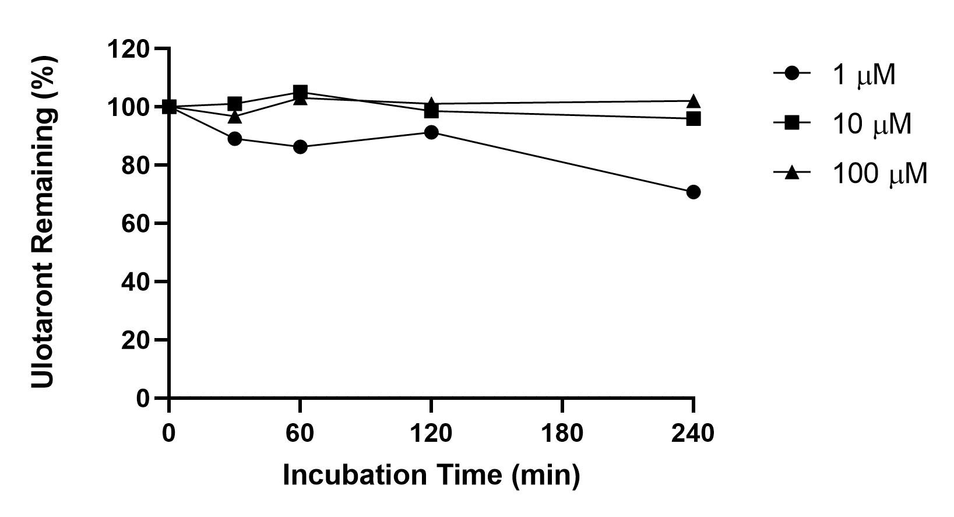

Figure S2

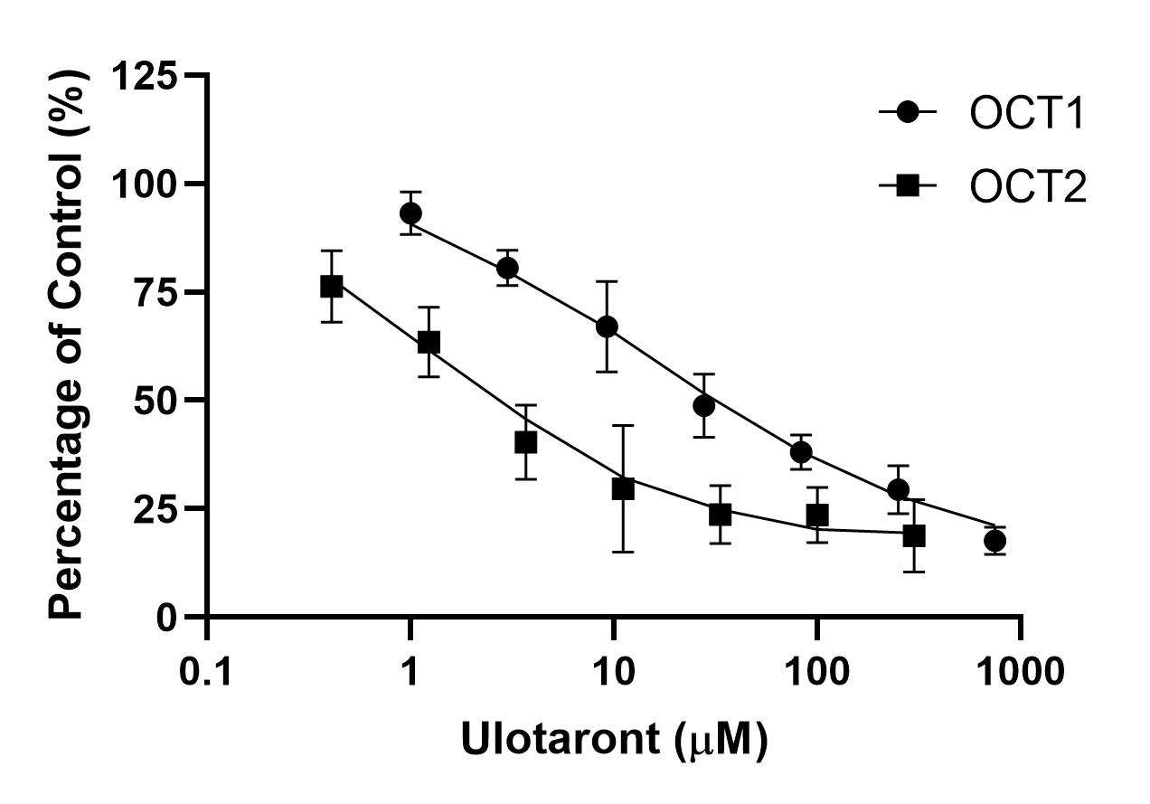

Figure S3
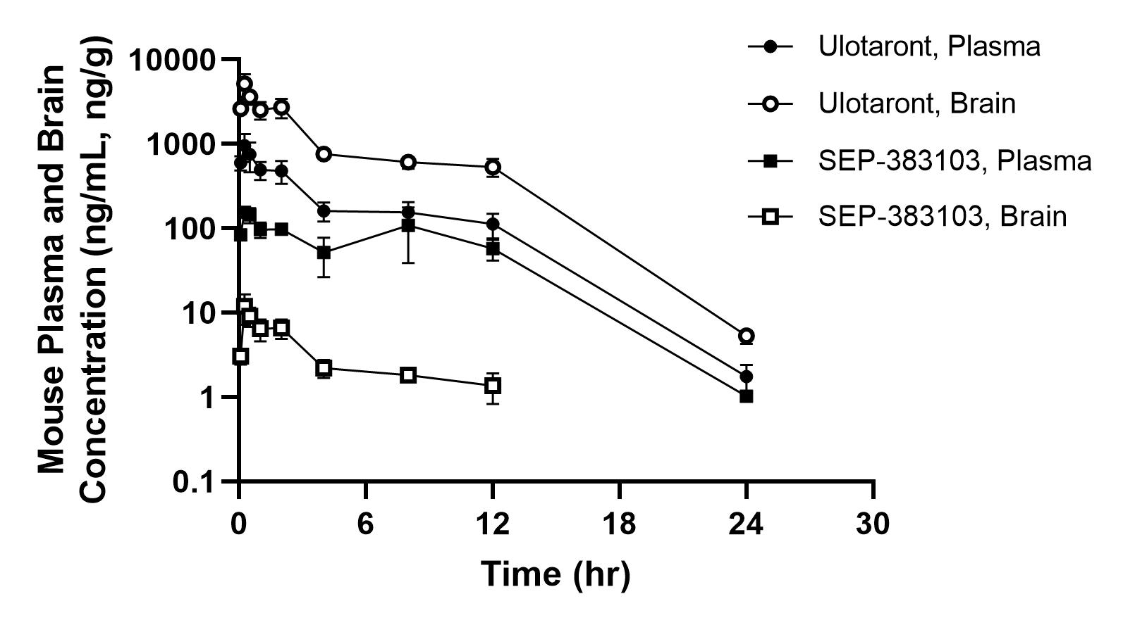

Supplemental Tables
Table S1: Probe Substrates and Prototypical Inhibitors Used for CYP Inhibition Assays
CYP Isoform | Substrate | Direct Control Inhibitor | TDI Control Inhibitor
 | Ulotaront CYP Inhibition Assay
CYP1A2 | Phenacetin | α-Naphthoflavone | Furafylline
CYP2A6 | Coumarin | Nicotine | 8-Methoxypsoralen
CYP2B6 | Efavirenz | Orphenadrine | Phencyclidine
CYP2C8 | Amodiaquine | Montelukast | Gemfibrozil glucuronide
CYP2C9 | Diclofenac | Sulfaphenazole | Tienilic acid
CYP2C19 | S-Mephenytoin | Modafinil | S-Fluoxetine
CYP2D6 | Dextromethorphan | Quinidine | Paroxetine
CYP2E1 | Chlorzoxazone | 4-Methylpyrazole | 3-Amino-1,2,4-triazole
CYP3A4/5 | Testosterone | Ketoconazole | Troleandomycin
CYP3A4/5 | Midazolam | Ketoconazole | Troleandomycin
CYP4A11 | Lauric acid | 10-IDA | 1-Aminobenzotriazole
 | SEP-383103 CYP Inhibition Assay
CYP1A2 | Phenacetin | 7,8-Benzoflavone | Furafylline
CYP2B6 | Bupropion | Ketoconazole | Ticlopidine
CYP2C8 | Amodiaquine | Montelukast | Gemfibrozil glucuronide
CYP2C9 | Diclofenac | Sulfaphenazole | Tienilic acid
CYP2C19 | S-Mephenytoin | S-Benzylnirvanol | S-Fluoxetine
CYP2D6 | Dextromethorphan | Quinidine | Paroxetine
CYP3A4/5 | Testosterone | Ketoconazole | Azamulin
CYP3A4/5 | Midazolam | Ketoconazole | Azamulin

Table S2: Probe Substrates and Prototypical Inhibitors for Transporter Assays
Transporter | Substrate | Inhibitor
 | Ulotaront Transporter Assay
OCT1 | Metformin | Verapamil
OCT2 | Metformin | Verapamil
MATE1 | Metformin | Pyrimethamine
MATE2K | Metformin | Pyrimethamine
OAT1 | Tenofovir | Probenecid
OAT3 | Estrone-3-sulfate | Probenecid
OATP1B1 | Estradiol-17-β-glucuronide | Rifampicin
OATP1B3 | Cholecystokinin octapeptide | Rifampicin
P-gp | Digoxin | Valspodar
BCRP | Estrone-3-sulfate | Ko143
BSEP | Taurocholate | Cyclosporin A
 | SEP-380103 Transporter Assay
OCT1 | Tetraethylammonium | Quinidine
OCT2 | Metformin | Quinidine
MATE1 | Tetraethylammonium | Cimetidine
MATE2K | Tetraethylammonium | Cimetidine
OAT1 | para-Aminohippurate | Probenecid
OAT3 | Estrone-3-sulfate | Probenecid
OATP1B1 | Estradiol-17-β-glucuronide | Cyclosporine A
OATP1B3 | Cholecystokinin octapeptide | Cyclosporine A
P-gp | Digoxin | Zosuquidar
BCRP | Estrone-3-sulfate | Ko143

Table S3: Ulotaront Plasma Protein Binding, Reb Blood Cell Partitioning, and Hepatocyte Stability
Species | fu (%) | RBC | CL_{int} (mL/min/kg) | CL_{hep} (mL/min/kg)
Mouse | 80.6 | 0.89 | 12.0 | 9.8
Rat | 78.7 | 0.90 | 6.9 | 5.5
Dog | 79.2 | 1.16 | 42.9 | 15.5
Monkey | 85.9 | 1.12 | 13.4 | 8.3
Human | 77.5 | 1.14 | 7.2 | 3.9

Table S4: Ulotaront Permeability across Caco-2 Monolayers
Ulotaront (µM) | Incubation Time (min) | P_{app}A-B (10⁻⁶ cm/s) | P_{app}B-A (10⁻⁶ cm/s) | Efflux Ratio
1 | 45 | 26.7 | 29.7 | 1.1
1 | 90 | 23.0 | 28.7 | 1.2
1 | 120 | 22.0 | 29.3 | 1.3
10 | 45 | 26.0 | 28.3 | 1.1
10 | 90 | 24.0 | 27.7 | 1.2
10 | 120 | 22.7 | 28.3 | 1.3
100 | 45 | 27.3 | 29.0 | 1.1
100 | 90 | 25.3 | 28.3 | 1.1
100 | 120 | 23.7 | 28.7 | 1.2

