Supplement
Table S1: Maximum concentrations of voriconazole and voriconazole N-oxide in plasma and interstitial space fluid of four healthy male adults with different CYP2C19 genotype-predicted phenotypes for the respective dosing interval.
CYP2C19 metabolizer | Maximum concentration [µmol/L]
CYP2C19 metabolizer | Plasma |  |  | Interstitial space fluids
CYP2C19 metabolizer | Dosing interval |  |  | Dosing interval
CYP2C19 metabolizer | 1 | 5 | 7 | 1 | 5 | 7
Voriconazole
Rapid metabolizer | 5.54 | 6.73 | 7.24 | 2.30 | 2.69 | 2.27
Normal metabolizer | 6.43 | 9.48 | 9.31 | 2.77 | 4.40 | 3.20
Rapid/poor metabolizer | 7.33 | 10.7 | 11.6 | 2.75 | 5.20 | 4.95
Intermediate metabolizer | 7.68 | 12.8 | 14.9 | 1.97 | 8.37 | 7.34
Voriconazole N-oxide
Rapid metabolizer | 9.09 | 14.9 | 13.1 | 2.37 | 4.12 | 4.24
Normal metabolizer | 7.84 | 13.5 | 11.2 | 2.55 | 5.21 | 5.47
Rapid/poor metabolizer | 6.28 | 9.33 | 10.6 | 1.56 | 2.97 | 3.81
Intermediate metabolizer | 5.54 | 9.29 | 9.19 | 0.338 | 0.651 | 0.791

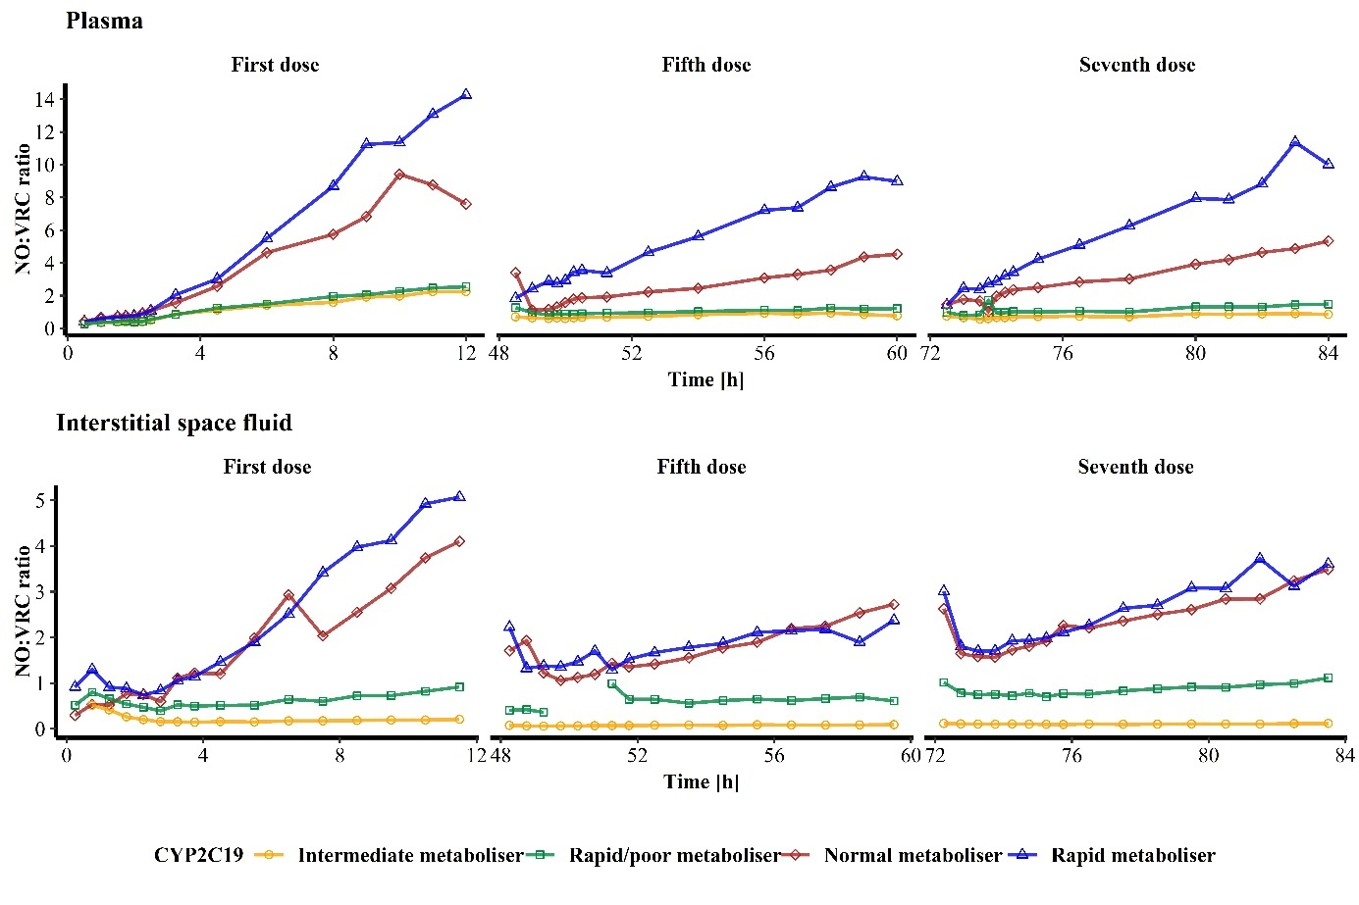
Figure S1: Metabolic ratio over time of voriconazole N-oxide (NO) to voriconazole (VRC) concentrations in plasma (upper panel) and interstitial space fluid (lower panel) after the first, fifth and seventh VRC dose administration to four healthy volunteers with different CYP2C19 genotype-predicted phenotypes. Time is presented as hours after the first VRC dose administration.

