SUPPLEMENTAL INFORMATION
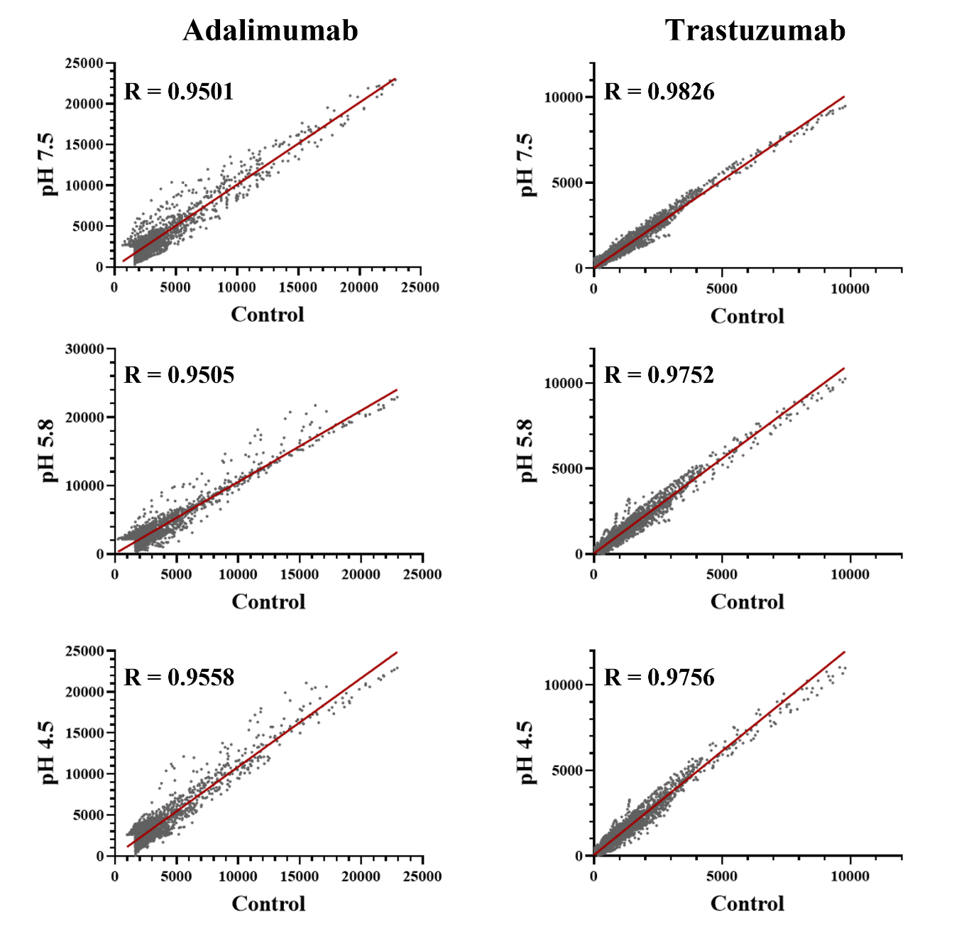
Figure S1: ECHOS plots of control spectrum intensities versus the spectra intensity of forced degraded samples for adalimumab (left) and trastuzumab (right). The ECHOS plots for the control and the forced degraded sample at pH 7.5 (top), pH 5.8 (middle), and pH 4.5 (bottom) are shown where the gray points are the intensity cross correlation points, and the red line is the line of best fit. The R values recorded are the measure of goodness of fit calculated by MBioHOS for each corresponding plot.

