Characterizing the Effect of Relative Humidity and Ethanol Content on Aerosols Generated from a Soft Mist Inhaler - Supplementary

Yiliang Lance Jiang¹, Jose R. Ruiz², Richard Friend², Jonathan P. Reid^{1,*}

- University of Bristol, School of Chemistry, Cantock’s Cl, Bristol, BS8 1TS, United Kingdom
- Chiesi Ltd., 1 Bath Road Industrial Estate, Bath Rd, Chippenham, SN14 0AB, United Kingdom

* - Corresponding author: j.p.reid@bristol.ac.uk

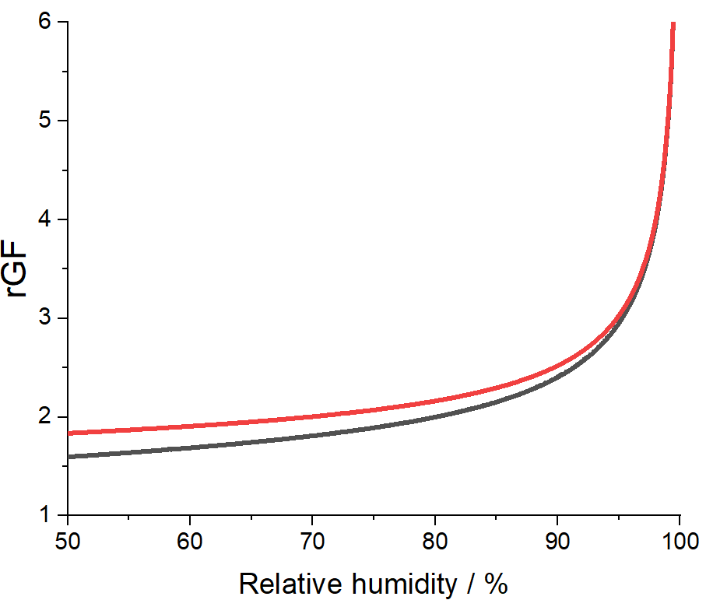
Figure S1 – Geometric rGF curve (black line) for NaCl derived from CK-EDB data and the aerodynamic rGF curve (red line) incorporating AIOMFAC output and density parameterization.

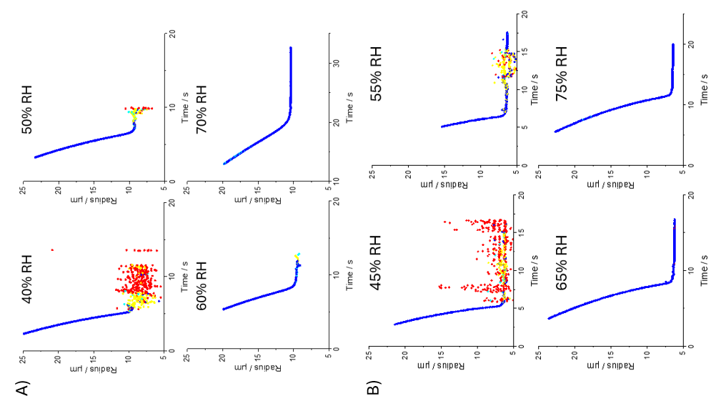
Figure S2 – Phase function data obtained from CK-EDB with A) 2% w/w mannitol in pure water, and B) 2% w/w salbutamol sulphate in pure water. The colour indicates particle type: blue is homogeneous, yellow is inclusions and red is crystallized.

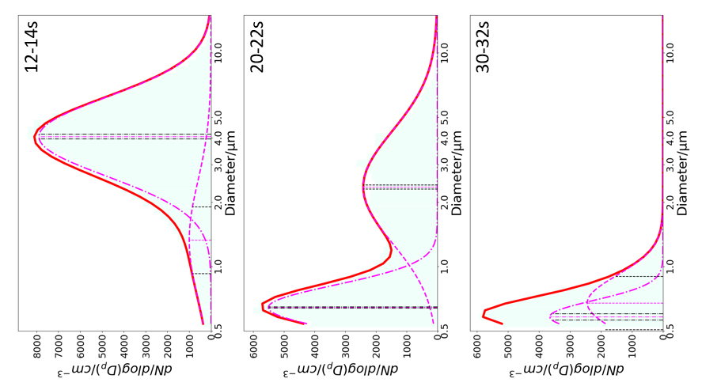
Figure S3 – 2% w/w mannitol (0% ethanol content) TAPS size distribution at different time points during plume development at 85% RH.

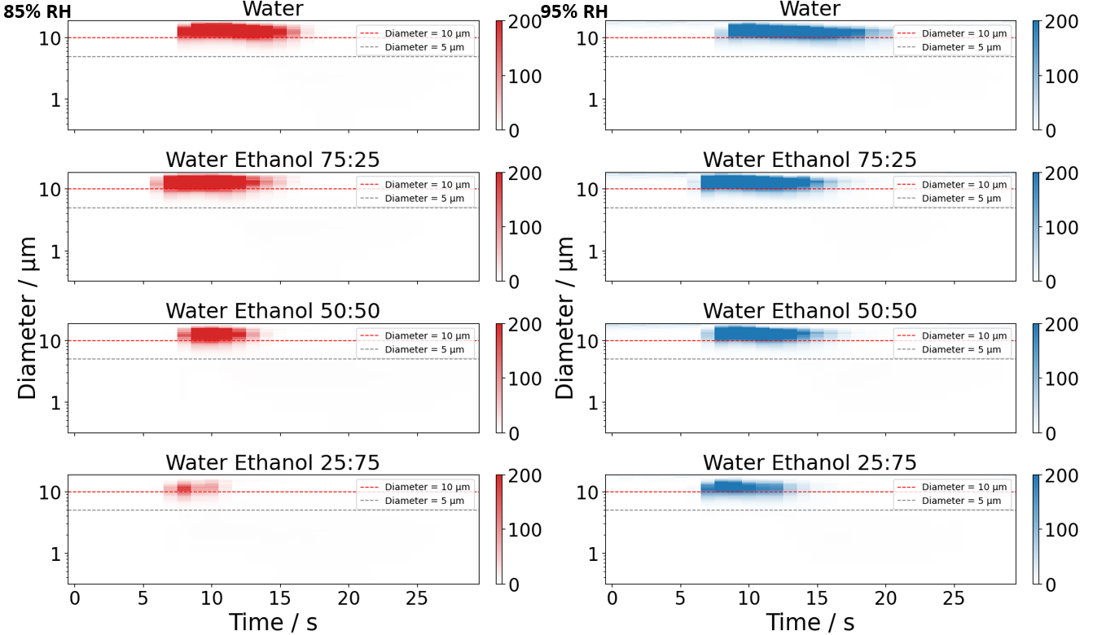
Figure S4 – Plume development obtained from the TAPS size distribution data with 1 second time resolution of 2% w/w mannitol with 0 – 75% v/v ethanol content at 85% RH (left column) and 95% RH (right column). The colour bar represents the mass concentrations (dM / dlog(D_{p}) / cm⁻³).

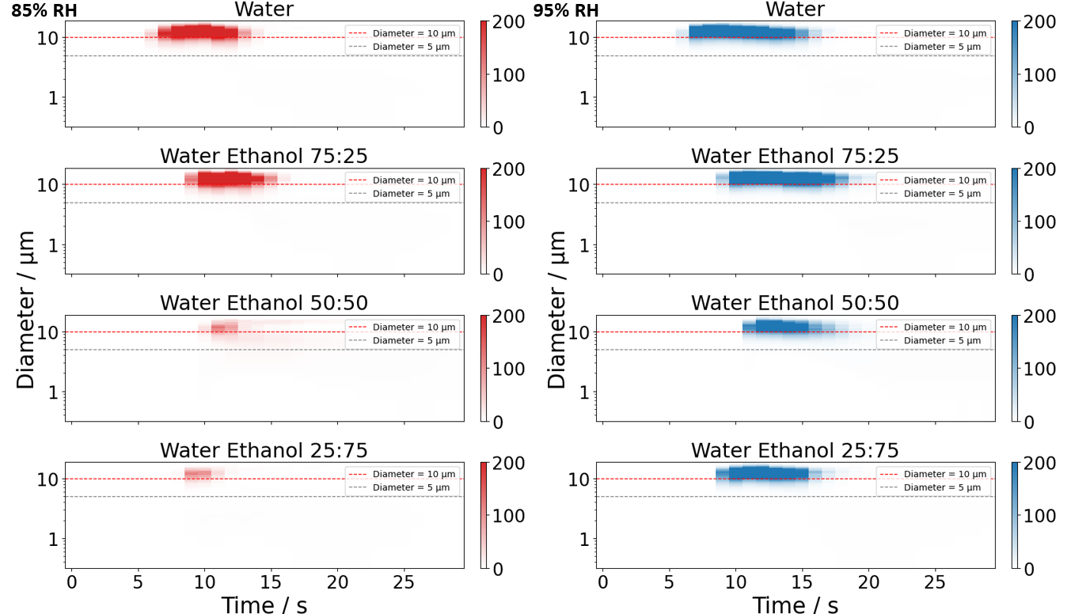
Figure S5 - Plume development obtained from the TAPS size distribution data with 1 second time resolution of 2% w/w salbutamol sulphate with 0 – 75% v/v ethanol content at 85% RH (left column) and 95% RH (right column). The colour bar represents the mass concentrations (dM / dlog(D_{p}) / cm⁻³).

