Changes in the fraction metabolized in children younger than four years; when is clearance scaling for the dominant elimination route in adults appropriate?

Anne van Rongen¹; Robbin Grijseels¹; Elisa A.M. Calvier²; Karel Allegaert^{3,4,5}; Catherijne A.J. Knibbe^{1,6}; Elke H.J. Krekels^{1,7}

1. Division of Systems Pharmacology and Pharmacy, Leiden Academic Center for Drug Research, Leiden University, Leiden, the Netherlands
2. Pharmacokinetics-Dynamics and Metabolism, Translational Medicine and Early Development, Sanofi R&D, Montpellier, France.
3. Department of Development and Regeneration, KU Leuven, Leuven, Belgium.
4. Department of Pharmaceutical and Pharmacological Sciences, KU Leuven, Leuven, Belgium.
5. Department of Hospital Pharmacy, Erasmus MC, Rotterdam, Netherlands.
6. Department of Clinical Pharmacy, St. Antonius Hospital, Nieuwegein and Utrecht, The Netherlands.
7. Certara Inc, Princeton, NJ, USA

Corresponding author: Elke H.J. Krekels (elke.krekels@certara.com)

Supplemental table 1. Overview of model parameters used for the typical individuals in the virtual population.
Parameter value [unit] | Typical individuals
Age | 1 day | 2 weeks | 1 month | 6 months | 1 year | 2 years | 4 years | 25 years
PMA [weeks] | 40.1 | 42.1 | 44.3 | 66.0 | 92.0 | 144.0 | 248.0 | 1340.0
Bodyweight [kg] ª | 3.47 | 3.90 | 4.29 | 7.57 | 9.92 | 12.37 | 16.01 | 72.65
Height  [cm] ª | 49.6 | 52.2 | 54.1 | 66.1 | 74.7 | 85.7 | 101.5 | 172.3
BSA [m²] ^{b} | 0.223 | 0.242 | 0.258 | 0.380 | 0.461 | 0.548 | 0.665 | 1.857
HSA [g/L] ^{c} | 33.7 | 36.8 | 37.6 | 39.6 | 40.4 | 41.2 | 42.0 | 44.0
AAG [g/L] ^{c} | 0.269 | 0.487 | 0.545 | 0.6730 | 0.713 | 0.747 | 0.775 | 0.828
Liver weight [g] ^{c} | 133.2 | 147.0 | 158.6 | 249.6 | 313.3 | 384.2 | 482.7 | 1614.2
MPPGL ^{d} | 25.53 | 25.57 | 25.60 | 25.99 | 26.45 | 27.36 | 29.12 | 39.79
hematocrit [%] ^{d} | 51.9 | 41.7 | 38.1 | 35.1 | 35.8 | 36.8 | 36.8 | 40.7
Qh  [mL/min] ^{c} | 142.8 | 155.7 | 166.6 | 252.3 | 316.6 | 401.7 | 548.7 | 1705.0
GFR [mL/min] ^{e} | 4.30 | 5.21 | 6.20 | 17.6 | 27.4 | 35.9 | 43.8 | 114.7
MF [%] ^{f}
CYP1A2 ^{d} | 24 | 28 | 35 | 118 | 150 | 164 | 166 | 100
CYP2A6 ^{d} | 2.1∙10⁻⁹ | 1.1∙10⁻² | 0.48 | 99 | 100 | 100 | 100 | 100
CYP2B6 ^{d} | 15 | 17 | 19 | 34 | 47 | 62 | 78 | 100
CYP2C8 ^{d} | 38 | 77 | 86 | 97 | 99 | 99 | 100 | 100
CYP2C9 ^{d} | 40 | 68 | 74 | 87 | 90 | 92 | 100 | 100
CYP2C18 ^{d} | 30 | 31 | 33 | 84 | 95 | 97 | 98 | 100
CYP2C19 ^{d} | 30 | 31 | 33 | 84 | 95 | 97 | 98 | 100
CYP2D6 ^{d} | 6 | 32 | 47 | 84 | 91 | 95 | 98 | 100
CYP2E1 ^{d} | 10 | 29 | 37 | 59 | 67 | 74 | 80 | 100
CYP3A4 ^{d} | 11 | 11 | 13 | 48 | 78 | 96 | 103 | 100
UGT1A1 ^{d} | 0.2 | 7 | 23 | 98 | 104 | 100 | 100 | 100
UGT1A4 ^{d} | 74 | 74 | 74 | 74 | 75 | 77 | 80 | 100
UGT1A6 ^{d} | 15 | 23 | 30 | 63 | 76 | 87 | 94 | 100
UGT1A9 ^{d} | 9 | 10 | 12 | 34 | 52 | 71 | 86 | 100
UGT2B7 ^{d} | 8 | 9 | 9 | 11 | 13 | 18 | 27 | 100
SULT1A1 ^{g} | 100 | 100 | 100 | 100 | 100 | 100 | 100 | 100
AGP = concentration α1-acid glycoprotein; BSA = body surface area; HSA = concentration human serum albumin; MPPGL = milligram protein per gram of liver; PMA = post menstrual age; Qh = hepatic blood flow;
ª Average value from males and females from CDC growth chart
^{b} According to Haycock et al. (J Pediatr. 1978 ;93(1) : 62-6) for children ≤15 kg and to Du Bois and Du Bois (Arch Intern Med. 1916; 17:863-871) for heavier individuals
^{c} According to Johnson et al. Clin Pharmacokinet. 2006; 45(9) : 931-56
^{d} According to Simcyp® V15.R1 library
^{e} According to Salem et al. Clin. Pharmacokinet. 2014; 53 : 625–36
^{f} MF is expressed as percentage of adult microsomal unbound intrinsic clearance
^{g} According to Hines (Pharmacol Ther. 2008 ;118(2) : 250-67)

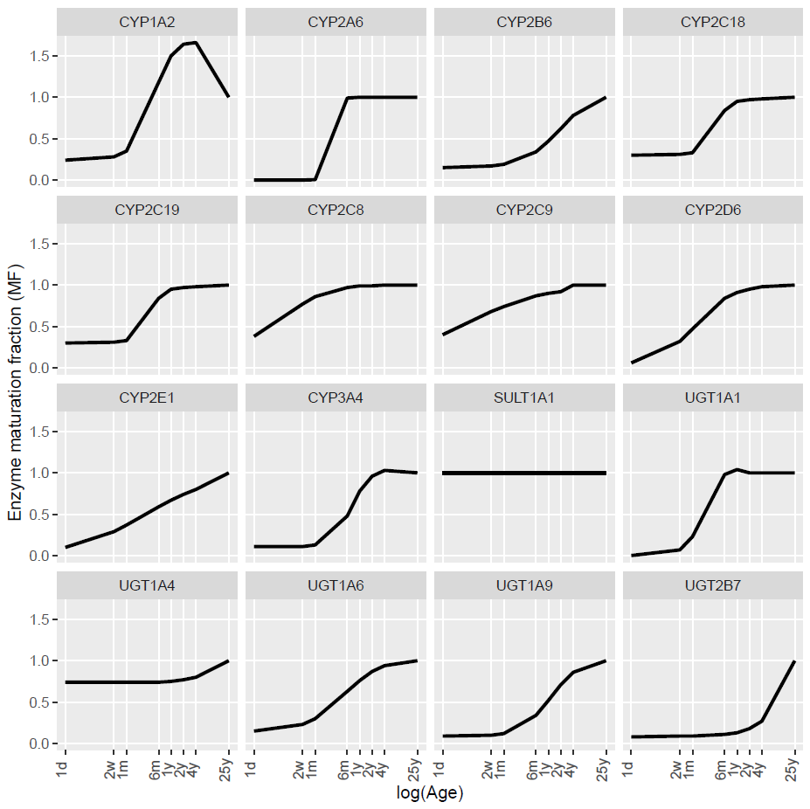
Supplemental figure 1. Maturation pattens of the iso-enzymes included in the analysis. The enzyme maturation functions (MF) are expressed as fraction of enzyme activity per gram of microsomal protein in adults. All maturation patterns are according to the Simcyp® V15.R1 library, except for SULT1A1 which is taken from Hines (Pharmacol Ther. 2008 ;118(2) : 250-67)

