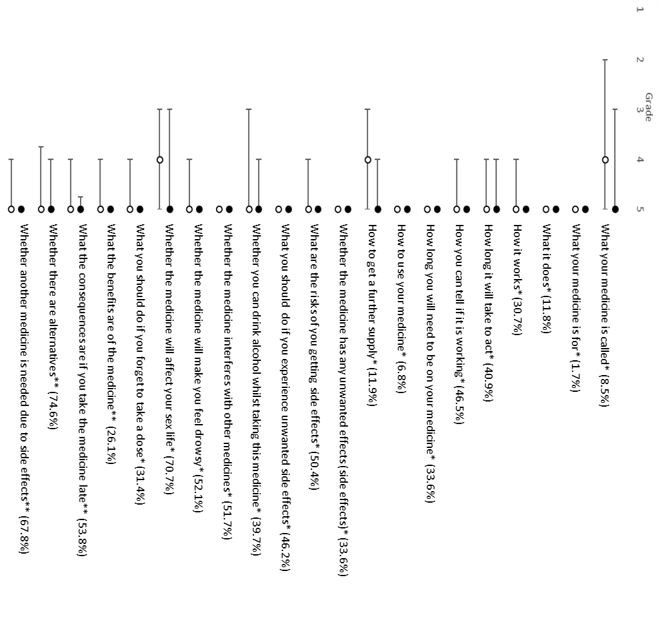
Figure 1: Median importance score with upper and lower quartile for each medication information item of cardiology patients (1=unimportant to 5=important). In black score of informed patients, in white score of uninformed patients. Proportions represent the percentage of uninformed patients.
*Item corresponds with Satisfaction about Information Medicines Scale
**Disease specific items

