Supplementary file 1. Search strategy and key terms

(tirzepatide or LY3298176 or "dual GIP and GLP-1RA" or " dual glucagon-like peptide and glucose-dependent insulinotropic polypeptide" or Zepbound) AND (Random or RCT or RCTs or "randomized controlled trial" or trial* or "clinical trial*")

PubMed:
Query | Results
Search: (tirzepatide or LY3298176 or "dual GIP and GLP-1RA" or " dual glucagon-like peptide and glucose-dependent insulinotropic polypeptide" or Zepbound) AND (Random or RCT or RCTs or "randomized controlled trial" or trial* or "clinical trial*") | 200

Embase:

No | Query | Results | Date
#1 | ('tirzepatide'/exp OR tirzepatide OR 'ly3298176'/exp OR ly3298176 OR 'dual gip and glp-1ra' OR 'dual glucagon-like peptide and glucose-dependent insulinotropic polypeptide' OR zepbound) AND (random OR rct OR rcts OR 'randomized controlled trial'/exp OR 'randomized controlled trial' OR trial* OR 'clinical trial*') | 144 | 18-Jan-24

The Cochrane Library:

259 Trials matching (tirzepatide or LY3298176 or "dual GIP and GLP-1RA" or " dual glucagon-like peptide and glucose-dependent insulinotropic polypeptide" or Zepbound) AND (Random or RCT or RCTs or "randomized controlled trial" or trial* or "clinical trial*") in Title Abstract Keyword - (Word variations have been searched)

Fig. S1
1) 5% weight loss
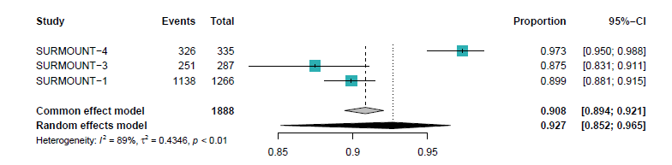
2) 10% weight loss
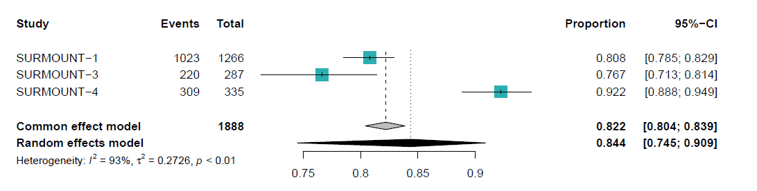
3) 15% weight loss
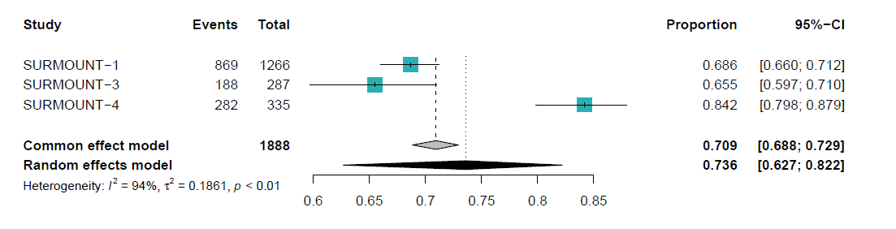
4) 20% weight loss
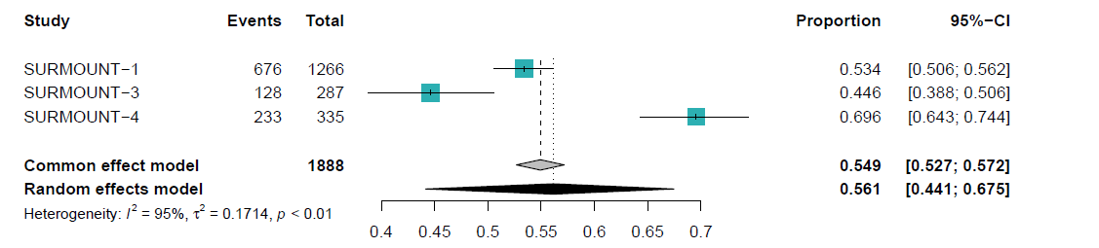
5) 25% weight loss
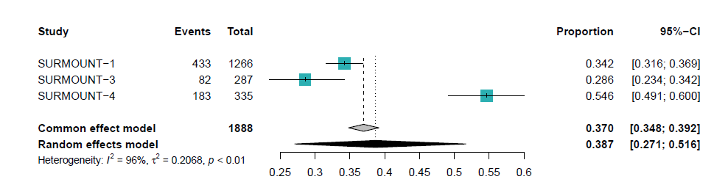
6) Weight loss (%)
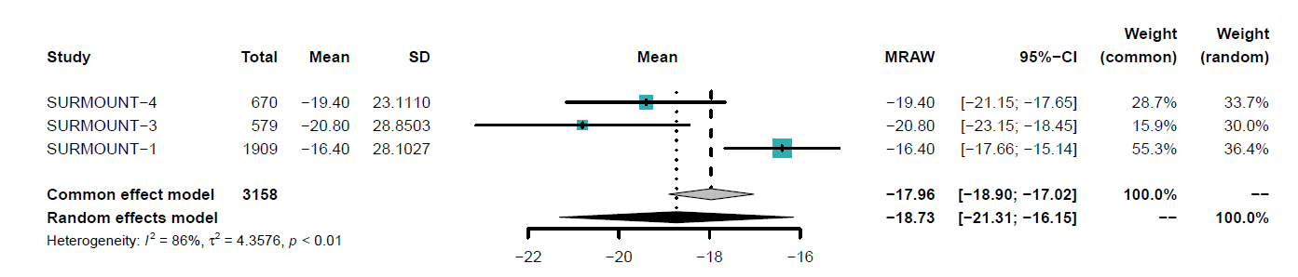
7) BMI (kg/m²)
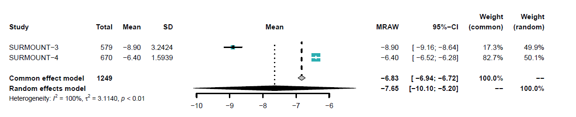8) Waist circumference (cm)
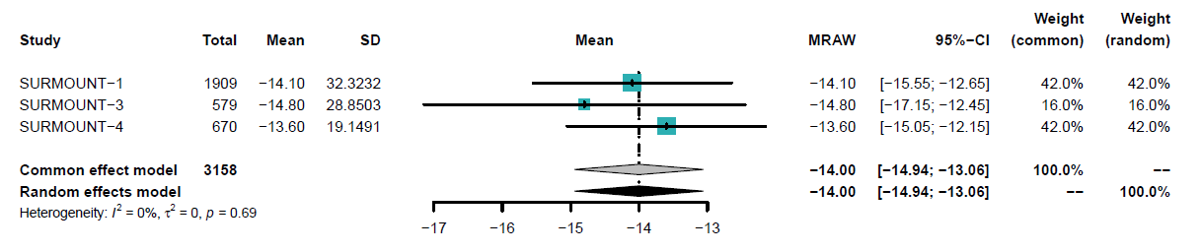
9) HbA1c (%)
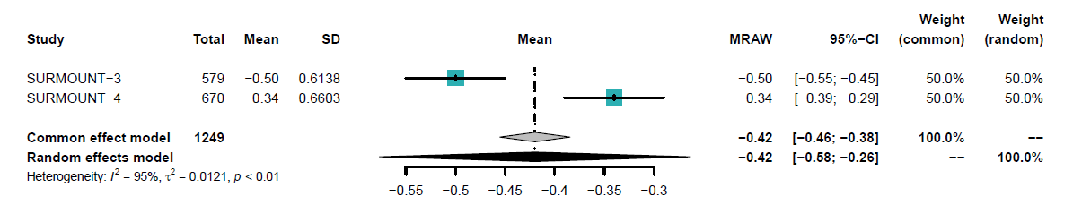
10) SBP (mmHg)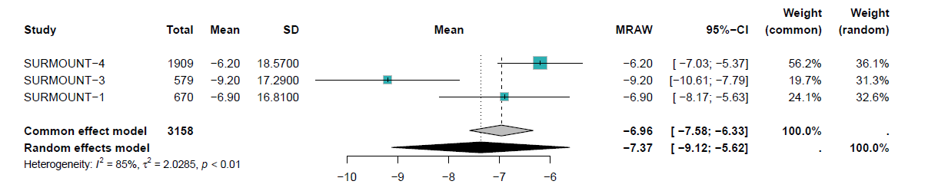 11) DBP (mmHg)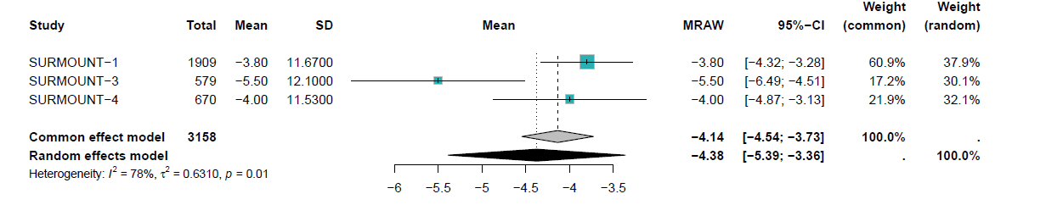
12) SF-36 PF score
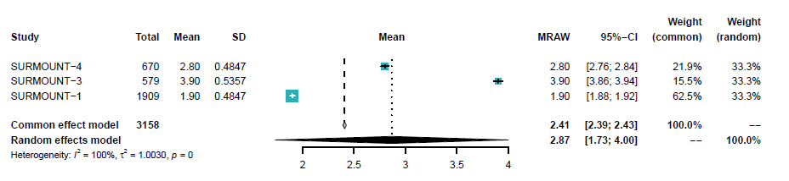
13) IWQOL score
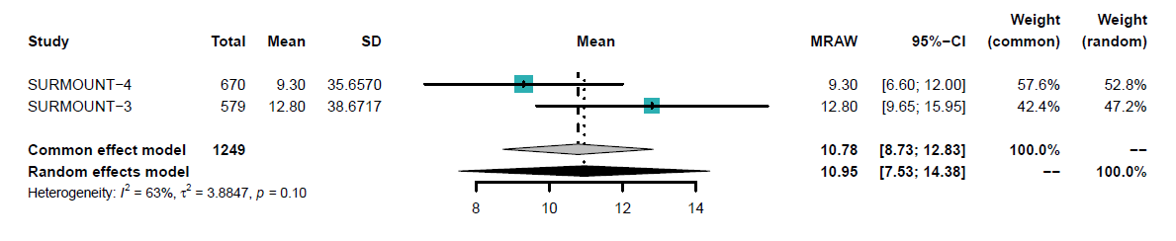
Pooled efficacy results of tirzepatide versus placebo: 1) 5% weight loss; 2) 10% weight loss; 3) 15% weight loss; 4) 20% weight loss; 5) 25% weight loss; 6) Weight loss (%); 7) BMI (kg/m2); 8) Waist circumference (cm); 9) HbA1c (%); 10) SBP (mmHg); 11) DBP (mmHg); 12) SF-36 PF score; 13) IWQOL score. Abbreviations: BMI: body mass index, SBP: systolic blood pressure; DBP: diastolic blood pressure, HbA1c: hemoglobin A1c, SF-36 PF: short form-36 health survey physical functioning domain, IWQOL: impact of weight on quality of life, CI: confidence interval; MRAW: combined means.

Fig. S2
1) HbA1c (%)
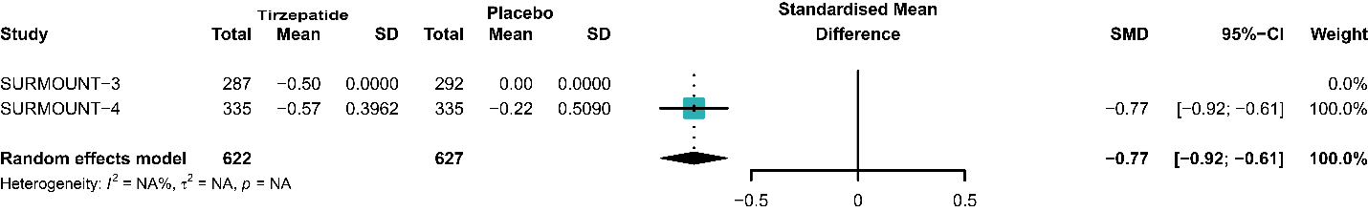
2) SBP (mmHg)
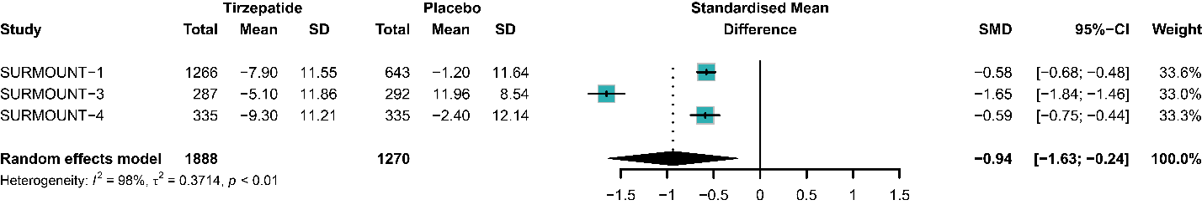
3) DBP (mmHg)
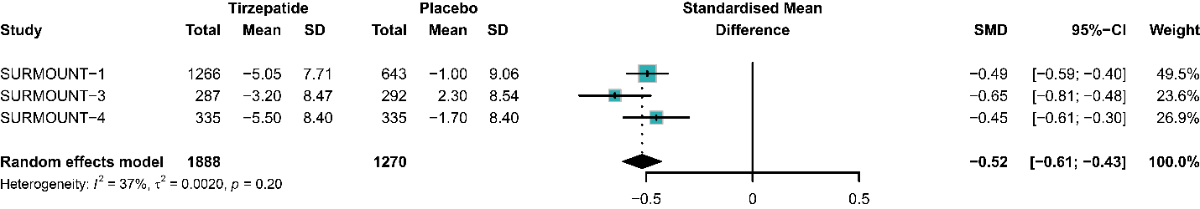
4) IWQOL score
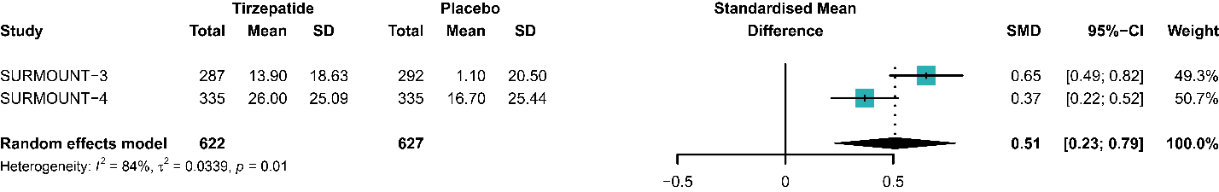
5) SF-36 PF score
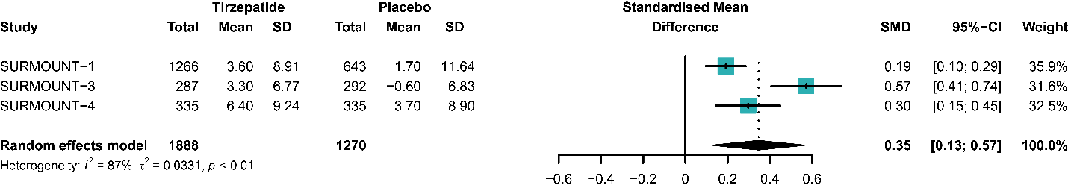
Comparison of tirzepatide versus placebo for 1) HbA1c, 2) SBP, 3) DBP, 4) IWQOL score, 5) SF-36 PF score. Abbreviations: SF-36 PF: short form-36 health survey physical functioning domain, IWQOL: impact of weight on quality of life, SBP: systolic blood pressure; DBP: diastolic blood pressure; HbA1c: hemoglobin A1c, SMD: standard mean deviation, CI: confidence interval.
Table S1. The risk of bias assessment of included studies.
Study | Year | Bias arising from randomization process | Bias due to deviations from intended interventions | Bias due to missing outcome data | Bias in measurement of the outcome | Bias in selection of the reported result | Overall
SURMOUNT 1 | 2022 | + | + | + | + | + | +
SURMOUNT 3 | 2023 | + | + | + | + | + | +
SURMOUNT 4 | 2024 | + | + | + | + | + | +

+
Low risk of bias

