SUPPLEMENTARY MATERIAL
Cost‑effectiveness of Toripalimab plus bevacizumab versus sorafenib as First-Line Treatment for Advanced Hepatocellular Carcinoma in the Chinese and the United States Healthcare Systems

- Table S1. Summary of Statistical Goodness-of-fit of standard parametric models and Royston-Parmar spline models
- Table S2. Survival curve fitting information
- Fig S1. Model structure of the partitioned survival model
- Fig S2. Progression-free Survival Curve Data Extraction
- Fig S3. Overall Survival Curve Data Extraction
- Fig S4. Progression-free Survival Curve standard parametric models for toripalimab plus bevacizumab group- The best-fitting survival curve was determined to follow a Gen.gamma distribution.
- Fig S5. Progression-free Survival Curve standard parametric models for Sorafenib group- The best-fitting survival curve was determined to follow a Gen.gamma distribution.
- Fig S6. Overall Survival Curve standard parametric models for toripalimab plus bevacizumab group- The best-fitting survival curve was determined to follow a Log-logistic distribution.
- Fig S7. Overall Survival Curve standard parametric models for sorafenib group- The best-fitting survival curve was determined to follow a Weibull distribution.
- Fig S8. Progression-free Survival Curve Royston-Parmar spline models for toripalimab plus bevacizumab group- The best-fitting survival curve was determined to follow a RP normal 3.
- Fig S9. Progression-free Survival Curve Royston-Parmar spline models for sorafenib group- The best-fitting survival curve was determined to follow a RP odds 3.
- Fig S10. Overall Survival Curve Royston-Parmar spline models for toripalimab plus bevacizumab group- The best-fitting survival curve was determined to follow a RP normal 2.
- Fig S11. Overall Survival Curve Royston-Parmar spline models for sorafenib group- The best-fitting survival curve was determined to follow a RP hazard 1.
- Fig S12.Convergence analysis of the mean ICER in the Chinese Healthcare System
- Fig S13.Convergence analysis of the mean ICER in the United States Healthcare System

Table S1. Summary of Statistical Goodness-of-fit of standard parametric models and Royston-Parmar spline models
 |  | AIC |  | BIC
 |  | Toripalimab plus bevacizumab group | Sorafenib group | Toripalimab plus bevacizumab group | Sorafenib group
OS
Exponential |  | 1197.777 | 661.5236 | 1201.451 | 664.5072
Gamma |  | 1184.176 | 652.2624 | 1191.523 | 658.2296
Gompertz |  | 1191.678 | 654.1566 | 1199.024 | 660.1238
Weibull |  | 1185.108 | 651.5634 | 1192.455 | 657.5306
Log-logistic |  | 1183.790 | 653.7336 | 1191.137 | 659.7008
Log-normal |  | 1191.139 | 661.4261 | 1198.486 | 667.3933
Gen.gamma |  | 1185.942 | 653.5119 | 1196.962 | 662.4627
RP hazard | knot=1 | 906.6847 | 1041.255 | 915.9475 | 1050.555
RP hazard | knot=2 | 897.9281 | 1043.158 | 910.2785 | 1055.557
RP hazard | knot=3 | 896.7823 | 1043.185 | 912.2203 | 1058.684
RP normal | knot=1 | 902.3582 | 1041.630 | 911.6210 | 1050.930
RP normal | knot=2 | 895.1825 | 1043.593 | 907.5328 | 1055.993
RP normal | knot=3 | 896.3301 | 1043.715 | 911.7681 | 1059.214
RP odd | knot=1 | 906.6606 | 1043.200 | 915.9234 | 1052.500
RP odd | knot=2 | 896.5121 | 1044.731 | 908.8625 | 1057.130
RP odd | knot=3 | 896.3862 | 1044.649 | 911.8241 | 1060.148
PFS
Exponential |  | 648.2123 | 622.5617 | 651.2999 | 625.6616
Gamma |  | 646.0293 | 609.3756 | 652.2045 | 615.5754
Gompertz |  | 650.0376 | 624.4597 | 656.2128 | 630.6594
Weibull |  | 647.6714 | 615.8174 | 653.8466 | 622.0171
Log-logistic |  | 641.9728 | 593.6300 | 648.1480 | 599.8298
Log-normal |  | 633.3184 | 586.8331 | 639.4936 | 593.0328
Gen.gamma |  | 609.8642 | 565.7648 | 619.1270 | 575.0644
RP hazard | knot=1 | 636.3513 | 583.2986 | 645.6141 | 592.5982
RP hazard | knot=2 | 600.2973 | 568.1946 | 612.6477 | 580.5941
RP hazard | knot=3 | 582.8557 | 546.5550 | 598.2937 | 562.0543
RP normal | knot=1 | 628.9669 | 574.0531 | 638.2297 | 583.3527
RP normal | knot=2 | 589.8050 | 561.0657 | 602.1554 | 573.4652
RP normal | knot=3 | 576.8464 | 544.6450 | 592.2843 | 560.1443
RP odds | knot=1 | 636.7620 | 581.3092 | 646.0248 | 590.6088
RP odds | knot=2 | 595.7381 | 563.6645 | 608.0885 | 576.0639
RP odds | knot=3 | 581.0401 | 541.9274 | 596.4780 | 557.4268

Table S2. Survival curve fitting information
Group | Model | Additional information
OS
Toripalimab plus bevacizumab group | RP normal | knot=2, gamma0=-3.8791020, gamma1= 1.8997769, gamma2=0.5246535, gamma3=-0.5494840
Sorafenib group | Weibull | Estimates: shape=1.43497, scale=0.01076
PFS
Toripalimab plus bevacizumab group | RP normal | knot=3,gamma0=-2.4294270,gamma1= 4.6839807,gamma2=4.7001963,gamma3=-2.4867305,gamma= 0.2992083
Sorafenib group | RP hazard | knot=1, gamma0=-2.9260477, gamma1= 2.6900985, gamma2=0.3663095

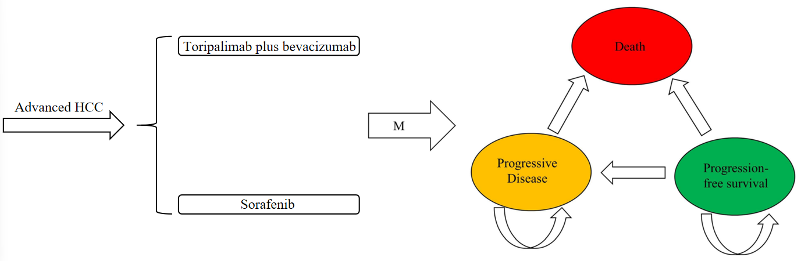
Fig S1. Model structure of the partitioned survival model

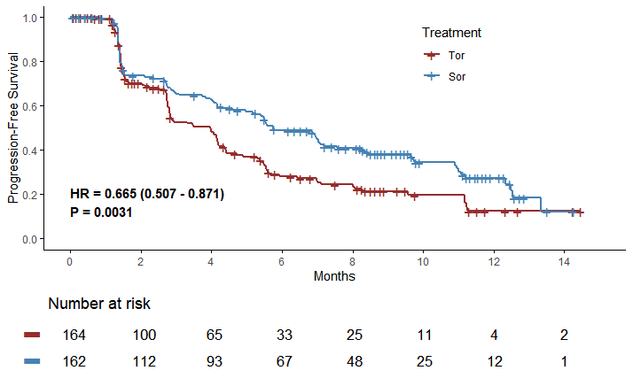
Fig S2. Progression-free Survival Curve Data Extraction. Tor: toripalimab plus bevacizumab; Sor:sorafenib

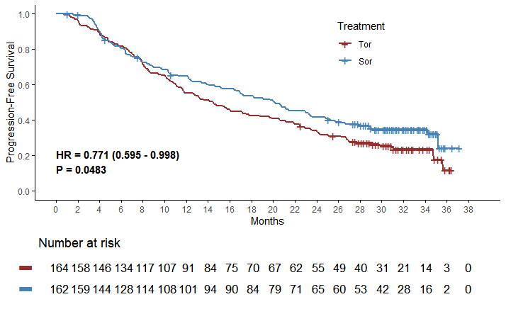
Fig S3. Overall Survival Curve Data Extraction. Tor: toripalimab plus bevacizumab; Sor:sorafenib

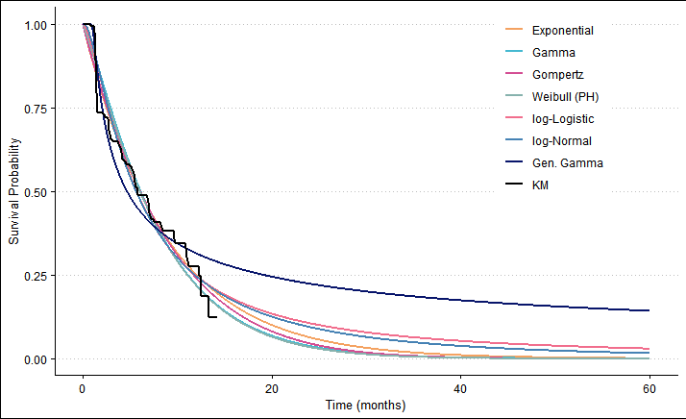
Fig S4. Progression-free Survival Curve standard parametric models for toripalimab plus bevacizumab group- The best-fitting survival curve was determined to follow a Gen.gamma distribution.
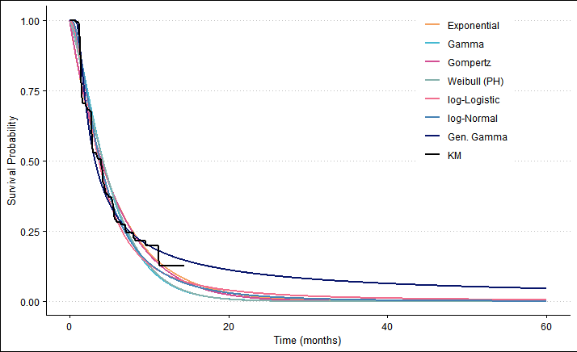
Fig S5. Progression-free Survival Curve standard parametric models for Sorafenib group- The best-fitting survival curve was determined to follow a Gen.gamma distribution.

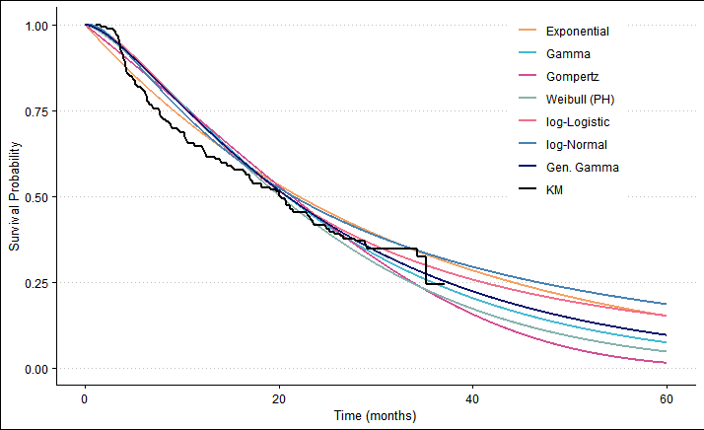
Fig S6. Overall Survival Curve standard parametric models for toripalimab plus bevacizumab group- The best-fitting survival curve was determined to follow a Log-logistic distribution.

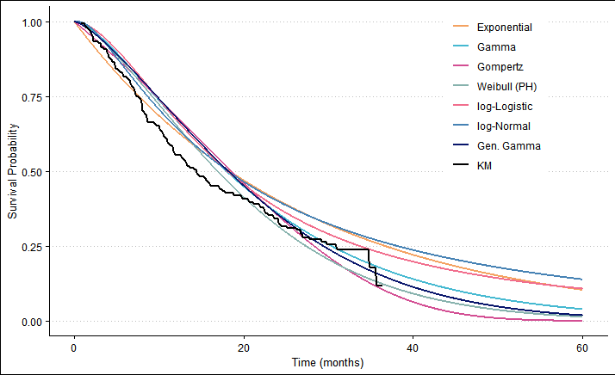
Fig S7. Overall Survival Curve standard parametric models for sorafenib group- The best-fitting survival curve was determined to follow a Weibull distribution.

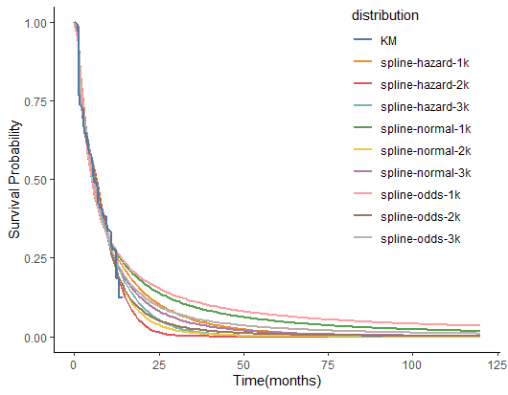
Fig S8. Progression-free Survival Curve Royston-Parmar spline models for toripalimab plus bevacizumab group- The best-fitting survival curve was determined to follow a RP normal 3.

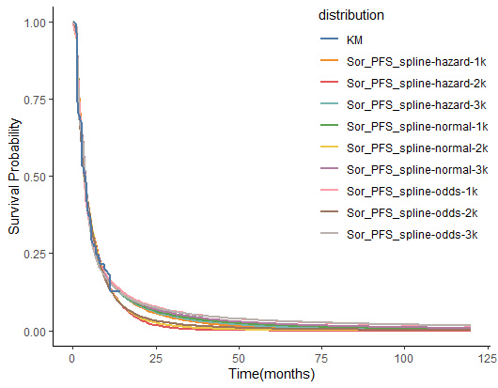
Fig S9. Progression-free Survival Curve Royston-Parmar spline models for sorafenib group- The best-fitting survival curve was determined to follow a RP odds 3.

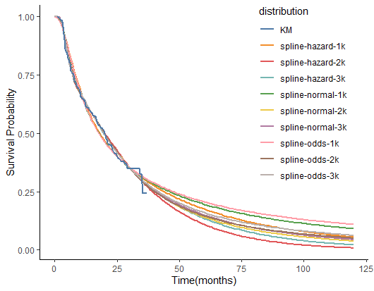
Fig S10. Overall Survival Curve Royston-Parmar spline models for toripalimab plus bevacizumab group- The best-fitting survival curve was determined to follow a RP normal 2.

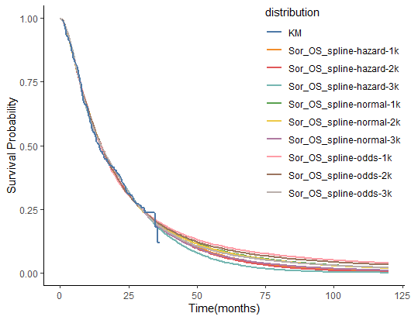
Fig S11. Overall Survival Curve Royston-Parmar spline models for sorafenib group- The best-fitting survival curve was determined to follow a RP hazard 1.

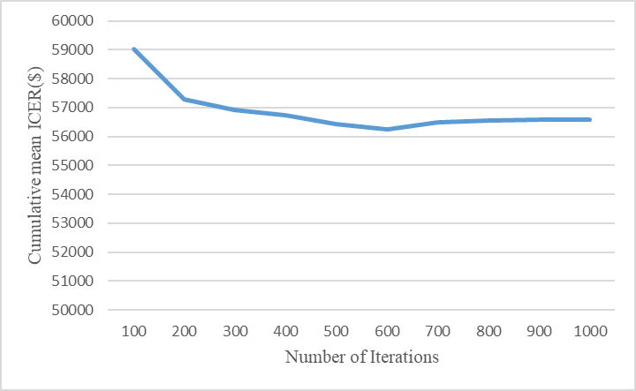
Fig S12.Convergence analysis of the mean ICER in the Chinese Healthcare System

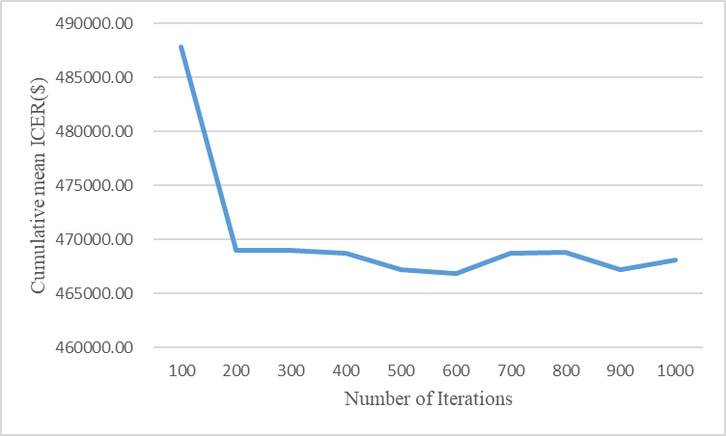
Fig S13.Convergence analysis of the mean ICER in the United States Healthcare System

