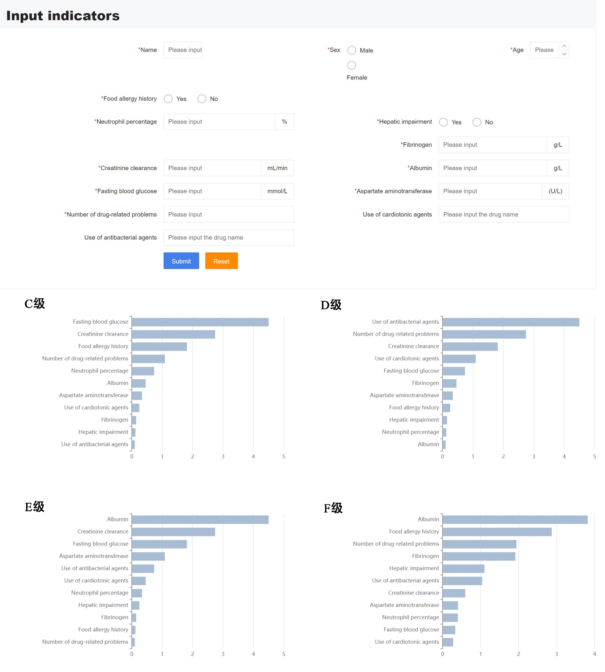
Supplemental Figure 1. Web-based intravenous medication risk prediction system for hospitalized patients with heart failure (Version 1.0). The upper panel shows the input and prediction interface, in which clinicians enter routinely available patient variables to obtain an individualized prediction of IV medication risk severity. The lower panels present SHAP-based feature importance plots for each severity category (C–F), showing the relative contribution of the key predictors and improving the interpretability of the ANN model.

