Supplementary Figure 2:
Treatment review protocol
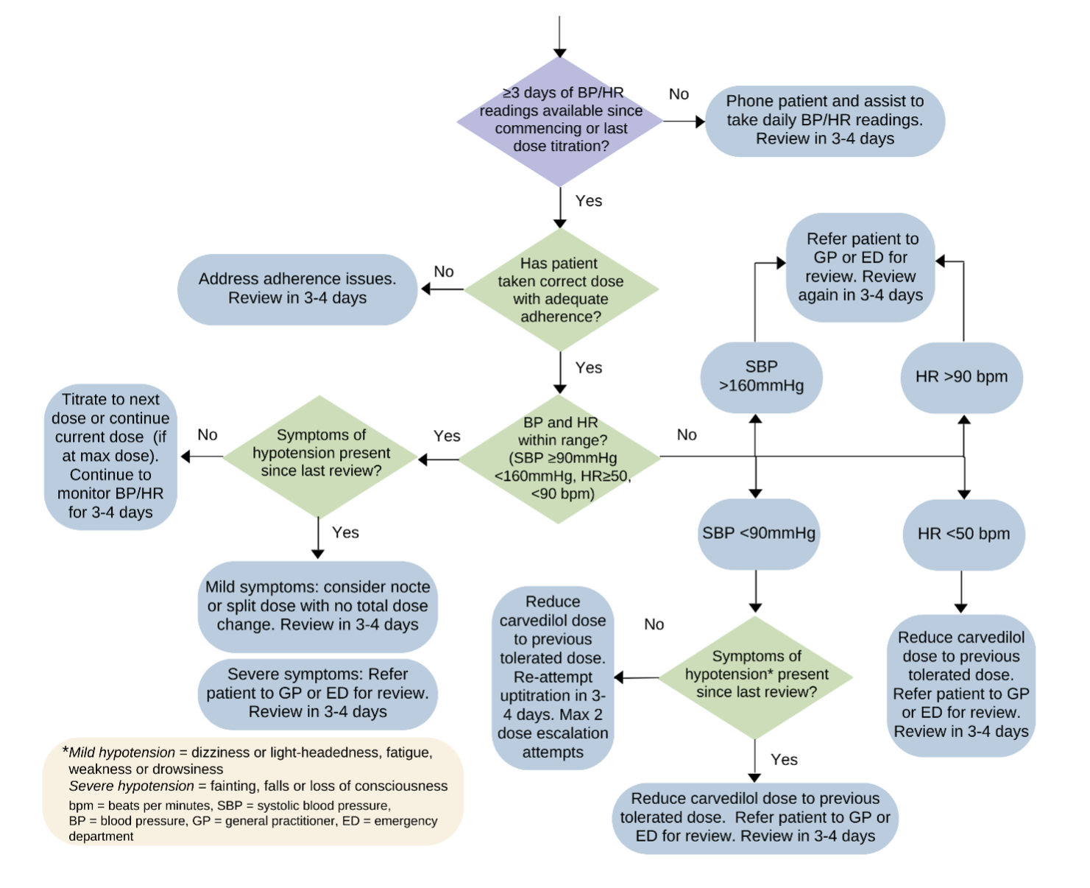
Dose escalation plan
