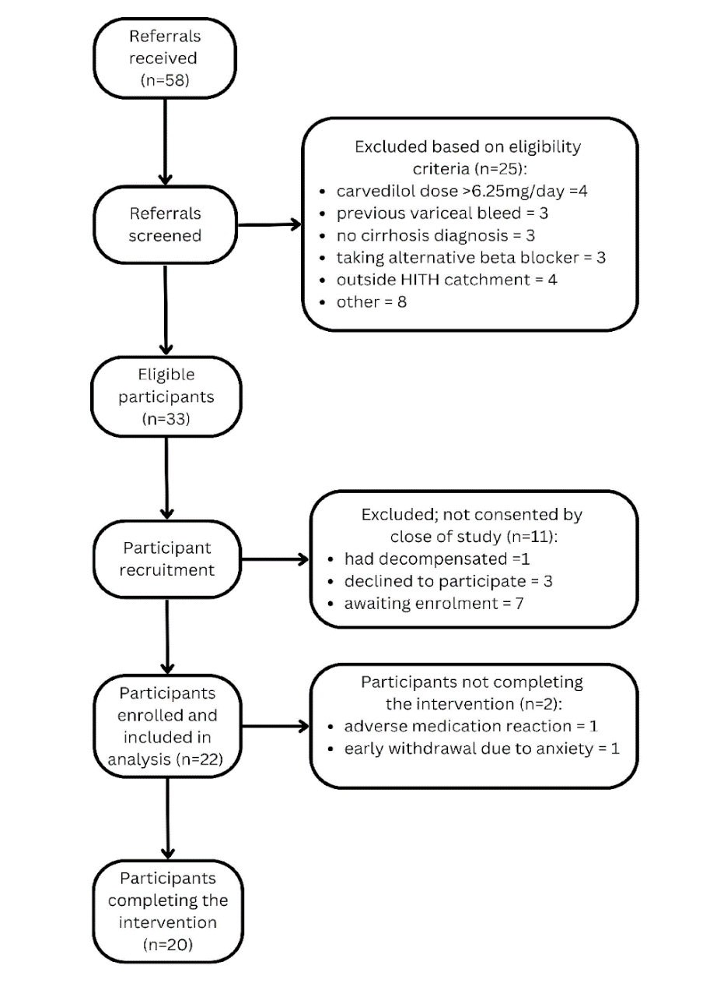
Supplementary Figure 3: Participant Flow Diagram

