Supplementary Material

Table S1 Summary of EGFR inhibitors
Drug | First time of approval(from FDA) | Targeted kinases | FDA approved indications
cetuximab | 02/12/2004 | EGFR | HNC, CRC
panitumumab | 09/27/2006 | EGFR | mCRC
necitumumab | 11/24/2015 | EGFR | Squamous NSCLC
amivantamab | 05/21/2021 | EGFR, MET | NSCLC
gefitinib | 05/05/2003 | EGFR | NSCLC
erlotinib | 11/18/2004 | EGFR | NSCLC, PC
afatinib | 07/12/2013 | EGFR, HER2, HER4 | NSCLC, Squamous NSCLC
dacomitinib | 09/27/2018 | EGFR, HER2, HER4 | NSCLC
osimertinib | 11/13/2015 | EGFR | NSCLC
vandetanib | 04/06/2011 | EGFR, VEGFR, RET, BRK, TIE2, EPH, Src | MTC
lapatinib | 03/13/2007 | EGFR, HER2 | BC
Abbreviations: FDA, the US food and drug administration; EGFR, the epidermal growth factor receptor; MET, the hepatocyte growth factor receptor; HER2, human epidermal growth factor receptor 2; HER4, human epidermal growth factor receptor 4; VEGFR, vascular endothelial growth factor receptor; RET, rearranged during transfection; BRK, breast tumor kinase; TIE2, tyrosine kinase with immunoglobulin-like and EGF-like domains 2; EPH, Erythropoietin-producing human hepatocellular receptor; HNC, head and neck cancer; CRC, colorectal cancer; mCRC, Metastatic Colorectal Cancer; NSCLC, Non-Small Cell Lung Cancer; PC, Pancreatic Cancer; MTC, medullary thyroidcancer; BC, breast cancer.

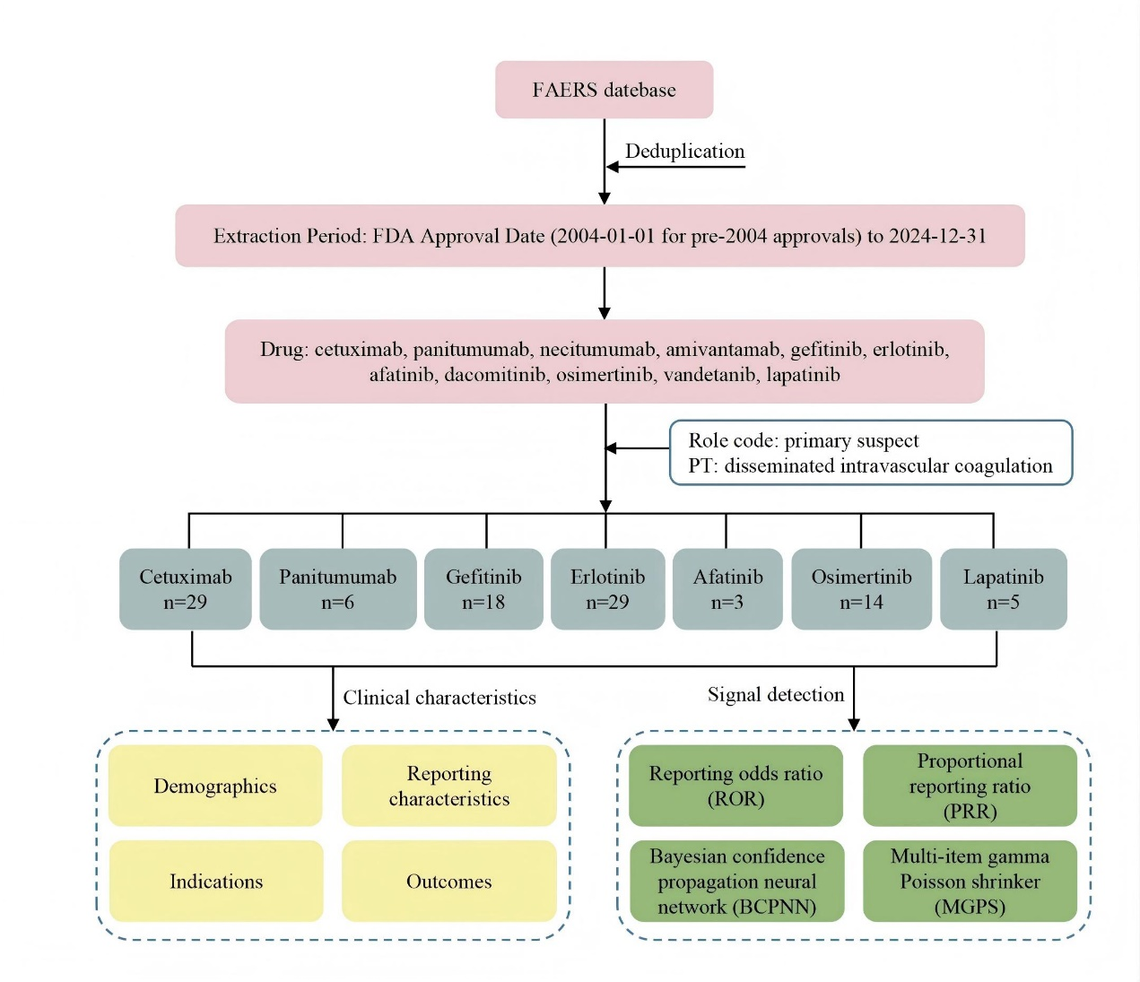
Fig. S1 Flowchart of the analysis process

Table S2 Four algorithms used for signal detection
Algorithms | Equation | Criteria
ROR | ROR=ad/bc | 95%CI＞1，n≥3
ROR | 95%CI=eln(ROR)±1.96(1/a+1/b+1/c+1/d)^0.5 | 95%CI＞1，n≥3
PRR | PRR = a(c + d)/c/(a + b) | PRR≥2，χ²≥4，n≥3
PRR | χ² = (ad-bc)²(a+b+c+d)/ [(a+b)(c+d)(a+c)(b+d)] | PRR≥2，χ²≥4，n≥3
BCPNN | IC = log₂^{a(a+b+c+d)/[(a + b)(a +c)]} | IC025＞0
BCPNN | IC025=eln(IC)-1.96(1/a+1/b+1/c+1/d)^0.5 | IC025＞0
MGPS | EBGM = a(a+b+c+d)/(a + c)/(a + b) | EBGM05≥2
MGPS | EBGM05=eln(EBGM)-1.96(1/a+1/b+1/c+1/d)^0.5 | EBGM05≥2
Abbreviations: a: the number of reports with suspect adverse drug event (ADE) of the suspect drug; b: the number of reports with all other ADEs of the suspect drug; c: the number of reports with the suspect ADE of all other drugs; d:the numberofreportswith allother ADEs of all other drugs; ROR: reporting odds ratio; CI: confidence interval; N: the number of co-occurrences; PRR: proportional reporting ratio; χ2: chi-squared; BCPNN: Bayesian confidence propagation neural network; IC: information component; IC025: the lower limit of the 95% two-sided CI of the IC; MGPS: multi-item gamma Poisson shrinker; EBGM: empirical Bayes geometric mean; EBGM05: the lower 95% one-sided CI of EBGM.

Table S3 Associations of different EGFR inhibitors with DIC in females.
Drug | n | N | ROR(95%CI) | PRR(χ²) | IC025 | EBGM05
cetuximab | 7 | 3639 | 4.07(1.94, 8.55) | 4.07(16.16) | 0.96 | 1.93
panitumumab | 0 | 1681 | - | - | - | -
gefitinib | 8 | 2822 | 5.99(2.99, 11.99) | 5.97(33.05) | 1.29 | 2.97
erlotinib | 16 | 13883 | 2.52(1.54, 4.12) | 2.52(14.61) | 0.81 | 1.54
afatinib | 2 | 1665 | 3.44(0.86, 13.78) | 3.44(3.46) | 0.44 | 0.86
osimertinib | 10 | 10539 | 2.80(1.51, 5.22) | 2.80(11.52) | 0.79 | 1.50
lapatinib | 5 | 7698 | 1.53(0.64, 3.68) | 1.53(0.91) | 0.25 | 0.64

Table S4 Associations of different EGFR inhibitors with DIC in males
Drug | n | N | ROR(95%CI) | PRR(χ²) | IC025 | EBGM05
cetuximab | 18 | 7844 | 3.21(2.02, 5.10) | 3.20(27.15) | 1.05 | 2.01
panitumumab | 5 | 2902 | 2.59(1.07, 6.22) | 2.58(4.85) | 0.57 | 1.07
gefitinib | 9 | 1889 | 6.65(3.45, 12.82) | 6.62(42.89) | 1.41 | 3.43
erlotinib | 11 | 12039 | 1.30(0.72, 2.36) | 1.30(0.78) | 0.21 | 0.72
afatinib | 1 | 1066 | 1.73(0.24, 12.32) | 1.73(0.31) | 0.11 | 0.24
osimertinib | 4 | 5676 | 1.34(0.50, 3.56) | 1.34(0.34) | 0.16 | 0.50
lapatinib | 0 | 364 | - | - | - | -

Table S5 Associations between positive/negative controls and DIC
Drug | n | N | ROR(95%CI) | PRR(χ²) | IC025 | EBGM05
obinutuzumab | 19 | 4527 | 10.03(6.38, 15.75) | 9.99(153.08) | 3.32 | 6.33
arsenic trioxide | 17 | 855 | 36.72(22.71, 59.38) | 36.01(577.60) | 5.17 | 22.22
diazepam | 6 | 12306 | 0.88(0.40, 1.96) | 0.88(0.10) | -0.18 | 0.40

