Supplementary Material

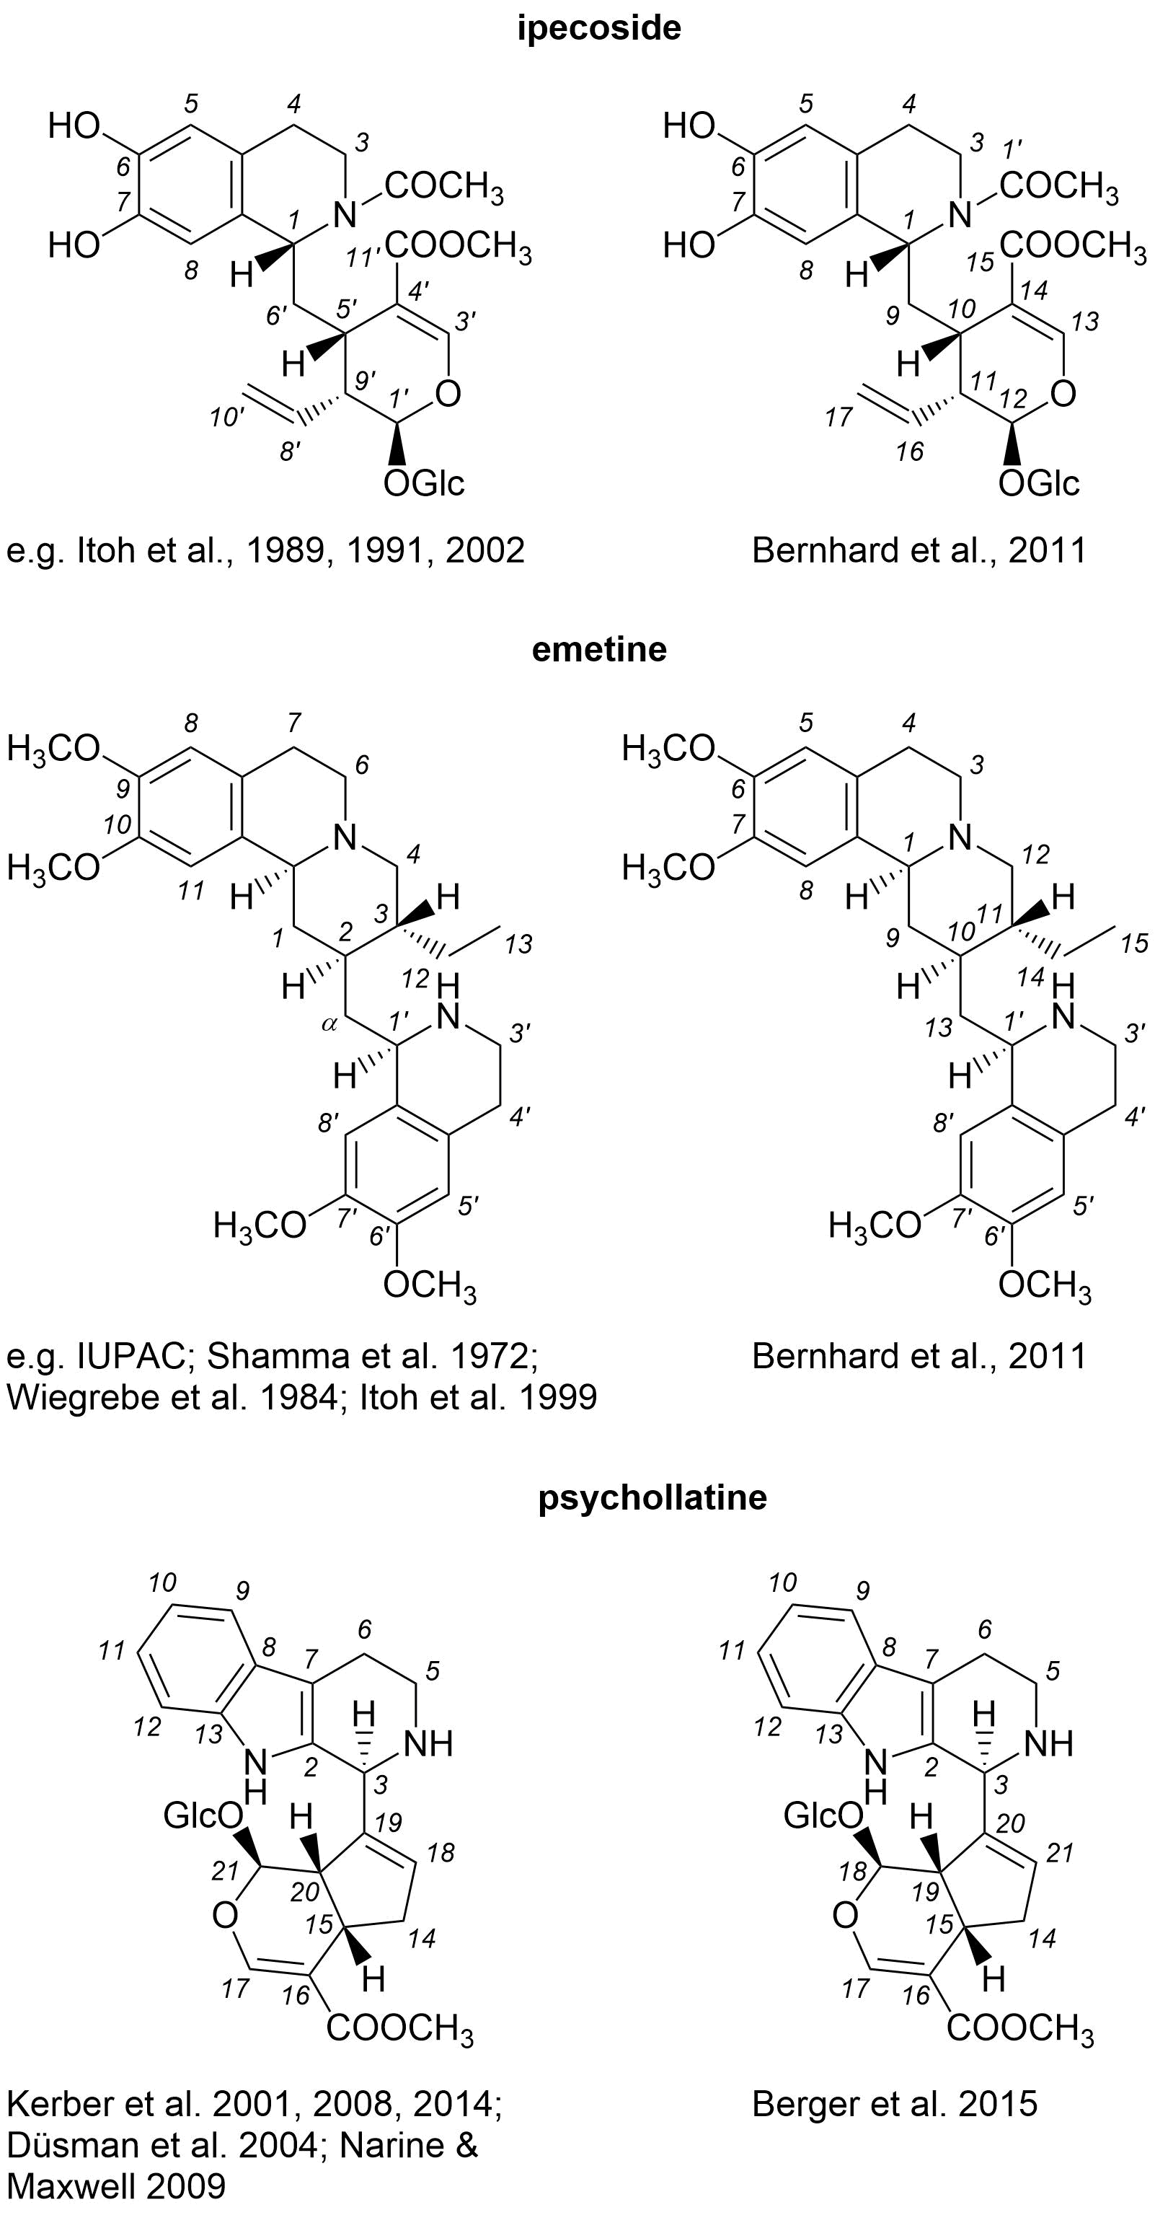
Fig. S1 Comparison of different numbering schemes for ipecoside, emetine, and psychollatine. The corresponding IUPAC names are: ipecoside, methyl (2S,3R,4S)-4-[[(1R)-2-acetyl-6,7-dihydroxy-3,4-dihydro-1H-isoquinolin-1-yl]methyl]-3-ethenyl-2-[(2S,3R,4S,5S,6R)-3,4,5-trihydroxy-6-(hydroxymethyl)oxan-2-yl]oxy-3,4-dihydro-2H-pyran-5-carboxylate; emetine, (2S,3R,11bS)-2-[[(1R)-6,7-dimethoxy-1,2,3,4-tetrahydroisoquinolin-1-yl]methyl]-3-ethyl-9,10-dimethoxy-2,3,4,6,7,11b-hexahydro-1H-benzo[a]quinolizine; psychollatine, methyl (1R,4aS,7aR)-7-(2,3,4,9-tetrahydro-1H-pyrido[3,4-b]indol-1-yl)-1-[(2S,3R,4S,5S,6R)-3,4,5-trihydroxy-6-(hydroxymethyl)oxan-2-yl]oxy-1,4a,5,7a-tetrahydrocyclopenta[c]pyran-4-carboxylate

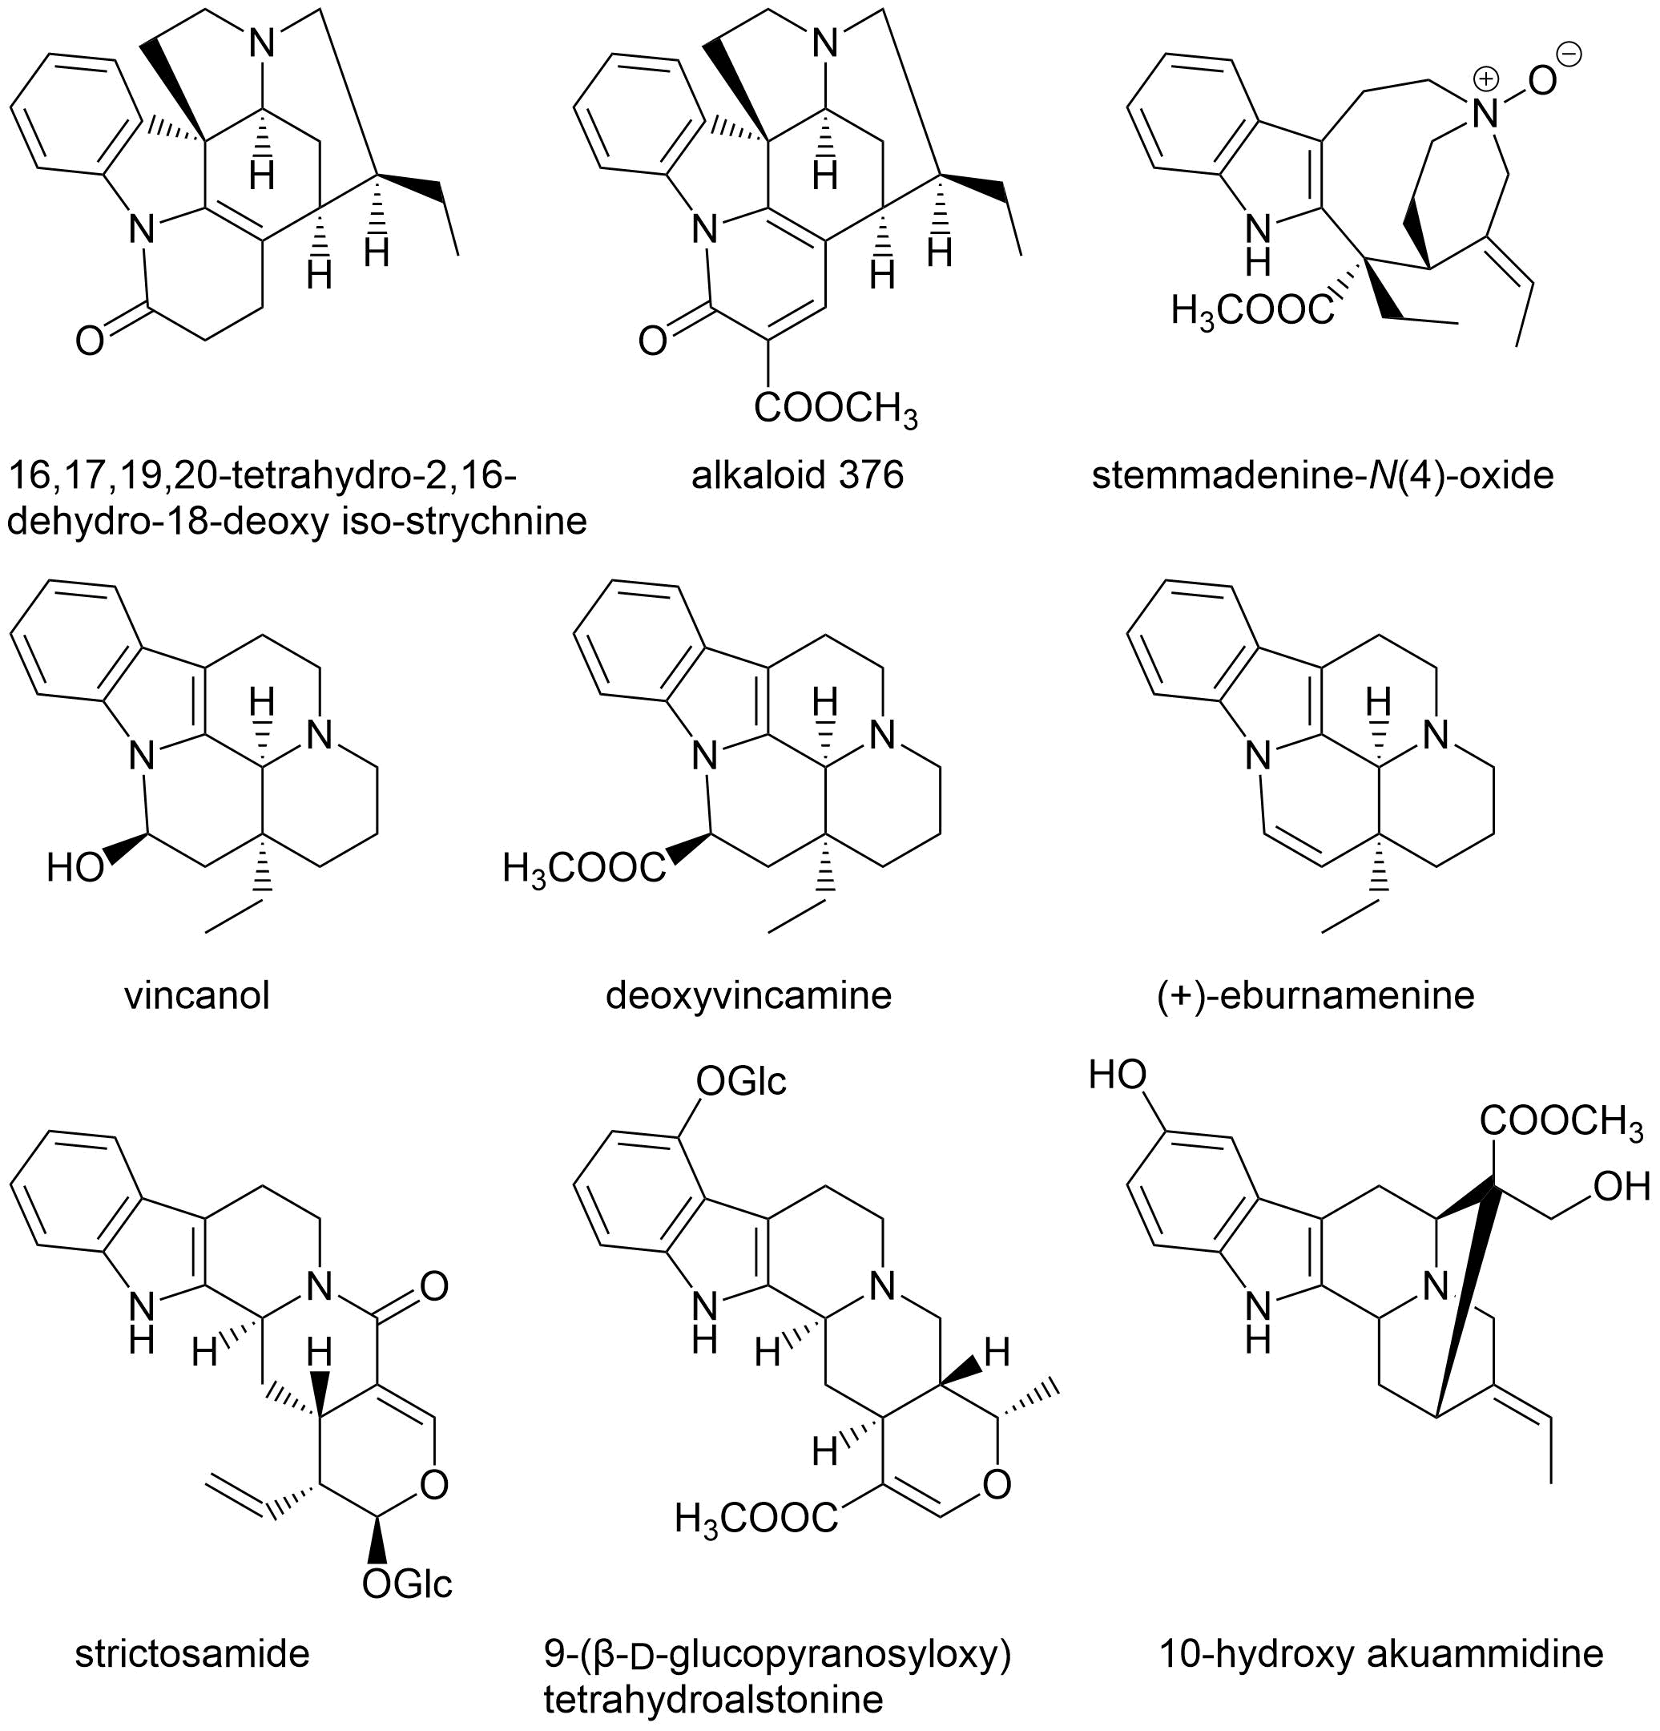
Fig. S2 Aberrant tryptamine-secologanin type monoterpene-indole alkaloids reported from ‘Psychotria pilifera’ (Rubiaceae), but probably originating from an adulteration with a species of Apocynaceae for which these compounds are characteristic

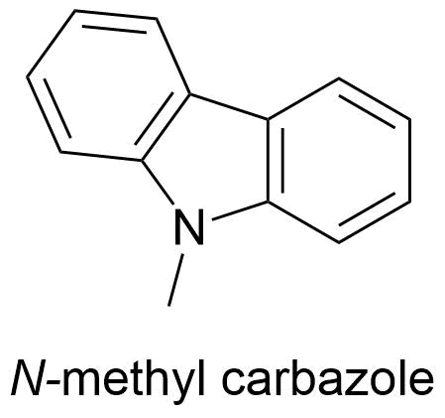
Fig. S3 N-methyl carbazole reported from ‘Psychotria pilifera’, but likely originating from environmental pollution or contaminated solvents used during the extraction and isolation process

