Long-term efficacy and safety of osilodrostat in Cushing’s disease: final results from a Phase II study with an optional extension phase (LINC 2)
Supplementary material

Supplementary Figure 1. Individual patient data for (a) morning serum cortisol, (b) morning salivary cortisol and (c) late-night salivary cortisol levels
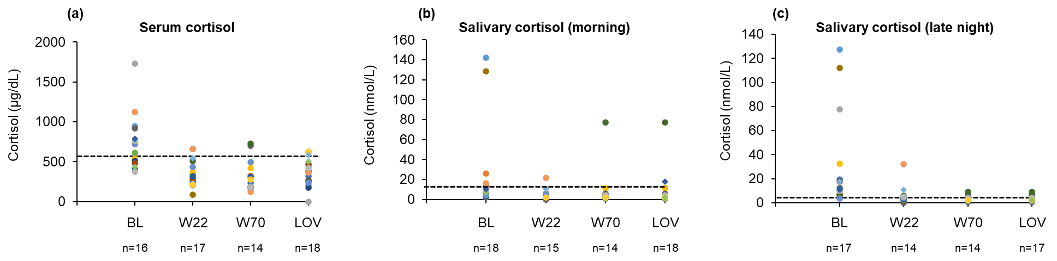
Dashed lines represent the ULN: morning serum cortisol 567 nmol/L; morning salivary cortisol,
15.5 nmol/L; late-night salivary cortisol, ≤2.5 nmol/L. Shaded areas highlight data that have been published previously [1]. BL, baseline; LOV, last observed value; ULN, upper limit of normal; W, week
Supplementary Figure 2. Individual patient data for (a) total cholesterol, (b) HDL cholesterol, (c) LDL cholesterol and (d) triglycerides
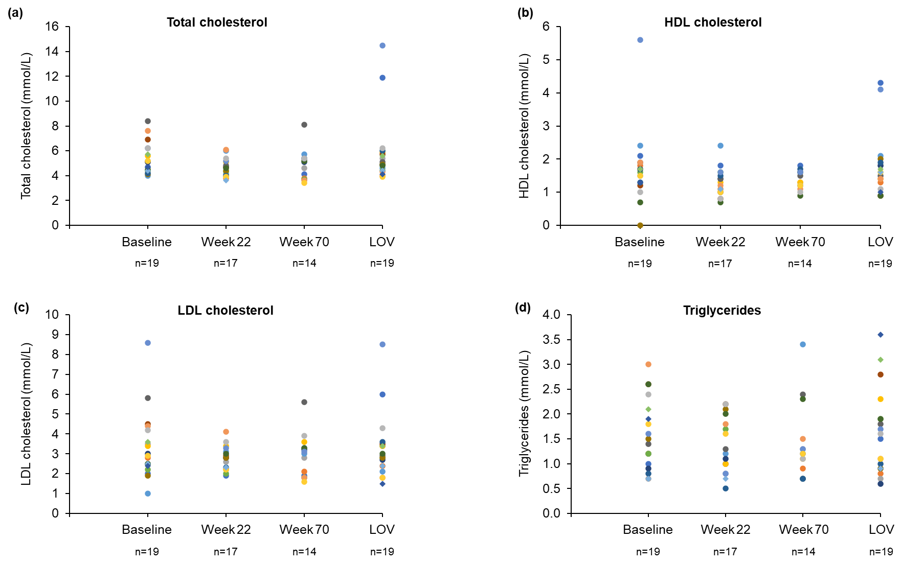
HDL, high-density lipoprotein; LDL, low-density lipoprotein
Supplementary Figure 3. Individual patient data for (a) testosterone (males), (b) renin, (c) aldosterone and (d) estradiol (males) levels
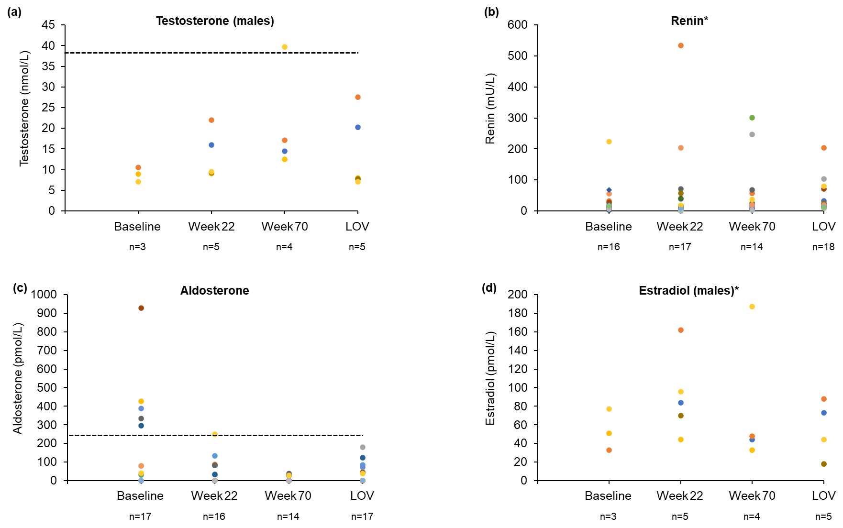
Dashed lines represent the ULN: testosterone (males), 38.2 nmol/L; aldosterone, 250 nmol/L. *ULN not available
Supplementary Table 1. AEs suspected to be related to osilodrostat treatment (≥10% of patients) (n=19)
 | All grades  n (%) | Grade ≥3  n (%)
AEs suspected to be related to study treatment
Adrenal insufficiency | 9 | 2
Blood corticotropin increased | 8 | 0
Hormone level abnormal | 7 | 0
Nausea | 7 | 0
Blood testosterone increased | 6 | 0
Fatigue | 5 | 0
Asthenia | 4 | 0
Diarrhea | 3 | 0
Acne | 2 | 0
Headache | 2 | 0
Hirsutism | 2 | 0
Hypertension | 2 | 2
Hypertrichosis | 2 | 0
Hypokalemia | 2 | 0
Sinus bradycardia | 2 | 0
Weight decreased | 2 | 1
AE, adverse event

