Supplementary data for the article submitted to Plant Molecular Biology

“Cysteine protease enhances plant-mediated bollworm RNA interference”
by
Ying-Bo Mao, Xue-Yi Xue, Xiao-Yuan Tao, Chang-Qing Yang, Ling-Jian Wang, Xiao-Ya Chen*

*Corresponding author: Xiao-Ya Chen. National Key Laboratory of Plant Molecular Genetics, Institute of Plant Physiology and Ecology, Shanghai Institutes for Biological Sciences, Chinese Academy of Sciences, 300 Fenglin Road, Shanghai 200032, P. R. China. email: xychen@sibs.ac.cn
Table S1. Primers used in this investigation.

Gene (Accession no.) | Primer | Purpose
GhCP1 (CAE54307) | 5-GGG GGATCC ATGGAATTAACCCTTCTTTTC-3' | amplify full-length open reading frames of GhCP1
GhCP1 (CAE54307) | 5'-GGG GAGCTC GCAATGAATTCAAGCACTGC-3' | amplify full-length open reading frames of GhCP1
GhCP1 (CAE54307) | 5'-ATCAGGAGTTTTTAATGGTG-3' | RT-PCR and qRT-PCR
GhCP1 (CAE54307) | 5'-GCAATGAATTCAAGCACTGC-3' | RT-PCR and qRT-PCR
GhCP2 (AY171099) | 5'-CACTGATTTACCATATGGTG-3' | RT-PCR
GhCP2 (AY171099) | 5'-AGGCAATAATCATAGAATTC-3' | RT-PCR
GhCP3 (CAE54306) | 5'-GGATTATCAAGAATTCATGG-3' | RT-PCR
GhCP3 (CAE54306) | 5'-CTGTTCGTAAAAGAAGAGCTC-3' | RT-PCR
AtCP1 (At4g11310) | 5'-AGCCTGTGACTGCCGTTAT-3' | RT-PCR
AtCP1 (At4g11310) | 5'-TTGCCCTCCATACAAATCC-3' | RT-PCR
AtCP2 (At4g11320) | 5'-GGG GGATCC ATGGGTTATGCTAAATCAGC-3' | amplify full-length open reading frames of AtCP2
AtCP2 (At4g11320) | 5'-GGG GAGCTC TAGGCAACCGAAACTTTATCC-3' | amplify full-length open reading frames of AtCP2
AtCP2 (At4g11320) | 5'-AATCGGGAGTGTTTGACG-3' | RT-PCR and qRT-PCR
AtCP2 (At4g11320) | 5'-ATGTTGCGAGCCATCTTC-3' | RT-PCR and qRT-PCR
S18 (At4g09800) | 5’-CCAGCGATCGTTTATTGCTT-3’ | RT-PCR and qRT-PCR
S18 (At4g09800) | 5’-AGTCTTTCCTCTGCGACCAG-3’ | RT-PCR and qRT-PCR
GFP (AAF65344) | 5'-Atggtagatctgactagtaaag-3' | amplify full-length open reading frames of GFP
GFP (AAF65344) | 5'-TTTGTATAGTTCATCCATGC-3' | amplify full-length open reading frames of GFP
NPTII (AFM76957) | 5’-GGCGATACCGTAAAGCACGAGGAA-3’ | RT-PCR
NPTII (AFM76957) | 5’-GCTATGACTGGGCACAACAGACAAT-3’ | RT-PCR
Histon3 (AF024716) | 5’-GGCATACCTTGTGGGTCTTTTTGA-3’ | qRT-PCR
Histon3 (AF024716) | 5’-CTACCACTACCATCATGGC-3’ | qRT-PCR
Actin (X97615.1) | 5'-AAGTTGCTGCGCTGGTAGTAG-3' | qRT-PCR
Actin (X97615.1) | 5'-AGTTCGTAGGACTTCTCCAGG-3' | qRT-PCR
CYP6AE14 (DQ986461) | 5'-GATTCAGAACTCTTCCACCAG-3' | qRT-PCR
CYP6AE14 (DQ986461) | 5'-TGGCATCTCCGAAAGGCACTC-3' | qRT-PCR
DpCPV-S1 (AY163247) | 5'-TGGTAAGGGAGTTGATGCC-3' | qRT-PCR
DpCPV-S1 (AY163247) | 5'-GAGCCGCGACGTTAGAGTA-3' | qRT-PCR
DpCPV-S3 (AY167578) | 5'-GATAGGACCCATAACCAAC-3' | qRT-PCR
DpCPV-S3 (AY167578) | 5'- ATCTACTTTCCAAGCCATAC-3' | qRT-PCR
DpCPV-S4 (AF542082) | 5'-ACAAATAACTGCCAACTCG-3' | qRT-PCR
DpCPV-S4 (AF542082) | 5'-ACCAACGAAAGTGATGTCC-3' | qRT-PCR

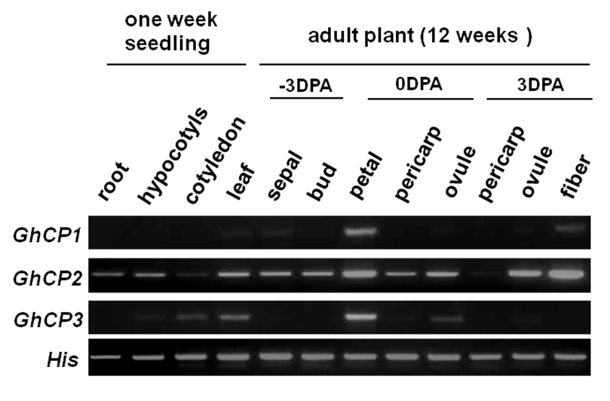
Figure S1. Expression of GhCP1, GhCP2 and GhCP3 in cotton plant.
RT-PCR analysis of GhCP1, GhCP2 and GhCP3 expressions in root, hypocotyl and cotyledon of one-week-old seedlings and in indicated tissues of adult plant (12 weeks old) of cotton (G. hirsutum). DPA: days post-anthesis. Expression of Histon3 (His) was analyzed as a reference.

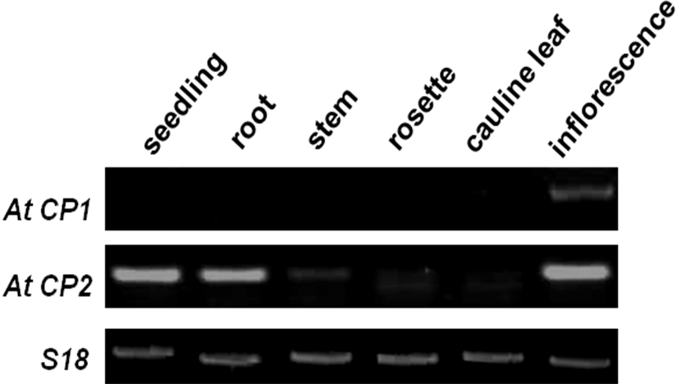

Figure S2. Expression of AtCP1 and AtCP2 in Arabidopsis plant.
RNAs were extracted from different tissues and subjected to RT-PCR analyses. Expression of S18 was used as a reference.

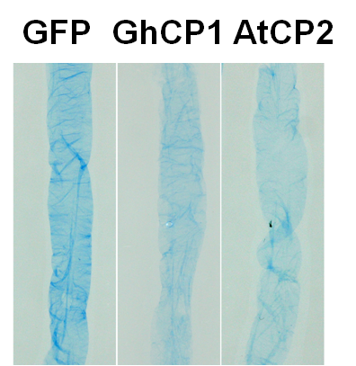

Figure S3. In vitro treatment of bollworm midgut peritrophic matrix (PM) by recombinant GhCP1 and AtCP2. Midgut PMs were incubated with 2 mg/ml purified GFP, GhCP1 and AtCP2 recombinant proteins respectively, in Tris-HCL buffer (50 mM Tris–HCl, pH 8.5) at 25 °C for 16 hours. Proteins in midgut PMs were then visualized by Coomassie blue staining. Note that after treatments by GhCP1 or AtCP2, the PM staining became much paler, indicating that the PM proteins were digested.

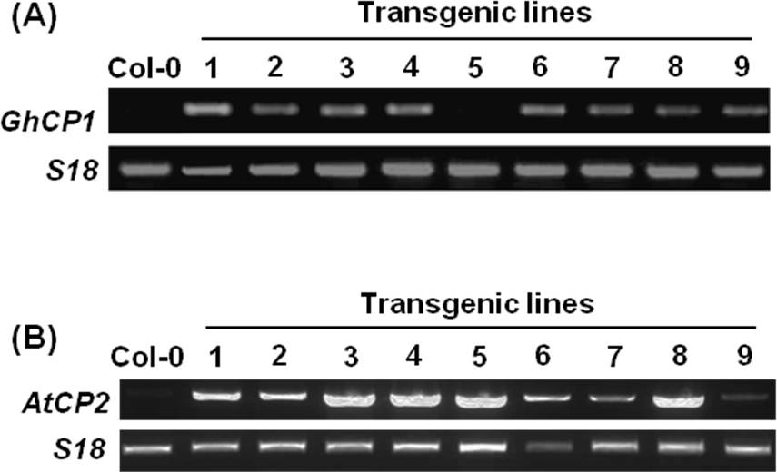

Figure S4. Expression of GhCP1 and AtCP2 in transgenic 35S:GhCP1 (a) and 35S:AtCP2 (b) Arabidopsis plants.
Total RNAs form leaves were extracted and subjected to RT-PCR analyses. Expression of S18 was used as a reference.
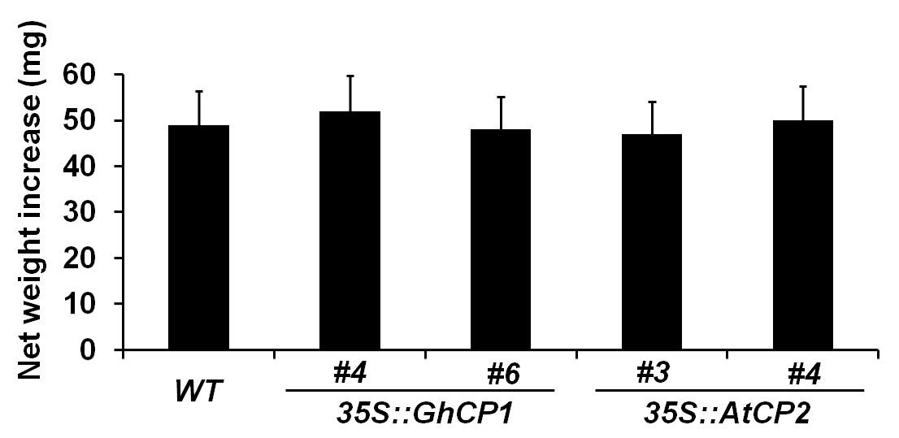 Figure S5. Net weight increase of the larvae fed on indicated plants. The 3rd instar larvae were fed with leaves of wild-type (WT) or transgenic Arabidopsis plants (4 weeks old) for 4 days. Error bars represent standard deviation.

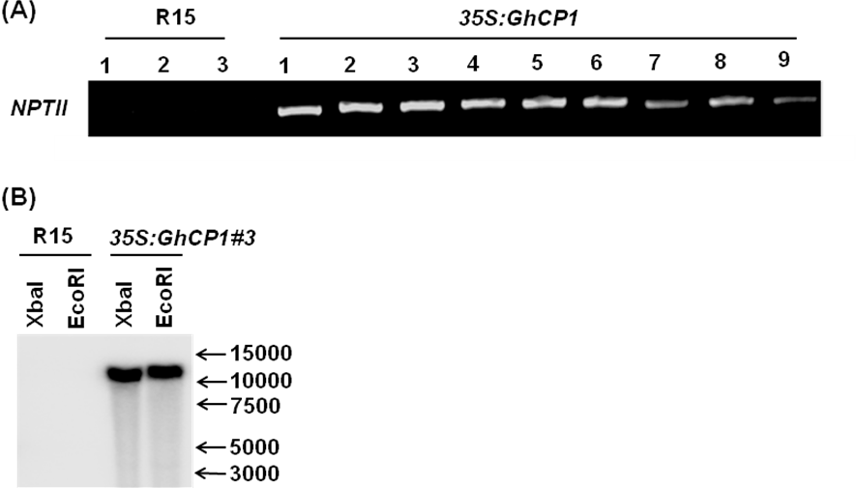

Figure S6. Identification of transgenic cotton lines.
a PCR analysis of NPTII in wild-type (R15) and 35S:GhCP1 transgenic cotton lines. Genomic DNA was isolated from leaves. b Southern blot analyses of transgenic cotton plants. Genomic DNA of wild-type and 35S:GhCP1 (#3) leaves was digested by enzymes as indicated.

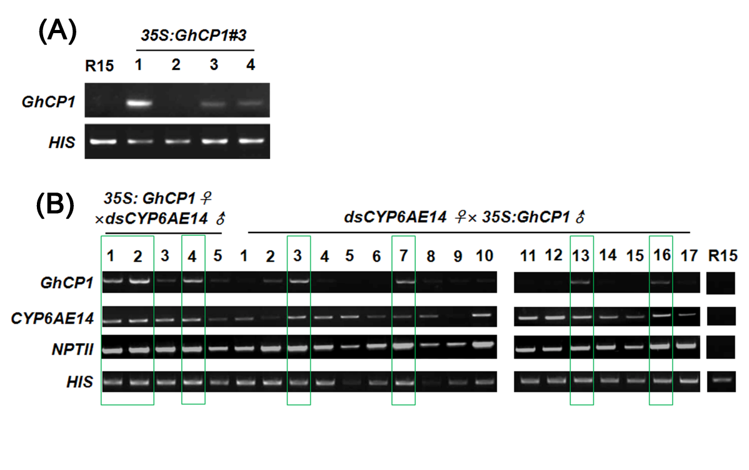
Figure S7. RT-PCA detection of GhCP1 and dsCYP6AE14 expression in 35S:GhCP1#3 and crossed cotton plants.
a GhCP1 expressions in wild-type (R15) and T1 generation of 35S:GhCP1#3. T1 plants of 35S:GhCP1#3-1 cotton overexpressing GhCP1 were used for insect feeding assay. b GhCP1, dsCYP6AE14 and NPTII expressions in 17 individuals of crossed (F1 generation) and wild-type (R15) cotton leaves were analyzed by RT-PCR. Green boxes indicate the transgenic lines expressing both GhCP1 and dsCYP6AE14, which were used for insect feeding assay. Young leaf (second from the top) from 4-week-old cotton plants was used for analysis. Expression of Histon 3 (HIS) was used as a reference.
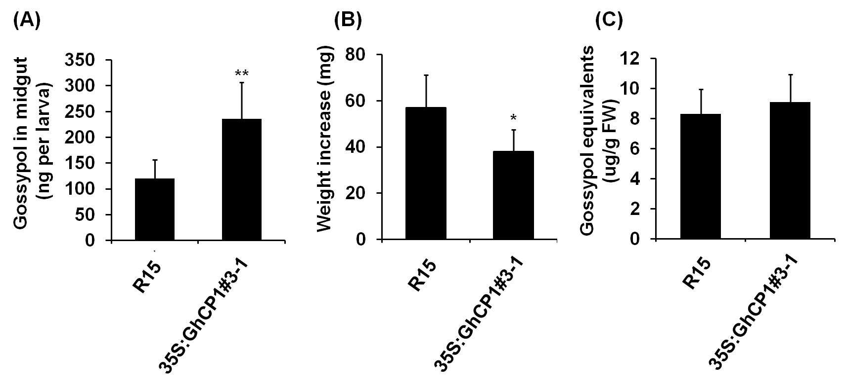

Figure S8. Adverse effect of 35S:GhCP1#3-1 on bollworm growth.
a Accumulation of gossypol in midgut. b Weight increase of tested larvae. c Level of gossypol equivalents in tested cotton plant leaves. The 3rd instar larvae were fed on leaves of wild-type (R15) and 35S:GhCP1#3-1 for 5 days. Gossypol accumulation in midgut and bollworm weight increase were recorded. *: P<0.05, **: P<0.01. Error bars represent standard deviation.

