Supplementary materials
Supplementary Figure 1. Check expression level of OsERF2 in nsf2857 and Ami-OsERF2 lines by qRT-PCR. Expression levels of OsERF2 in nsf2857 and Nip were standardized as 1. OsACTIN1 was used as an internal control. Data represent the means of three repeats.
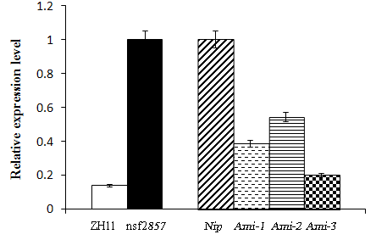

Supplementary Figure 2. Negative effect of OsEIL1 on primary root growth of 7-day-old seedlings. Compared with WT, mutation of OsEIL1 (oseil1) caused the longer primary roots, while transgenic plants overexpressing OsEIL1 (OsEIL1-OX) exhibited shorter primary roots.
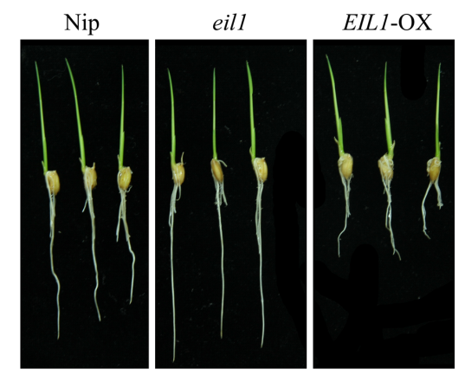
Supplementary table 1. Primers used in this study
Gene and its ID | Primers
Gene-speciﬁc primer sets for amiRNA-OsERF2
I miR-s1th agTTTATGCTCTAAATGATGCTGcaggagattcagtttga,
II miR-a1th tgCAGCATCATTTAGAGCATAAActgctgctgctacagcc,
III miR*s1th ctCAGCAACATATAGAGCATAAAttcctgctgctaggctg,
IV miR*a1th aaTTTATGCTCTATATGTTGCTGagagaggcaaaagtgaa
Primers for qRT-PCR
OsERF2 Os06g0181700  OsACTIN1 Os03g0718100  β-OsLCY Os02g0190600  OsZDS Os07g0204900  OsCRTISO Os11g0572700  OsPDS Os03g0184000  MHZ4 Os01g0128300  OsCYT-INV1 1 Os02g0550600  OsSUS3 Os07g0616800  OsSUS6 Os02g0831500  INV Os01g0332100  KASI Os06g0196600  OsMPK3 Os03g0285800  OsMPK6 Os06g0154500  OsMPK20-4 Os01g0665200  OsMKK4 Os02g0787300  OsMKK5 Os06g0191300  OsPIN1b Os02g0743400  OsPIN2 Os06g0660200  OsPIN9 Os01g0802700  ARF1 Os01g0236300  RHL Os06g0730200  OsSPS2 Os01g0919400 | GTGGACCAGATGATCGAGGAG  CCAGAACTCACTGTGACCAA  GGACCCAAGAATGCTAAGCC  TGGTACCCTCATCAGGCATC'  CTGTCGTCGAGGCTCTTCTT  TGGATGAGGTTGCCGATCAT  TGACACATGCTGGAGTGAGT  TCGTGTCAAGGCAAAAAGGG  AGAAAAAGGAGCTTGTGGCG  GGTGTGTTTTTGGTGAGCCT  ACCTCTGCAAAGATCACCGA CTGAGCACAAAGCTTCCCAG  ACCTATCCTGGACTCCCGAC  CGTCATGGTACACCTGCCTT  AATGGCGTATTGTGACAGGC  AGTACTCTGGCCAACCATCC  CGTGTCTGGCTACCACATTG GAAACCGTAGAC ACCGGAG  GGACTCCAACGCATCTATGA  GGCACATTCTTTGCCAACTT  ACAAGCTGAGGGAATACTTAG  GACTCTGCTGTTTTACTCGACG  GCAGAGGTGAACGCCATTAG  AAATTCAACAGCTGGCTCCG  GCGAGGAAGTACATGAGGCA  ATTCTCTGCAGCGGGTTGAA  CGCCAACTTCCTAGACATGC  AGCAGACTGGCTCATCACTT  GCAGACAGAGCTGCCTTACA  AAGTGGCCATTGCACCCTAA  TGTGCTGGCTTCTTGGATTC  TCCCCTCAAAACCACCAGAG  TTCAGAAGCTTCGTCGGCTA  GATGACCGGATGGAATTGGC  CAAGCTTCAACCACACCGAC  GGTACTTGGGCTTGGACGC  GTTCATGGCTCTGCAACCAA  CAATGCCTTGTGGAAGTGCT  TTTCTGATAGGCCCGGTTGT  CCTGTGCTCATGATGTCTGC  GCGTCTTGTGCAGAAACAGA  TCCAACCTTACTAGCCGCAA  ATACTGGTAGGATGAGGCGG  GGATCCTGTGGTGGTTTCCT  ATTTCTGCACGGAGGAAGGA  TCATGGGAGTGTCTTGCTGT

