Online Resource 5. qPCR analysis of six genes in the lignin biosynthesis pathway in the intermediate internodes of a different set of plants from those used in the microarray assays (A). Different letters at the top of each bar indicate different means by one-way ANOVA followed by Tukey’s test. Error bars=SEM; N=3; p<0.05. PAL, Phenylalanine ammonia lyase; 4CL, 4-coumatare-CoA ligase; COMT, caffeic acid 3-O methyltransferase; F5H, ferulate 5-hydroxylase; C4H, cinnamate 4-hydroxylase;CCR, cinnamoyl-CoA reductase. B, GeNorm results are shown as M-value (average expression stability) graph, V-value (pairwise variation) graph and thresholds are shown as a green line in each graph. GeNorm interpretation for each tissue analyzed is shown as well. Eight endogenous controls were tested to identify the best ones for data normalization.

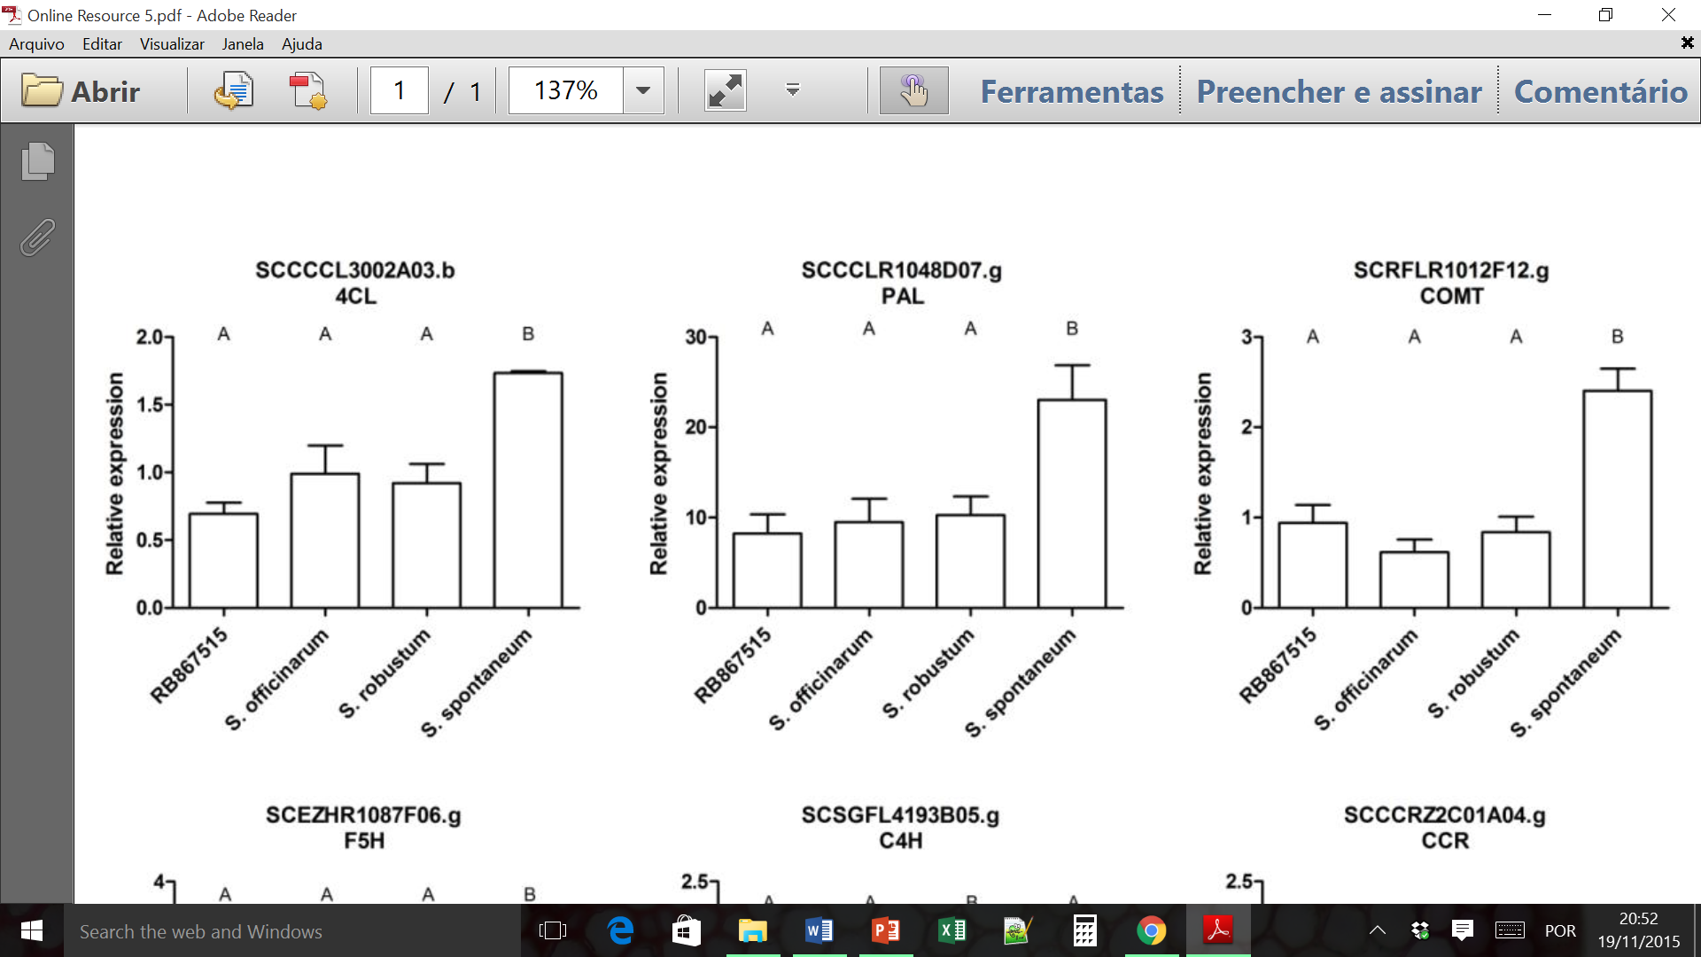
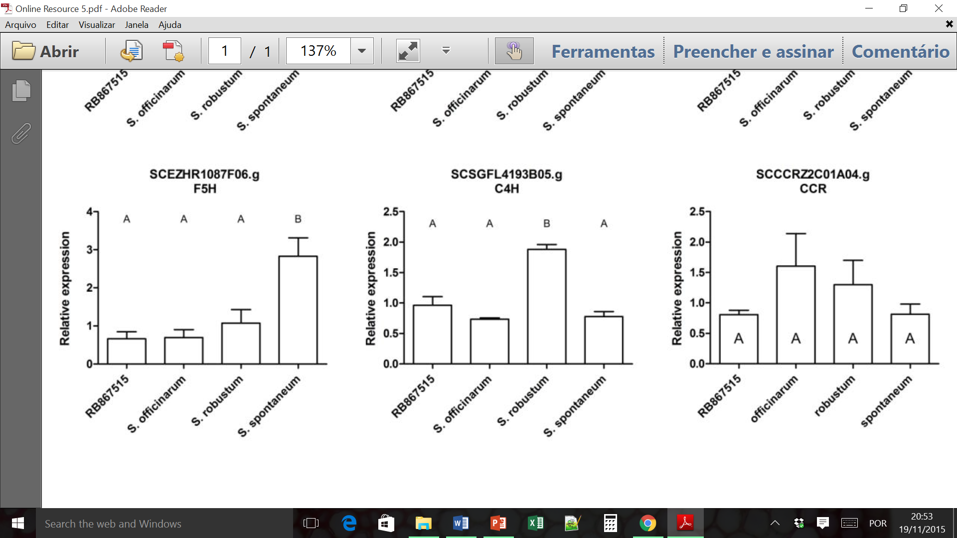
A

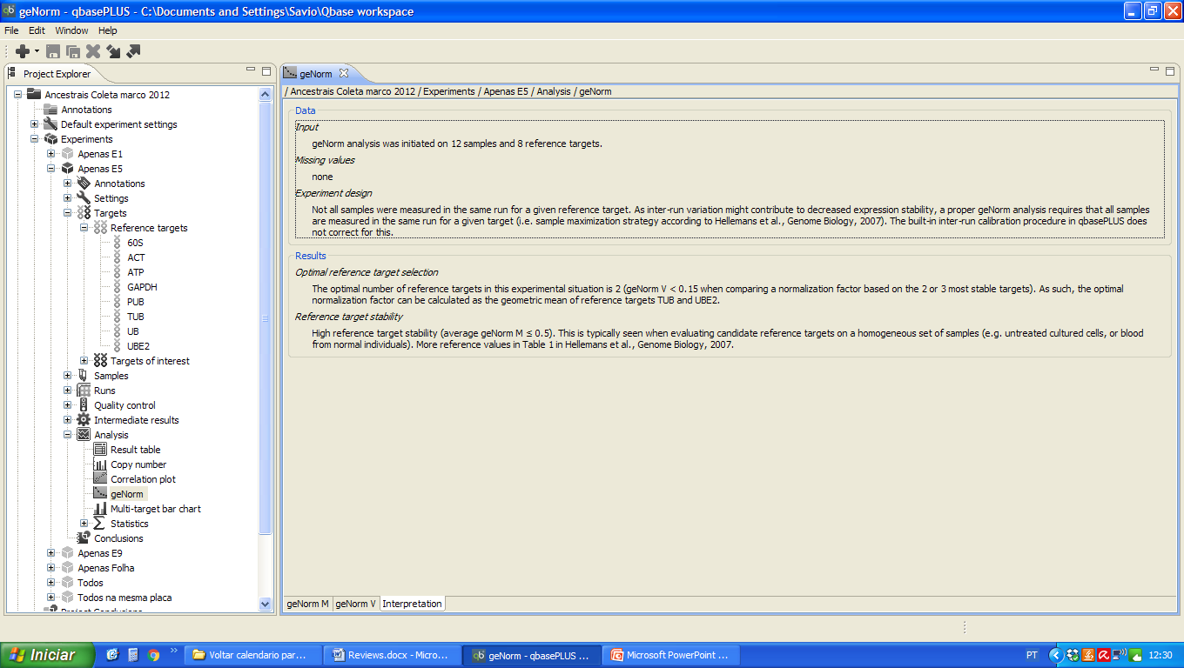
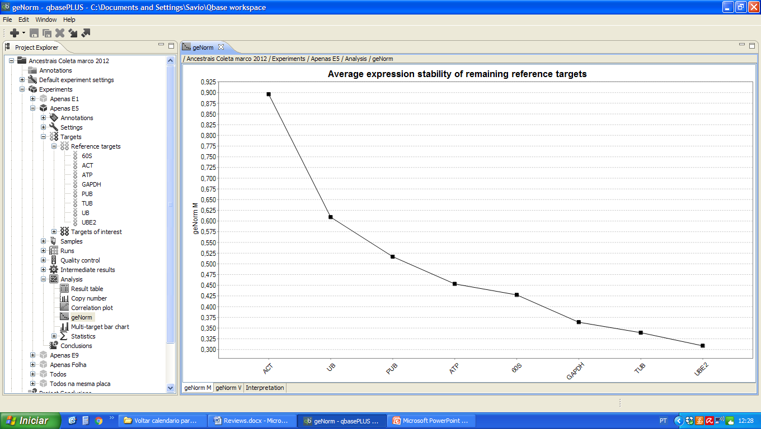
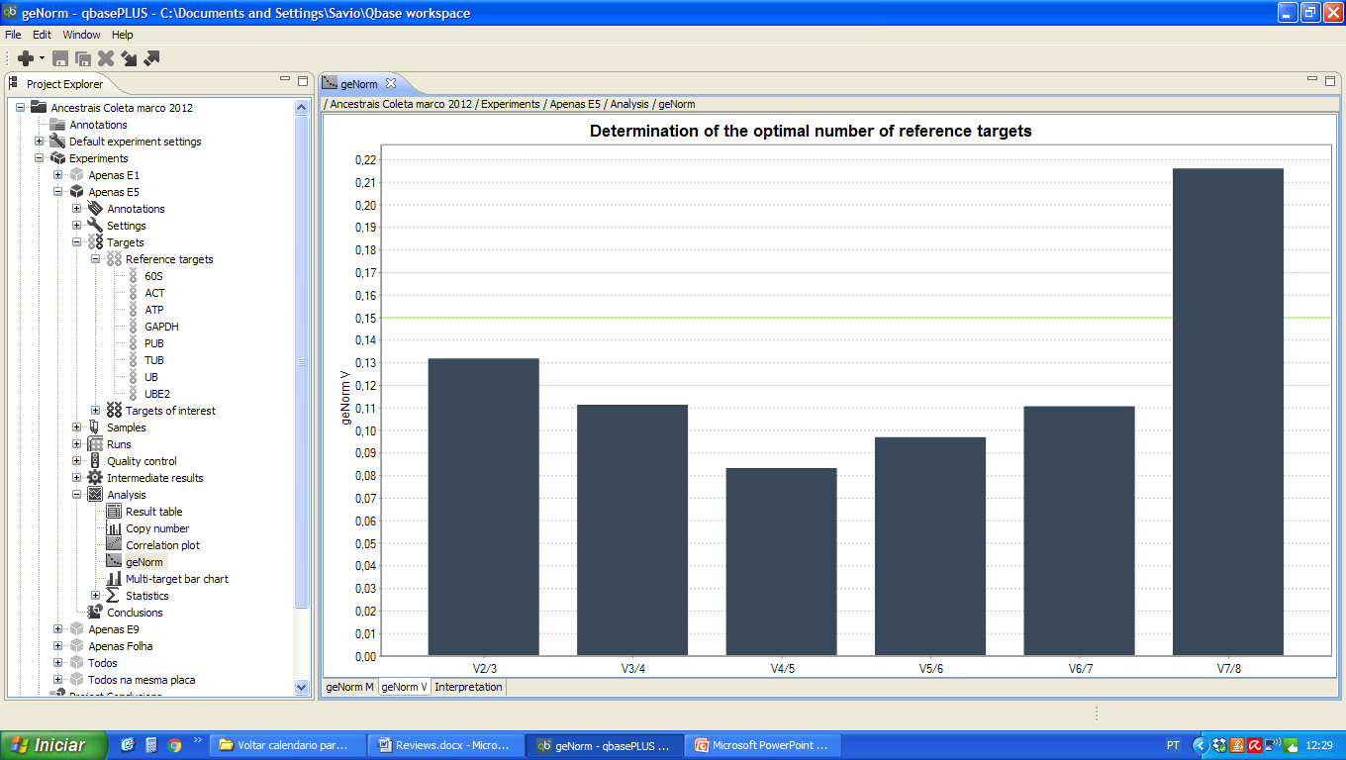
B

