Online Resource for:

Jasmonate signaling is activated in the very early stages of iron deficiency responses in rice roots

Journal: Plant Molecular Biology

Authors: Takanori Kobayashi^{1,2,*}, Reiko Nakanishi Itai³, Takeshi Senoura², Takaya Oikawa⁴, Yasuhiro Ishimaru⁴, Minoru Ueda⁴, Hiromi Nakanishi³, and Naoko K. Nishizawa²
Affiliations:
¹Japan Science and Technology Agency, PRESTO, 4-1-8 Honcho, Kawaguchi, Saitama 332-0012, Japan.
²Research Institute for Bioresources and Biotechnology, Ishikawa Prefectural University, 1-308 Suematsu, Nonoichi, Ishikawa 921-8836, Japan.
³Graduate School of Agricultural and Life Sciences, The University of Tokyo, 1-1-1 Yayoi, Bunkyo-ku, Tokyo 113-8657, Japan.
⁴Graduate School of Science, Tohoku University, 6-3 Aramaki-aza Aoba, Aoba-ku, Sendai 980-8578, Japan.

*Correspondence to: Takanori Kobayashi
Tel: +81 76 259 0579; Fax: +81 76 227 7557; E-mail: abkoba@ishikawa-pu.ac.jp

Online Resource 1. Primers used for quantitative RT-PCR.

Primer name | Sequence
OsDAD1;2 forward | 5’-ACGTCAAGCAGCTCTACATCAG-3’
OsDAD1;2 reverse | 5’-AAATATTTCTTGACCATCAGGAGG-3’
OsLOX2;1 forward | 5’-AACGCTCCAAAACTACTTGC-3’
OsLOX2;1 reverse | 5’-ACATTAAACATTGTGATACCTTGAG-3’
OsLOX2;3 forward | 5’-TGGGAGGACATCTACTTGC-3’
OsLOX2;3 reverse | 5’-AACATCAACAACAACCACTTC-3’
OsAOS1 forward | 5’-GCCGGCCATCACTTCAG-3’
OsAOS1 reverse | 5’-GTTTAAAGACACTGTCAGCCCTG-3’
OsAOS2 forward | 5’-CCACCGCCGGTCAAAG-3’
OsAOS2 reverse | 5’-AACTCCGTATCCGTACAAGCTG-3’
OsNAS1 forward | 5’-GTCTAACAGCCGGACGATCGAAAGG-3’
OsNAS1 reverse | 5’-TTTCTCACTGTCATACACAGATGGC-3’
OsDMAS1 forward | 5’-GCCGGCATCCCGCAGCGGAAGATCA-3’
OsDMAS1 reverse | 5’-CTCTCTCTCTCGCACGTGCTAGCGT-3'
OsYSL15 forward | 5’-CACCCTGGTGAAGCAGCTGGTGCTC-3’
OsYSL15 reverse | 5’-CGGCCATCGCCGTCGGCAGCGGCAC-3’
OsIRT1 forward | 5’-CGTCTTCTTCTTCTCCACCACGAC-3’
OsIRT1 reverse | 5’-GCAGCTGATGATCGAGTCTGACC-3’
OsYSL2 forward | 5’-TCTGCTGGCTTCTTTGCATTTTCTG-3’
OsYSL2 reverse | 5’-ACCATGTCGAACTCAGCATCCAGGA-3'
OsIRO2 forward | 5’-CCGGCGGATCCCGCTCCCAC-3'
OsIRO2 reverse | 5’-CGTCGTCGTCAGCTCCTTCT-3’
IDEF1 | TaqMan Gene Expression Assays Os03570590_m1
IBP1.1 | TaqMan Gene Expression Assays Os03470892_g1
a-2 tubulin | TaqMan Gene Expression Assays Os03562997_mH
OsNAS2 forward | 5’-TGAGTGCGTGCATAGTAATCCTGGC-3’
OsNAS2 reverse | 5’-CAGACGGTCACAAACACCTCTTGC-3’
OsHRZ2 | TaqMan Gene Expression Assays Os03496742_g1

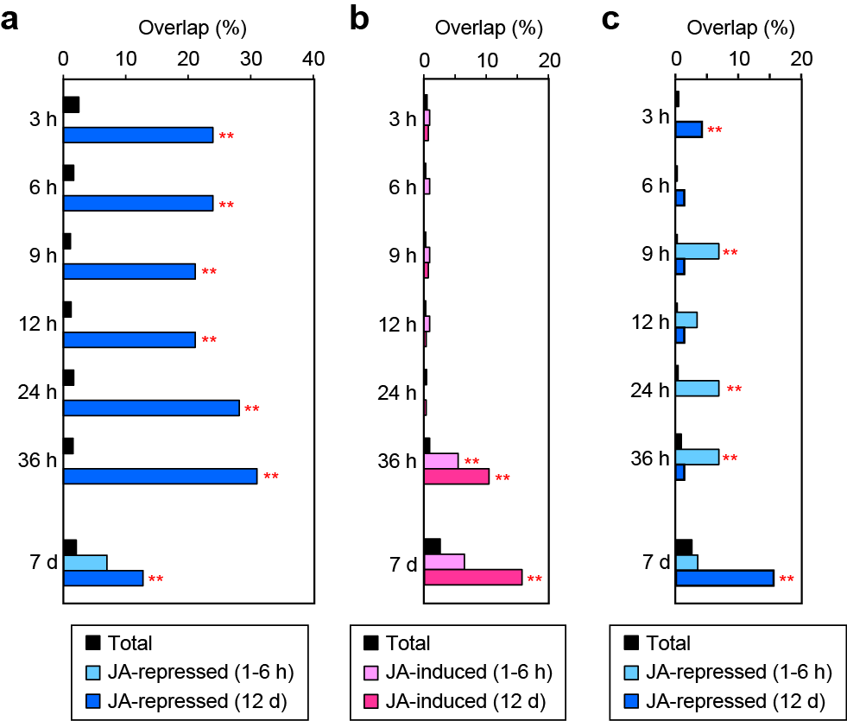

Online Resource 2. Overlap of the genes induced or repressed by jasmonates (JAs) with Fe deficiency-induced or -repressed genes. (a) JA-repressed genes after 1–6 h or 12 d with the Fe deficiency-induced genes. (b) JA-induced genes after 1–6 h or 12 d with the Fe deficiency-repressed genes. (c) JA-repressed genes after 1–6 h or 12 d with the Fe deficiency-repressed genes. Genes induced or repressed by JA treatment after 1–6 h and 12 d were analyzed based on previous reports by Yoshii et al. (2010) and Seo et al. (2011). Fe deficiency-induced or -repressed genes at 3–36 h and 7 d are based on previous microarray analyses by Itai et al. (2013) and Ogo et al. (2008), respectively. Overlap was calculated as (the number of the clones showing Fe deficiency-induction or -repression and JA-induction or -repression)/(the number of the total clones showing JA-induction or -repression). “Total” rate was calculated as (the number of the total clones showing Fe deficiency-induction or -repression)/(the number of the total clones analyzed). Asterisks indicate significant overrepresentations compared with the Total rates (**, P < 0.01). No significant underrepresentation was observed.
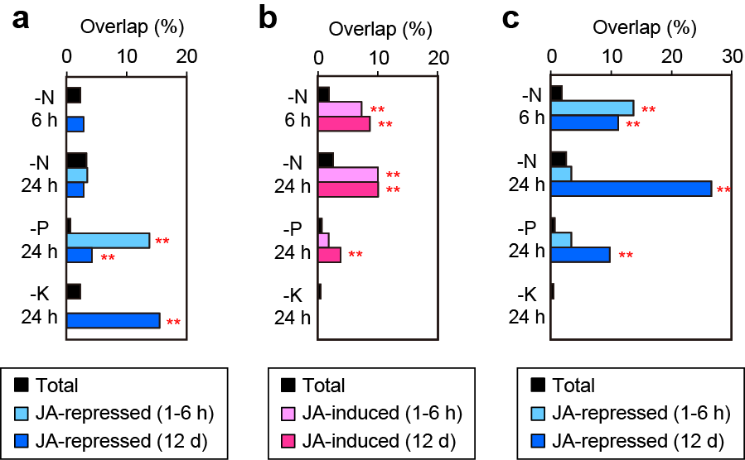

Online Resource 3. Overlap of the genes induced or repressed by jasmonates (JAs) with nutrient deficiency-induced or -repressed genes. (a) JA-repressed genes after 1–6 h or 12 d with the nutrient deficiency-induced genes. (b) JA-induced genes after 1–6 h or 12 d with the nutrient deficiency-repressed genes. (c) JA-repressed genes after 1–6 h or 12 d with the nutrient deficiency-repressed genes. Genes induced or repressed by JA treatment after 1–6 h and 12 d were analyzed based on previous reports by Yoshii et al. (2010) and Seo et al. (2011). N, P or K deficiency-induced or -repressed genes at 6 or 24 h are based on previous microarray analysis by Takehisa et al. (2013). Overlap was calculated as (the number of the clones showing nutrient deficiency-induction or -repression and JA-induction or -repression)/(the number of the total clones showing JA-induction or -repression). “Total” rate was calculated as (the number of the total clones showing nutrient deficiency-induction or -repression)/(the number of the total clones analyzed). Asterisks indicate significant overrepresentations compared with the Total rates (**, P < 0.01). No significant underrepresentation was observed.

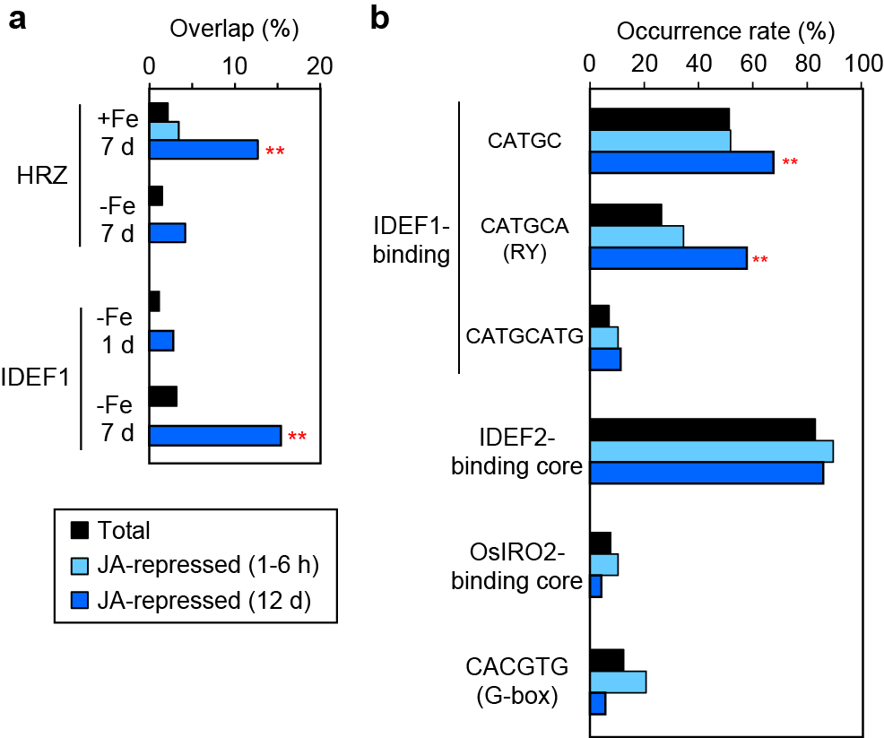

Online Resource 4. Involvement of trans-acting regulators and cis-acting elements for Fe deficiency responses in the expression of genes repressed by jasmonates (JAs). (a) Overlap of the genes repressed by JA treatment after 1–6 h or 12 d with those whose expression was induced in HRZ-knockdown (HRZ) or IDEF1-induced (IDEF1) lines under Fe sufficiency (+Fe) or deficiency (-Fe) after 1 or 7 d based on previous microarray analyses by Kobayashi et al. (2009, 2013). Overlap was calculated as (the number of the clones showing [induction in HRZ-knockdown or IDEF1-induced lines] and JA-repression)/(the number of the total clones showing JA-repression). “Total” rate was calculated as (the number of the total clones showing induction in HRZ-knockdown or IDEF1-induced lines)/(the number of the total clones analyzed). (b) Occurrence rates of cis-acting sequences in the genes repressed by JA treatment after 1–6 h or 12 d. CATGC, the minimal sequence recognized by IDEF1; CATGCA (RY) and CATGCATG, common binding sequences of IDEF1 and other ABI3/VP1 family transcription factors (Kobayashi et al. 2007); IDEF2-binding core, the minimal sequence recognized by IDEF2 [CA(A/C)G(T/C)(T/C/A)(T/C/A); Ogo et al. 2008]; OsIRO2-binding core, the minimal sequence efficiently recognized by OsIRO2 [CACGTGG; Ogo et al. 2006]; CACGTG (G-box), the binding sequence of many bHLH transcription factors, including MYC2/JIN1, a central regulator of the JA response (Fonseca et al. 2009). The putative promoter regions 500 nucleotides upstream of the 5' border of the predicted transcription initiation sites were used to search for cis-sequences. Occurrence rate was calculated as (the number of the clones possessing the cis-sequence and showing JA-repression)/(the number of the total clones showing JA-repression). “Total” rate was calculated as (the number of the total clones possessing the cis-sequence)/(the number of the total clones analyzed). Asterisks indicate significant overrepresentations compared with the Total rates (*, P < 0.05; **, P < 0.01). No significant underrepresentation was observed.

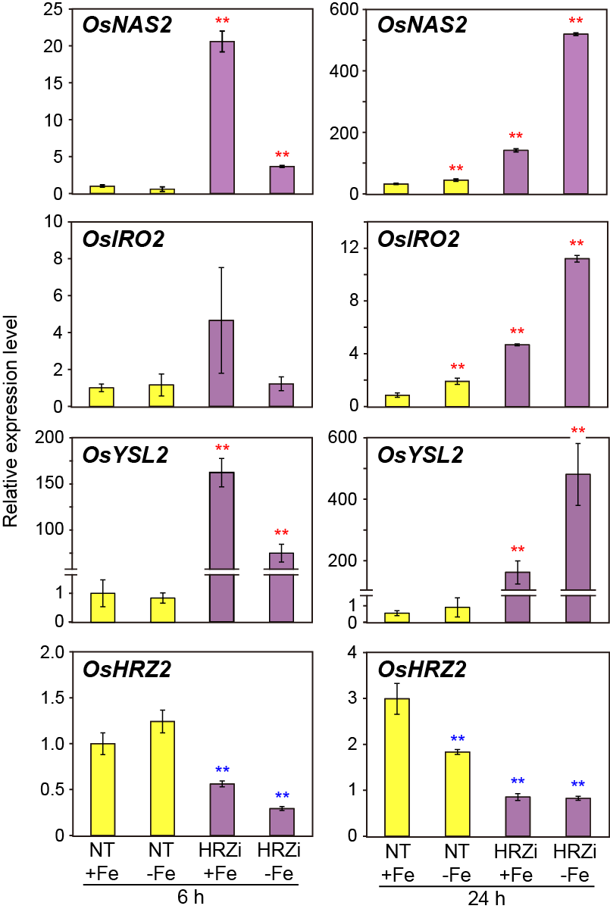

Online Resource 5. Transcript levels of the Fe deficiency-inducible genes OsNAS2, OsIRO2, OsYSL2, and OsHRZ2 during the early stages of Fe deficiency. The plants used for the analysis were identical to those in Fig. 4. Non-transgenic (NT) and HRZ-knockdown (HRZi) rice were subjected to Fe sufficiency (+Fe) or deficiency (-Fe) for 6 and 24 h. Roots were harvested and used for quantitative RT-PCR analysis. The transcript abundance was normalized against the rice α-2 tubulin transcript level and expressed as a ratio relative to the levels in the NT +Fe after 6 h (means ± SD, n = 3). Asterisks indicate significant differences compared with the +Fe NT level at each time point (*, P < 0.05; **, P < 0.01).
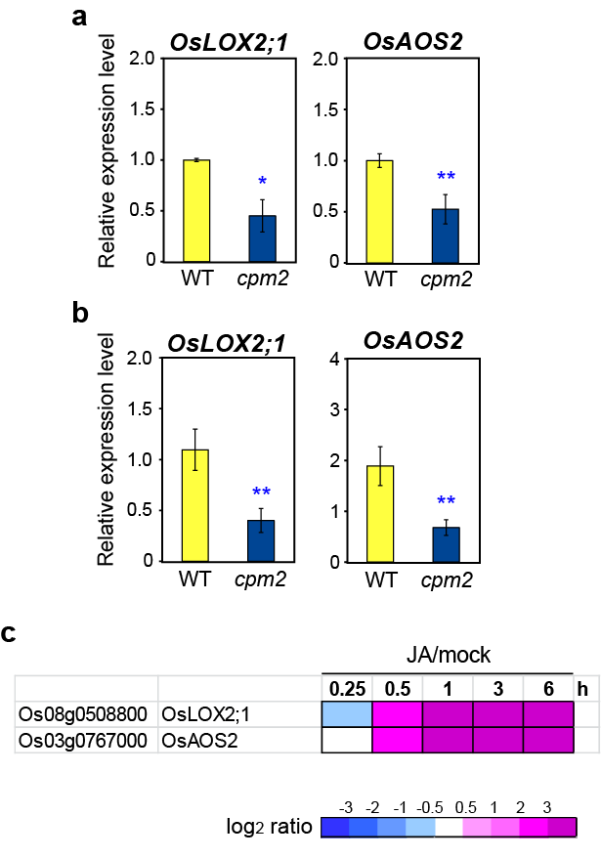

Online Resource 6. Transcript levels of OsLOX2;1 and OsAOS2 in the JA-deficient cpm2 mutant. (a, b) Wild-type (WT) and homozygous cpm2 mutant were subjected to Fe sufficiency (a) or deficiency (b) for 24 h. Roots were harvested and used for quantitative RT-PCR analysis. The transcript abundance was normalized against the rice α-2 tubulin transcript level and expressed as a ratio relative to the levels in the Fe-sufficient WT plants (means ± SD, n = 3). Asterisks indicate significant differences compared with the WT level at each condition (*, P < 0.05; **, P < 0.01). (c) Transcriptional responses of OsLOX2;1 and OsAOS2 to jasmonic acid (JA) treatment in roots. Expression ratios of 100 μM JA treatment versus mock treatment (JA/mock) at 0.25, 0.5, 1, 3, and 6 h are based on the microarray results provided on the RiceXPro website (Sato et al. 2013; http://ricexpro.dna.affrc.go.jp/index.html). The ratios are shown in the heat maps using a log₂ scale.
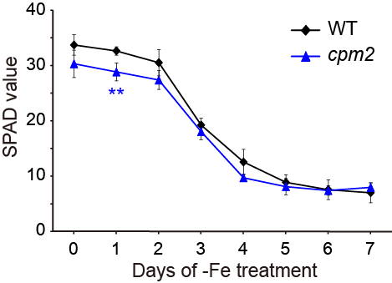

Online Resource 7. Tolerance of the JA-deficient cpm2 mutant to Fe deficiency. SPAD values (indicative of relative chlorophyll contents) of the newest leaves of the wild-type (WT) and homozygous cpm2 mutant were measured during the Fe-deficiency treatment in hydroponics (means ± SD, n = 4). Asterisks indicate significant differences compared with the WT level at each time point (**, P < 0.01).

