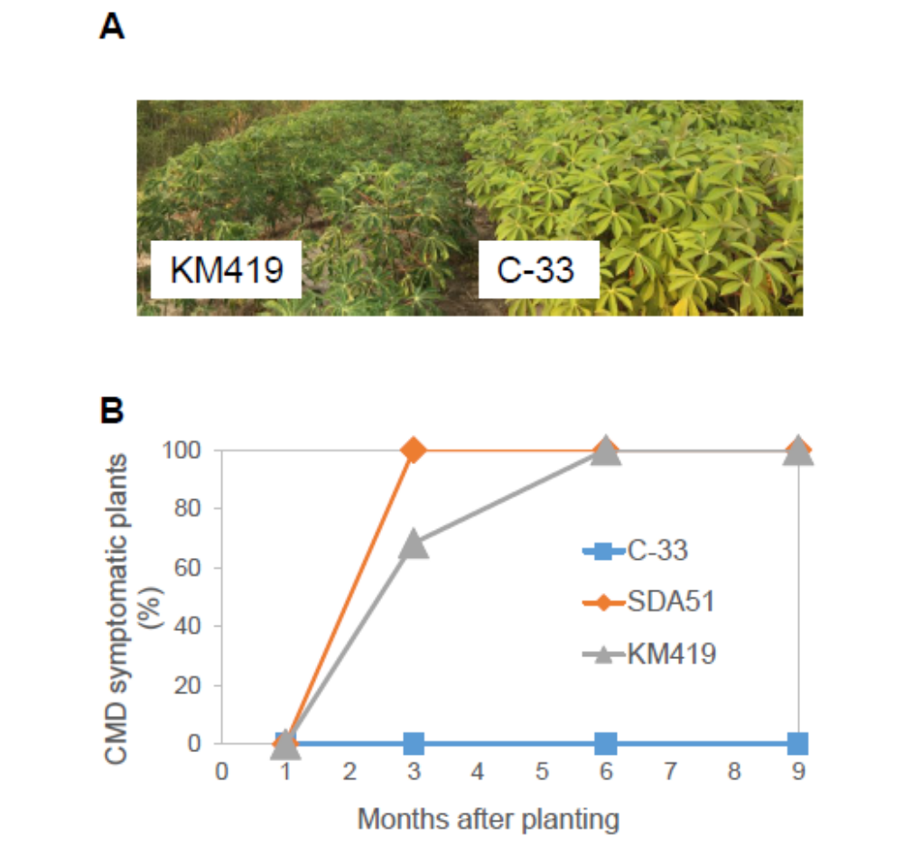

Supplementary Fig 1. CMD resistance of C33.
(A) Typical appearance of C33 and KM419 grown for 4 months in an CMD-infected field in Tay Ninh province, Vietnam. (B) The percentage of CMD-symptomatic plants from a survey conducted from October 2018 to September 2019. A similar result was obtained in 2020. The highest CMD score for each plant was recorded at 1, 3, 6, 9 months after planting. A total of 60 plants of each variety were monitored to determine the percentage of CMD symptomatic plants.

