Supplementary material
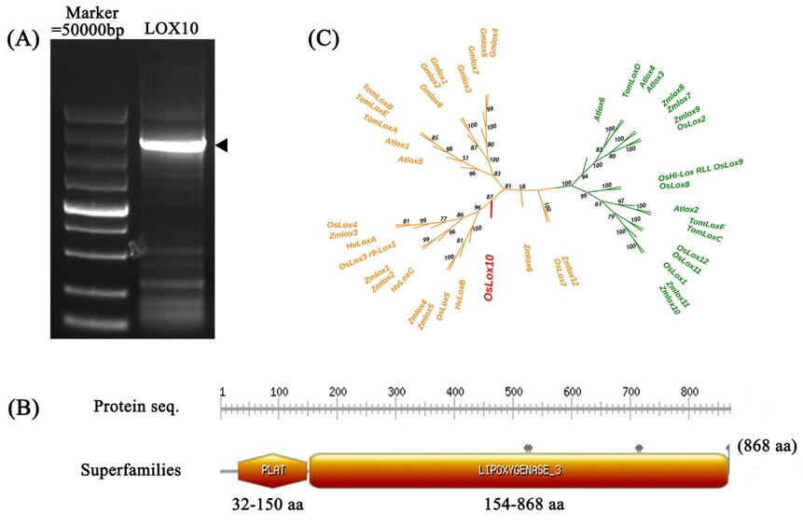
Fig.S1 Characterization of LOX10 in rice
- Cloning of intact LOX10; (b) The structure characterization and conserved domain analysis of LOX10 gene; (c) The phylogenetic tree analysis of LOX10 gene; The Os: Oryza sativa, At: Arabidopsis thaliana, Zm: Zea Mays, Tom: Tomato, Gm: Soybean, Hv: Wheat.

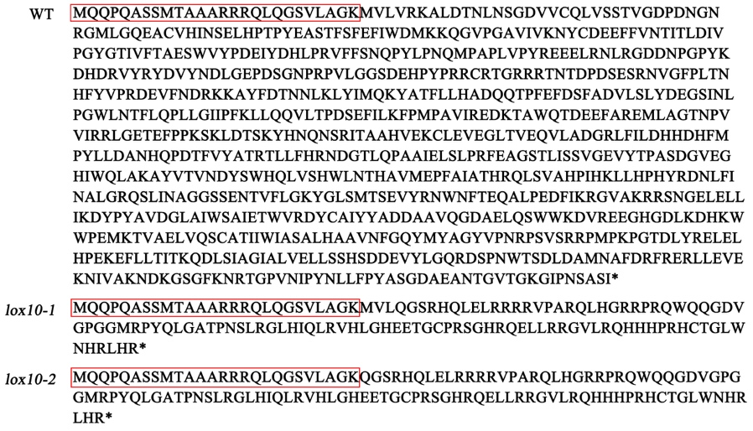
Fig.S2 Comparison of amino acid sequences between WT and lox10 mutants in rice.

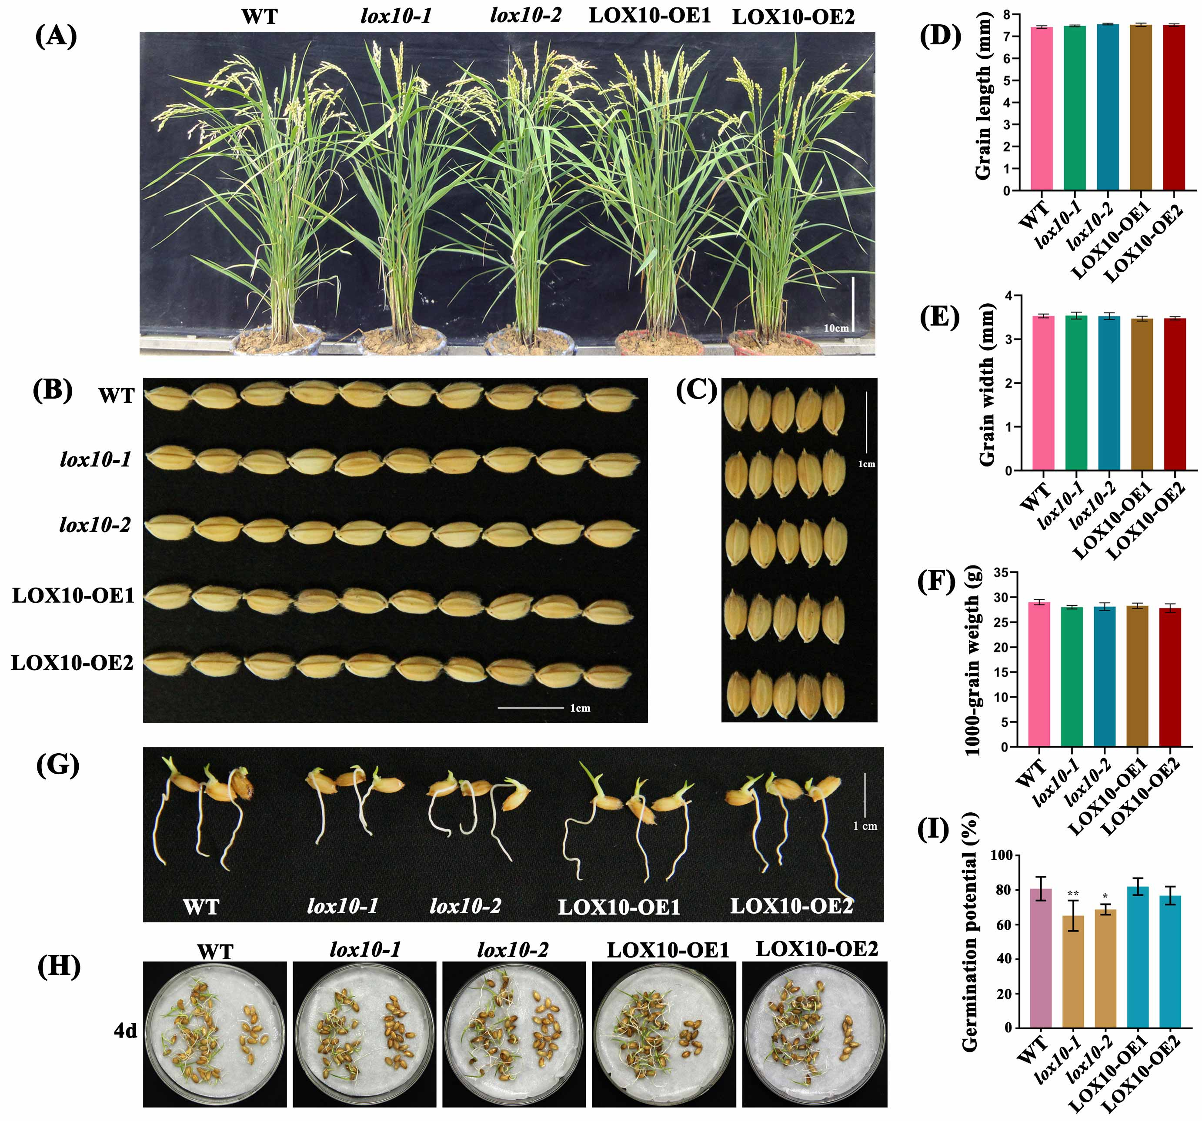
Fig.S3 Comparison of agronomic traits between WT, lox10 mutants and LOX10 overexpression lines.
- Phenotypes of WT, lox10 mutants and LOX10 overexpression lines in the experimental field. Bar=10 cm. (b,c) Comparison of grain traits between WT, lox10 mutants and LOX10 overexpression lines. Bar=1 cm. (d) Grain length. (e) Grain width. (f) 1000-grain weight. (g) Seed germination of WT, lox10 mutants and LOX10 overexpression lines after 4 days. Bar=1 cm. (h, i) Germination potential of WT, lox10 mutants and LOX10 overexpression lines after 4 days.
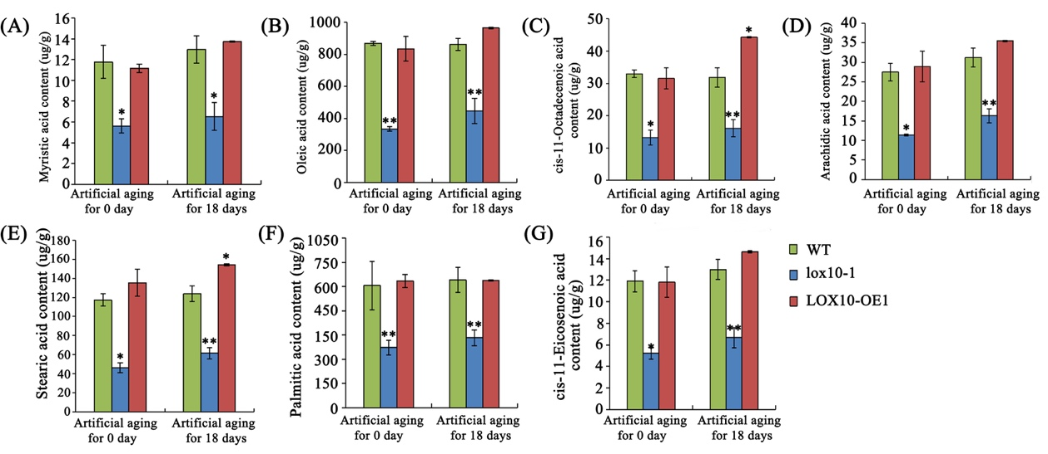
Fig.S4 Determination of free fatty acid content in rice embryo of WT, lox10 mutants and LOX10 overexpression lines.
- Myristic acid content. (b) Oleic acid content. (c) cis-11-Octadecenoic acid content. (d) Arachidic acid content. (e) Stearic acid content. (f) Palmitic acid content. (g) cis-11-Eicosenoic acid content.

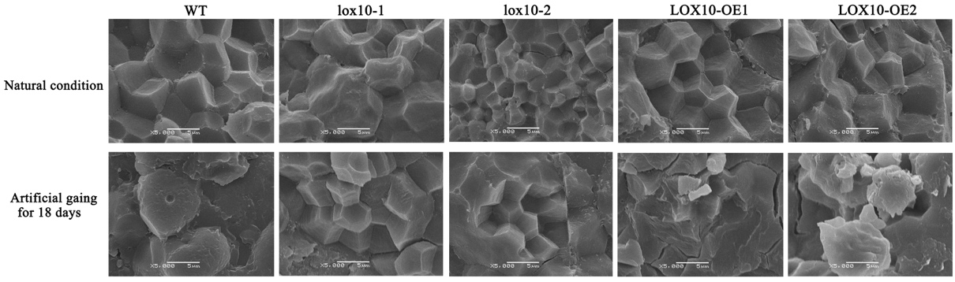
Fig.S5 The observation of starch granule structure in rice endosperm of WT, lox10-1 mutants and LOX10-OE1 overexpression plant under natural condition and artificial aging for 18 days. Bar=5 um.

Table S1. Primers used in this study.
Primer name | Sequence (5′ to 3′) | Function
OsU3-FD3 | GACAGGCGTCTTCTACTGGTGCTAC | Identification of transgenic lox10 mutant plants
TaU3-RD | CTCACAAATTATCAGCACGCTAGTC | Identification of transgenic lox10 mutant plants
LOX10-OE-Hyg-F | CGAGAGCCTGACCTATTG | Identification of LOX10 overexpression transgenic plants
LOX10-OE-Hyg-R | GCCTCCAGAAGAAGATGT | Identification of LOX10 overexpression transgenic plants
LOX10-CDS-F | AGGTAGCTAGTAGTACGATGCAG | Cloning of LOX10 gene
LOX10-CDS-R | ACACGAGAAGAGAAATGTTGCT | Cloning of LOX10 gene
LOX10-Pro-F | GACCAAGCTCCTGTTCCTCC | Cloning of LOX10 gene promoter
LOX10-Pro-R | TTCAAGTTGGTGTCGAGAGC | Cloning of LOX10 gene promoter
LOX10-OE-NcoI-F | GGACTCTTGACCATGGCAGCAGCCGCAGGCGAG | Cloning pCAMBIA-1302, pairing with LOX10-OE-NcoI-F and LOX10-OE-BstEII-R
LOX10-OE-BstEII-R | GGAAATTCGAGCTGGTCACCTCAGATGGAGGCGCTG
LOX10-GFP-BamH-F | GATCCAGTGGGATCCATGCAGCAGCCGCAGGCG | Cloning pRTVcGFP , pairing with LOX10-GFP-BamH-F and LOX10-GFP-HindIII-R
LOX10-GFP-HindIII-R | CCGCACTAGTAAGCTTGATGGAGGCGCTGTTGGG
LOX10-GUS-BamH-F | GAGCTCGGTACCCGGCTCAGTTCGATCCCCTACC | Cloning pCAMBIA-1305, pairing with LOX10-GUS-BamH-F and LOX10-GUS-NcoI-R
LOX10-GUS-NcoI-R | TACCCTCAGATCTACCATGGTTCAAGTTGGTGTCGAGAGC
LOX10-28a-NdeI-F | GTGCCGCGCGGCAGCCATATGATGCAGCAGCCGCAGGCG | Cloning pET28a(+), pairing with LOX10-28a-NdeI-F and LOX10-28a-HindIII-R
LOX10-28a-HindIII-R | CTCGAGTGCGGCCGCAAGCTTTCAGATGGAGGCGCTGTTG
Actin-qPCR-F | AGTGTCTGGATTGGAGGAT | internal control
Actin-qPCR-R | TCTTGGCTTAGCATTCTTG | internal control
LOX10-qPCR-F | TTCCTTCTCACCATCACTAA | Relative expression level analysis of LOX10
LOX10-qPCR-R | GTTCTTCTCCACCTCCAA | Relative expression level analysis of LOX10
LOX1-qPCR-F | GAGGAGATGGCACAGGTGTT | Relative expression level analysis of LOX1
LOX1-qPCR-R | TTGGATGCGGCTTCTCTACT | Relative expression level analysis of LOX1
LOX2-qPCR-F | CTCAACGGACTCACAGTA | Relative expression level analysis of LOX2
LOX2-qPCR-R | GGCTGGAGGAAGACTAAG | Relative expression level analysis of LOX2
LOX3-qPCR-F | AGAGCAAGGTCCATACAC | Relative expression level analysis of LOX3
LOX3-qPCR-R | GTCATTAACAGCAACATAAGC | Relative expression level analysis of LOX3
OsAOS2- qPCR-F | CCTAGCGTTGACAACAAG | Relative expression level analysis of OsAOS2
OsAOS2- qPCR-R | TAAGCAGTACGATTGACG | Relative expression level analysis of OsAOS2
OsHPL1- qPCR-F | AGTTCAACAAGCTCAACA | Relative expression level analysis of OsHPL1
OsHPL1- qPCR-R | GTGAAGCTGGAAGATGAG | Relative expression level analysis of OsHPL1
OsHPL3-qPCR-F | GTACGTGTACTGGTCCAA | Relative expression level analysis of OsHPL3
OsHPL3- qPCR-R | CTTGTCGAGCTTGGTGAA | Relative expression level analysis of OsHPL3

