Supplemental Figures
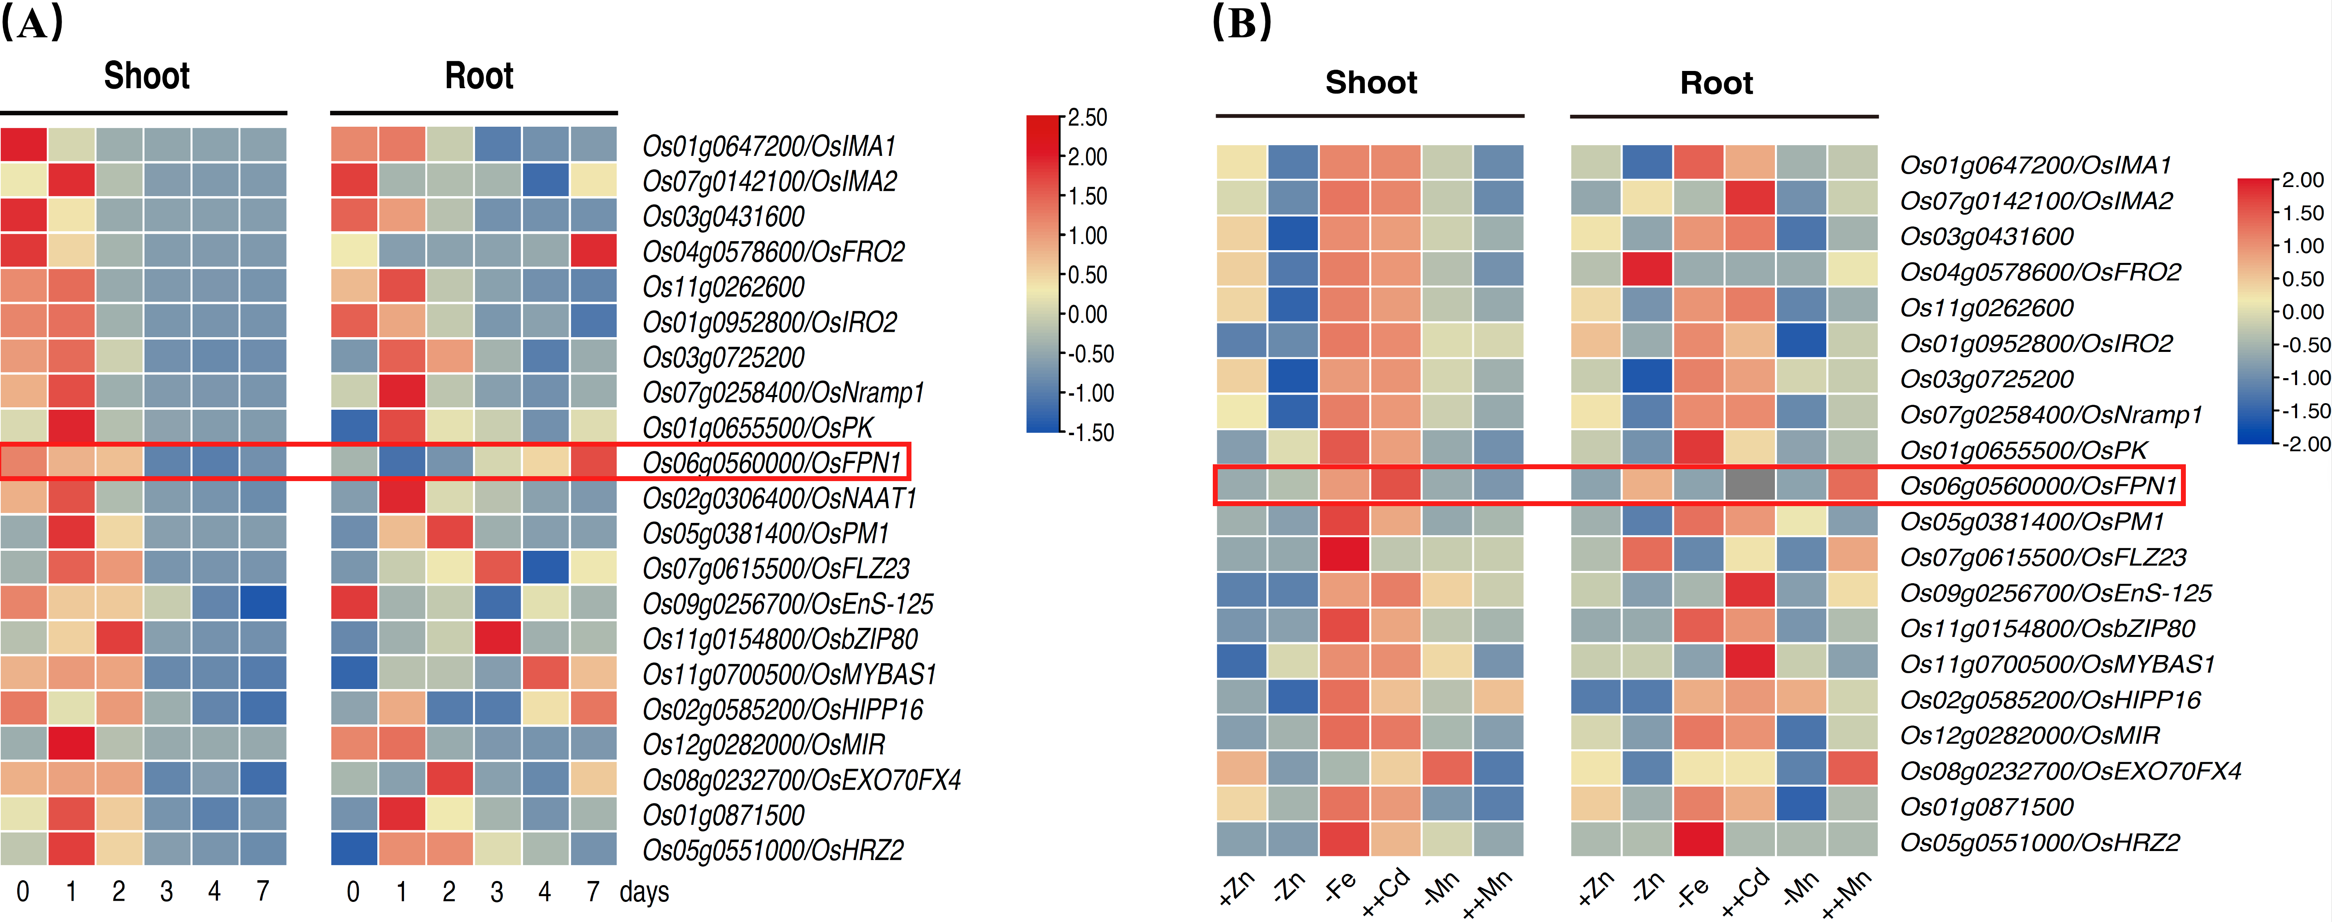
Fig. S1 Expression patterns of Fe homeostasis–related genes in rice. (A) Heatmap showing the expression changes of genes related to Fe homeostasis in shoots and roots of osiro3 mutants during a time course of Fe deficiency (0–7 days) (Wang et al., 2020). (B) Heatmap showing the expression changes of the same gene set in shoots and roots of NT plants under multiple metal treatment conditions (–Zn, –Fe, ++Cd, –Mn, ++Mn) (Ogo et al., 2008). All heatmaps were generated from normalized microarray data, and the red box highlights OsFPN1.
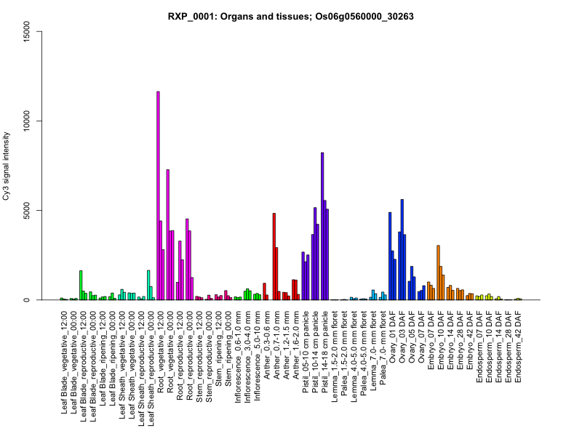
Fig. S2 Transcript expression levels of OsFPN1 in rice organs and tissues. Microarray data were obtained from the RiceXPro database (Sato et al., 2011, 2013; http://ricexpro.dna.affrc.go.jp). The result of probe ID 30263 in dataset RXP_0001 (Organs and tissues) is shown as a representative profile. Cy3 signal intensities are presented for various organs and developmental stages.
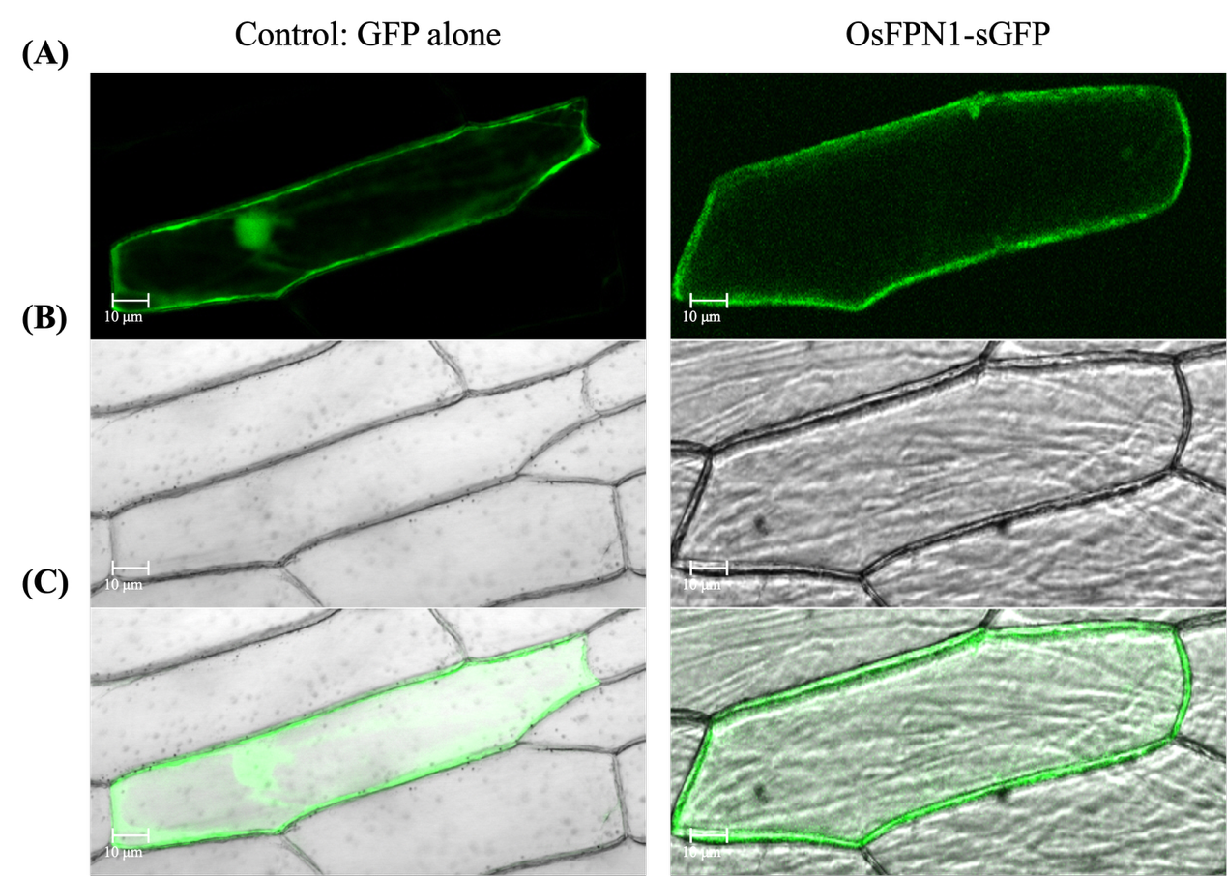
Fig. S3 Subcellular localization of OsFPN1-sGFP in onion (Allium cepa) epidermal cells. (A) Fluorescence images of sGFP alone (control) and OsFPN1-sGFP transiently expressed in onion epidermal cells. (B) Corresponding bright-field images. (C) Merged images of fluorescence and bright-field channels.

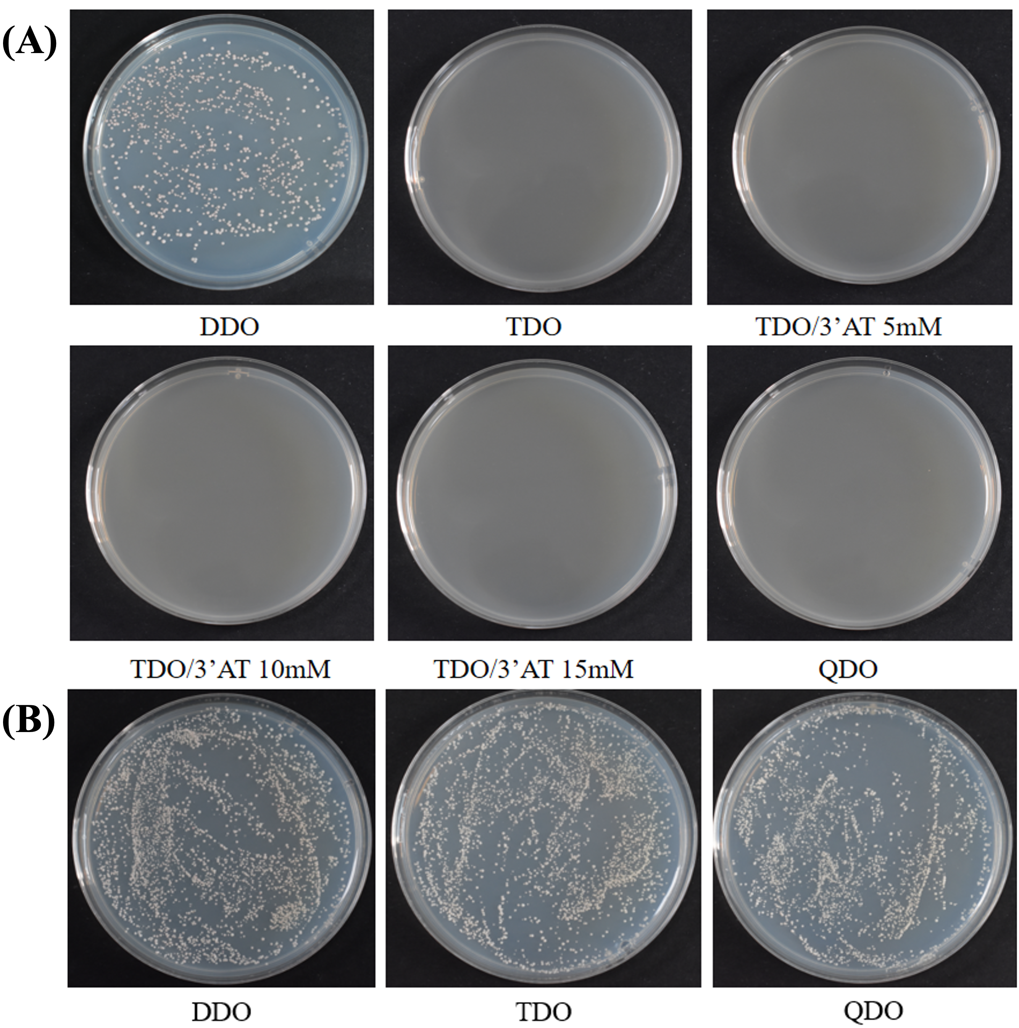
Fig. S4 Autoactivation and functional competence assays of OsFPN1 in the split-ubiquitin Y2H system. (A) Autoactivation test of OsFPN1. Yeast strain NMY51 was co-transformed with OsFPN1-pBT3-STE and empty prey vector pPR3-N, and transformants were grown on DDO (–Leu/–Trp), TDO (–Leu/–Trp/–His), TDO supplemented with 3-AT (5, 10, and 15 mM), and QDO (–Leu/–Trp/–His/–Ade) media. (B) Functional competence test of the system. Yeast cells were co-transformed with OsFPN1-pBT3-STE and the positive control prey pOst1-NubI, and plated on DDO, TDO, and QDO media.
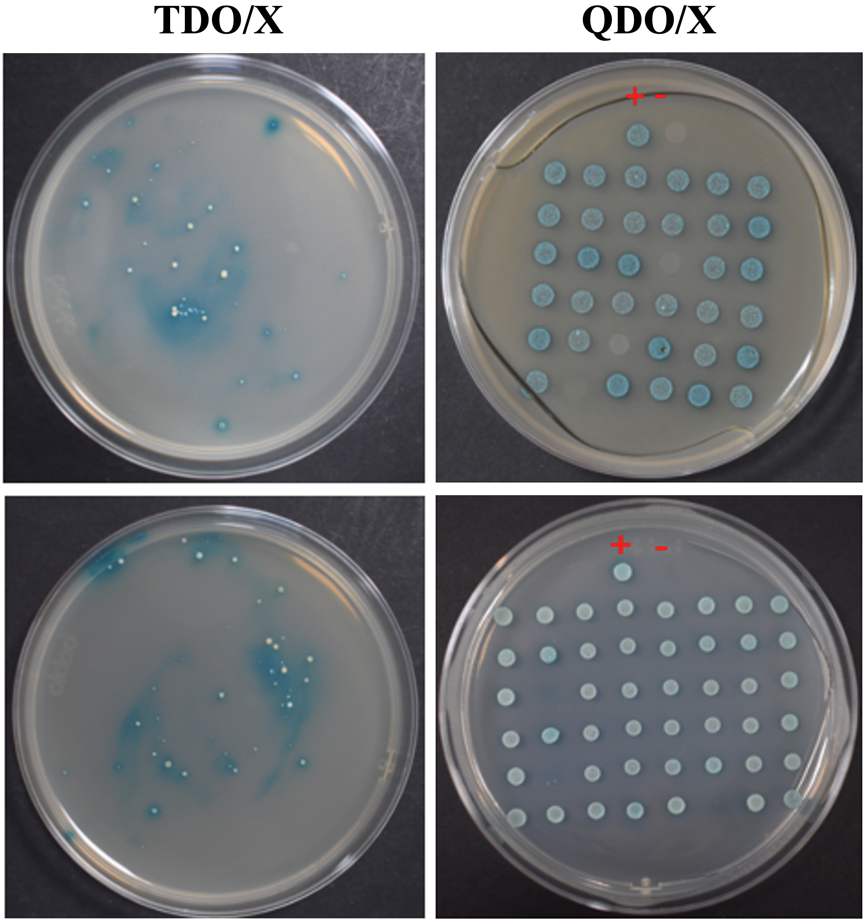
Fig. S5 Primary Y2H screening of OsFPN1-interacting proteins. Yeast strain NMY51 was co-transformed with OsFPN1-pBT3-STE and the rice cDNA prey library. Transformants were first selected on TDO/X (–Leu/–Trp/–His + X-α-Gal) plates and subsequently re-streaked on QDO/X (–Leu/–Trp/–His/–Ade + X-α-Gal) plates to reduce false positives. Blue colonies indicate positive interactions. (+) Positive control: PTSU2-APP + pNubG-Fe65; (−) Negative control: PTSU2-APP + pPR3-N.
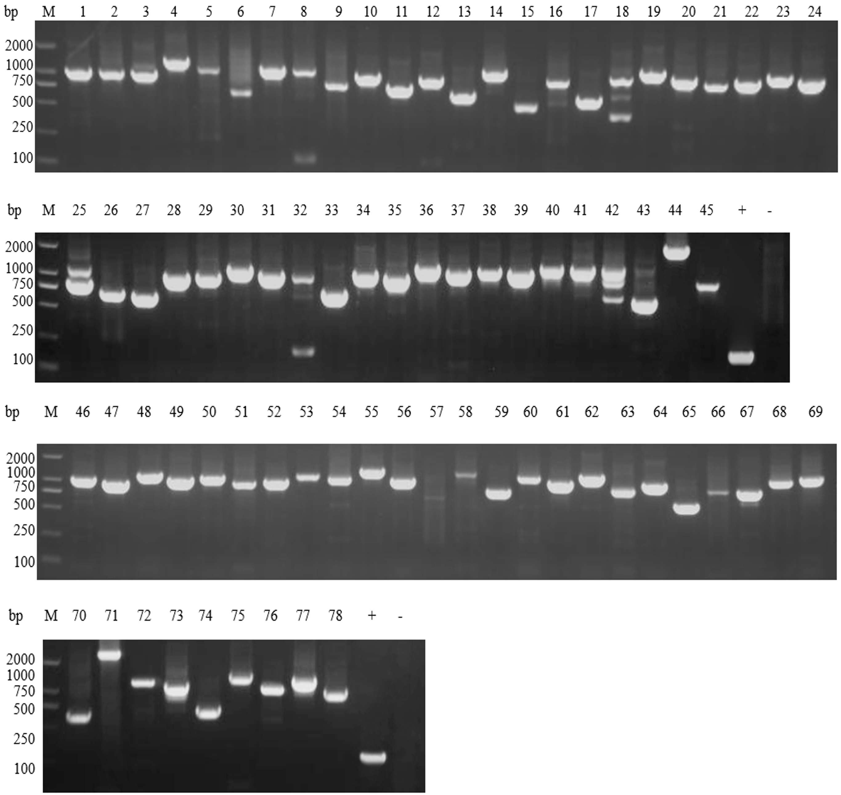
Fig. S6 Colony PCR confirmation of candidate OsFPN1-interacting clones. Prey plasmids rescued from positive yeast clones were PCR-amplified using CYC1 primers. Lanes 1–78 represent colony PCR products. Lane (+) indicates the positive control amplified using PPR3-N as the template, and lane (−) indicates the negative control using water as the template. M, DNA size marker.
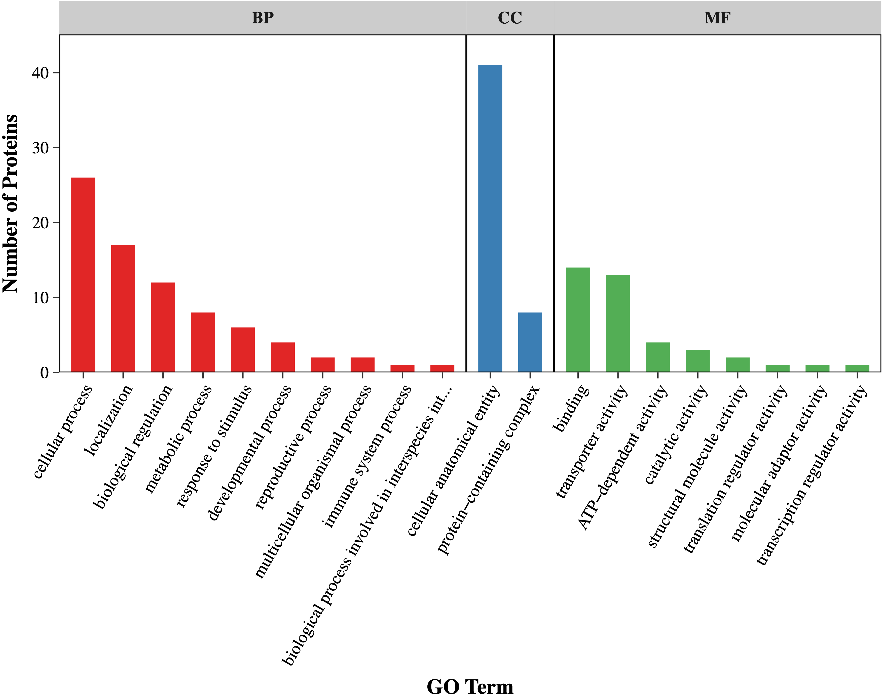
Fig. S7 Gene Ontology (GO) classification of OsFPN1-interacting proteins. Candidate interacting proteins identified from yeast two-hybrid screening were assigned to GO categories of Biological Process (BP), Cellular Component (CC), and Molecular Function (MF). The bar chart shows the distribution of proteins annotated under each GO term.
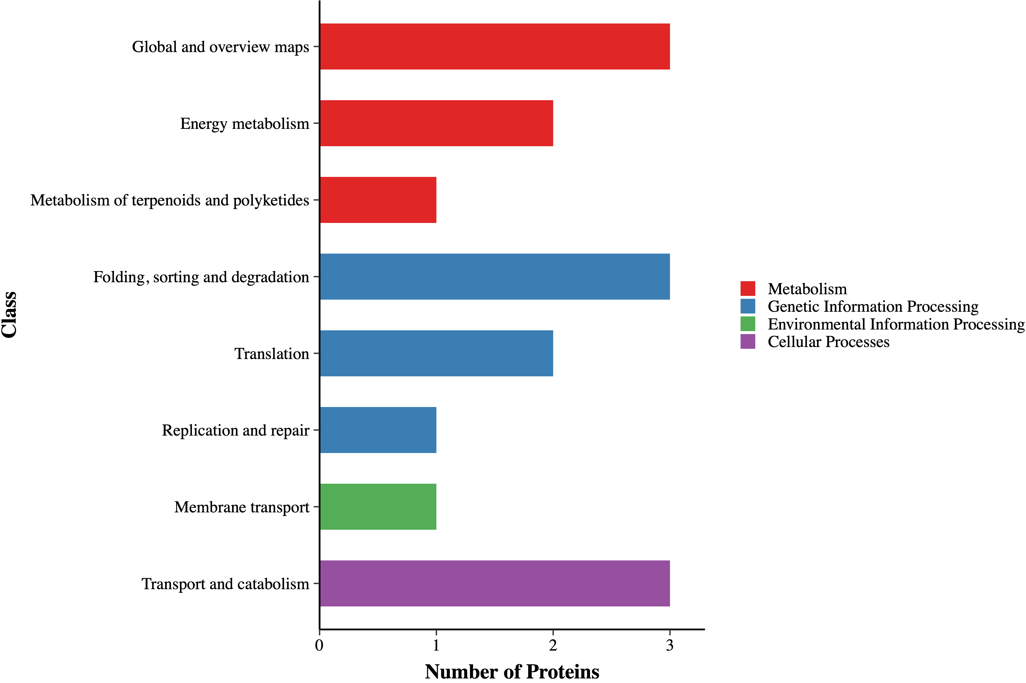
Fig. S8 KEGG pathway enrichment of OsFPN1-interacting proteins. Candidate interacting proteins were mapped to KEGG pathways. The bar chart shows the classification of proteins into functional categories, including metabolism, genetic information processing, environmental information processing, and cellular processes.

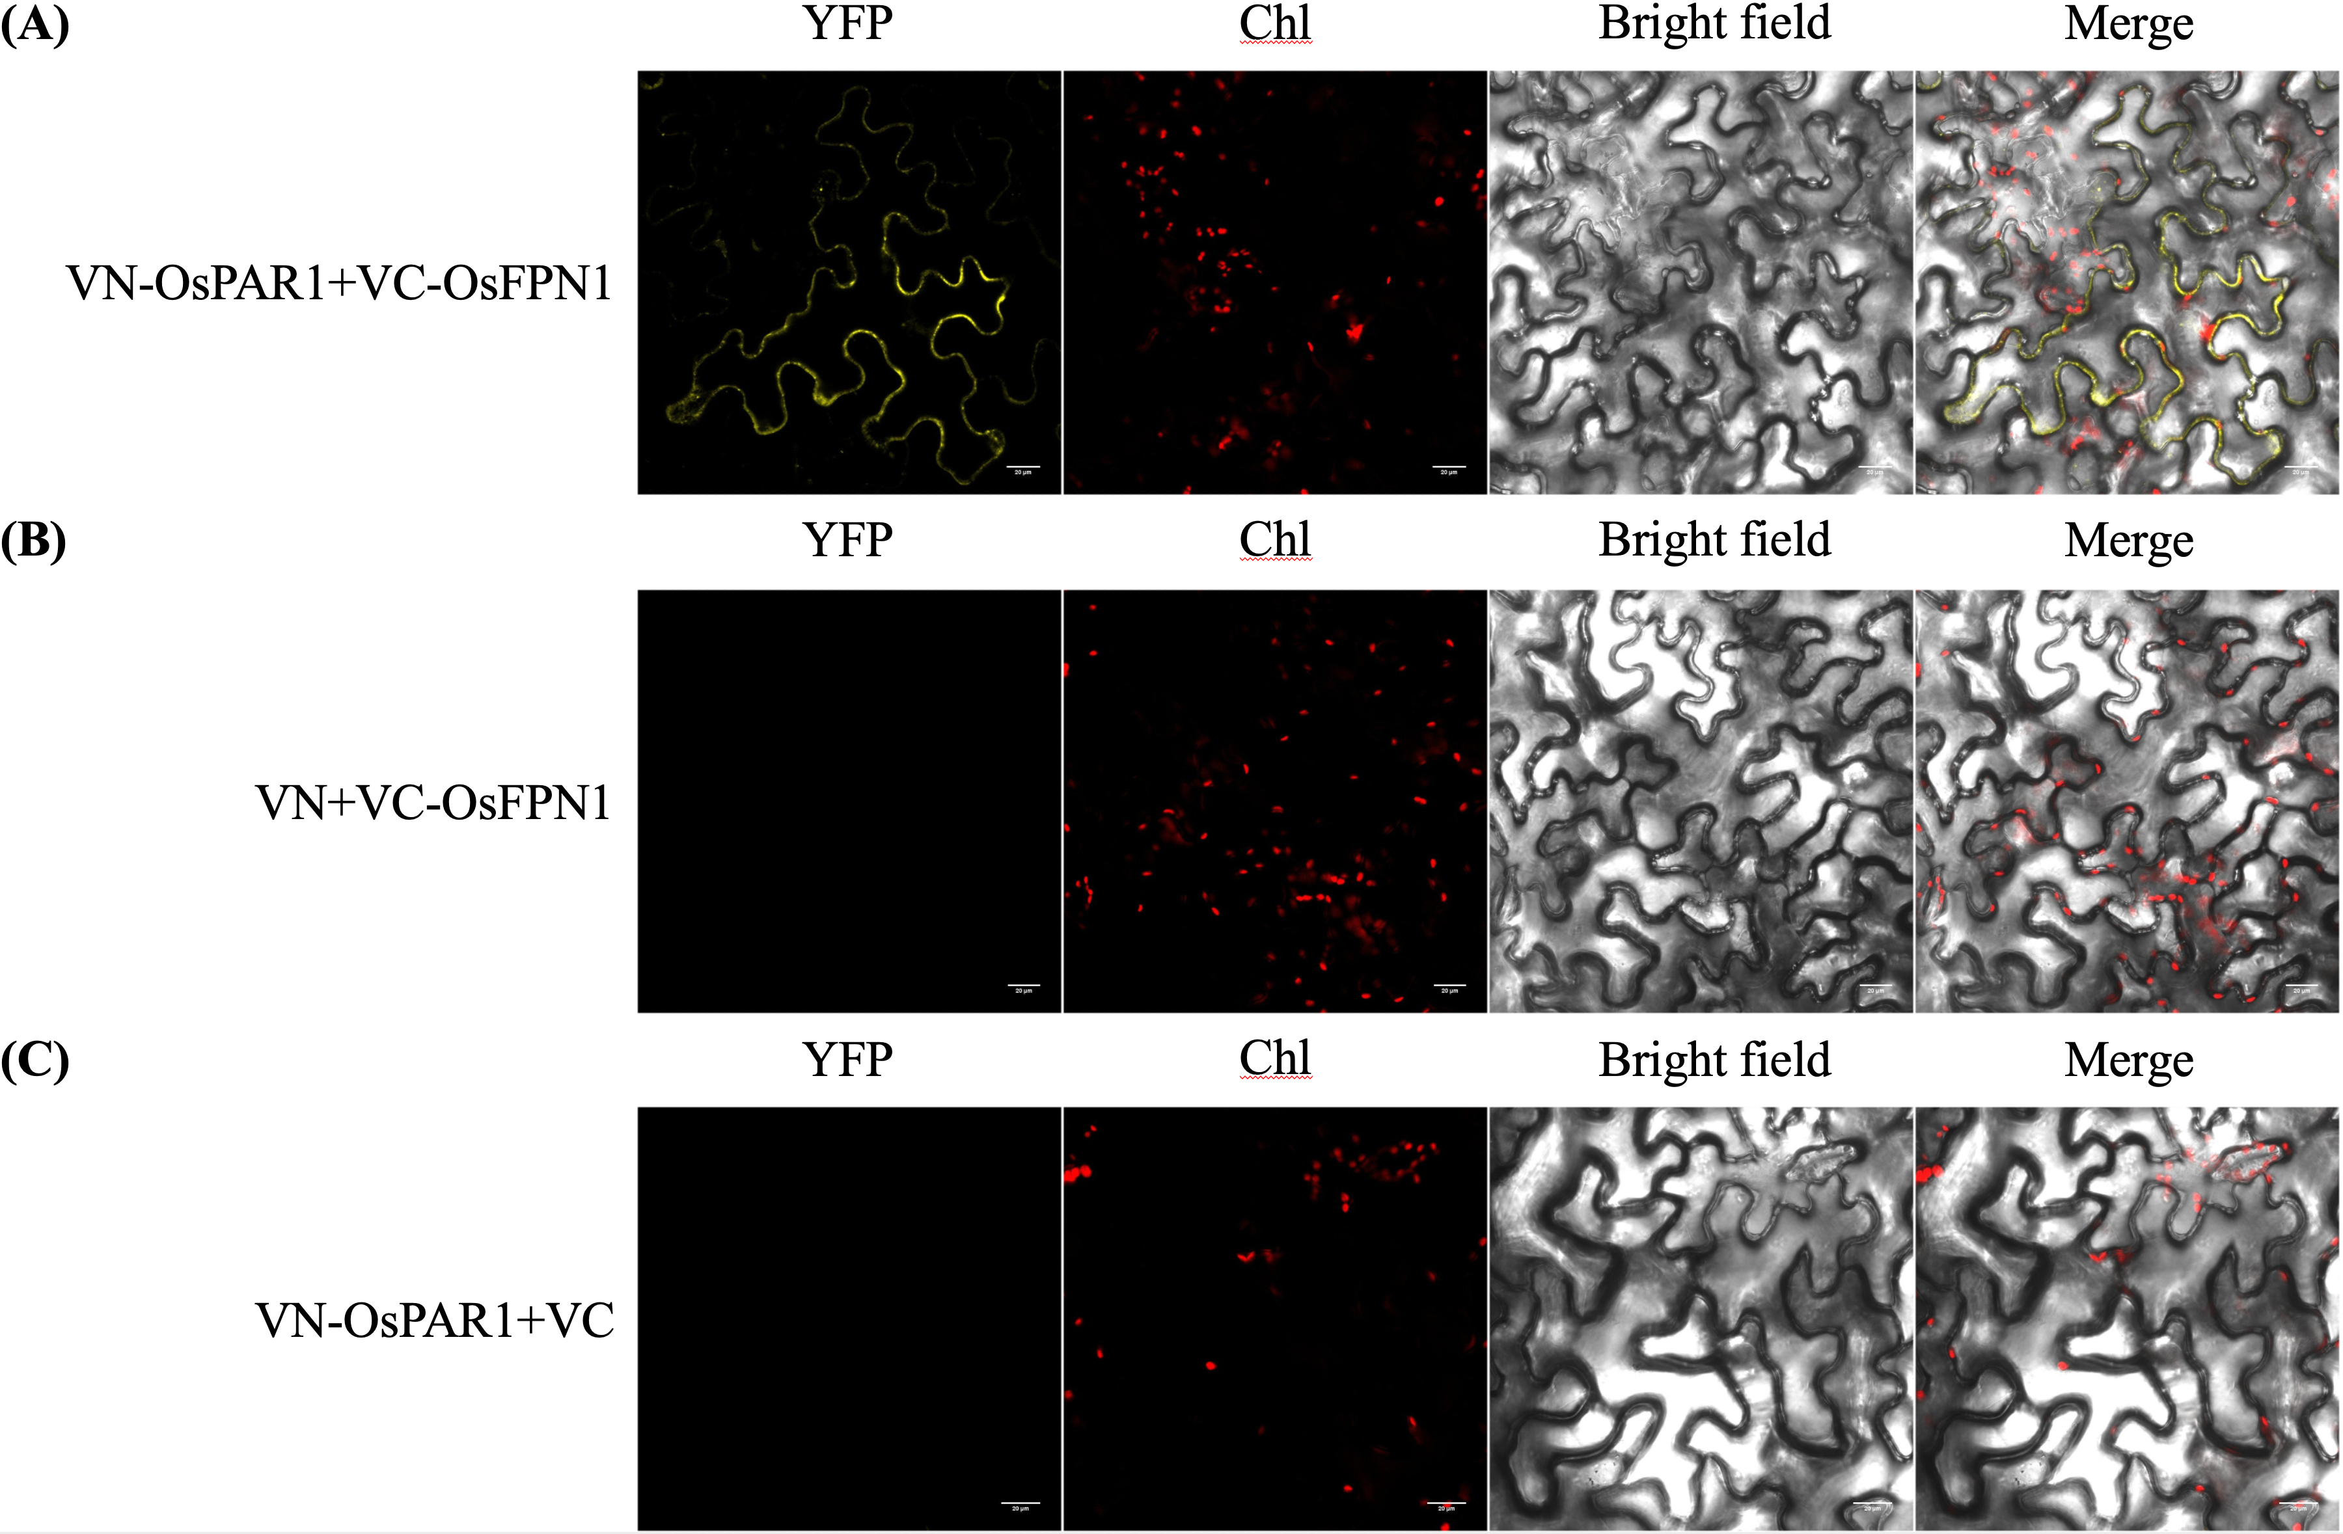
Fig. S9 Bimolecular fluorescence complementation (BiFC) analysis of OsPAR1 and OsFPN1 in Nicotiana benthamiana leaf epidermal cells. (A) Confocal fluorescence images of leaf epidermal cells co-expressing VN–OsPAR1 and VC–OsFPN1. (B) Confocal fluorescence images of leaf epidermal cells co-expressing empty VN and VC–OsFPN1. (C) Confocal fluorescence images of leaf epidermal cells co-expressing VN–OsPAR1 and empty VC. From left to right: BiFC (YFP) channel, Chlorophyll (Chl) autofluorescence, bright-field image, and merged image. Scale bars = 20 μm.

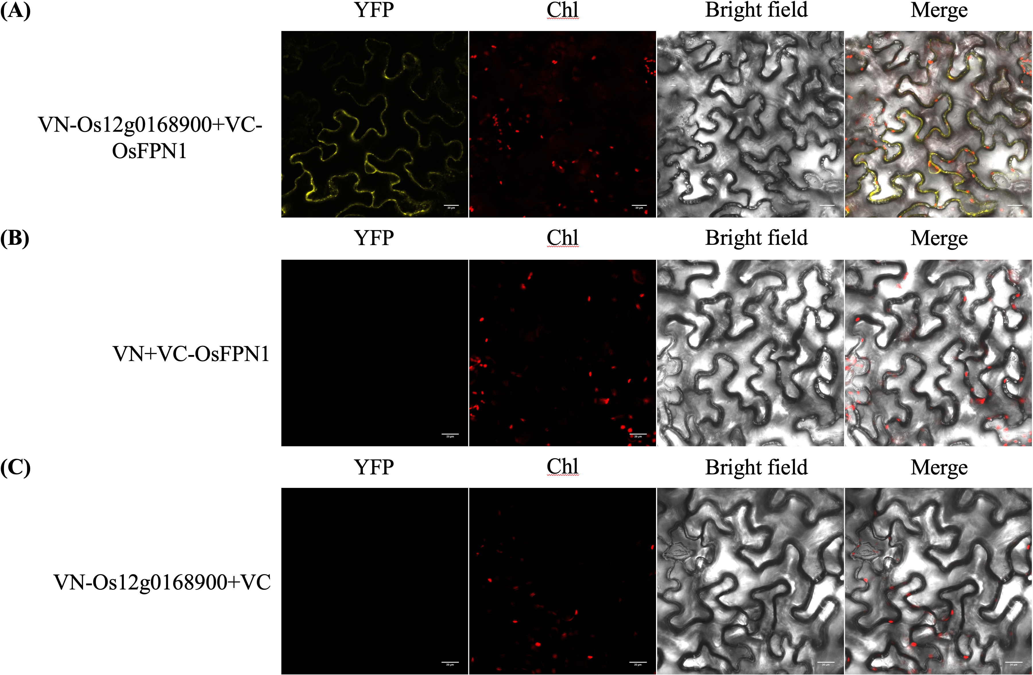
Fig. S10 Bimolecular fluorescence complementation (BiFC) analysis of Os12g0168900 and OsFPN1 in Nicotiana benthamiana leaf epidermal cells. (A) Confocal fluorescence images of leaf epidermal cells co-expressing VN–Os12g0168900 and VC–OsFPN1. (B) Confocal fluorescence images of leaf epidermal cells co-expressing empty VN and VC–OsFPN1. (C) Confocal fluorescence images of leaf epidermal cells co-expressing VN–Os12g0168900 and empty VC. From left to right: BiFC (YFP) channel, Chlorophyll (Chl) autofluorescence, bright-field image, and merged image. Scale bars = 20 μm.

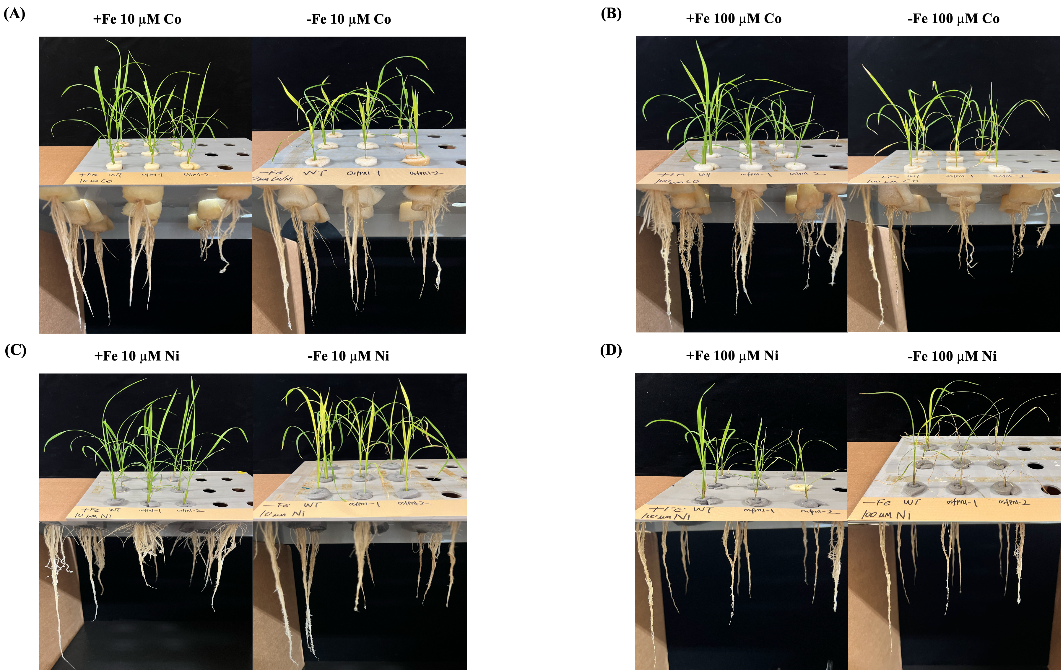
Fig. S11 Hydroponic phenotypes of wild-type (WT) and osfpn1 mutant seedlings under Fe-sufficient (+Fe) and Fe-deficient (−Fe) conditions with Co/Ni supplementation.(A–D) Representative photographs of WT and osfpn1-1/-2 grown hydroponically for 10 d under the indicated treatments. In each panel, the left image shows +Fe and the right image shows −Fe; shoots and roots are shown. Treatments were: (A) 10 μM CoCl₂·6H₂O; (B) 100 μM CoCl₂·6H₂O; (C) 10 μM NiCl₂·6H₂O; (D) 100 μM NiCl₂·6H₂O.
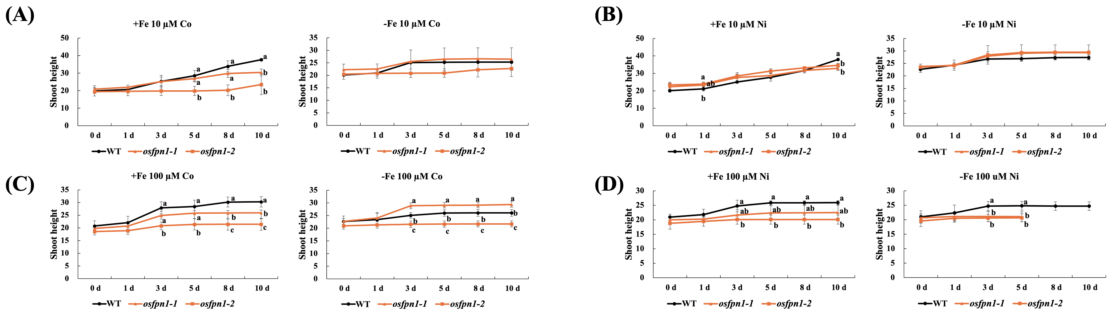
Fig. S12 Shoot height of wild-type (WT) and osfpn1 mutant seedlings under Fe-sufficient (+Fe) and Fe-deficient (−Fe) conditions with Co/Ni supplementation. Data were recorded at 0, 1, 3, 5, 8, and 10 days. (A–D) Time-course measurements of shoot height for WT and osfpn1-1/-2 grown hydroponically for 10 d under the indicated treatments: (A) 10 μM CoCl₂·6H₂O, (B) 10 μM NiCl₂·6H₂O, (C) 100 μM CoCl₂·6H₂O, and (D) 100 μM NiCl₂·6H₂O. Data represent the mean ± SD (n = 3). Different letters indicate significant differences among genotypes (one-way ANOVA followed by Tukey’s HSD, p < 0.05).

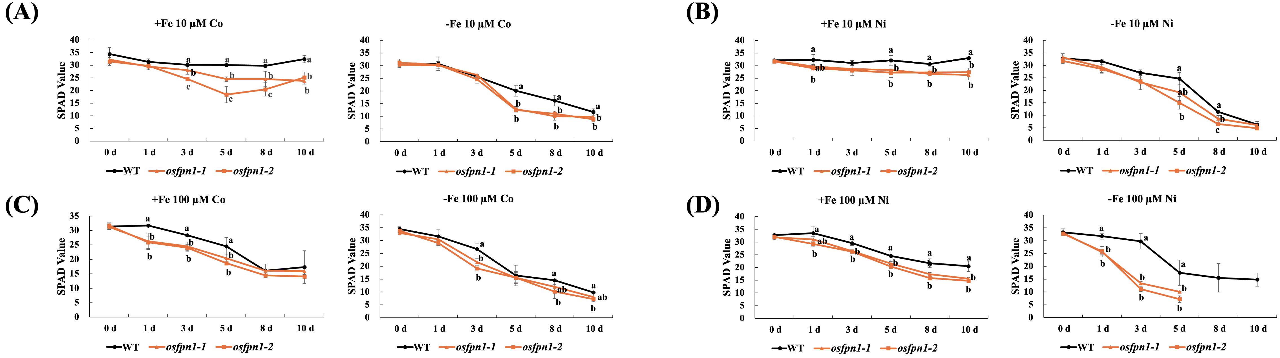
Fig. S13 SPAD values of wild-type (WT) and osfpn1 mutant seedlings under Fe-sufficient (+Fe) and Fe-deficient (−Fe) conditions with Co/Ni supplementation. Data were recorded at 0, 1, 3, 5, 8, and 10 days. (A–D) Time-course measurements of SPAD values for WT and osfpn1-1/-2 grown hydroponically for 10 d under the indicated treatments: (A) 10 μM CoCl₂·6H₂O, (B) 10 μM NiCl₂·6H₂O, (C) 100 μM CoCl₂·6H₂O, and (D) 100 μM NiCl₂·6H₂O. Data represent the mean ± SD (n = 3). Different letters indicate significant differences among genotypes (one-way ANOVA followed by Tukey’s HSD, p < 0.05).

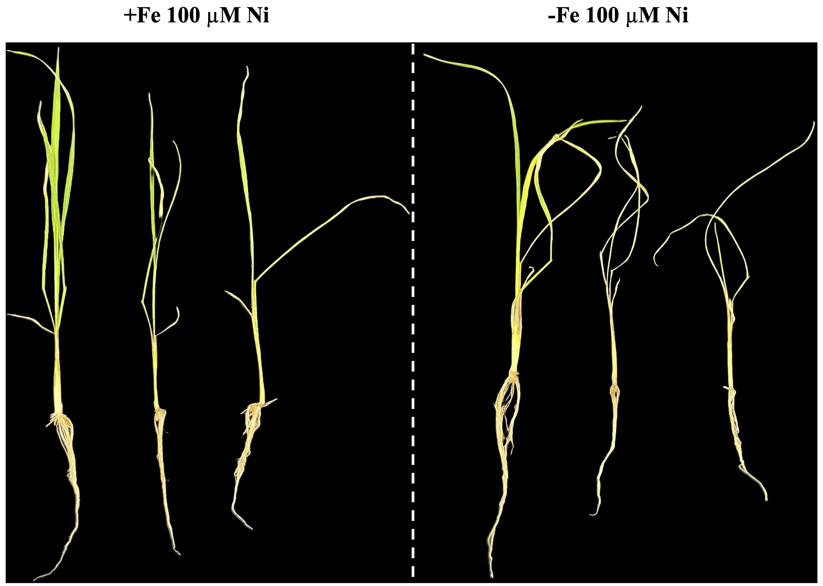
Fig. S14 Representative phenotypes of wild-type (WT) and osfpn1 mutant seedlings grown hydroponically under Fe-sufficient (+Fe) and Fe-deficient (−Fe) conditions with 100 μM NiCl₂·6H₂O for 10 d.

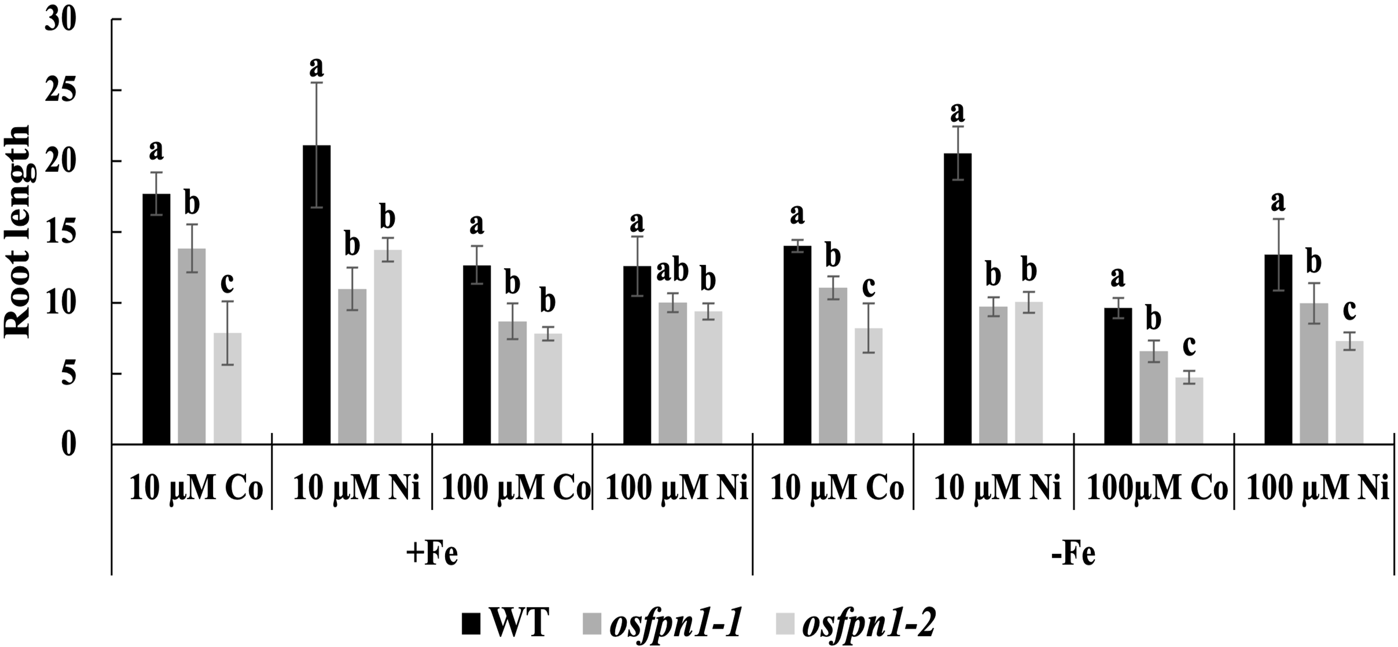
Fig. S15 Root length of wild-type (WT) and osfpn1 mutant seedlings grown hydroponically under Fe-sufficient (+Fe) and Fe-deficient (−Fe) conditions with CoCl₂·6H₂O (10 μM and 100 μM) or NiCl₂·6H₂O (10 μM and 100 μM) for 10 d. Data represent the mean ± SD (n = 3). Different letters indicate significant differences among genotypes (one-way ANOVA followed by Tukey’s HSD, p < 0.05).

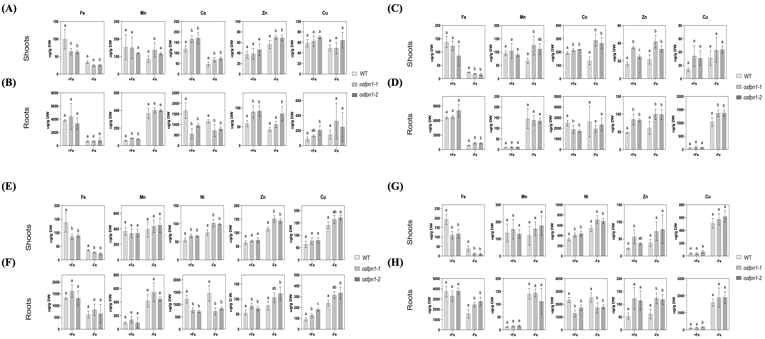
Fig. S16 ICP-OES analysis of metal concentrations in WT and osfpn1 mutants under Fe-sufficient (+Fe) and Fe-deficient (−Fe) conditions with Co or Ni treatments. (A, B) Metal concentrations (Fe, Mn, Co, Zn, and Cu) in shoots (A) and roots (B) of plants treated with 10 μM Co. (C, D) Metal concentrations in shoots (C) and roots (D) of plants treated with 100 μM Co. (E, F) Metal concentrations (Fe, Mn, Ni, Zn, and Cu) in shoots (E) and roots (F) of plants treated with 10 μM Ni. (G, H) Metal concentrations in shoots (G) and roots (H) of plants treated with 100 μM Ni. Data represent the mean ± SD (n = 3). Different letters indicate significant differences among genotypes (one-way ANOVA followed by Tukey’s HSD, p < 0.05).

