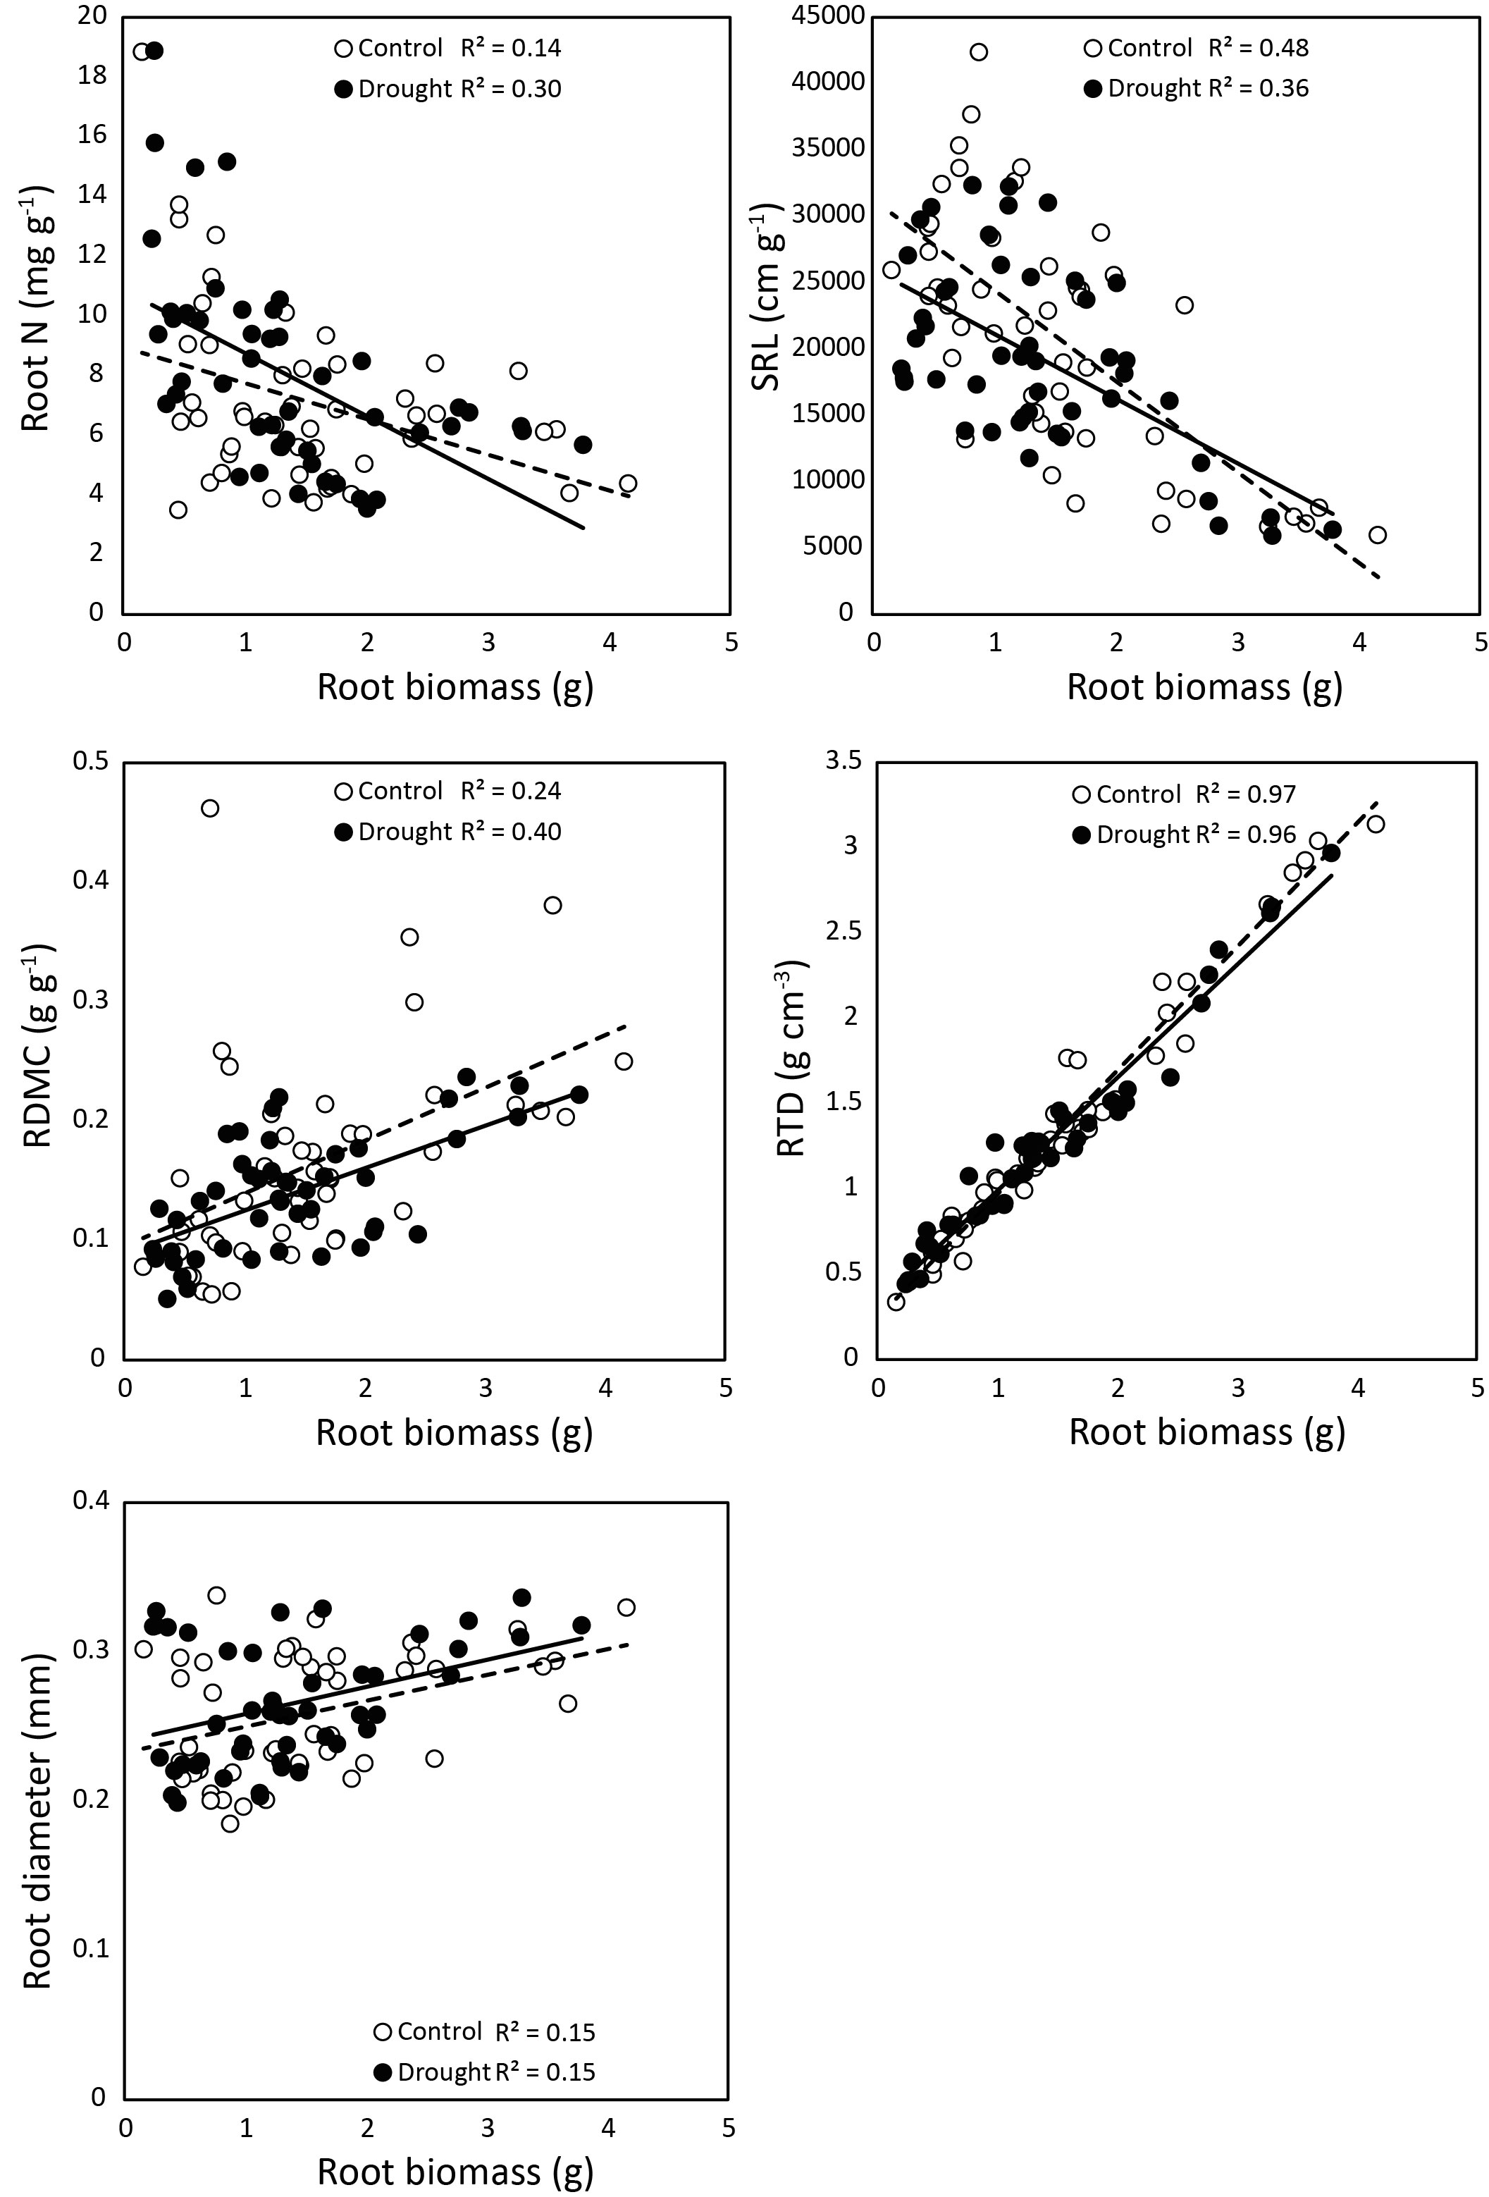
Suppl. Figure 4. The influence of drought on the relationship between root traits and root biomass. Drought only affected the relationship of the traits SRL and RTD with biomass, indicating plasticity (Root biomass × Drought interaction P = 0.04 and P = 0.032 for SRL and RTD, respectively). Symbols represent individual observations.

