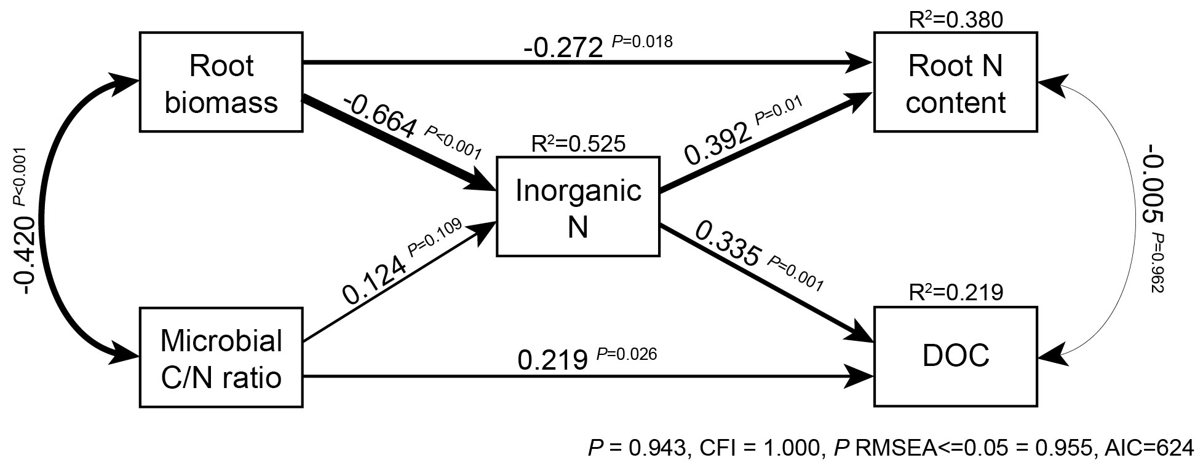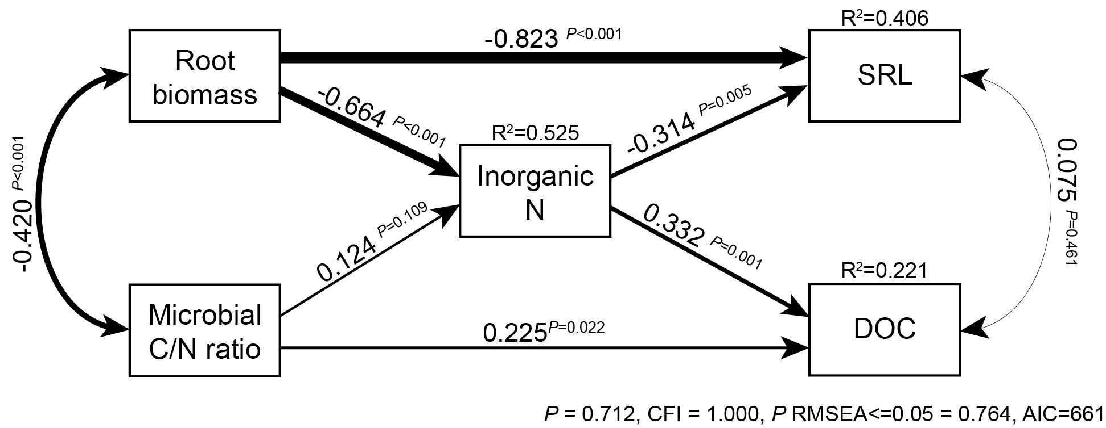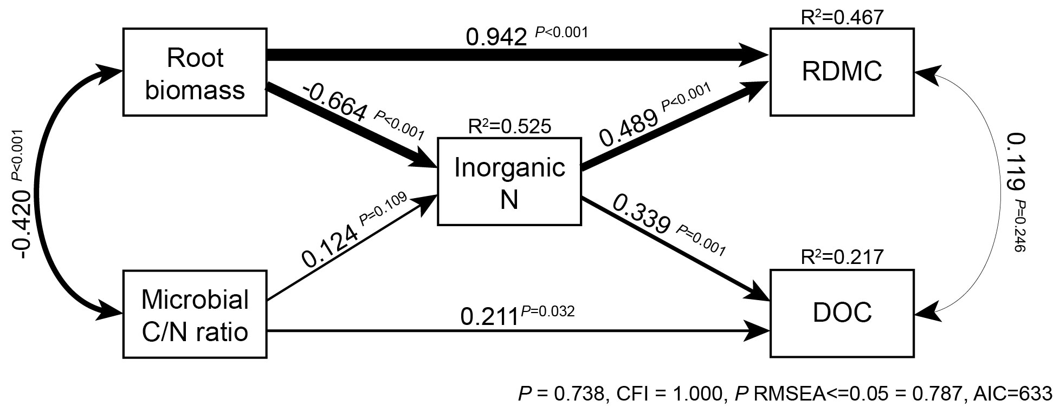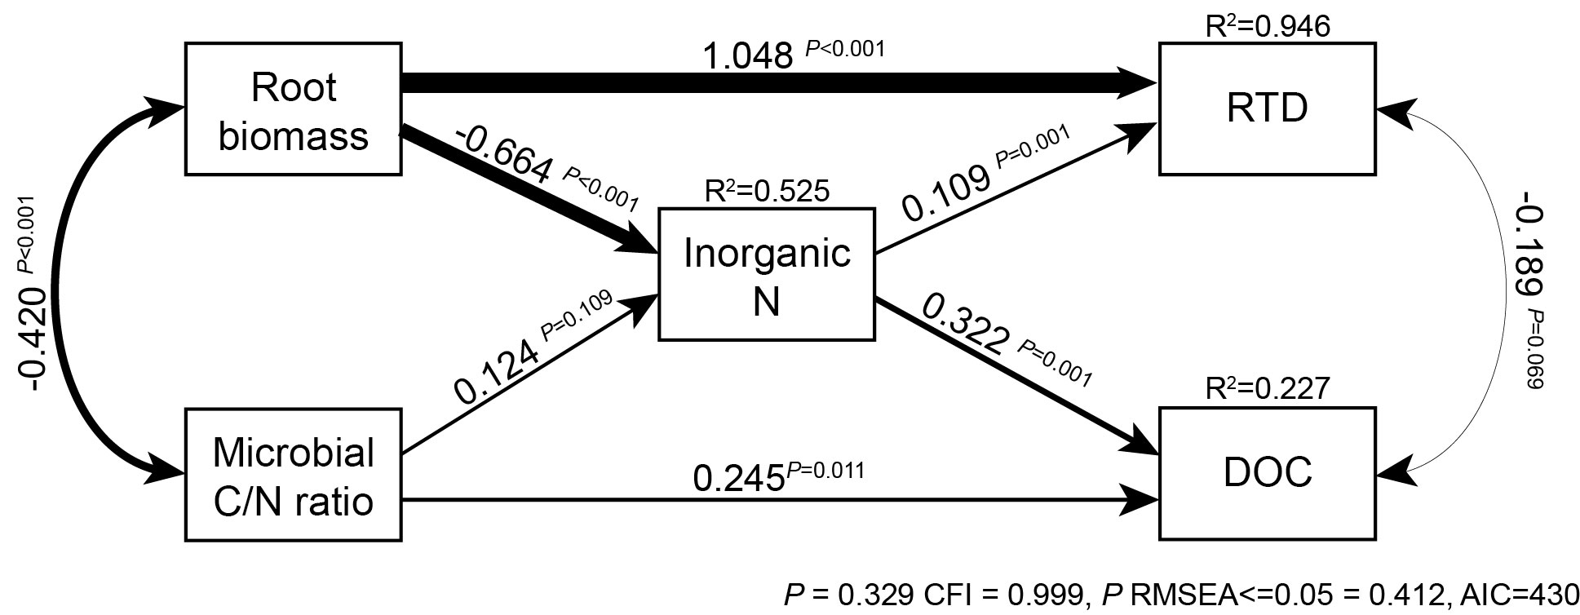
Suppl. Figure 8. SEMs in which soil inorganic N concentration affects root traits, for root N content, specific root length (SRL), root dry matter content (RDMC), and root tissue density (RTD). The model for root diameter did not fit the data. Model indicators of fit are given under each model. Arrow size represents standardized effect sizes, values alongside arrows indicate standardized effect size and significance, and values underneath boxes indicate variation explained by the model.

