Supporting information
Table S1. Full mixed model statistics on soil differences between soil types (i.e. clay vs. sand), species, soil layers, and their interactions. Bold P-values are significant (P < 0.05); df_{num}, numerator degrees of freedom, df_{den}, denominator degrees of freedom.
 | df_{num} | df_{den} | F | P
Soil pH
Soil type | 1 | 8 | 3445.82 | < 0.001
Species | 1 | 8 | 1.52 | 0.25
Soil depth | 1 | 106 | 30.37 | <0.001
Species * soil type | 1 | 8 | 0.61 | 0.46
Soil type * soil depth | 1 | 106 | 4.63 | 0.03
Species * soil depth | 1 | 106 | 1.21 | 0.27
Species * soil type * soil depth | 1 | 106 | 13.09 | <0.001
Soil C : N ratio
Soil type | 1 | 8 | 21.72 | 0.002
Species | 1 | 8 | 0.00 | 0.95
Soil depth | 1 | 116 | 7.75 | 0.006
Species * soil type | 1 | 8 | 0.05 | 0.83
Soil type * soil depth | 1 | 116 | 2.46 | 0.12
Species * soil depth | 1 | 116 | 1.42 | 0.24
Species * soil type * soil depth | 1 | 116 | 10.13 | 0.002
Soil organic matter content
Soil type | 1 | 7 | 1.66 | 0.24
Species | 1 | 7 | 0.45 | 0.53
Soil depth | 1 | 88 | 244.57 | <0.001
Species * soil type | 1 | 7 | 0.04 | 0.84
Soil type * soil depth | 1 | 88 | 29.50 | <0.001
Species * soil depth | 1 | 88 | 0.05 | 0.83
Species * soil type * soil depth | 1 | 88 | 1.31 | 0.26
Available NO₃⁻
Soil type | 1 | 8 | 52.38 | <0.001
Species | 1 | 8 | 0.05 | 0.84
Soil depth | 1 | 110 | 145.28 | <0.001
Species * soil type | 1 | 8 | 0.01 | 0.93
Soil type * soil depth | 1 | 110 | 1.02 | 0.31
Species * soil depth | 1 | 110 | 0.11 | 0.72
Species * soil type * soil depth | 1 | 110 | 2.51 | 0.12
Available NH₄⁺
Soil type | 1 | 8 | 19.64 | <0.001
Species | 1 | 8 | 0.44 | 0.53
Soil depth | 1 | 110 | 77.51 | <0.001
Species * soil type | 1 | 8 | 1.74 | 0.22
Soil type * soil depth | 1 | 110 | 84.57 | <0.001
Species * soil depth | 1 | 110 | 0.08 | 0.77
Species * soil type * soil depth | 1 | 110 | 7.11 | 0.009
Available P-P₂O₅
Soil type | 1 | 8 | 1.09 | 0.33
Species | 1 | 8 | 2.66 | 0.15
Soil depth | 1 | 110 | 162.33 | <0.001
Species * soil type | 1 | 8 | 1.36 | 0.28
Soil type * soil depth | 1 | 110 | 19.72 | <0.001
Species * soil depth | 1 | 110 | 5.67 | 0.02
Species * soil type * soil depth | 1 | 110 | 5.37 | 0.02
Plant available water* |  | df | F | P
Soil type |  | 1 | 9.82 | 0.01
Species |  | 1 | 5.65 | 0.04
Species * soil type |  | 1 | 4.99 | 0.06
* Plant available water is an integrated variable based on the effective rooting zone (estimated at 120 cm below the soil surface) and covers the entire soil profile sampled (0 – 40 cm) separated over three layers as described below. Because this variable was already averaged per stand, it was analysed in a linear model including the soil type, species and their interaction.

Soil data methods and analyses
Soil data were collected at the plot-level and analyzed at three different depths: 0 – 5, 10 – 20 and 30 – 40 cm depth below the soil surface. Between late August and early September 2013, we collected five soil samples per plot, which were analyzed for available pH, C : N ratios, organic matter content, nitrate, ammonium, and phosphorus. Plant available water was measured from water retention curves, based on two soil samples per plot at the same three soil depths. We measured the soil volumetric water content at different soil water potentials, and deduced the soil water content at field capacity (VWC_{FC}, soil water potential = -0.01 MPa) and at wilting point (VWC_{WP}, soil water potential = -1.5 MPa). The differences between VWC_{FC} and VWC_{WP} per plot and soil layer were used as a measure of plant available water, integrated throughout the soil profile assuming an effective rooting depth of 120 cm.
Differences in soil variables between the two soil types (clay vs. sandy soils) were tested using a mixed model similar to the model used to compare root traits between soil types (see also methods section). Soil data were log- or square-root transformed to improve homogeneity of variance, and statistical analyses were carried out in R (R Core Team 2014, packages lme4 and nlme). All soil variables except for plant water availability were compared between soil types using mixed models that can correct for our nested design and potential dependencies between soil data from the same plot or soil core (Zuur et al. 2009). Soil type (clay vs. sand), species (beech vs. spruce) soil depth and their interaction were included as fixed factors. Plot (nested within the soil types) and soil core sample (nested within the plot) were added as random factors.

Table S2. Full mixed model statistics on fine root trait differences between species, soil types (i.e. clay vs. sand), soil layers and their interactions. Bold P-values are significant (P < 0.05); df_{num}, numerator degrees of freedom, df_{den}, denominator degrees of freedom (see model description in methods section).
 | N | df_{num} | df_{den} | F | P
Fine-root mass | 459
Species |  | 1 | 8 | 28.253 | <0.001
Soil type |  | 1 | 8 | 122.992 | <0.001
Soil depth |  | 5 | 362 | 38.692 | <0.001
Species * soil type |  | 1 | 8 | 2.176 | 0.178
Species * soil depth |  | 5 | 362 | 8.073 | <0.001
Soil type * soil depth |  | 5 | 362 | 19.795 | <0.001
Species * soil type * soil depth |  | 5 | 362 | 0.598 | 0.702
Fine-root length density | 430
Species |  | 1 | 8 | 0.098 | 0.762
Soil type |  | 1 | 8 | 59.797 | <0.001
Soil depth |  | 5 | 334 | 84.447 | <0.001
Species * soil type |  | 1 | 8 | 0.362 | 0.564
Species * soil depth |  | 5 | 334 | 6.360 | <0.001
Soil type * soil depth |  | 5 | 334 | 3.102 | 0.009
Species * soil type * soil depth |  | 5 | 334 | 0.631 | 0.676
Fine-root ingrowth | 72
Species |  | 1 | 8 | 11.678 | 0.009
Soil type |  | 1 | 8 | 55.760 | <0.001
Species * soil type |  | 1 | 8 | 0.000 | 0.993
Fine-root decomposition | 32
Species |  | 1 | 8 | 4.811 | 0.060
Soil type |  | 1 | 8 | 10.647 | 0.012
Species * soil type |  | 1 | 8 | 9.151 | 0.016
Specific root length | 429
Species |  | 1 | 8 | 54.339 | <0.001
Soil type |  | 1 | 8 | 2.238 | 0.173
Soil depth |  | 5 | 333 | 0.767 | 0.574
Species * soil type |  | 1 | 8 | 0.940 | 0.361
Species * soil depth |  | 5 | 333 | 2.552 | 0.028
Soil type * soil depth |  | 5 | 333 | 1.605 | 0.158
Species * soil type * soil depth |  | 5 | 333 | 1.637 | 0.150
Fine-root tissue density | 429
Species |  | 1 | 8 | 5.578 | 0.046
Soil type |  | 1 | 8 | 3.904 | 0.084
Soil depth |  | 5 | 333 | 5.287 | < 0.001
Species * soil type |  | 1 | 8 | 8.896 | 0.018
Species * soil depth |  | 5 | 333 | 0.601 | 0.670
Soil type * soil depth |  | 5 | 333 | 1.917 | 0.091
Species * soil type * soil depth |  | 5 | 333 | 0.652 | 0.660
Mean fine-root diameter | 428
Species |  | 1 | 8 | 95.309 | <0.001
Soil type |  | 1 | 8 | 3.014 | 0.12
Soil depth |  | 5 | 332 | 7.556 | <0.001
Species * soil type |  | 1 | 8 | 0.545 | 0.482
Species * soil depth |  | 5 | 332 | 6.138 | <0.001
Soil type * soil depth |  | 5 | 332 | 8.301 | <0.001
Species * soil type * soil depth |  | 5 | 332 | 2.042 | 0.072
Mycelium mass | 72
Species |  | 1 | 8 | 14.400 | 0.005
Soil type |  | 1 | 8 | 33.080 | <0.001
Species * soil type |  | 1 | 8 | 11.137 | 0.010

Root trait differences between species
Overall, spruce forests had significantly (c. 1.8 times) more fine-root mass than beech forests, although fine-root length density did not differ between the two species (Table S2, Fig. 1a,b). Furthermore, root growth in the ingrowth cores was significantly and almost three times higher for spruce than for beech, but fine-root decomposition rates did not differ between the species (Fig. 1c,d). Moreover, spruce also had thicker fine roots (i.e. a greater mean fine-root diameter and lower SRL) and of higher RTD (Fig. 1e-g). Mycelium biomass was also significantly (c. 2 times) greater in the spruce than in the beech plots (Fig. 1h). Interaction effects of species and soil type on the root traits measured were not significant with the exception of RTD and root decomposition.

Table S3. Mixed model statistics on fine-root trait differences within species between soil types (i.e. clay vs. sand), soil layers, and their interactions. Bold P-values are significant (P < 0.05); df_{num}, numerator degrees of freedom, df_{den}, denominator degrees of freedom.
Species | Beech |  |  |  |  | Spruce
 | N | df_{num} | df_{den} | F | P | N | df_{num} | df_{den} | F | P
Fine-root mass | 221 |  |  |  |  | 238
Soil type |  | 1 | 4 | 62.0 | 0.001 |  | 1 | 4 | 50.2 | 0.002
Soil depth |  | 5 | 174 | 13.5 | <0.001 |  | 5 | 188 | 22.8 | <0.001
Soil type *depth |  | 5 | 174 | 10.3 | <0.001 |  | 5 | 188 | 2.3 | 0.049
Fine-root length density | 210 |  |  |  |  | 220
Soil type |  | 1 | 4 | 46.3 | 0.002 |  | 1 | 4 | 13.9 | 0.020
Soil depth |  | 5 | 163 | 24.1 | <0.001 |  | 5 | 171 | 73.6 | <0.001
Soil type * depth |  | 5 | 163 | 2.0 | 0.077 |  | 5 | 171 | 1.6 | 0.164
Fine-root ingrowth | 36 |  |  |  |  | 36
Soil type |  | 1 | 4 | 20.5 | 0.011 |  | 1 | 4 | 43.6 | 0.003
Fine-root decomposition | 17 |  |  |  |  | 15
Soil type |  | 1 | 4 | 0.4 | 0.543 |  | 1 | 4 | 23.4 | 0.008
Specific root length | 210 |  |  |  |  | 219
Soil type |  | 1 | 4 | 0.1 | 0.767 |  | 1 | 4 | 6.5 | 0.063
Soil depth |  | 5 | 163 | 0.5 | 0.766 |  | 5 | 170 | 4.1 | 0.002
Soil type * depth |  | 5 | 163 | 2.2 | 0.057 |  | 5 | 170 | 0.4 | 0.862
Fine-root tissue density | 210 |  |  |  |  | 219
Soil type |  | 1 | 4 | 8.6 | 0.043 |  | 1 | 4 | 0.6 | 0.476
Soil depth |  | 5 | 163 | 2.2 | 0.060 |  | 5 | 170 | 4.3 | 0.001
Soil type * depth |  | 5 | 163 | 0.9 | 0.455 |  | 5 | 170 | 1.9 | 0.097
Fine-root diameter | 209 |  |  |  |  | 219
Soil type |  | 1 | 4 | 2.4 | 0.196 |  | 1 | 4 | 0.66 | 0.463
Soil depth |  | 5 | 162 | 0.2 | 0.940 |  | 5 | 170 | 22.5 | <0.001
Soil type * depth |  | 5 | 162 | 5.1 | <0.001 |  | 5 | 170 | 4.4 | <0.001
Mycelium biomass | 36 |  |  |  |  | 36
Soil type |  | 1 | 4 | 2.3 | 0.206 |  | 1 | 4 | 68.0 | 0.001
Bold P-values are significant (P < 0.05); df_{num}, numerator degrees of freedom, df_{den}, denominator degrees of freedom. Non-significant interaction terms were omitted from the model before further analysis (see methods section). Because the use of degrees of freedom and P-values in mixed effects models is debated, we also selected the best model based on Akaike information criterion (AIC). The P-values of the models reported here agreed with model selection based on AIC and are therefore considered robust.
Fig. S1. Soil characteristics throughout the soil profile. Soil pH, C : N ratios, organic matter content and available nitrogen and phosphorous in beech and spruce stand on clay and sandy soils (see methods description below Table S1).
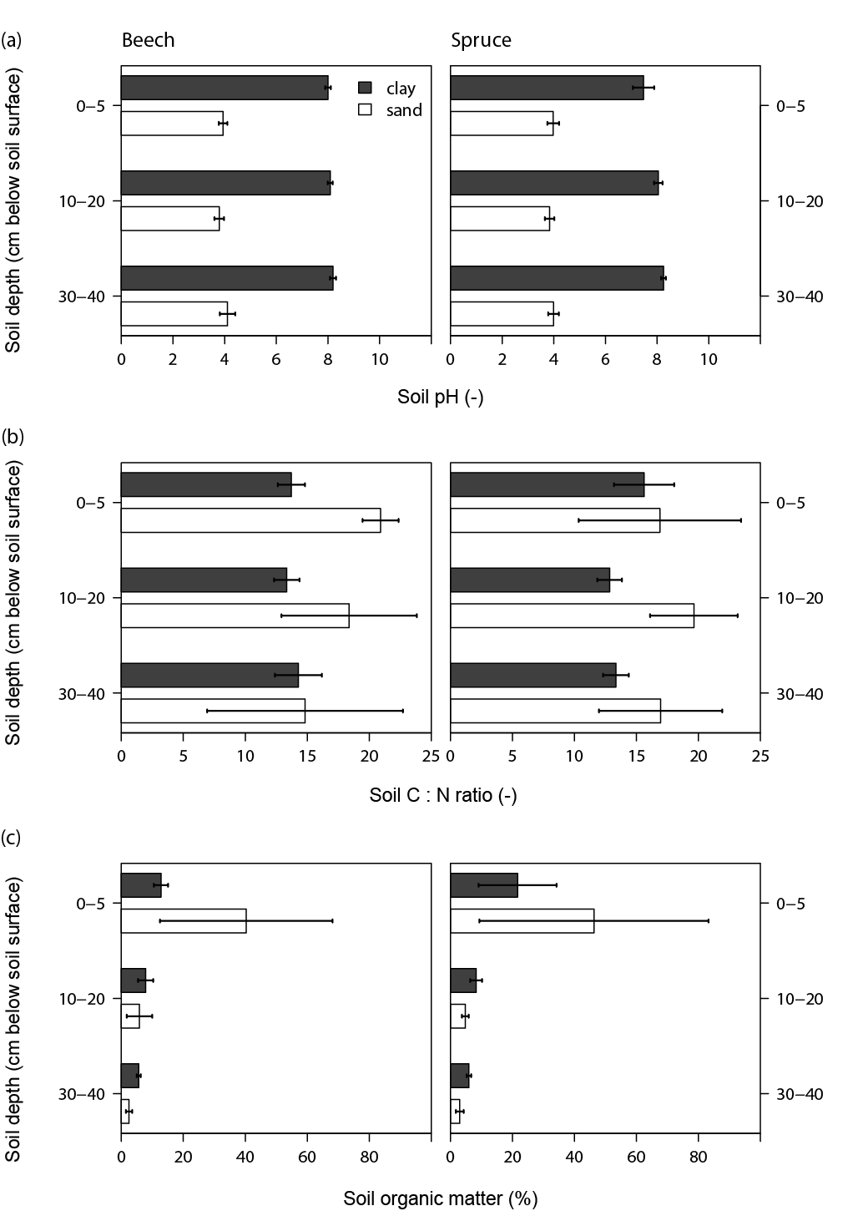
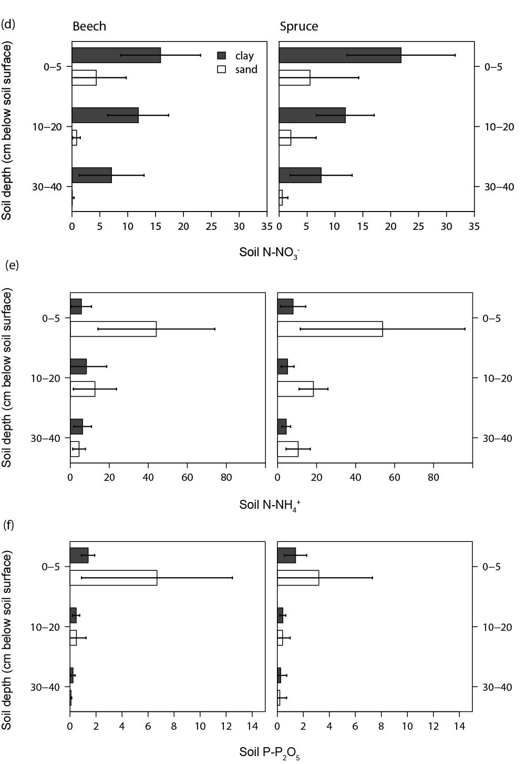
Fig. S2. Fine-root morphological trait distribution over the soil profile. Specific root length, root tissue density and mean fine root diameter per soil layer (means ± 1standard deviation) for beech and spruce stands on clay and sandy soils. Soil depth effects on root traits are described in Table S2 (between species) and Table S3 (within-species).
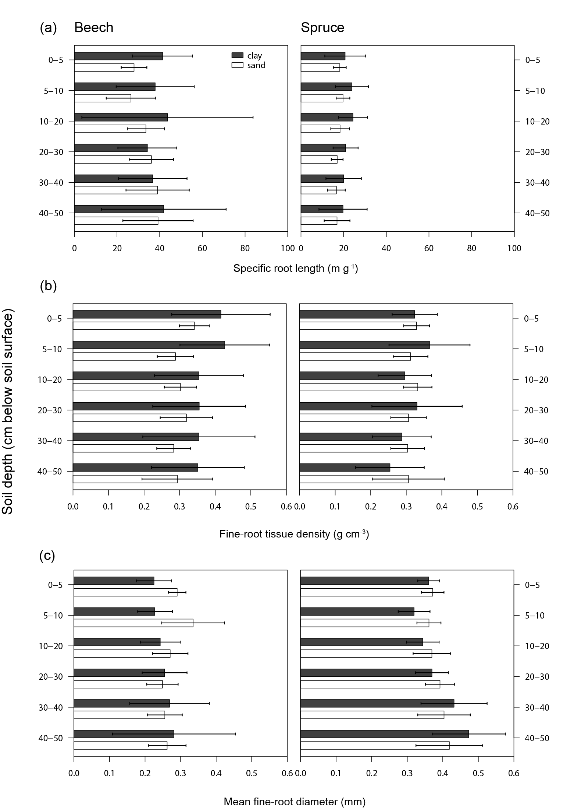
Appendix 1. Ectomycorrhizal exploration types
In addition to our mesh bag analyses, we categorized mycorrhizal root tips into different exploration types (Agerer 2001). Therefore, we sampled fine roots from six soil cores per plot and from three different soil layers (0 – 5, 10 – 20 and 30 – 40 cm depth) in March (spruce) and May (beech) 2014. After carefully washing out and rinsing the fine roots, they were microscopically classified into three exploration types based on fungal morphological properties. Using the identification criteria of Agerer (2001), contact exploration types were characterized by a smooth hyphal mantle with few or no extraradical mycelium or rhizomorphs; short-distance exploration types were identified based on having many emanating hyphae but no rhizomorphs; medium- and long-distance exploration types were characterized by long emanating hyphae and, in some cases, by the presence of rhizomorphs. We estimated the number of root tips that were colonized by these exploration types, the uncolonised root tips and the dead root tips, and calculated their relative abundance on the roots sampled.
For both tree species, we observed only contact exploration types on the roots collected at the clay soil. Due to their smooth hyphal mantle with few extraradical mycelium, they present relatively low carbon costs, but they are also less efficient in terms of nutrient foraging and transfer to the host tree (Agerer 2001). In contrast, on the sandy soils, we also observed short- and medium distance exploration types. With their extraradical mycelia and/or rhizomorphs, they efficiently acquire soil resources, but at higher carbon costs to the host tree (Hobbie and Agerer 2009). Consistent with our mesh bag results and other studies, at more fertile soils the abundance of contact exploration types increased, whereas medium- and long-distance exploration type abundance decreased (Kjøller et al. 2012), and mycelium productivity was reduced (Nilsson and Wallander 2003; Bahr et al. 2013).

References
Agerer R (2001) Exploration types of ectomycorrhizae. A proposal to classify ectomycorrhizal mycelial systems according to their patterns of differentiation and putative ecological importance. Mycorrhiza 11:107–114.
Bahr A, Ellström M, Akselsson C, et al. (2013) Growth of ectomycorrhizal fungal mycelium along a Norway spruce forest nitrogen deposition gradient and its effect on nitrogen leakage. Soil Biol Biochem 59:38–48.
Hobbie EA, Agerer R (2009) Nitrogen isotopes in ectomycorrhizal sporocarps correspond to belowground exploration types. Plant Soil 327:71–83.
Kjøller R, Nilsson L-O, Hansen K, et al. (2012) Dramatic changes in ectomycorrhizal community composition, root tip abundance and mycelial production along a stand-scale nitrogen deposition gradient. New Phytol 194:278–86.
Nilsson LO, Wallander H (2003) Production of external mycelium by ectomycorrhizal fungi in a norway spruce forest was reduced in response to nitrogen fertilization. New Phytol 158:409–416.
Zuur AF, Ieno EN, Walker N, et al. (2009) Mixed effects models and extensions in ecology with R. Springer, New York.

