Supplementary Figures

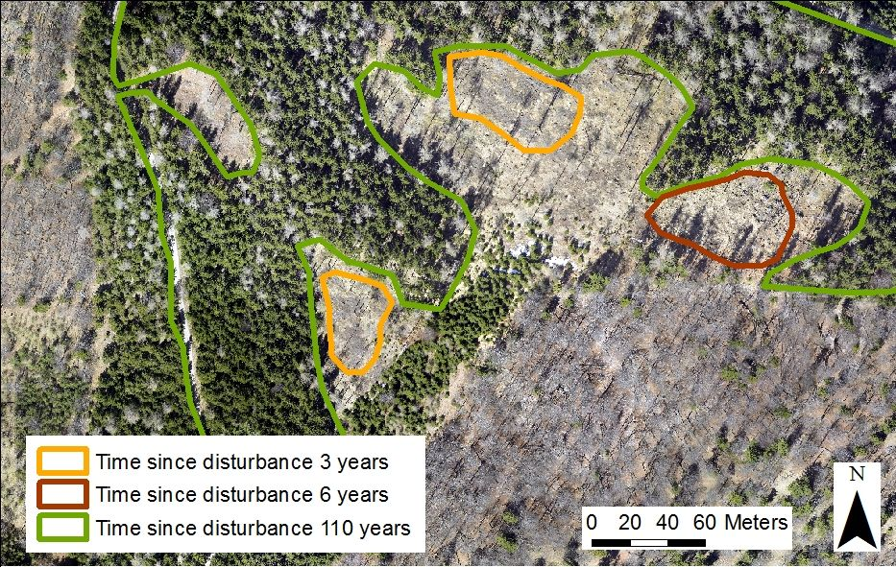

Figure A1: Overview map of the study sites: time since disturbance of 3 (PD03), 6 (PD06) and 110 years (MS).

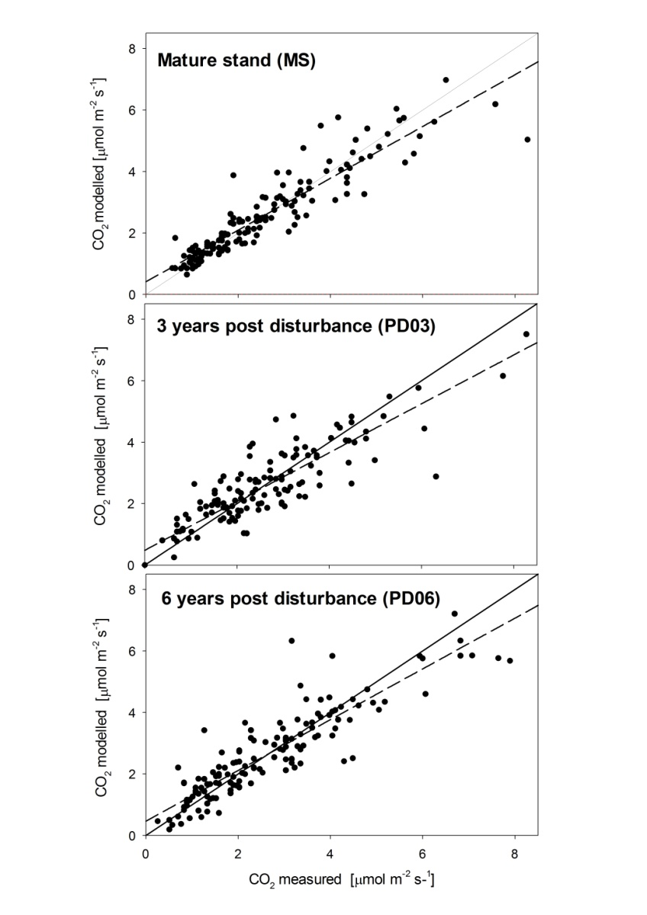
Figure A2: Measured vs. modelled soil CO₂ efflux. Upper panel: MS (Mature stand); mid panel: PD06 (2008 Clearing); lower panel: PD03 (2011 Clearing). The linear relationship is shown by the dashed regression line.

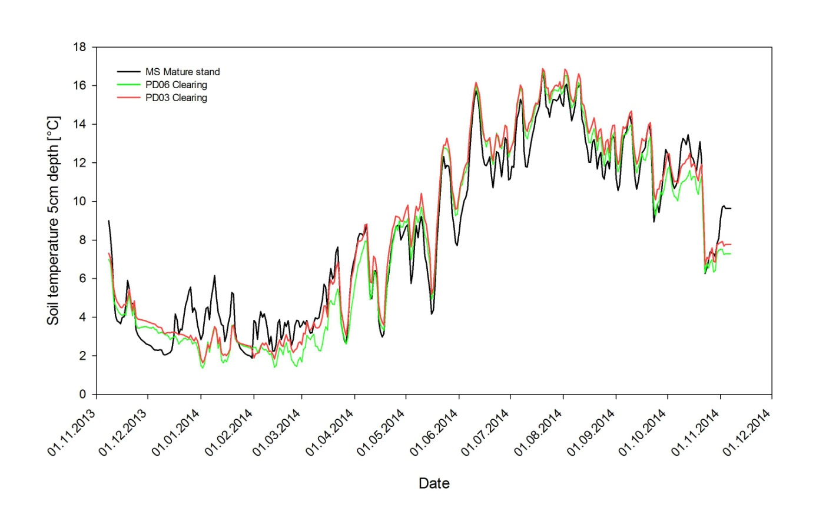

Figure A3: High resolution soil temperatures of the different stand-sections from November 2013 to November 2014.

