Online Resource 1. Supplemental Material
Supplemental Figure 1. Maps of modeled soil properties. Soil pH (top row) and soil textural separates (bottom three rows) are modeled and mapped. The final ensemble models (column 1) represent an equally weighted mean of kriged survey point data (column 2), resampled Soil Grids 100m data (column 3), and rasterized SSURGO soil survey polygons (column 4).
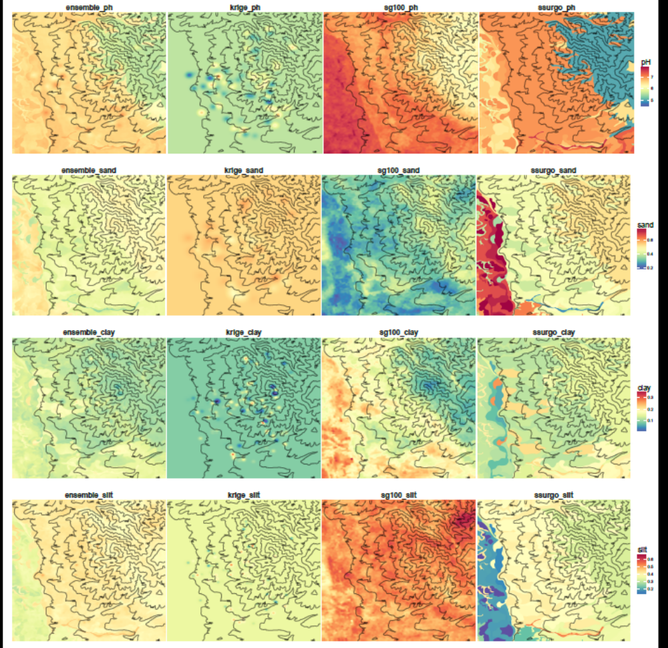

Supplemental Table 1. Model performance (R²) for our ensemble soil models. We used our empirical soil survey results to test our models.

Soil property | R²
pH | 0.37
Percent Sand | 0.20
Percent Clay | 0.83
Percent Silt | 0.54

Supplemental Table 2. Correlations of environmental variables with final NMDS ordination, rotated to maximize correlation with minimum insolation. * Absolute value of largest possible correlation with any axis, obtained via rotation.
 | Axis 1 | Axis 2 | Axis 3 | Maximal
 | r | r | r | │r│*
pH | 0.119 | -0.192 | 0.066 | 0.22
Percent Sand | 0.114 | -0.081 | 0.205 | 0.25
Percent Clay | -0.035 | 0.097 | -0.184 | 0.20
Percent Silt | -0.12 | 0.04 | -0.138 | 0.19
Eastness | 0.078 | -0.011 | 0.035 | 0.10
Elevation | -0.116 | -0.075 | 0.235 | 0.46
Northness | -0.438 | -0.052 | -0.033 | 0.43
Max. Insolation | 0.511 | 0.116 | -0.111 | 0.55
Slope | -0.207 | -0.161 | 0.09 | 0.30
TPI 10m | -0.202 | 0.136 | -0.05 | 0.24
TPI 100m | -0.151 | 0.196 | 0.033 | 0.23
TPI 1000m | -0.049 | 0.052 | 0.215 | 0.22
Wetness Index | 0.147 | -0.065 | -0.092 | 0.18
Min. Insolation | 0.541 | -0.04 | -0.023 | 0.54
Past Tillage | 0.445 | 0.078 | 0.014 | 0.47

Supplemental Table 3. Pearson correlations of taxa with final NMDS ordination, rotated to maximize correlation with minimum insolation.
Taxon | Taxonomic | Code | Axis 1 | Axis 2 | Axis 3
 | group |  | r | r | r
Acarospora schleicheri | B | AcaSch | -0.056 | -0.01 | -0.09
Anthoceros sp1. | B | AntSp1 | -0.048 | 0.003 | -0.192
Arthonia glebosa | L | ArtGle | -0.193 | 0.309 | -0.034
Aspicilia reptans | L | AspRep | -0.059 | 0.227 | -0.047
Aulacomnium androgynum | B | AulAnd | -0.051 | 0.028 | 0.151
Brachythecium fendleri | B | BraFen | -0.061 | 0.027 | 0.148
Bryoria chalybeiformis | L | BryCha | -0.231 | 0.011 | 0.023
Bryonora pruinosa | L | BryPru | -0.343 | 0.054 | -0.003
Bryum argenteum | B | BryArg | -0.108 | 0.119 | -0.045
Bryum sp.2 | B | BrySp2 | 0.07 | 0.012 | 0.335
Buellia elegans | L | BueEle | -0.112 | -0.044 | -0.079
Buellia punctata | L | BuePun | -0.171 | 0.058 | -0.231
Buellia terricola | L | BueTer | -0.297 | 0.523 | 0.145
Buellia sp.4 | L | BueSp4 | -0.135 | -0.026 | -0.185
Buellia sp 5 | L | BueSp5 | -0.296 | 0.114 | 0.024
Caloplaca ammiospila | L | CalAmm | -0.226 | 0.109 | 0.059
Caloplaca jungermanniae | L | CalJun | -0.454 | 0.202 | -0.031
Caloplaca stillicidiorum | L | CalSti | -0.248 | 0.161 | 0.027
Caloplaca tiriolensis | L | CalTir | -0.135 | -0.026 | -0.185
Caloplaca sp.5 | L | CalSp5 | -0.135 | 0.187 | 0.035
Caloplaca sp.6 | L | CalSp6 | -0.302 | -0.263 | -0.021
Candelariella aggregata | L | CanAgg | -0.083 | 0.44 | 0.06
Candellariella citrina | L | CanCit | -0.125 | 0.08 | -0.099
Cephaloziella divaricata | B | CepDiv | -0.262 | 0.262 | -0.039
Ceratodon purpureus | B | CerPur | -0.217 | 0.173 | 0.168
Cetraria muricata | L | CetMur | -0.159 | 0.108 | -0.049
Cladonia cariosa | L | ClaCar | -0.083 | -0.011 | 0.334
Cladonia cenotea | L | ClaCen | -0.002 | -0.063 | 0.135
Cladonia chlorophaea | L | ClaChl | -0.31 | 0.113 | -0.108
Cladonia fimbriata | L | ClaFim | -0.229 | -0.203 | 0.078
Cladonia macrophylloides | L | ClaMac | -0.429 | 0.276 | 0.062
Cladonia pocillum | L | ClaPoc | -0.474 | 0.111 | -0.024
Cladonia pyxidata | L | ClaPyx | -0.548 | 0.07 | -0.041
Cladonia verruculosa | L | ClaVer | -0.189 | 0.147 | 0.111
Cladonia sp.9 | L | ClaSp9 | -0.465 | 0.343 | -0.369
Cladonia sp.10 | L | ClaSp10 | -0.062 | -0.032 | -0.07
Collema tenax | L | ColTen | -0.061 | 0.224 | -0.217
Dicranum montanum | B | DicMon | -0.171 | 0.002 | 0.058
Dicranum scoparium | B | DicSco | -0.081 | 0.154 | 0.088
Didymodon vinealis | B | DidVin | -0.032 | 0.28 | 0.047
Diploschistes muscorum | L | DipMus | -0.188 | 0.183 | -0.173
Encalypta vulgaris | B | EncVul | -0.375 | 0.024 | -0.138
Endocarpon pusillum | L | EndPus | -0.145 | 0.063 | -0.21
Eurhynchiastrum pulchellum | B | EurPul | -0.459 | 0.023 | 0.028
Fossombronia sp.1 | B | FosSp1 | -0.135 | -0.026 | -0.185
Funaria hygrometrica | B | FunHyg | 0.022 | -0.178 | 0.091
Gemmabryum caespiticium | B | GemCae | -0.329 | 0.052 | -0.046
Homalothecium aureum | B | HomAur | -0.427 | -0.022 | 0.095
Lecanora laxa | L | LecLax | -0.185 | 0.118 | -0.049
Lecanora muralis | L | LecMur | 0.066 | 0.08 | -0.211
Lecanora sp.3 | L | LecSp3 | -0.163 | 0.114 | 0.06
Lecanora sp.4 | L | LecSp4 | -0.13 | 0.118 | -0.125
Lecidella wulfenii | L | LecWul | -0.173 | 0.066 | -0.025
Lecanora zosterae | L | LecZos | -0.175 | 0.048 | -0.008
Lepraria sp.1 | L | LepaSp1 | -0.124 | -0.014 | -0.204
Leptochidium albociliatum | L | LepAlb | -0.135 | -0.026 | -0.185
Leptogium intermedium | L | LepInt | -0.283 | 0.25 | 0.011
Leptogium lichenoides | L | LepLic | -0.16 | 0.322 | -0.02
Leptogium sp.4 | L | LeptSp3 | -0.16 | -0.018 | -0.051
Leptogium sp.5 | L | LeptSp4 | -0.219 | 0.174 | -0.288
Leptogium sp.6 | L | LeptSp5 | -0.096 | 0.148 | 0.058
Massalongia carnosa | L | MasCar | -0.112 | -0.044 | -0.079
Megaspora verrucosa | L | MegVer | -0.267 | 0.096 | 0.034
Ochrolechia upsaliensis | L | OchUps | -0.32 | 0.061 | 0.011
Parmelia sulcata | L | ParSul | -0.175 | 0.048 | -0.008
Peltigera aphthosa | L | PelAph | -0.101 | -0.073 | 0.164
Peltigera canina | L | PelCan | -0.197 | -0.079 | 0.103
Peltigera didactyla | L | PelDid | -0.371 | 0.144 | -0.008
Peltigera extenuata | L | PelExt | -0.276 | 0.061 | -0.009
Peltigera kristinssonii | L | PelKri | -0.339 | 0.1 | 0
Peltigera malacea | L | PelMal | -0.286 | 0.178 | 0.025
Peltigera ponojensis | L | PelPon | -0.292 | 0.148 | -0.061
Peltigera rufescens | L | PelRuf | -0.264 | -0.006 | -0.145
Peltigera sp. 9 | L | PelSp9 | -0.341 | -0.138 | 0.042
Phaeorrhiza nimbosa | L | PhaNim | -0.112 | 0.121 | -0.048
Phaeorrhiza sareptana | L | PhaSar | -0.143 | 0.057 | -0.185
Physconia muscigena | L | PhyMus | -0.166 | 0.069 | -0.007
Placynthiella icmalea | L | PlaIcm | -0.192 | 0.102 | 0.02
Placidium lachneum | L | PlaLach | -0.078 | -0.012 | -0.243
Placidium lacinulatum | L | PlaLaci | 0.031 | -0.059 | 0.066
Placynthiella uliginosa | L | PlaUli | -0.099 | 0.085 | -0.022
Placidium squamulosum | L | PlaSqu | -0.181 | -0.023 | -0.259
Plagiomnium sp.1 | B | PlagSp1 | -0.164 | 0.186 | 0.149
Polytrichum juniperinum | B | PolJun | -0.317 | 0.154 | 0.188
Polychidium muscicola | L | PolMus | -0.135 | -0.026 | -0.185
Polytrichum piliferum | B | PolPil | -0.145 | 0.013 | 0.043
Psora cerebriformis | L | PsoCer | -0.112 | 0.118 | -0.049
Psora globifera | L | PsoGlo | -0.09 | 0.251 | -0.035
Psora montana | L | PsoMon | -0.037 | 0.125 | -0.103
Psora sp.4 | L | PsoSp4 | -0.091 | 0.095 | -0.068
Pterygoneurum ovatum | B | PteOve | -0.042 | 0.184 | -0.063
Pterygoneurum subsessile | B | PteSub | -0.002 | 0.288 | 0.173
Riccia sorocarpa | B | RicSor | -0.069 | 0.129 | 0.032
Rinodina conradii | L | RinCon | -0.164 | 0.145 | -0.054
Rinodina olivaceobrunnea | L | RinOli | -0.158 | 0.069 | -0.003
Rinodina terrestris | L | TrinTer | -0.213 | 0.036 | -0.056
Squamarina lentigera | L | SquLen | 0.063 | 0.175 | -0.077
Syntrichia caninervis | B | SynCan | 0.001 | 0.077 | -0.306
Syntrichia montana | B | SynMon | -0.064 | 0.147 | 0.023
Syntrichia ruralis | B | SynRur | -0.297 | -0.077 | 0.203
Thelenella muscorum | L | TheMus | -0.073 | 0.043 | -0.136
Xanthoparmelia wyomingica | L | XanWyo | -0.161 | -0.106 | -0.071

