SUPPLEMENTARY MATERIAL

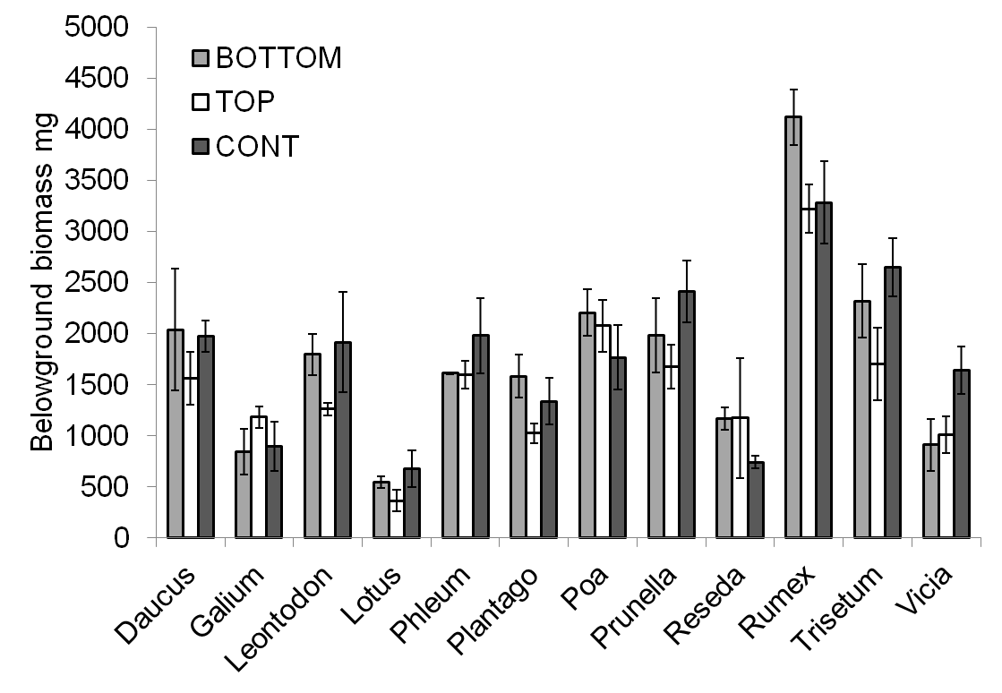
Figure S1: Experiment 1- species and drought effects on Belowground biomass cross-taxonomy.

Figure S2: Proportion of root mass at different column depths for the three drought treatments, divided by species.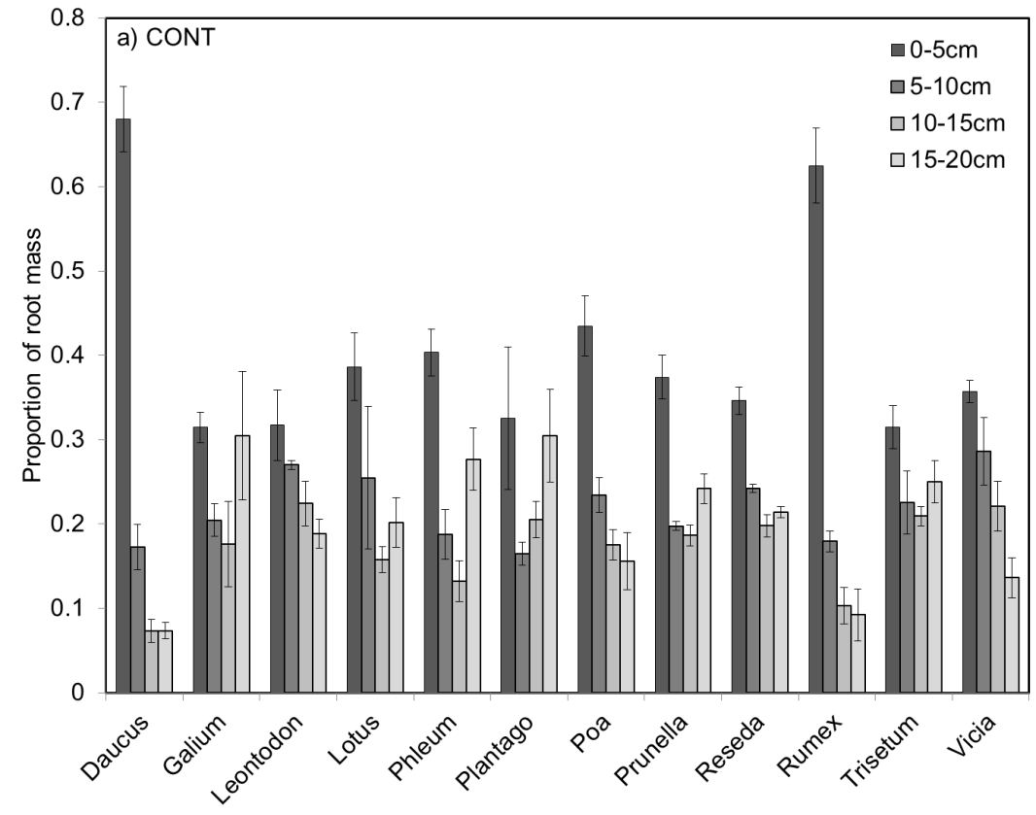
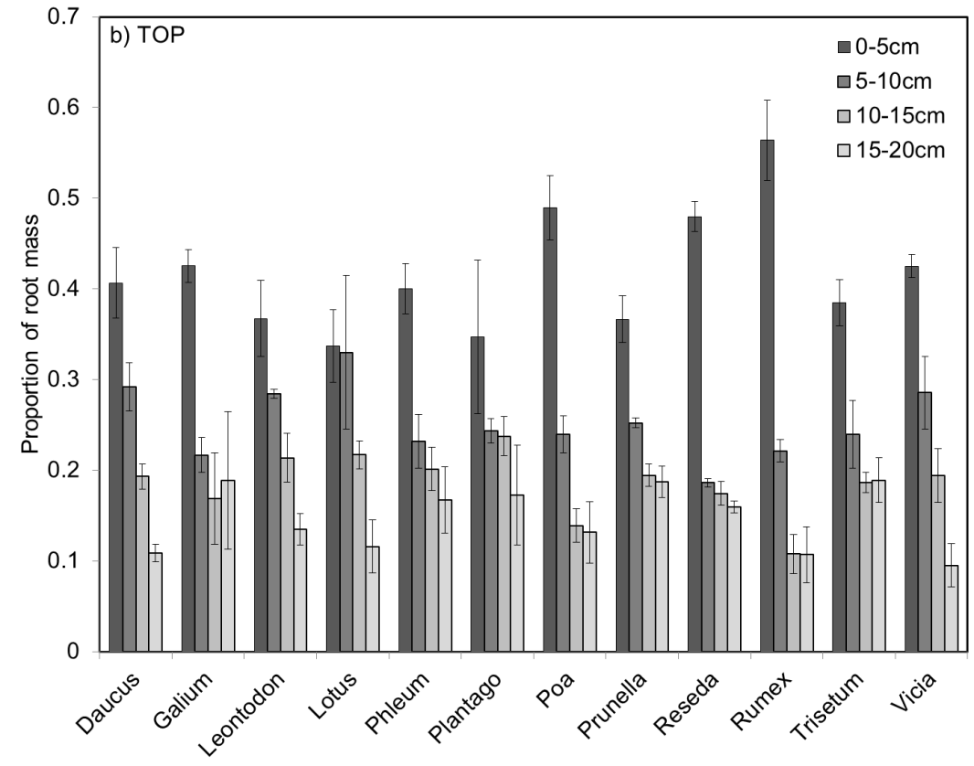
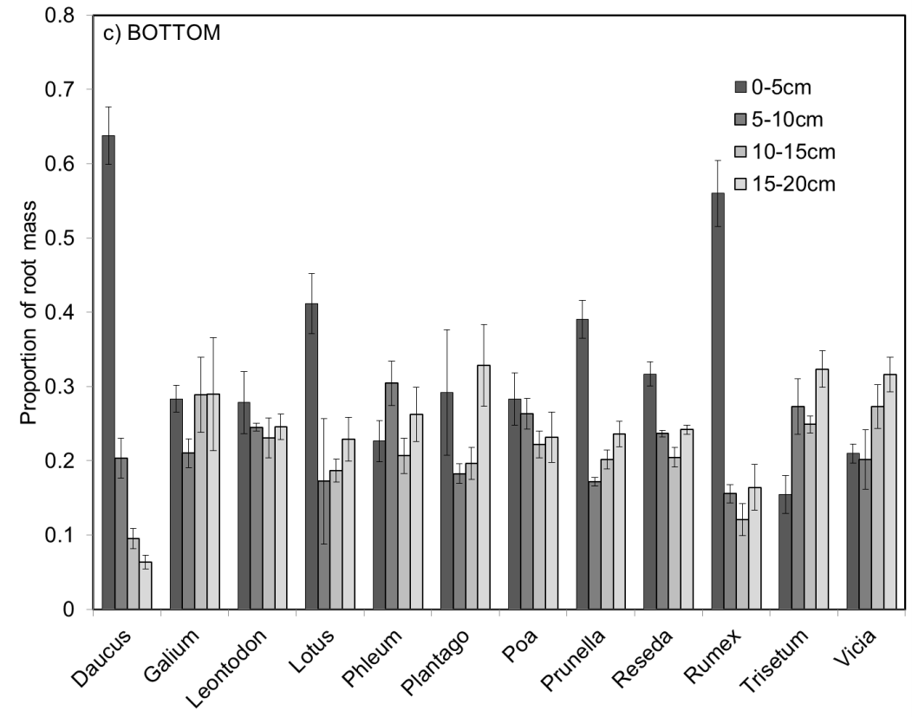

Figure S3: Experiment 2- species and drought effects on Belowground biomass of Asteraceae.
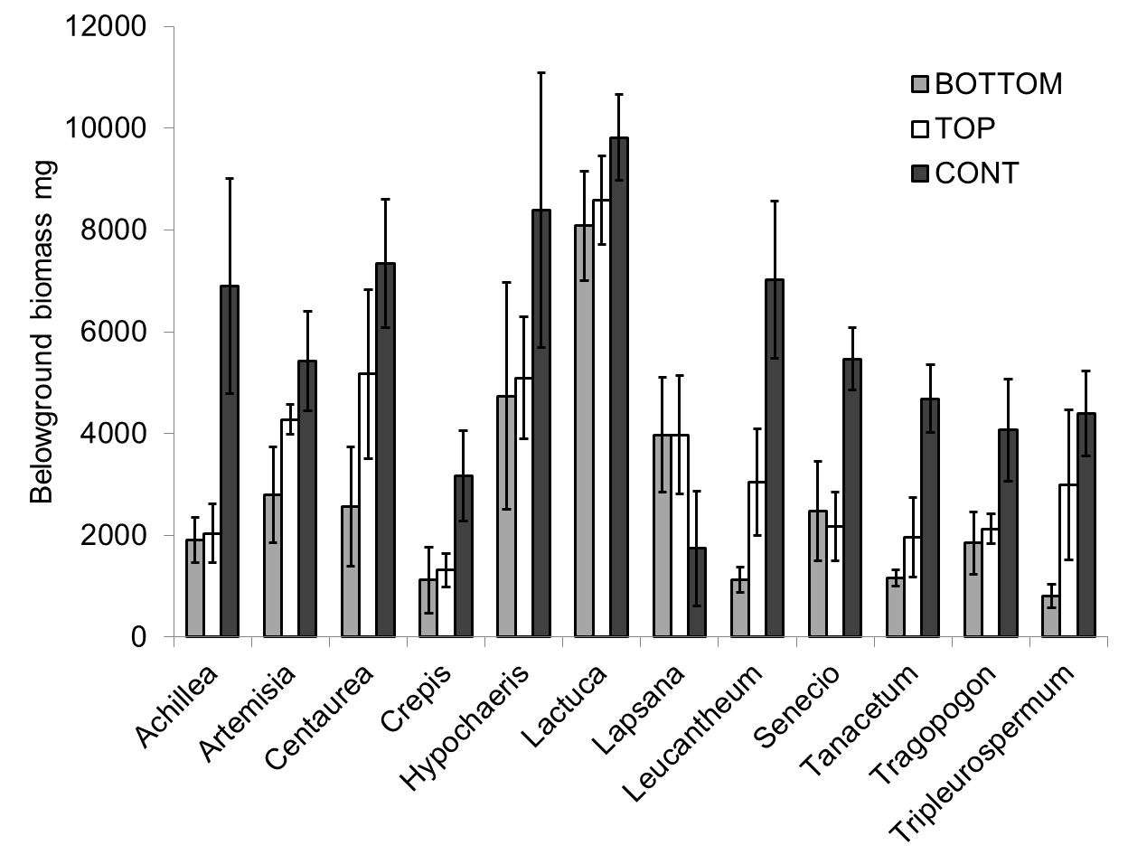

Table S1: Correlation matrix of 3D root traits in Experiment 2 (Asteraceae).
 | Volume mm³ | Area mm² | Convex hull volume mm³ | Depth mm
Volume mm³ |  | 0.796 | 0.606 | 0.459
Area mm² | 0.796 |  | 0.617 | 0.514
Convex hull volume mm³ | 0.606 | 0.617 |  | 0.594
Depth mm | 0.459 | 0.514 | 0.594

