Plant and Soil: Supplementary Material
Carry-over effects of soil inoculation on plant growth and health under sequential exposure to soil-borne diseases
Hai-kun Ma*, Ana Pineda, Andre W.G. van der Wurff, T. Martijn Bezemer
* Correspondence: Corresponding Author: H.Ma@nioo.knaw.nl

Table S1 The effects of soil inoculation (plant-conditioned soil inocula and un-inoculated soil) and disease treatment 1 on chrysanthemum shoot biomass, root biomass, leaf yellowness, root darkness and nematode infestation score. Presented are F values from a linear mixed model (generalized mixed linear model for leaf yellowness and root darkness, generalized linear model for nematode score). Nematode score were only measured for plants in the Meloidogyne treatment. **,*** indicate significant difference at P<0.01 or 0.001, respectively.

 | Df | Shoot biomass | Root biomass | Yellowness | Root darkness | Nematode score
Soil | 8,72 | 7.870*** | 4.216*** | 5.234*** | 1.209 | 0.150
Treatment1 | 2,711 | 0.867 | 0.522 | 3.185** | 0.670 | N.A
Treatment1*Soil | 16,711 | 1.613 | 0.995 | 6.597*** | 0.382 | N.A

Table S2 Overall effects of plant-conditioned soil inocula, disease treatment 1 and disease treatment 2 on chrysanthemum root darkness and nematode scores. “Species” indicates the identity of conditioning plant species. Presented are F-values following a generalized mixed linear model. For pairwise comparisons between each category of disease treatments Z-values are presented. *,**,*** indicates significant difference at P<0.05, 0.01 or 0.001, respectively.

 | Df | Root darkness | Nematode score
Species | 7,72 | 0.082 | 1.072
Treatment1 | 2,576 | 0.237 | 1.264
Control vs Meloidogyne |  | -0.251 | 0
Control vs Pythium |  | 0.416 | 0
Meloidogyne vs Pythium |  | 0.668 | 0
Treatment2 | 2,576 | 5.281* | 71.906***
Control vs Disease soil |  | 3.316** | -0.005
Control vs Pythium |  | 0.791 | 0
Disease soil vs Pythium |  | -2.530* | 0
Treatment1*Species | 14,576 | 0.287 | 0.644
Treatment2*Species | 14,576 | 0.234 | 0.203
Treatment1*treatment2 | 4,576 | 0.567 | 0
Treatment1*Treatment2*Species | 28,576 | 0.276 | 0

Table S3 Overall effects of soil inoculation (plant-conditioned soil inocula and un-inoculated soil), disease treatment 1, and disease treatment 2 on chrysanthemum shoot biomass, root biomass, leaf yellowness, root darkness and nematode scores at the end of cycle 2. Presented are F-values from a mixed linear model (generalized mixed linear model for leaf yellowness, root darkness and nematode scores), for pairwise comparisons between each category of disease treatments, T-values are presented (Z-value for leaf yellowness, root darkness and nematode scores). *,**,*** indicates significant difference at P<0.05, 0.01 or 0.001, respectively.

 | Df | Shoot biomass | Root biomass | Yellowness | Root darkness | Nematode score
Soil | 8,72 | 1.697 | 2.251* | 1.962* | 0.101 | 0.940
Treatment1 | 2,657 | 4.258* | 3.888* | 9.962** | 0.406 | 1.064
Control vs Meloidogyne |  | -2.918* | -2.761* | 3.029** | -0.547 | 0
Control vs Pythium |  | -1.461 | -1.722 | 0.065 | 0.346 | 0
Meloidogyne vs Pythium |  | 1.458 | 1.039 | 0.032 | 0.893 | 0
Treatment2 | 2,657 | 1.415 | 63.403*** | 84.331*** | 5.046* | 82.515***
Control vs Disease soil |  | -0.804 | -10.563*** | 0.179 | 3.217** | -0.005
Control vs Pythium |  | -1.682 | -1.903 | 2.185 | 0.804 | 0
Disease soil vs Pythium |  | -0.878 | 8.660*** | -0.160 | -2.418* | 0
Treatment1*Soil | 16,657 | 1.615 | 1.074 | 4.621* | 0.267 | 0.671
Treatment2*Soil | 16,657 | 0.957 | 0.643 | 2.497 | 0.242 | 0.251
Treatment1*treatment2 | 4,657 | 0.799 | 0.572 | 6.916* | 0.206 | 0.000
Treatment1*Treatment2*Soil | 32,657 | 1.199 | 0.784 | 4.174* | 0.328 | 0.000

Table S4 Statistics of Fig.4, presented are degrees of freedom (df) and F-values folowing a linear mixed model (generalized linear mixed model for leaf yellowness, root darkness and nematode scores) for plant-conditioned soil and un-inoculated soil and a one-way ANOVA (generalized linear model for leaf yellowness, root darkness and nematode score) for sterile soil. *,**,*** indicates significant difference at P<0.05, 0.01 or 0.001, respectively. Only plants grown in the diseased soil treatment added to sterile soil had detectable nematode infections. This was not the case for plants grown in sterile soil with the control and Pythium treatments, so there are no one-way ANOVA results for the disease treatments effects. Thus, the F-value in sterile soil is presented as “N.A”. Abbreviations of plant species are described in materials and methods.
Species | df | Shoot biomass | Root biomass | Leaf yellowness | Root darkness | Nematode score
AO | 8,72 | 1.096 | 2.262* | 7.730*** | 0.428 | 23.049***
BH | 8,72 | 1.285 | 2.341* | 5.564*** | 0.197 | 37.27***
FF | 8,72 | 1.078 | 2.297* | 2.504* | 0.233 | 44.124***
GV | 8,72 | 0.716 | 1.535 | 8.617*** | 0.722 | 20.75***
HL | 8,72 | 0.563 | 0.831 | 6.315*** | 0.551 | 53.11***
HR | 8,72 | 0.804 | 2.492* | 4.722** | 0.523 | 27.36***
LP | 8,72 | 2.491* | 5.628*** | 7.906*** | 0.586 | 40.34***
RA | 8,72 | 1.139 | 3.645** | 5.966*** | 0.314 | 30.42***
Un-inoculated | 8,72 | 2.909** | 4.111*** | 8.555*** | 0.265 | 28.57***
Sterile soil | 2,57 | 18.22*** | 4.895* | 6.872** | 0.310 | N.A

Table S5 Statistics of Fig.S3, presented are degrees of freedom and F-values folowing a linear mixed model (generalized linear mixed model for leaf yellowness). *,**,*** indicates significant difference at P<0.05, 0.01 or 0.001, respectively. Abbreviations of disease treatments are described in material and methods.

Treatment | df | Shoot biomass | Root biomass | Leaf yellowness | Root darkness
C-C | 8,81 | 2.450* | 1.809 | 2.265* | 0.996
M-C | 8,81 | 1.383 | 1.137 | 0.663 | 0.999
P-C | 8,81 | 1.168 | 1.567 | 1.502 | 0.981
C-P | 8,81 | 1.257 | 1.062 | 0.466 | 0.965
M-P | 8,81 | 0.794 | 0.484 | 1.855 | 0.926
P-P | 8,81 | 1.627 | 1.111 | 1.272 | 0.998
C-D | 8,81 | 1.035 | 0.796 | 0.748 | 0.782
M-D | 8,81 | 1.898 | 2.073 * | 0.778 | 0.966
P-D | 8,81 | 0.657 | 0.443 | 0.787 | 0.991

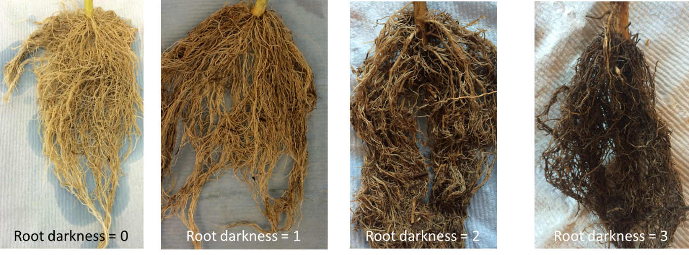
Fig.S1 Photos of root systems indicative for the root darkness scores at each level.

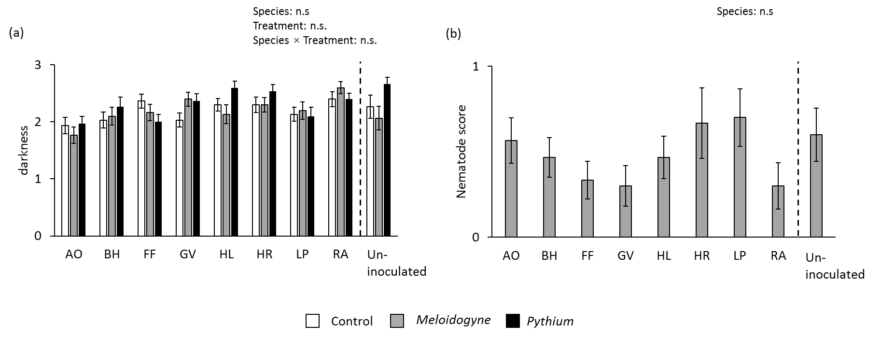
Fig.S2 Root darkness (a) and nematode infestation scores (b) of chrysanthemum grown in soil inoculated with plant-conditioned soil and in un-inoculated soil with and without disease treatments after growth cycle 1. White bars indicate root darkness in the control treatment, grey bars indicate the Meloidogyne treatment, black bars indicate the Pythium treatment. Statistics presented in the upper part of the graph are the results from a generalized linear mixed model for root darkness, and a generalized linear model for nematode score. “n.s.” indicates no significant difference.

Fig.S3 Chrysanthemum root darkness (a) and nematode scores (b) in all soils with and without disease treatments after growth cycle 2. Different colors of the bars indicate different disease treatments. “n.s.” indicates no significant difference detected. Within each soil treatment, bars with identical letters are not significantly different.
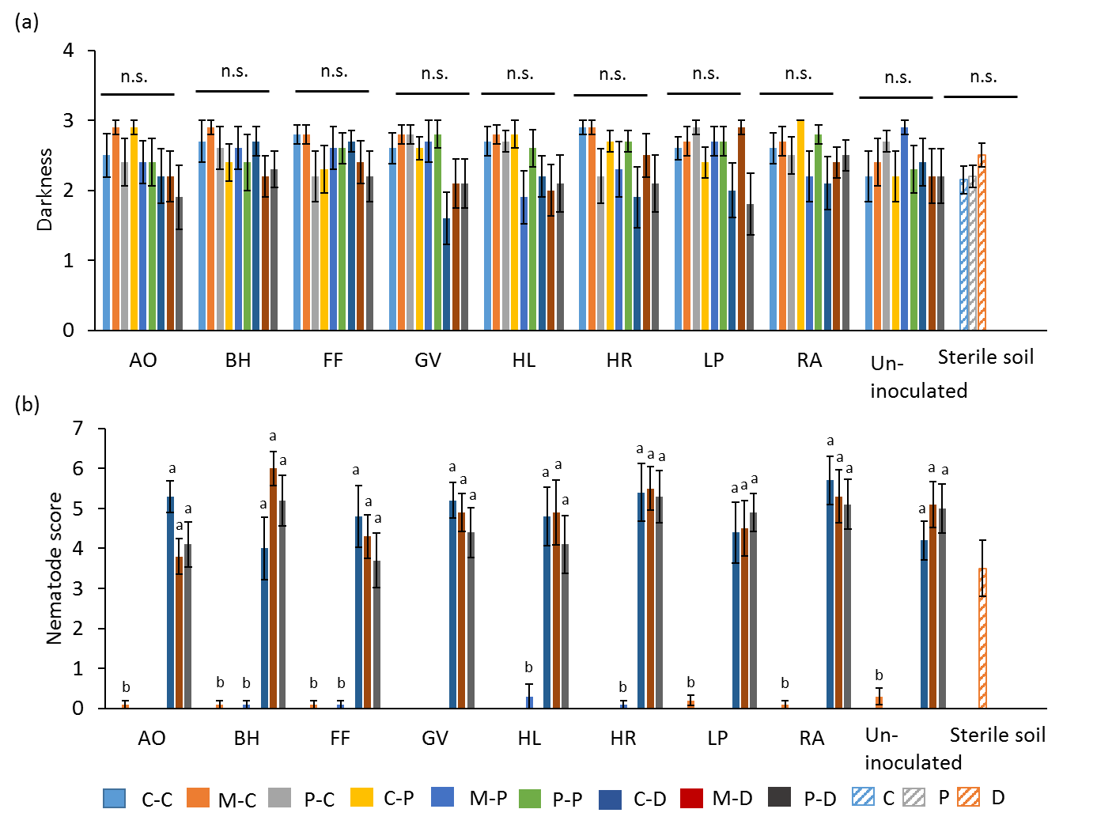
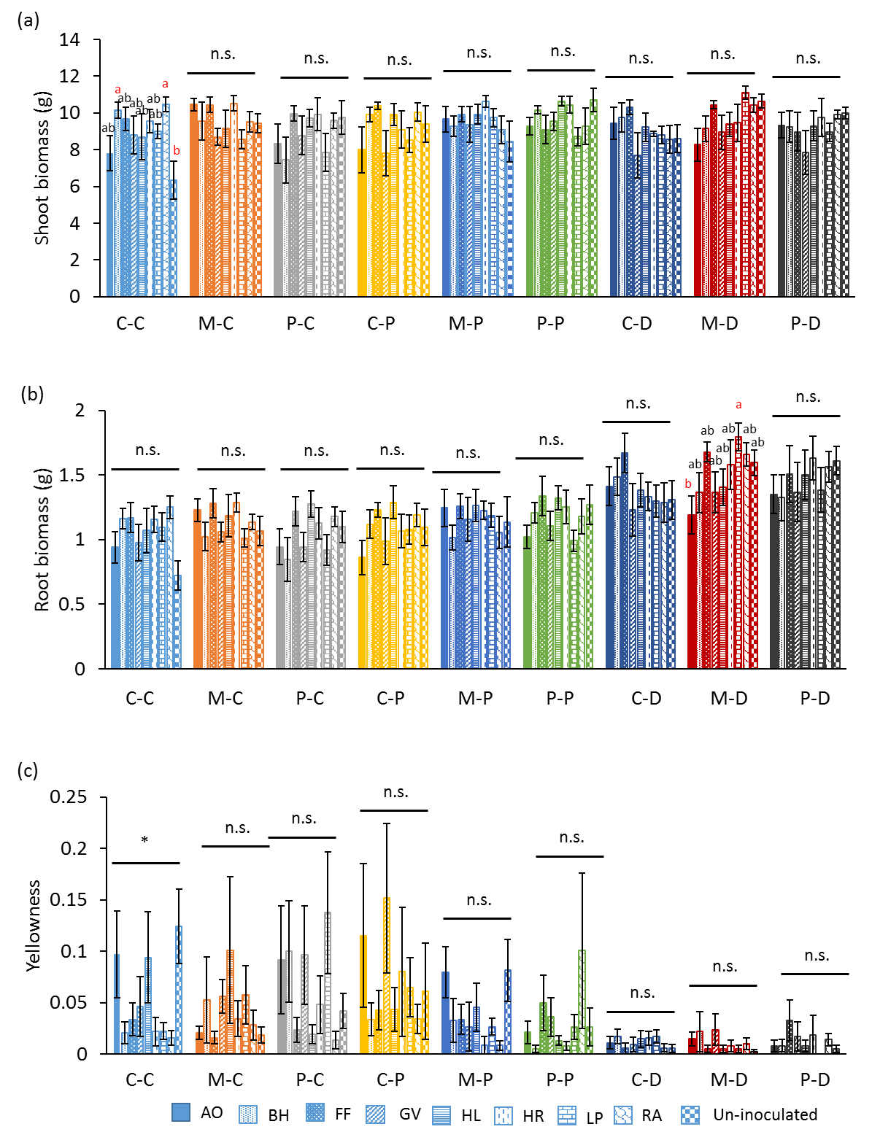
Fig.S4 Chrysanthemum shoot biomass (a), root biomass (b) and leaf yellowness (c) in all soil and treatment combinations after growth cycle 2. Presented data are grouped by each disease treatment, in each treatment, different filling patterns of the bars indicate different soil types (plant-conditioned soils or un-inoculated soil). The color of each disease treatment corresponds with Fig.3 and Fig.S2. “n.s.” indicates no significant difference detected. * indicates significant difference between soils in the relevant disease treatment (P < 0.05), but no significant pairwise comparisons detected. Letters above bars indicate significant differences among soil treatments in that relative disease treatment, bars that are significantly different are highlighted in red. Statistics for each disease treatment are presented in Table S5.

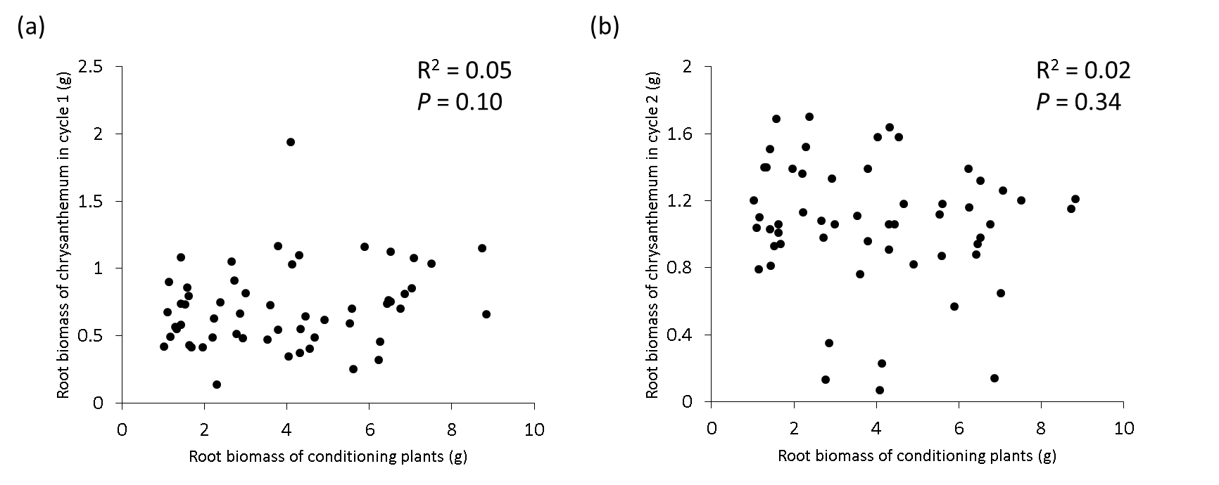
Fig.S5 Relationships between root biomass of conditioning plant species and root biomass of chrysanthemum in cycle 1 (a) and cycle 2 (b). R² and P-values following a linear regression are presented on each panel.

