Electronic Supplement Material
Imaging plant responses to water deficit drought condition using Electrical Resistivity Tomography
Sathyanarayan Rao¹, Nolwenn Lesparre², Adrián Flores Orozco³, Florian Wagner^{4,} Andreas Kemna⁵ and Mathieu Javaux^{1,6*}.
- Earth and Life Institute-Environmental Sciences, Université catholique de Louvain,
Louvain-la-Neuve, Belgium
- Laboratoire d’Hydrologie et Géochimie de Strasbourg, University of Strasbourg/EOST/ENGEES, CNRS UMR 7517, 1 Rue Blessig, 67084 Strasbourg, France
- Geophysics Research Group, Vienna University of Technology, Gusshausstraße 27-29,
E120-3, 1040 Vienna, Austria
- Institute for Applied Geophysics and Geothermal Energy, RWTH Aachen University, Aachen, Germany
- Geophysics Section, Institute of Geosciences, University of Bonn, Bonn, Germany
- Agrosphere, IBG3, Forschungszentrum Juelich GmbH, Germany
*corresponding author: mathieu.javaux@uclouvain.be; Tel/Fax: +32 10 47 37 08

S1: Soil Layer Description
The description of soil layers for water deficit condition from the observation is as follows:
- Ap1 (0-10 cm): the moist color of the horizon is brown. The horizon has a moderate fine to medium granular structure. This horizon contain many very fine to coarse roots.
- Ap2 (10-25cm): the moist color of the horizon is brown. The horizon has a weak fine to medium platy structure. This horizon is less porous than the Ap1 horizon. However, many fine to medium roots was still present.
- Ap3 (25-35cm): the plough sole. The horizon has a strong thick platy structure. The roots were growing horizontally along the boundary between Ap2 and Ap3 horizon.
- Bt (35-95 cm): the horizon has brownish color. The horizon has a moderate to strong coarse/thick blocky structure. The horizon contains few roots. Earthworm’s channels were present in the horizon
- C (95cm +): Bruxellien sand. The horizon has yellowish brown color. The horizon has strong coarse/thick blocky structure. The horizon contains very few fine roots. Little rocks were also present is this horizon.
The description of soil layers for control condition from the observation is as follows:
- Ap1(0-10 cm): the moist color of the horizon is brown. The horizon has a moderate fine to medium granular structure. This horizon contains many very fine to coarse roots. Some remaining vegetation still also present. This horizon is highly porous.
- Ap2(10-25cm): the moist color of the horizon is brown. The horizon has a weak fine to medium granular structure. This horizon is less porous than the Ap1 horizon. However, many very fine to coarse roots still presents.
- Ap3(25-38cm): the plough sole. The horizon has a strong thick platy structure. Many very fine to coarse roots are present. The roots are growing horizontally belong the boundary between Ap2 and Ap3 horizon.
- Bt1(38-78 cm): the horizon has brownish color. The horizon has a moderate to strong coarse/thick blocky structure. The horizon contains few very fine to fine roots. Earthworms channels are also present is the horizon.
- Bt2 (78cm +): the loess layer. The horizon has a greyish color. The horizon has a strong very coarse/thick blocky structure.

S2: ERT data processing:
The detailed workflow for processing raw ERT data and assessment of measurement error prior to inversion procedure is shown in Figure S1 a. In this section, we describe in detail each step, namely: preliminary filtering, normal-reciprocal analysis and error model. Figure S1 b shows the number of quadrupoles remaining at each stage of the data processing described below.
Preliminary Filtering: identification and removal of outliers
A filter is applied to remove ERT data having the following criteria:
- Geometric factor > 50000
- Apparent resistivity outside [5 – 2000] [Ω.m]. Such bounds include the TDR values measured on the field and vary in [25 – 200] [Ω.m].
- data having stacking error greater than 50% (Beff et al., 2013).
Normal-Reciprocal Analysis: detailed filtering of the data
We look at the resistance measured in normal ($R_{n}$) and reciprocal ($R_{r}$) readings to characterize the error as shown in Figure S2 a. The number of quadrupoles having reciprocals were 450 out of 3084 quadrupoles in the raw data. In the normal-reciprocal filtering, we have the following steps:
- compute error and fractional error ($FE$) as:
$E={|R}_{n}-R_{r}|$ (1)
$FE=\frac{E}{R_{mean}}$ (2)
- Remove quadrupoles having $FE$ > 0.5
- For remaining normal-reciprocal pairs, we replace $R_{n}$ and $R_{r}$ by their arithmetic mean ($R_{mean}$:
$R_{mean}=\frac{R_{n}+R_{r}}{2}$ (3)
Quantification of the data-error
The data-error in ERT can be described by a linear model (e.g., LaBrecque et al., 1996; Slater et al., 2000) that depends on the magnitude of measured resistances and expressed in terms of two parameters, which can be written as:
$E_{model}=a+bR$ (4)
where, $R$ is the magnitude of the resistance, $a$ is the absolute error and $b$ is the relative error. As described in LaBrecque et al. (1996), the absolute error is mainly dominating for low resistance values (e.g., above 1 Ω); whereas the relative error is mainly describing the error for high resistance readings.
After removal of clear outliers, we assume that the measurements are only affected by random error, which can be quantified by the model expressed in Equation 4.
In Figure S2 b, we compare the histograms of $R_{mean}$ with that of resistances of all data (quadrupoles that did not have reciprocals included) concatenated for all three-time stamps. The available normal-reciprocal data represents only about one-fifth of the total data as seen from their histograms. We see that the cumulative reciprocals are representing the total data for large range of resistances.
Among the different methods allowing the quantification of the error parameters, we used the log-binning method (described in detail in Koestel et al., 2008). We find the absolute error ($a=0.04$) and the relative error ($b=0.12$) as shown in Figure S2 c. These values were used for ERT inversion of all-time series.

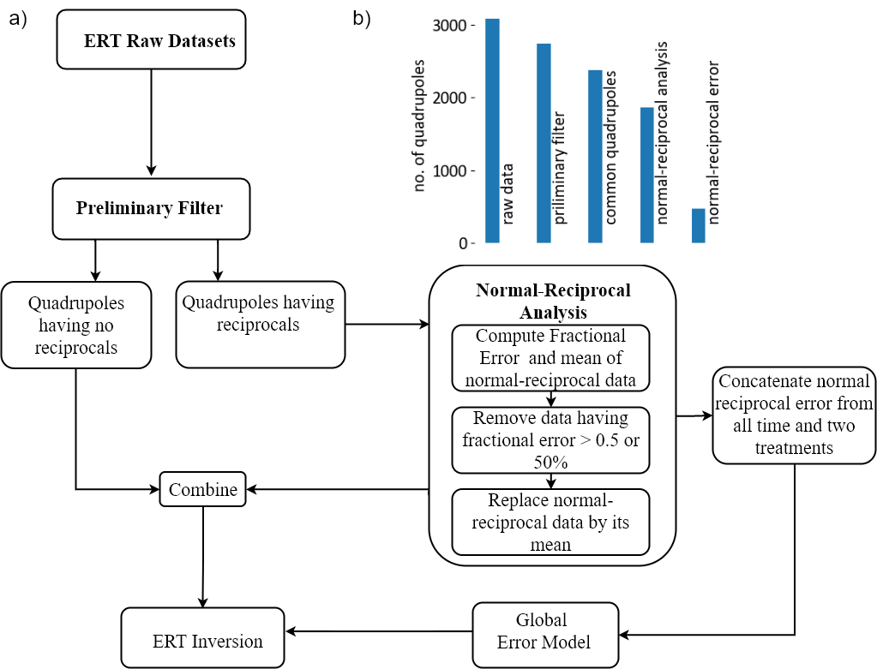

Figure S1: a) Methodology workflow chart for ERT data processing of field data and b) no. of quadrupoles per dataset remaining at various stages of filtering process.

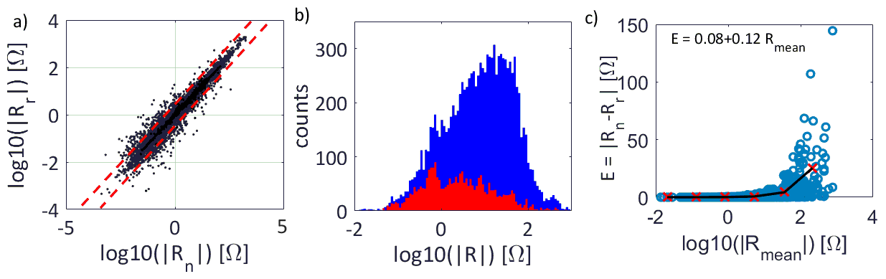
Figure S2: a) Normal and reciprocal resistances of cumulative data from t1 to t3. The dashed line indicates the range considered in the error model ($FE<0.5$ while data points outside the dashed lines are discarded, b) Histograms of cumulative resistances of all data from t1 to t3 in blue, and normal-reciprocal resistances averaged in red, c) Error vs resistance plot (blue circles) with log binned values: standard deviation of error vs mean resistance (red crosses) and a fit to log binned values (black line). The fit is E = 0.04+0.12 R.
S3: Optimizing λ and Zw
Figure S3 shows the L-curve computed for control condition at t1 for different Zw (other times are not shown although we computed optimal lambda for each time separately). The optimal λ or the corner of L-curve varied between 150 and 200 for most of our synthetic and experimental data. Hence, we chose the value of 175 to be optimal for our further studies. We provide the inversion quality and images in section E.
To optimize $Z_{w}$, we looked at two indices: a) Mean Square Error ($mse$) between original synthetic model and inverted model interpolated on the same mesh and b) Structural Similarity Index ($ssim$) (Wang et al., 2004) which measured the structural similarity (0 to 1 scale) between original synthetic model and the inverted model. Optimized $Z_{w}$ is assumed to be the one for which $mse$ is lowest and $ssim$ is highest between inverted and original model. For $Z_{w}$ optimization, we compare $mse$ and $ssim$ indices for the following quantities between original model and inverted model:
- Electrical resistivity distribution at a given time denoted by ρ(t1), ρ(t2) and ρ(t3).
- Water content distribution at a given time denoted by θ(t1), θ (t2) and θ (t3).
- Log difference of electrical resistivity at t3 and t1: $δρ=log(ρ(t3))-log⁡(ρ(t1))$.
- Difference of water content between t3 and t1: $δθ = θ (t3) - θ (t1)$.

The optimal Zw for which $ssim$ was maximum and $mse$ was minimum varied for different quantities, time and treatments ($ρ$, $θ$, $δθ$ and $δρ$) and ranged from 0.1 to 0.8. To have a common Zw for all the data, we took the mean value which was around $Zw$= 0.5. Also, this choice of Zw = 0.5 produced minimal artifacts when inspected visually (See section S4).
Up to 1m in depth, we have good uniform coverage below which the sensitivity of electrodes becomes non-uniform mainly due to greater electrode separation and lesser electrodes (See Figure S3). Hence, we can expect that inversion results below 1m depth may contain artifacts and should not be interpreted. However, at depths greater than 1m, TDR measurements showed less variations in the resistivity and hence lower coverage of ERT electrodes was sufficient.
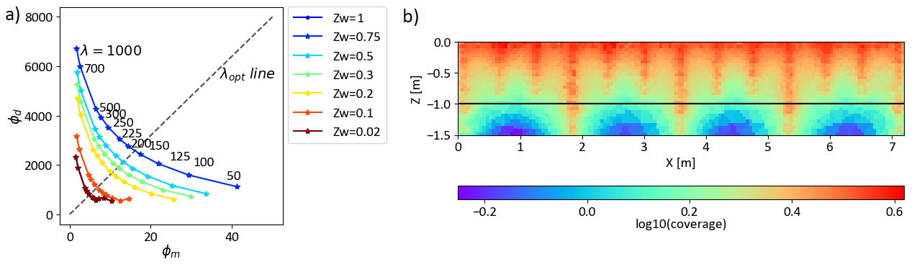
Figure S3: a) L-curves computed for electrical resistivity at t3 of Figure 7c for different Zw. The optimal lambda is at the corner of the L-curve indicated by diagonal line, b) Logarithm of electrode coverage of the ERT injection scheme.

S4: Impact of Zw on Inversion
The optimal Zw as predicted by mse and ssim indices differed for each data, quantity and treatments. We compared the inversion with forward synthetic map of $ρ$(t3), $θ$(t3), $δθ$ and $δρ$ for different values of Zw. First, we can see that our injection scheme recovers most important features in the soil-root zone. Note that the injection scheme is able to recover the uptake patterns of different plants up to 1m in depth. Second, we find that Zw=0.5 performs better than other choices in terms of reduced artifacts.
The $rrms$ was within 2% and $χ^{2}$ within 5% for all inversions results involving both synthetic and real data showing good quality of ERT inversion fits at Zw=0.5. The $ssim$ index between synthetic forward and ERT inverted varied between 0.55 to 0.62 for synthetic studies while $mse$ index ranged from 34 to 74${[Ω}^{2}m^{2}]$.

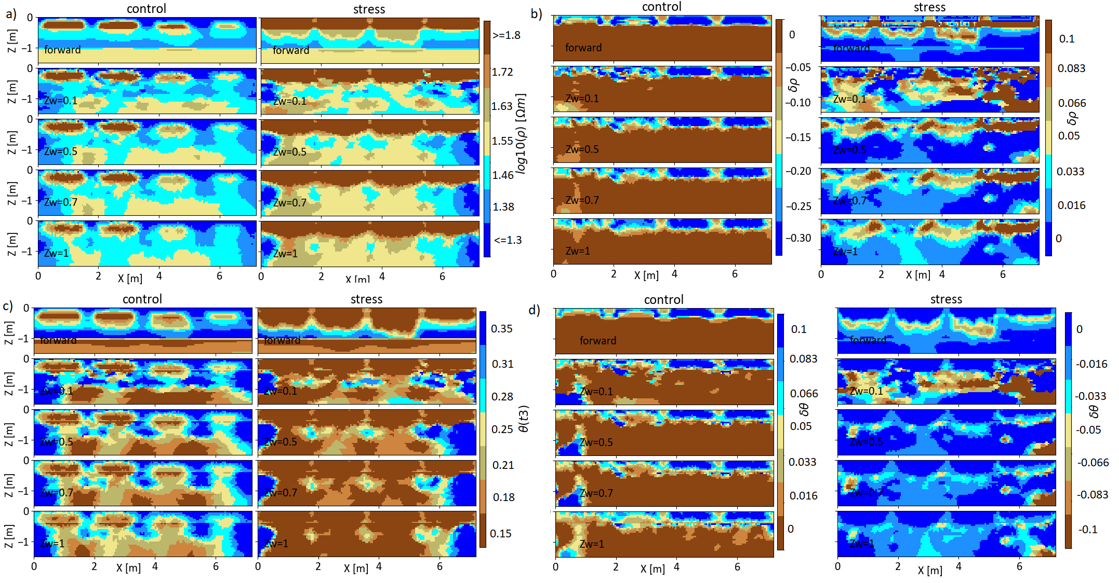

Figure S4: a) Comparison of Synthetic forward resistivity distribution at $ρ$(t3) with ERT inversion at different Zw for control treatment and stress treatment, b) Comparison of forward log ratio of resistivity at time 3 and time1 ($δρ$) with ERT inversion at different Zw for control treatment and stress treatment, c) Comparison of transformed forward water content distribution at $θ$(t3) with ERT inversion at different Zw for control treatment and stress treatment, and d) Comparison of forward difference of water content at time 3 and time1 ($δθ$) with ERT inversion at different Zw for control treatment and stress treatment.

S5: Plant and Soil boundary condition

Horizon | $θr$  [cm³cm⁻³] | $$θs$$  [cm³cm⁻³] | $a$  [1/cm] | $$n$$ | $m$= 1-1/$n$ | $Ks$ [cm/day] | $$λ$$
Ap1 | 0 | 0.4260 | 0.0264 | 1.174 | 0.1482 | 44.4 | 0.1
Ap2 | 0.039 | 0.404 | 0.00416 | 1.521 | 0.3425 | 0.732 | 1.340
Ap3 | 0.039 | 0.404 | 0.00416 | 1.521 | 0.3425 | 0.732 | 1.340
Bt1 | 0 | 0.4 | 0.00421 | 1.214 | 0.1762 | 1.5 | 1.731
Bt2 | 0 | 0.4 | 0.00421 | 1.214 | 0.1762 | 1.5 | 1.731
C | 0.1 | 0.357 | 0.0148 | 2.056 | 0.5136 | 5 | 1.155
Table S1: Soil hydraulic properties per horizon. $θr$: Residual water content, $θs$: Saturated water content, $a$ , $n$ , $m$ and $λ$: shape parameters in Van Genuchten-Mualem equations, $Ks$: saturated soil hydraulic conductivity.
Equivalent conductance of the whole root system | 1 [cm³/hPa/day]
Compensatory RWU conductance of the root system | 1 [cm³/hPa/day]
Limiting collar water potential (isohydric plant) | -15000 hPA
Table S2: Plant parameters used in R-SWMS simulation

S6: Mixing model choice of alpha
To find the exponent ($α$) of two-phase mixing model, we designed specific numerical experiments in a 5cm x 5cm x 0.1cm container or numerical grid filled with artistic root architectures in a homogeneous soil that had root to total volume fraction of 12% and diameter of 0.03cm (see Figure S5-a). We assume that it represents the conditions present in each root counting box where we applied the mixing model.
We assumed $ρ_{root}$ to be 10 Ωm and $ρ_{soil}$ to be 100 Ωm. Next with the resistivity map, we computed the effective resistivity ($ρ_{eff}$) between two-line electrodes situated at top and bottom wall and two-line electrodes at left and right walls similar to the approach of Rao et al. (2019). The $α$ for which the following objective function ($ϕ$) is minimal is computed:
$ϕ= ρ_{eff}-{\left[f\left({ρ_{root}}^{α}\right)+\left(1-f\right)\left({ρ_{soil}}^{α}\right)\right]}^{\frac{1}{α}}$
The minimal $α$ is shown in Figure S5-b which is around 0.5 for vertical direction and -0.5 for horizontal direction. In our analysis, we chose $α$ to be 0.5.
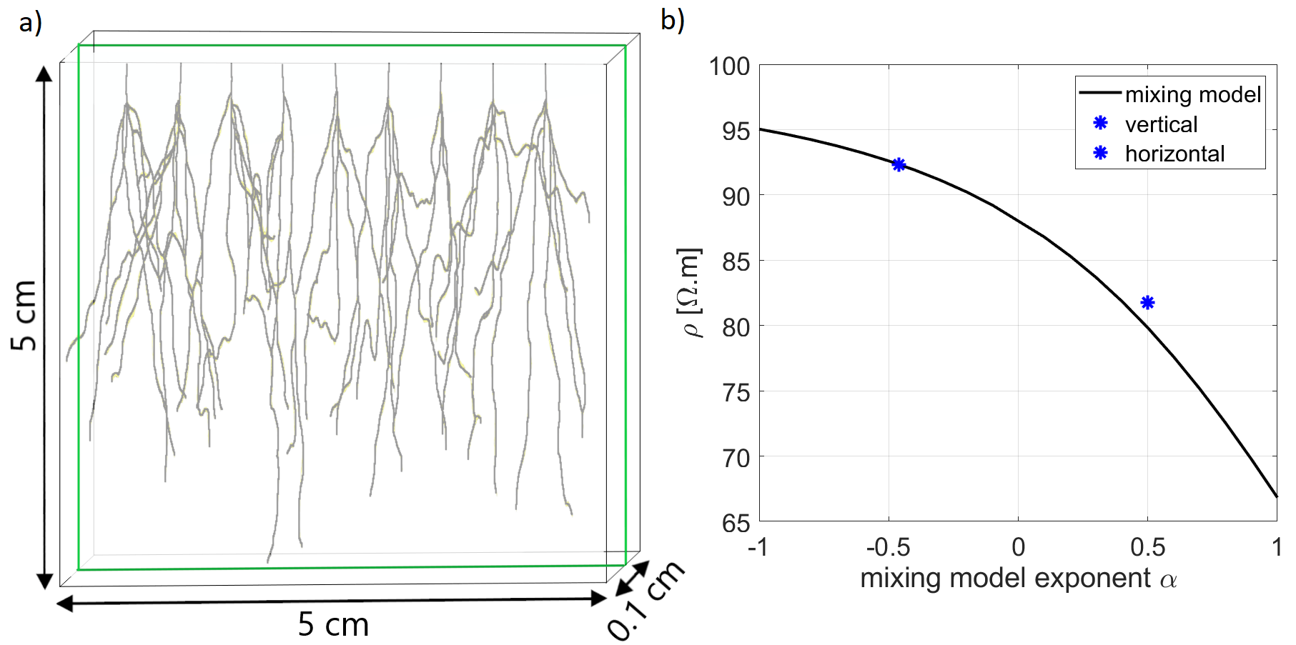
Figure S5: a) Artistic root architecture in a thin rhizotron geometry of dimension 5cm x 5cm x 0.1cm. The green line represents the line electrode used for computing effective property of underlying two phases ($ρ_{root}$ = 10 Ωm and $ρ_{soil}$ = 100 Ωm) and b) The mixing model and the computed effective properties showing $α$ to be approximately -0.5 and 0.5.

References for supplement:
Beff, L., Günther, T., Vandoorne, B., Couvreur, V. and Javaux, M.: Three-dimensional monitoring of soil water content in a maize field using Electrical Resistivity Tomography, Hydrology and Earth System Sciences, 17(2), 595–609, doi:10.5194/hess-17-595-2013, 2013.
Koestel, J., Kemna, A., Javaux, M., Binley, A. and Vereecken, H.: Quantitative imaging of solute transport in an unsaturated and undisturbed soil monolith with 3‐D ERT and TDR, Water Resources Research, 44(12), 2008.
LaBrecque, D. J., Miletto, M., Daily, W., Ramirez, A. and Owen, E.: The effects of noise on Occam’s inversion of resistivity tomography data, Geophysics, 61(2), 538–548, 1996.
Slater, L., Binley, A. M., Daily, W. and Johnson, R.: Cross-hole electrical imaging of a controlled saline tracer injection, Journal of applied geophysics, 44(2–3), 85–102, 2000.
Wang, Z., Bovik, A. C., Sheikh, H. R. and Simoncelli, E. P.: Image quality assessment: from error visibility to structural similarity, IEEE transactions on image processing, 13(4), 600–612, 2004.

